CMV Driver Examination Results Form
U.S. Department of Transportation
Federal Motor Carrier Safety Administration
OMB Control Number: 2126-0006
Expiration Date:
Assigned FMCSA Form Number: MCSA-5850
Public Burden Statement:
A Federal agency may not conduct or sponsor, and a person is not required to respond to, nor shall a person be subject to a
penalty for failure to comply with a collection of information subject to the requirements of the Paperwork Reduction Act unless that collection of information displays a current valid OMB Control Number. The OMB Control Number for this information collection is 2126-0006. Public reporting for this collection of information is estimated to be approximately 5 minutes per response, including the time for reviewing instructions, gathering the data needed, and completing and reviewing the collection of information. All responses to this collection of information are mandatory and confidentiality will be provided to the extent allowed by the Privacy Act of 1974. Send comments regarding this burden estimate or any other aspect of this collection of information, including suggestions for reducing this burden to: Information Collection Clearance Officer, Federal Motor Carrier Safety Administration, MC-RRA, 1200 New Jersey Avenue, SE, Washington, D.C. 20590.

You are required to submit the following driver medical examination data every month. Complete this form for each driver medical examination concluded.

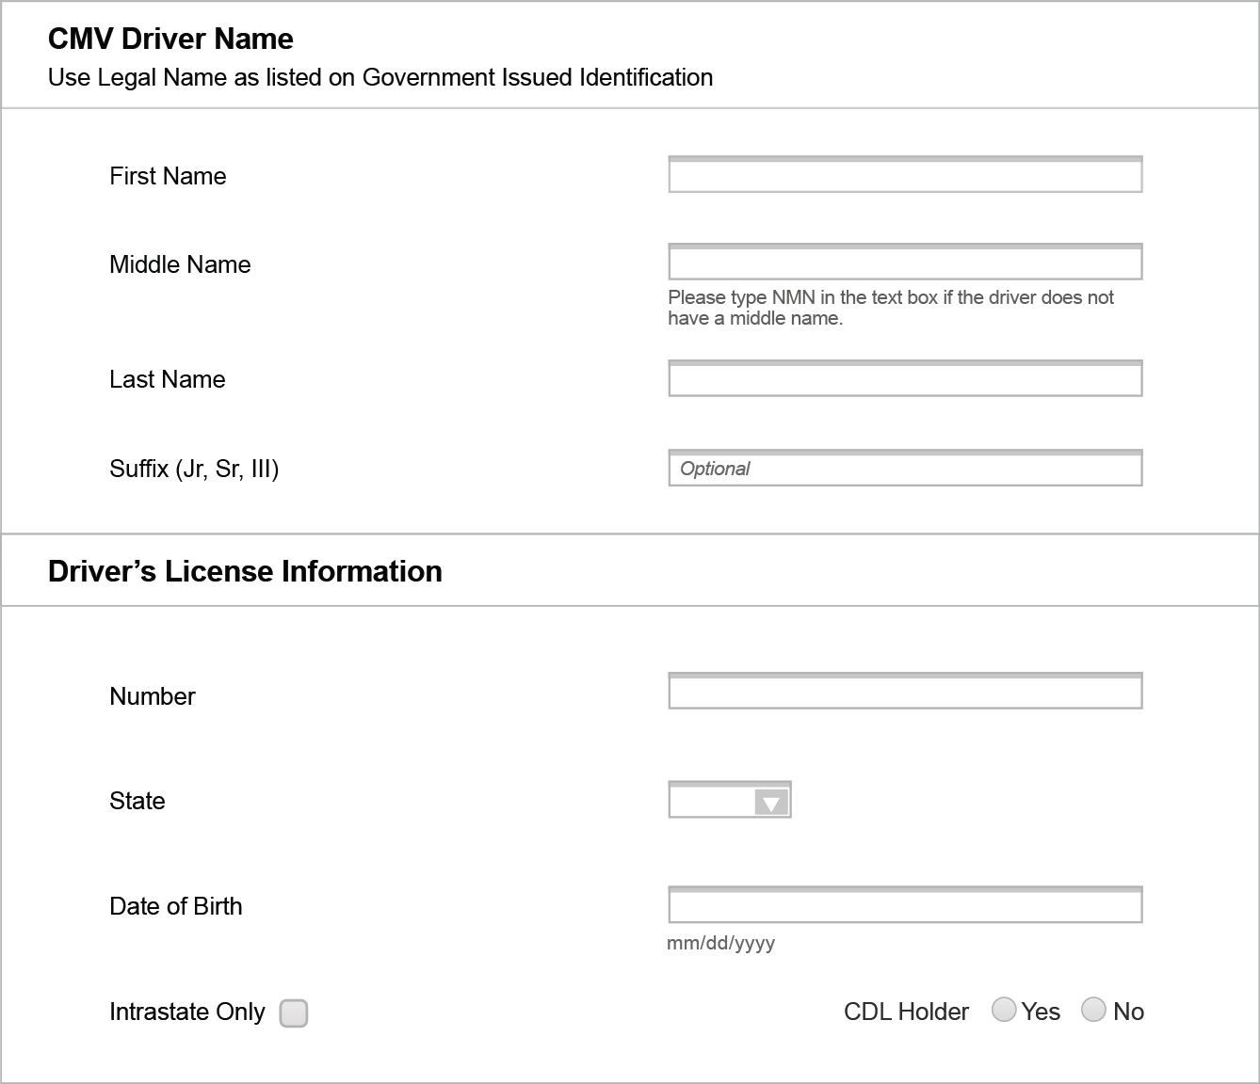
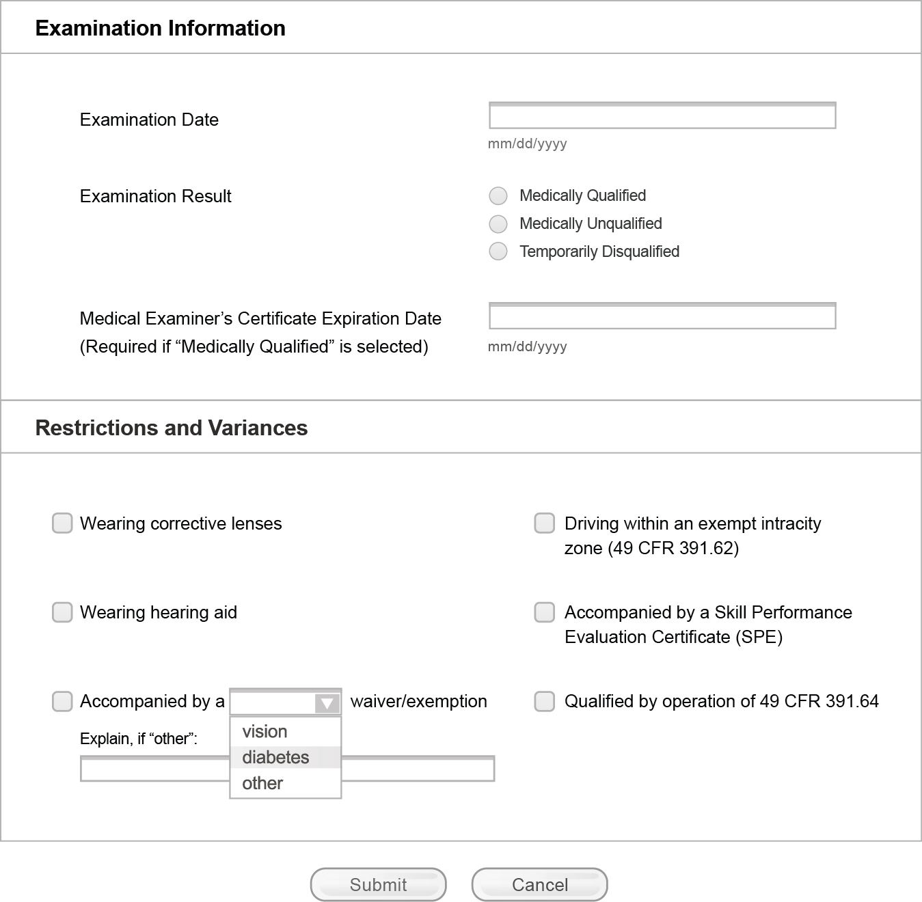National Registry of Certified Medical Examiners Privacy Act Statement
This statement is provided pursuant to the Privacy Act of 1974, 5 USC § 552a. The information on the attached Form MCSA-5850 CMV Driver Examination Results is solicited under the authority of Title 49, United States Code (U.S.C.) §§ 40113, 44702, 44703, 44709 and 14 C.F.R. Part 6-7.
With limited exceptions, all drivers who operate commercial motor vehicles (CMVs), as defined in 49 CFR 390.5, in interstate commerce must comply with the qualification requirements of part 391 (§ 391.1). Each driver subject to the physical qualification requirements must be examined and certified by a medical examiner, as defined in § 390.5, at least once every 2 years. For certain drivers, such as those with severe cases of hypertension or other acute medical conditions, more frequent medical re-examination by a medical examiner may be required to determine whether the driver can still be certified.
Medical examiners are required to submit data every month for each driver physical examination conducted. Driver or medical examiner social security number is not required. Incomplete submission may result in removal of a medical examiner from the National Registry Program. The purpose of information is to record results of a driver’s physical qualification to operate a CMV in interstate commerce according to the requirement in 49 CFR 391.41-49.
The information will be used to provide data for FMCSA’s automated National Registry Data System. The information will become part of an FMCSA Privacy Act system of record. These records and information in these records will be collected and used to link a specific medical examiner to specific driver medical examination outcome data.
The written consent authorization of this form under OMB Control Number: 2126-0006 permits FMCSA to request driver physical examination outcome data from medical examiners.

