Date
POC Name
Title
Company Name
Company Address

Dear POC Name,

The Bureau of Industry and Security’s (BIS) Office of Technology Evaluation, in coordination with the CAD/PAD Joint Program Office, Naval Surface Warfare Center, Indian Head Division, is conducting a national security assessment of the U.S. cartridge and propellant actuated device (CAD/PAD) industry and its supply chains. The principal goal of this data collection is to update industry and government officials on the underlying health and competitiveness of this defense critical industry, and to ensure the ability of the industry to support defense missions and programs.

Your company has been identified as manufacturing, integrating, or assembling products relating to the cartridge and propellant actuated device industry. To begin, download the Excel formatted survey and corresponding instructions at:
http://www.bis.doc.gov/cadpad_survey/index.htm
For internal data collection purposes, a PDF version of the survey can also be downloaded at this website. BIS will only accept Excel survey submissions.

If your company has more than one U.S. facility or division supporting the healthcare industry and finds it easier to submit individual business unit-level survey responses, please notify BIS. If not, BIS will expect one consolidated Excel survey response from your company.

Information furnished to BIS is business confidential and will not be published or disclosed, other than in aggregate form. Such information is also protected from disclosure from Freedom of Information Act (FOIA) requests. Also note that your company is required by federal law under 50 U.S.C. App Sec 2155 to complete the survey within 30 days of receipt of this letter.

If you have any questions regarding the survey, e-mail CADPADsurvey@bis.doc.gov or contact BIS staffers: Anna Bruse at 202-482-7418 and Erika Maynard at 202-482-5572.

Please contact me at 202-482-4060 if you have any questions regarding the overall Cartridge and Propellant Actuated Device Industry supply chain assessment.

Thank you for your participation.

Sincerely,

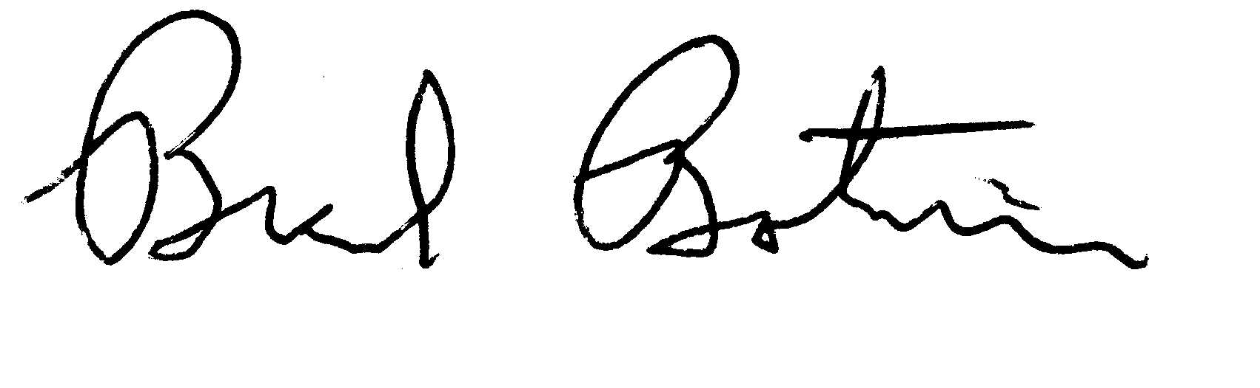
Brad Botwin
Director, Industrial Studies
Office of Technology Evaluation

