**Attachment 2a: Semi-targeted advertisement**

**PARTICIPANTS WANTED FOR RESEARCH STUDY**

The National Center for Health Statistics is looking for persons aged 18 or over to answer a variety of health questions. Anyone is eligible to participate, but we are especially interested in talking with people who have learning disabilities, depression or anxiety, mobility issues, and individuals over the age of 65.

The interview will be no longer than 90 minutes, and participants will receive $40.

**FOR MORE INFORMATION,**

**call Lauren at**: **301-458-4676**

**Centers for Disease Control and Prevention**

**National Center for Health Statistics**

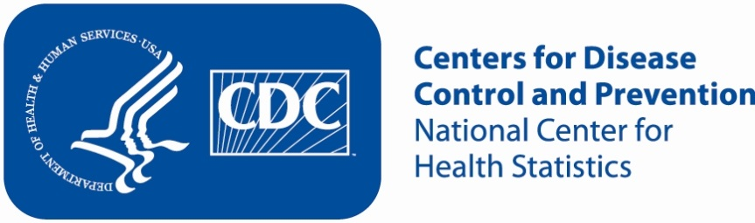

**Attachment 2b: Targeted advertisement [note that only one statement within the bracketed section below will be selected at a time, depending on recruiting needs]**

**PARTICIPANTS WANTED FOR RESEARCH STUDY**

The National Center for Health Statistics is looking for persons aged 18 or over who [have learning disabilities/have depression or anxiety/have mobility issues and use a walker, a wheelchair, or a cane/are over the age of 65] to answer a variety of health related questions.

The interview will be no longer than 90 minutes, and participants will receive $40.

**FOR MORE INFORMATION,**

**call Lauren at**: **301-458-4676**

**Centers for Disease Control and Prevention**

**National Center for Health Statistics**



**Attachment 2c: Un-targeted advertisement**

**PARTICIPANTS WANTED FOR RESEARCH STUDY**

The National Center for Health Statistics is looking for persons aged 18 or over to answer a variety of health related questions.

The interview will be no longer than 90 minutes, and participants will receive $40.

**FOR MORE INFORMATION, call Lauren at**: **301-458-4676**

**Centers for Disease Control and Prevention**

**National Center for Health Statistics**

