Attachment 2a: Adult Disability Questions -- Semi-targeted advertisement

**Participants Wanted for Research Study**

The National Center for Health Statistics

is looking for persons aged 18 or over to answer a variety of health and quality of life questions. Anyone is eligible to participate, but we are especially interested in talking with people who have learning disabilities, depression or anxiety, mobility issues, and individuals over the age of 65. The interview will be no longer than 60 minutes and participants will receive $40.

**FOR MORE INFORMATION,**

call Lauren at: **301-458-4676**

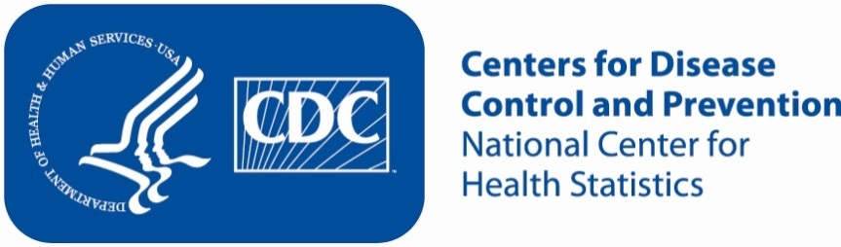

Attachment 2b: Adult Disability Questions -- Targeted advertisement [note that only one statement within the bracketed section below will be selected at a time, depending on recruiting needs]

**Participants Wanted for Research Study**

The National Center for Health Statistics

is looking for persons aged 18 or over who [have learning disabilities/have depression or anxiety/have mobility issues and use a walker, a wheelchair, or a cane/are over the age of 65] to answer a variety of health related and quality of life questions. The interview will be no longer than 60 minutes and participants will receive $40.

**FOR MORE INFORMATION,**

call Lauren at: **301-458-4676**



Attachment 2c: Adult Disability Questions -- Un-targeted advertisement

**Participants Wanted for Research Study**

The National Center for Health Statistics

is looking for persons aged 18 or over to answer a variety of health related and quality of life questions. The interview will be no longer than 60 minutes and participants will receive $40.

**FOR MORE INFORMATION,**

call Lauren at: **301-458-4676**



Attachment 2d: Child Disability Questions Advertisement/flyer

**Participants Wanted for Research Study**

The National Center for Health Statistics

is looking for adults aged 18 years and over with children living in the household to answer a variety of health questions that may be asked on a national survey. We want to talk to parents or guardians of children 2 to 17 years of age who may have difficulties in the following areas: seeing, hearing, walking, learning, behavior. The survey research interview will be no longer than 60 minutes and participants will receive $40.

**FOR MORE INFORMATION,**

call Lauren at: **301-458-4676**

**Centers for Disease Control and Prevention**

**National Center for Health Statistics**

Attachment 2e: Child Disability Questions -- Non Child Disability Specific Advertisement/flyer

**Participants Wanted for Research Study**

The National Center for Health Statistics

is looking for adults aged 18 years and over with children living in the household to answer a variety of health questions that may be asked on a national survey. We want to talk to parents or guardians of children 2 to 17 years of age. The survey research interview will be no longer than 60 minutes and participants will receive $40.

**FOR MORE INFORMATION,**

call Lauren at: **301-458-4676**

**Centers for Disease Control and Prevention**

**National Center for Health Statistics**

Attachment 2f: Adult and Child Disability Questions -- Targeted advertisement [note that only one statement within the bracketed section below will be selected at a time, depending on recruiting needs].

**Participants Wanted for Research Study**

The National Center for Health Statistics

is looking for persons aged 18 years or over who [have learning disabilities/have depression or anxiety/have mobility issues and use a walker, a wheelchair, or a cane/are over the age of 65] and who have children 2 to 17 years of age who may have difficulties in the following areas: seeing, hearing, walking, learning, behavior to answer a variety of health related questions. The interview will be no longer than 60 minutes and participants will receive $40.

**FOR MORE INFORMATION,**

call Lauren at: **301-458-4676**

