Attachment 2: 2015 NHIS Cancer Supplement – Advertisement/Flyer

Note to reviewers: The phrase “or use a tanning device” may appear in some advertisements/flyers and not others.

Participants Wanted for Research Study

The National Center for Health Statistics
is looking for adults aged 18 and over to answer a variety of health questions. We would like to talk to you if you have had a mammogram and follow-up procedures, PSA test, Chest CT scan, PSA test, genetic counseling for cancer risk, [or use a tanning device]. The interview will be no longer than 60 minutes and participants will receive $40.

FOR MORE INFORMATION,
call Lauren at: 301-458-4676

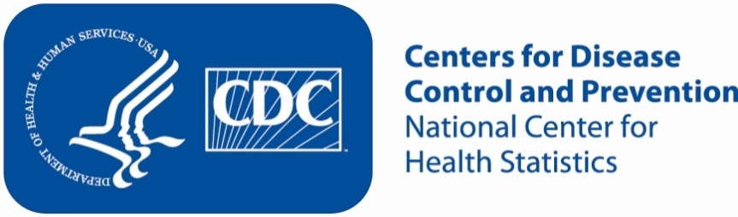

Attachment 2: 2015 NHIS Cancer Supplement – Advertisement/Flyer

Participants Wanted for Research Study

The National Center for Health Statistics
is looking for adults aged 18 and over to answer a variety of health questions. We would like to talk to you if you have ever used non-cigarette tobacco products including cigars, pipes, hookahs, cigarillos, bidis, chewing tobacco, snuff, dip, snus or dissolvable tobacco. The interview will be no longer than 60 minutes and participants will receive $40.

FOR MORE INFORMATION,
call Lauren at: 301-458-4676

