Attachment 2a: PRAMS Advertisement/flyer (English version)

Note to reviewers: We may select all of the text currently listed within brackets or select specific text within the brackets.

Participants Wanted for Research Study

The National Center for Health Statistics
is looking for mothers (aged 18 and over) with babies 2-12 months old to answer questions that may be used on a national survey. We are interested in mothers who [worked for pay during pregnancy, or breastfed, or used a breast pump, or used cigarettes, e-cigarettes, or hookah]. The interview will be no longer than 90 minutes and participants will receive $50.

FOR MORE INFORMATION,
call Lauren at: 301-458-4676

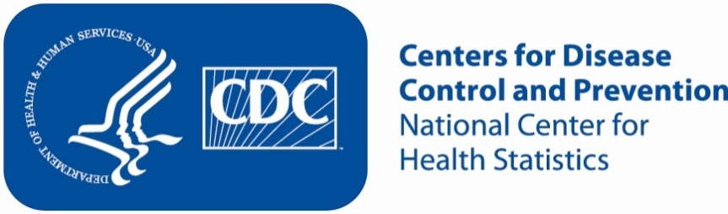

Attachment 2b: PRAMS Advertisement/flyer (Spanish version)

Note to reviewers: We may select all of the text currently listed within brackets or select specific text within the brackets.

Se necesitan mamás para un estudio

El Centro Nacional para Estadísticas de Salud está buscando mamás (de 18 años o más) con bebés entre 2 y 12 meses de edad para responder unas preguntas que podrían usarse en una encuesta nacional. Estamos interesados en entrevistar mamás quienes hayan [trabajado por un sueldo durante el embarazo, hayan amamantado, o usado un sacaleches, o hayan usado cigarrillos, cigarrillos electrónicos, o narguile (hookah)].
La entrevista tomará un máximo de 90 minutos y las participantes recibirán $50.

PARA MÁS INFORMACIÓN,
Por favor llame a [fill name]al: [fill phone number]

