Attachment 2a: Semi-targeted advertisement

**Participants Wanted for Research Study**

The National Center for Health Statistics

is looking for persons aged 18 – 64 to answer a variety of health and quality of life questions. Anyone is eligible to participate, but we are especially interested in talking with people who have chronic health conditions (diabetes, asthma, addiction), depression or anxiety, mobility issues or difficulty seeing or hearing. The interview will be no longer than 60 minutes and participants will receive $40.

**FOR MORE INFORMATION,**

call Lauren at: **301-458-4676**

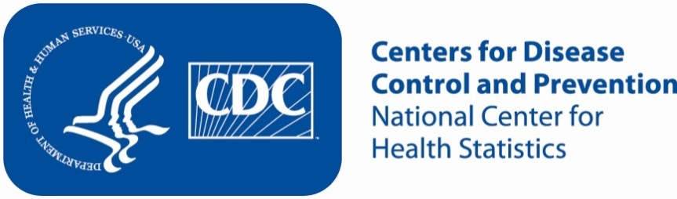

Attachment 2b: Targeted advertisement [note that only one statement within the bracketed section below will be selected at a time, depending on recruiting needs].

**Participants Wanted for Research Study**

The National Center for Health Statistics

is looking for persons aged 18 – 64 who have [chronic health conditions (diabetes, asthma, addiction), depression or anxiety, mobility issues or difficulty seeing or hearing] to answer a variety of health related and quality of life questions. The interview will be no longer than 60 minutes and participants will receive $40.

**FOR MORE INFORMATION,**

call Lauren at: **301-458-4676**



Attachment 2c: Un-targeted advertisement

**Participants Wanted for Research Study**

The National Center for Health Statistics

is looking for persons aged 18 - 64 to answer a variety of health related and quality of life questions. The interview will be no longer than 60 minutes and participants will receive $40.

**FOR MORE INFORMATION,**

call Lauren at: **301-458-4676**

