Attachment 2a: Semi-targeted advertisement [note that only one or more statements within the bracketed section below will be selected at a time, depending on recruiting needs].

**Note to reviewers: Interviewing dyads is a complex concept to recruit for. Although both 3a and 3b contain the same core message, potential respondents may understand one of the ads better due to the difference in organization. With this in mind, keeping both 3a and 3b will give recruitment the flexibility of using one ad over the other if it is found that people understand one of the ads better than the other.**

**Participants Wanted for Research Study**

The National Center for Health Statistics

is looking for parents and teens to answer a variety of health questions that may be asked on a national survey. We want to talk to parents or guardians and teens 12 to 17 years of age [who may have difficulties in the following areas: seeing, hearing, walking, learning, behavior, depression or anxiety] about topics related to their health. The survey research interview will be no longer than 60 minutes. The parent/guardian and the teen will receive $40 each.

**FOR MORE INFORMATION,**

Call Lauren at: **301-458-4676**

**Centers for Disease Control and Prevention**

**National Center for Health Statistics**

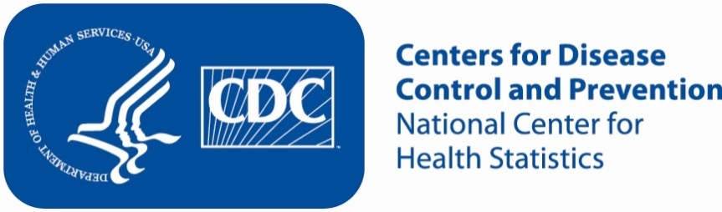**Attachment 2b: Semi-targeted advertisement [note that only one or more statements within the bracketed section below will be selected at a time, depending on recruiting needs].**

**Note to reviewers: Interviewing dyads is a complex concept to recruit for. Although both 3a and 3b contain the same core message, potential respondents may understand one of the ads better due to the difference in organization. With this in mind, keeping both 3a and 3b will give recruitment the flexibility of using one ad over the other if it is found that people understand one of the ads better than the other.**

**Participants Wanted for Research Study**

The National Center for Health Statistics

is looking for parents/guardians of teens (aged 12-17) [who may have difficulties in the following areas: seeing, hearing, walking, learning, behavior, depression or anxiety] to answer a variety of health related questions. Both parent/guardian and teen will participate in the interview. The survey research interview will be no longer than 60 minutes. The parent/guardian and the teen will receive $40 each.

**FOR MORE INFORMATION,**

call Lauren at: **301-458-4676**

**Centers for Disease Control and Prevention**

**National Center for Health Statistics**



**Attachment 2c: Non Specific Advertisement/flyer**

**Participants Wanted for Research Study**

The National Center for Health Statistics

is looking for adults and their teen children (aged 12-17) to answer a variety of health questions that may be asked on a national survey. We want to talk to parents or guardians of teens 12 to 17 years of age and to the teens themselves. The survey research interview will be no longer than 60 minutes. The parent/guardian and the teen will receive $40 each.

**FOR MORE INFORMATION,**

Call Lauren at: **301-458-4676**

**Centers for Disease Control and Prevention**

**National Center for Health Statistics**

