Attachment 2a: Semi-targeted advertisement/flyer [one or more statements within the bracketed section may be selected at a time, depending on recruiting needs].

**Participants Wanted for Research Study**

The National Center for Health Statistics

is looking for adult men and women aged 18 and over to answer a variety of health questions. We would like to talk to you if you have had a [Chest CT scan, CAT scan, lung cancer screening with low dose computer tomography, Chest X-ray lung cancer screening, Pap test, or HPV test]. The survey research interview will be no longer than 60 minutes and participants will receive $40.

**FOR MORE INFORMATION,**

Call Lauren at: **301-458-4676**

**Centers for Disease Control and Prevention**

**National Center for Health Statistics**

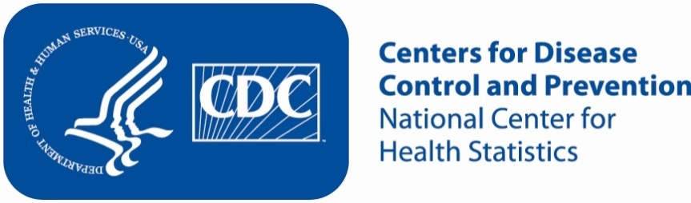**Attachment 2b: Targeted advertisement/flyer**

**Participants Wanted for Research Study**

The National Center for Health Statistics

is looking for women aged 18 and over to answer a variety of health questions. We would like to talk to you if you have had a [Pap test and/or an HPV test]. The survey research interview will be no longer than 60 minutes and participants will receive $40.

**FOR MORE INFORMATION,**

Call Lauren at: **301-458-4676**

**Centers for Disease Control and Prevention**

**National Center for Health Statistics**



Attachment 2c: Semi-targeted advertisement/flyer [one or more statements within the bracketed section may be selected at a time, depending on recruiting needs].

**Participants Wanted for Research Study**

The National Center for Health Statistics

is looking for adults aged 55 to 80 years of age to answer a variety of health questions. We would like to talk to you if you have had a [Chest CT scan, CAT scan, lung cancer screening, chest X-ray lung cancer screening, or lung cancer screening with low dose computer tomography]. The survey research interview will be no longer than 60 minutes and participants will receive $40.

**FOR MORE INFORMATION,**

Call Lauren at: **301-458-4676**

**Centers for Disease Control and Prevention**

**National Center for Health Statistics**

