**Attachment 2a: Semi-targeted advertisement**

**Note that one or more statements within the bracketed section below may be selected at a time, depending on recruiting needs.**

**Participants Wanted for Research Study**

The National Center for Health Statistics

is looking for adults aged 18 and over who have pain that impacts their participation in [work, school, social and self-care activities], as well as those without pain. The survey research interview will be no longer than 60 minutes and participants will receive $40.

**FOR MORE INFORMATION,**

Call Lauren at: **301-458-4676**

**Centers for Disease Control and Prevention**

**National Center for Health Statistics**

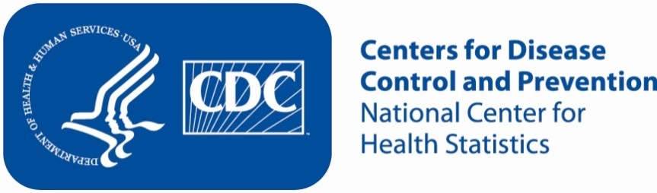**Attachment 2b: Non Specific Advertisement/flyer**

**Participants Wanted for Research Study**

The National Center for Health Statistics

is looking for adults aged 18 and over to answer a variety of health questions that may be asked on a national survey. The survey research interview will be no longer than 60 minutes. Participants will receive $40.

**FOR MORE INFORMATION,**

Call Lauren at: **301-458-4676**

**Centers for Disease Control and Prevention**

**National Center for Health Statistics**

