Attachment 2a: Semi-targeted advertisement/flyer [one or more statements within the bracketed section may be selected at a time, depending on recruiting needs].

Participants Wanted for Research Study

The National Center for Health Statistics
is looking for adult men and women aged 18 and over to answer a variety of health questions. We would like to talk to you if you have had a [Chest CT scan, CAT scan, lung cancer screening with low dose computer tomography, Chest X-ray lung cancer screening, Pap test, or HPV test]. The survey research interview will be no longer than 60 minutes and participants will receive $40.

FOR MORE INFORMATION,
Call Lauren at: 301-458-4676

Centers for Disease Control and Prevention
National Center for Health Statistics
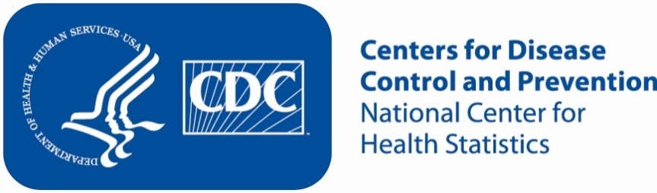
Attachment 2b: Targeted advertisement/flyer

Participants Wanted for Research Study

The National Center for Health Statistics
is looking for women aged 18 and over to answer a variety of health questions. We would like to talk to you if you have had a [Pap test and/or an HPV test]. The survey research interview will be no longer than 60 minutes and participants will receive $40.

FOR MORE INFORMATION,
Call Lauren at: 301-458-4676

Centers for Disease Control and Prevention
National Center for Health Statistics

Attachment 2c: Semi-targeted advertisement/flyer [one or more statements within the bracketed section may be selected at a time, depending on recruiting needs].

Participants Wanted for Research Study

The National Center for Health Statistics
is looking for adults aged 55 to 80 years of age to answer a variety of health questions. We would like to talk to you if you have had a [Chest CT scan, CAT scan, lung cancer screening, chest X-ray lung cancer screening, or lung cancer screening with low dose computer tomography]. The survey research interview will be no longer than 60 minutes and participants will receive $40.

FOR MORE INFORMATION,
Call Lauren at: 301-458-4676

Centers for Disease Control and Prevention
National Center for Health Statistics

