Appendix 7 – Project Specific Thank you letter

DEPARTMENT OF HEALTH & HUMAN SERVICES Public Health Service
Centers for Disease Control and Prevention

National Center for Health Statistics
3311 Toledo Road
Hyattsville, Maryland 20782

Thank you

…for the assistance you have given us in testing the Cultural and Linguistic Competency in Health Care Self-Administered Mail Survey for Office-Based Physicians. Once fielded, the survey will enable an accurate understanding of physicians’ training, awareness, and provision of culturally and linguistically appropriate services, with the ultimate goal of informing future policy.

The information you provided will, of course, be held in confidence. When combined with information given by other volunteers, it will help us to identify and correct problems with question wording and order. This will improve the quality of the information collected in the national survey. We greatly appreciate your help in this effort.

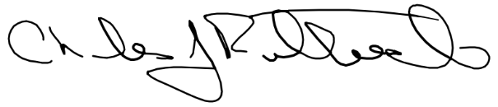

Charles J. Rothwell
Director
National Center for Health Statistics

