APPENDIX B
Focus Group Moderator Guide for Task A

- Introduction (8 minutes)

- [Moderator introduces herself/himself.]

- [Explain:] A focus group is a group discussion where we can learn more in-depth about peoples’ ideas and opinions (compared to telephone or written surveys).

- My job is to facilitate the discussion and make sure that everyone has an opportunity to speak and to make sure that no one dominates the conversation.

- Housekeeping – Toilets and refreshments.

- [Mention ground rules.]
  - There are no right or wrong answers; we’re interested in your honest and candid opinions and ideas. It’s OK to disagree.
  - Our discussion is totally anonymous. We will not use your names in any report.
  - Our discussion today is being recorded. These recordings allow us to write a more complete report, and to make sure we accurately reflect your opinions. However, please only speak one at a time, so that the recorder can pick up all your comments.
  - That is a one-way mirror behind me and one of my colleagues is observing our discussion
  - It is important to tell us YOUR thoughts, not what you think others will think, or what you think others want to hear.
  - Please turn off cell phones
  - Your stipend will be provided as you leave.
  - Relax and enjoy

- We’re going to spend our time talking about the content, organization, and visual appeal of the brochure for the Health Hazard Evaluation Program. Any questions about the purpose of our focus group or the ground rules before we begin?

- I’d like you each to introduce yourselves. Please tell us:
- Your FIRST name
- What type of industry do you work in?
- How long have you worked there?
- What is your job title/responsibilities?

- What Are Health Hazards (5 minutes)
  - What comes to mind when you see the phrase ‘health hazards in the workplace’?
(Listen for and probe on ‘things that can cause a rash, an injury, respiratory problems, work-related illnesses, etc.)

- Overall Perceptions of Health Hazard Evaluations and Brochure Purpose (15 minutes)

- [Provide participants with Word Bubbles form] Ask them to individually write down what they think, what they feel, and what they would say to someone else about Health Hazard Evaluations. (Max 5 minutes to do this).

Then open up to discussion and write common themes on flip-chart and summarize common themes.

- Who do you think health hazard evaluations are for?

- What do you think the purpose of a brochure about Health Hazard Evaluations would be?

- Feedback on New Brochure Content (30 minutes)

- [Distribute new brochure content. This document has the content, but no formatting or visuals.] Please read through the new brochure content sheet and write down on the sheet any reactions you might have regarding the content. For example, is there any information that is not clear, is some information missing that you think is needed, is there something about the information that causes you to not want to read any further, should things be said in a different way, etc

- What do you think the main idea or ideas are of the brochure?

- In general, how well did the main ideas come across?

- Was the content relevant to you?

- Did the content motivate you to take action? If yes, what types of action?

- Is there anything confusing or unclear? Are there words that you think some employees or employers might not understand? (Probe on what and how it could be improved.)

- Is there any other content that would be useful to include? (Probe on what and why it would be important to include.)

- Did any of the content strike you as unnecessary? (Probe on what and why.)

- Is there anything about the content that caused you to want to stop reading? (Probe on what, why and how it could be improved.)

Check with observers to see if there are any other questions before moving on.

- Feedback on New Brochure order of Information (15 minutes)

- Distribute the Order of Information Rating form. Then present the new brochure in layout minus any visuals. Remind them that we are NOT interested in the content, but rather in the order of information. And that we are not interested in the visuals at this time. By order of information we mean the order in which the information is presented and. Have them individually assess the order of information in regard to the following:
- What did they like about the order of information?
- What did they dislike about the order of information?
- How does the order of information help or hurt the likelihood that you will read this information?

- Overall what was your general reaction to the order of the information?

- Then open up to discussion on each of the order of information issues above in Q13. Probe on ideas for improving the order of information. Have the group reach a consensus on which order of information they would recommend and why.

Check with observers to see if there are any other questions before moving on.

- Assessing New Brochure Visuals (25 minutes)

- [Distribute the Visuals Rating form. Present the full new brochure with the visuals. Remind them that we are NOT interested in the content or the layout, but rather in the visuals.] Have them individually assess the visuals in regard to the following:
- What did they like about the visuals?
- What did they dislike about the visuals?
- How do the visuals help or hurt the likelihood that you would read the information?

- Overall, how do you feel about the visuals, including colors, photos, and graphics?

- Then open up to discussion on each of the visual issues above in Q16. Probe on ideas for improving the visuals.

- Is there anything about the visuals that caused you to want to stop reading? (Probe on what, why and how it could be improved.)

- Show approximately 10-15 other visuals to see if participants believe that any of those are preferable. (Probe on why or why not.)

- Are there any other visuals that would be useful to include? (Probe on what and why it would be important to include.)

Check with client to see if there are any other questions before moving on.

Wrap Up (10 minutes)

- Moderator to summarize key content, layout and visual aspect ideas from the group.

- Any other comments that you would like me to pass on to the NIOSH about the content, layout, and visuals for the brochure?

- Thinking back over everything we’ve discussed this evening, what are you most likely to remember and use?

- Possibly bring NIOSH staff in to the group to answer any questions from participants.
Word Bubbles Form – Health Hazard Evaluation

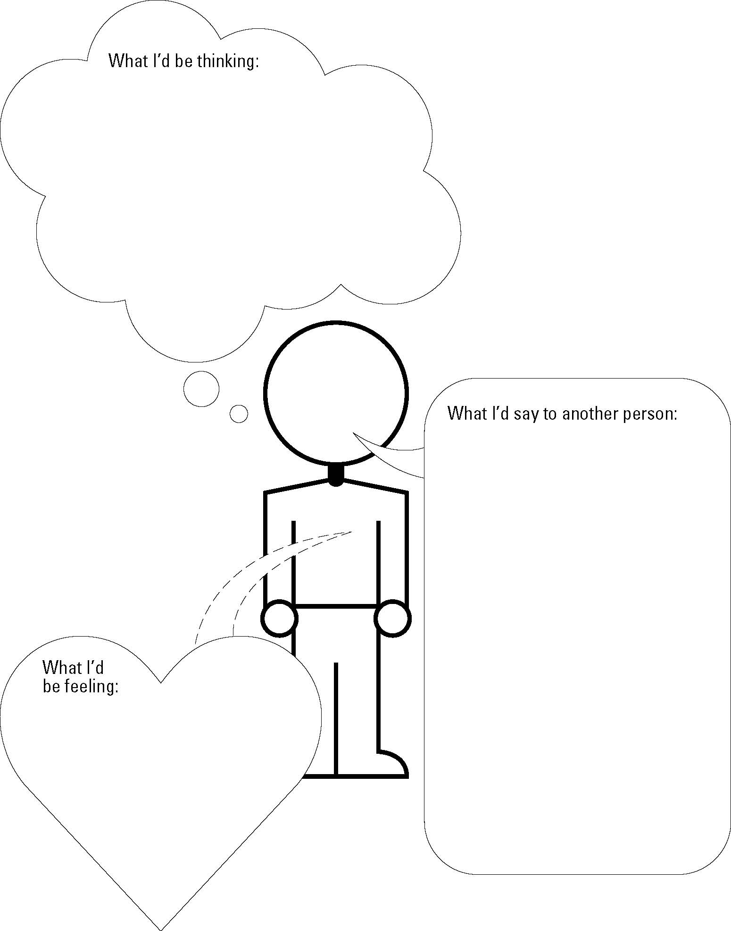
BROCHURE ORDER OF INFORMATION FEEDBACK FORM Focus Group Date: ___________

- What do you like about the order of information?
________________________________________________________________________________________________________________________________________________________________________________________________________________________________________________________________________________________________
________________________________________________________________________

- What do you dislike about the order of information?
________________________________________________________________________________________________________________________________________________________________________________________________________________________________________________________________________________________________
________________________________________________________________________

- How does the order of information help or hurt the likelihood that you will read this information?
________________________________________________________________________________________________________________________________________________________________________________________________________________________________________________________________________________________________
________________________________________________________________________

BROCHURE VISUALS FEEDBACK FORM Focus Group Date: _____________________

- What do you like about the visuals?
________________________________________________________________________________________________________________________________________________________________________________________________________________________________________________________________________________________________
________________________________________________________________________

- What do you dislike about the visuals?
________________________________________________________________________________________________________________________________________________________________________________________________________________________________________________________________________________________________
________________________________________________________________________

- How do the visuals help or hurt your ability to understand this information?
________________________________________________________________________________________________________________________________________________________________________________________________________________________________________________________________________________________________
________________________________________________________________________

