Special Notice Options (iSNO) Screenshots

Overview of Pages in iSNO
These screenshots were generated using updated to Validation Build #7 on May 19, 2010 around 12:00 noon.
Screen Number | Screen Name
Section: Public Internet Path
Pub010 | Welcome [Name of User]
Pub030 | Select an Option
Pub040 | Verify Selection
Pub050 | Confirmation
Section: CSR Intranet Path (Update Mode)
Csr020 | Authenticate a Client
Csr030 | Select Option
Csr030 | Select Option (Pending Other Accommodation)
Csr035 | Other Accommodation Information
Csr040 | Summary
Csr050 | Confirmation
Csr070 | Other Accommodation History
Csr080 | Other Accommodation History Details
Csr080 | Other Accommodation History Details (May 2011 Release Version)
Section: CSR Intranet Path (Query Mode)
Csr020 | Authenticate a Client
Csr030 | Select Option
Csr070 | Other Accommodation History
Csr080 | Other Accommodation History Details
Csr080 | Other Accommodation History Details (May 2011 Release Version)
Section: OGC Intranet Path
OGC020 | Authenticate a Client
OGC070 | Other Accommodation Decision History
OGC080 | Other Accommodation Decision Details (Update Mode)
OGC080 | Other Accommodation Decision Details (Update Mode) (May 2011 Release Version)
OGC080 | Other Accommodation Decision Details (View Mode)
OGC080 | Other Accommodation Decision Details (View Mode - May 2011 Release Version)
Section: Messages
Msg021 | Not Authorized
Msg026 | We Cannot Process Your Request
Msg027 | We Cannot Process Your Request at This Time

PUB010 Welcome

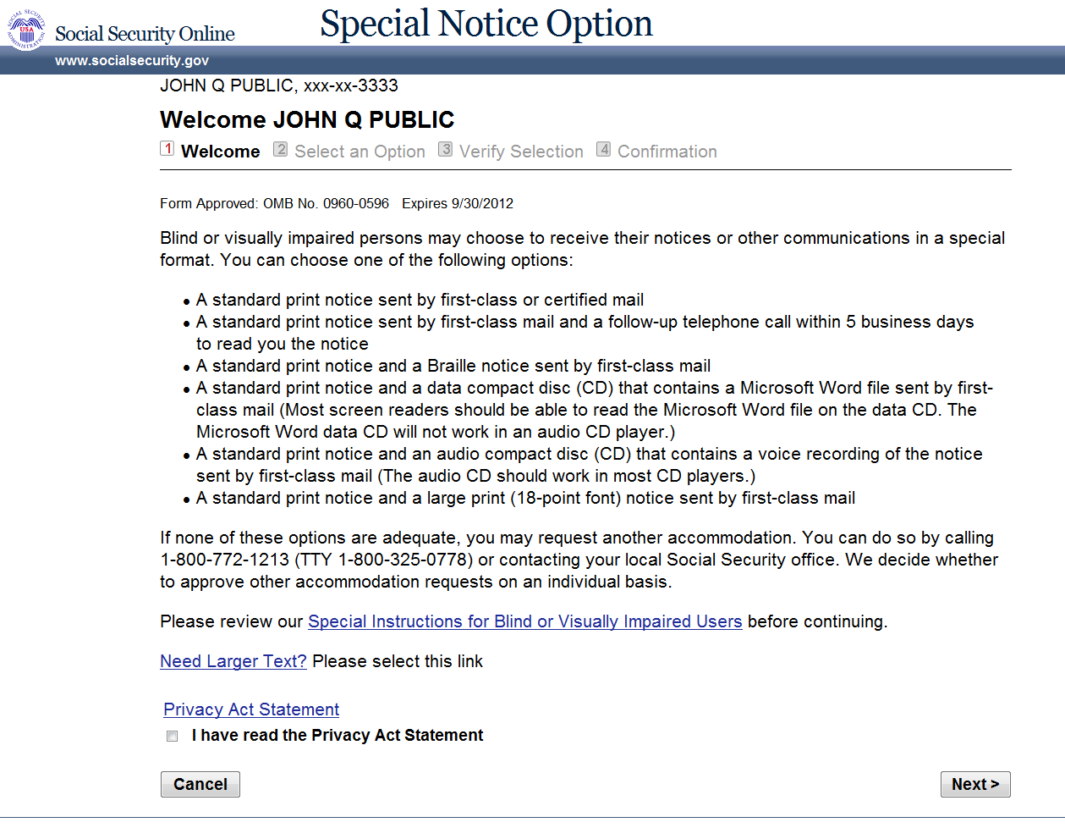

PUB030 Select an Option
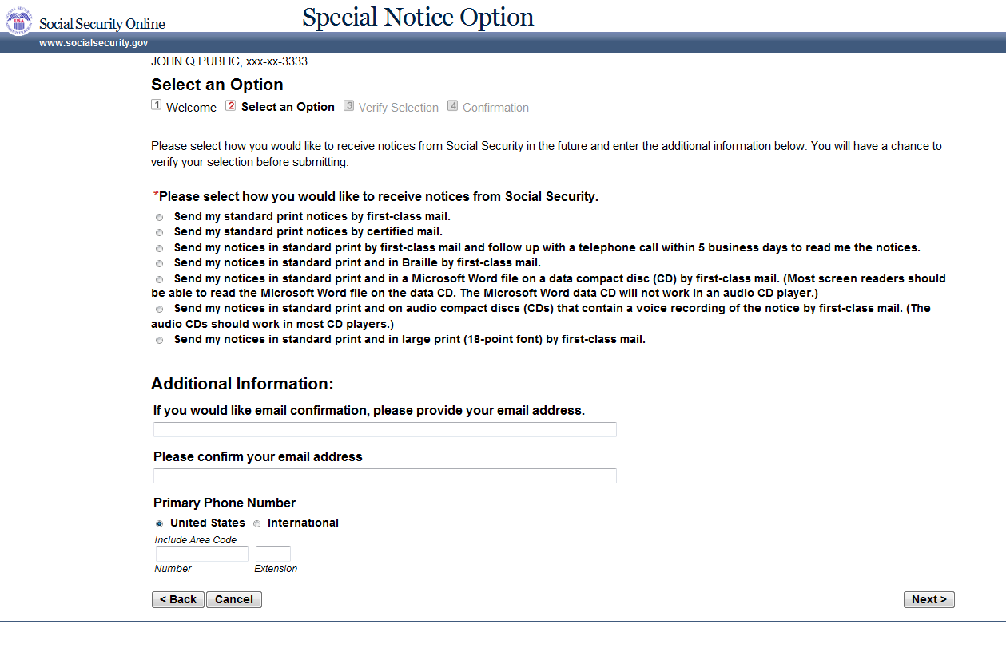

PUB040 Verify Selection
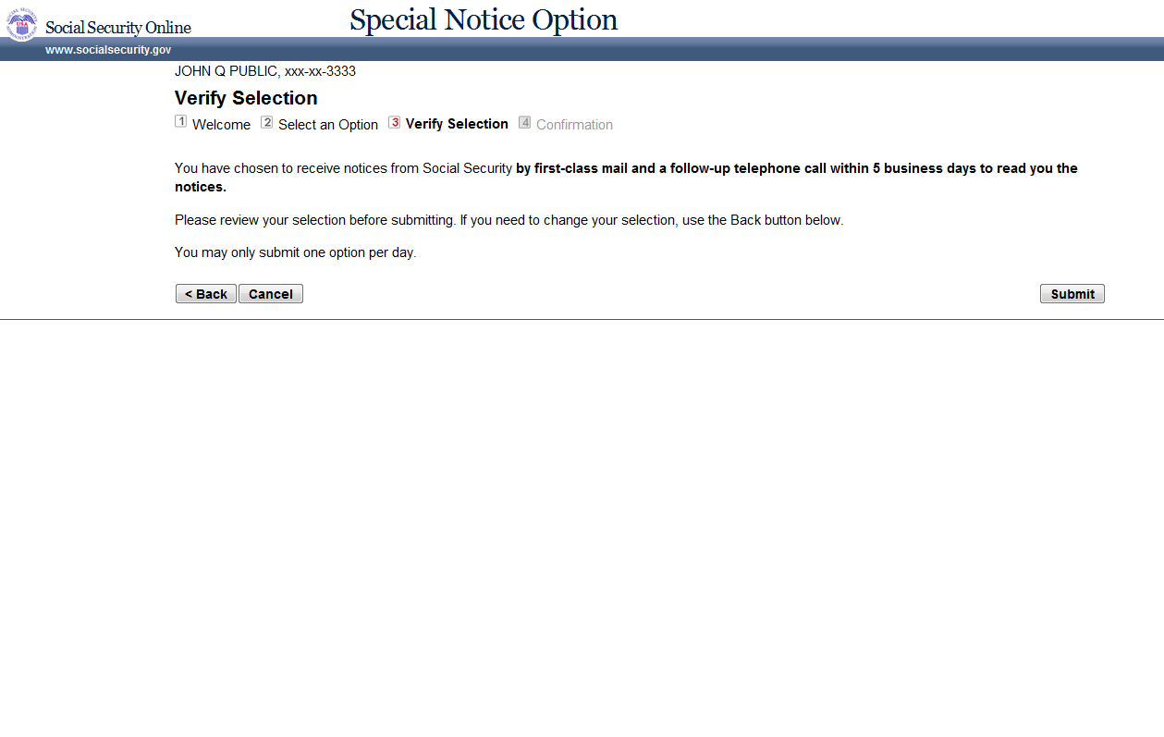

PUB050 Confirmation
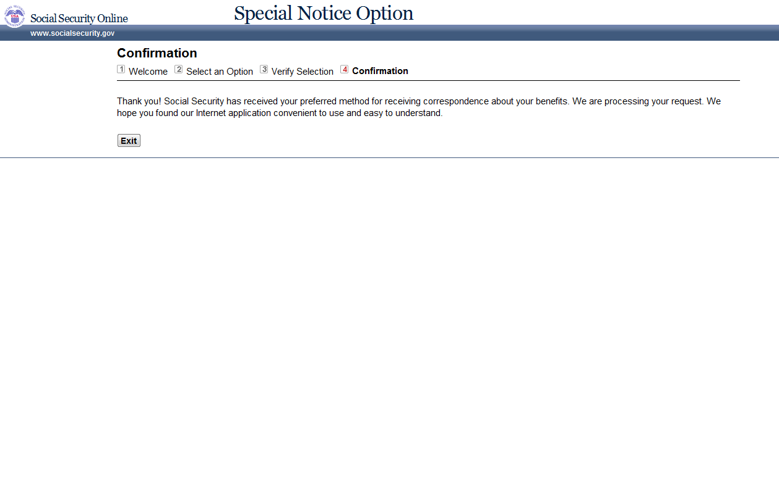

CSR020 Authenticate a Client
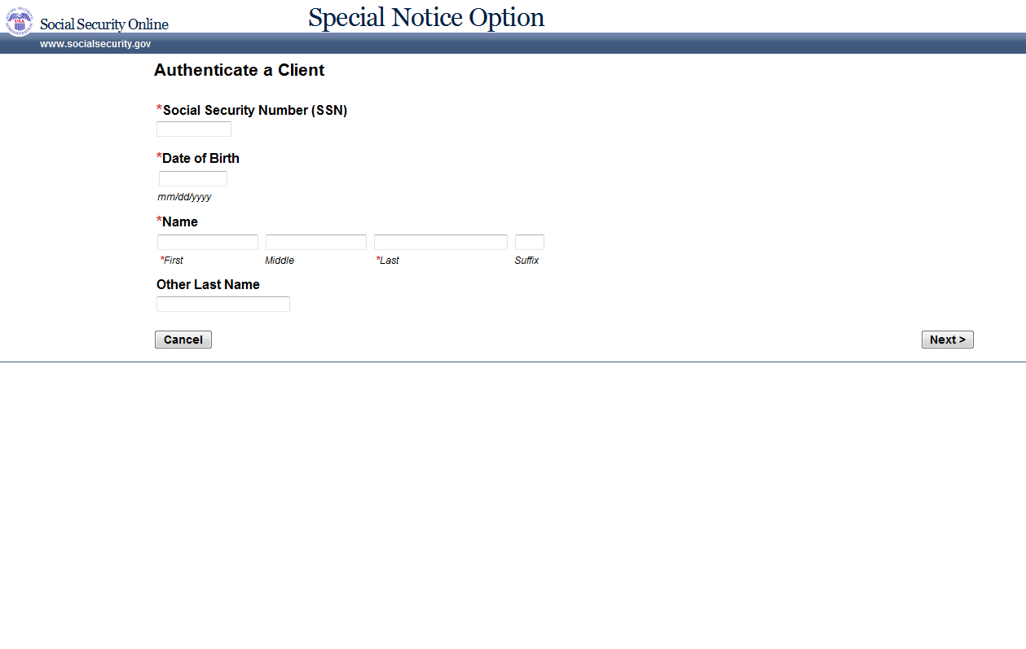

CSR030 Select Option
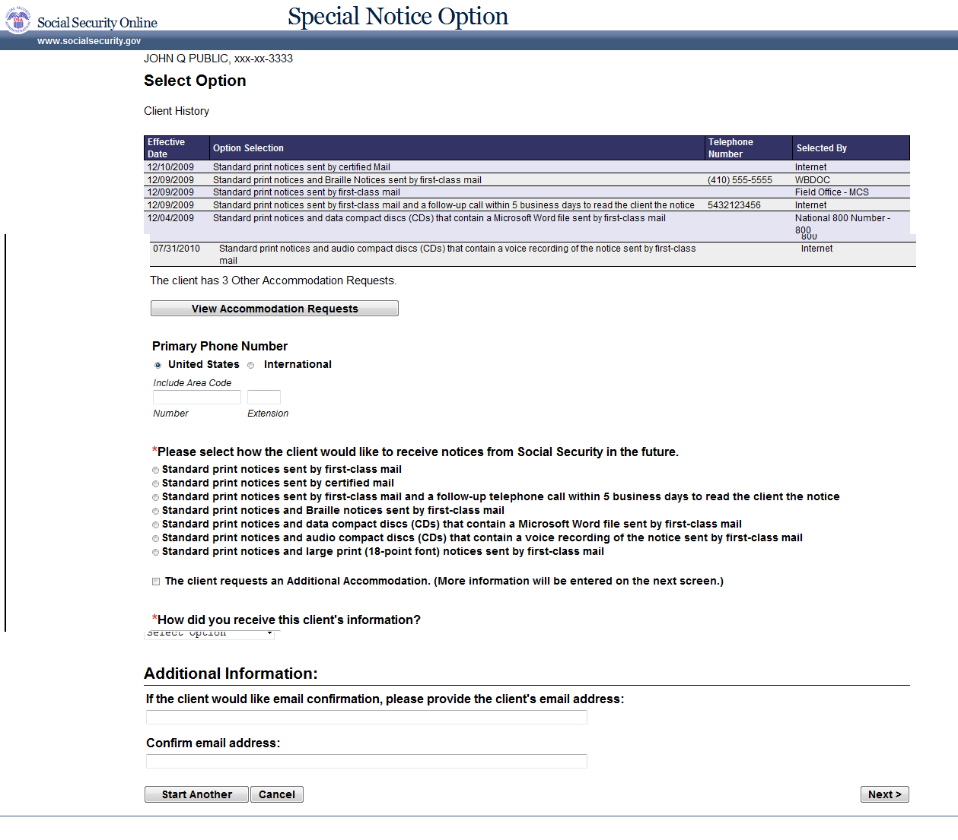

CSR030 Select Options (Pending Other Accommodation)

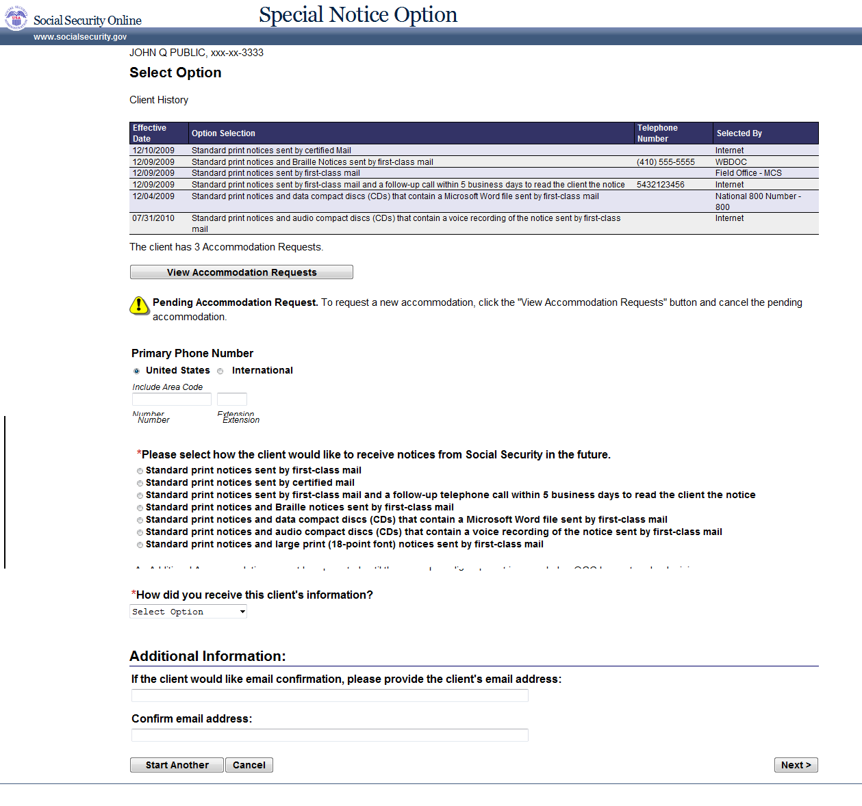

CSR035 Other Accommodation Information
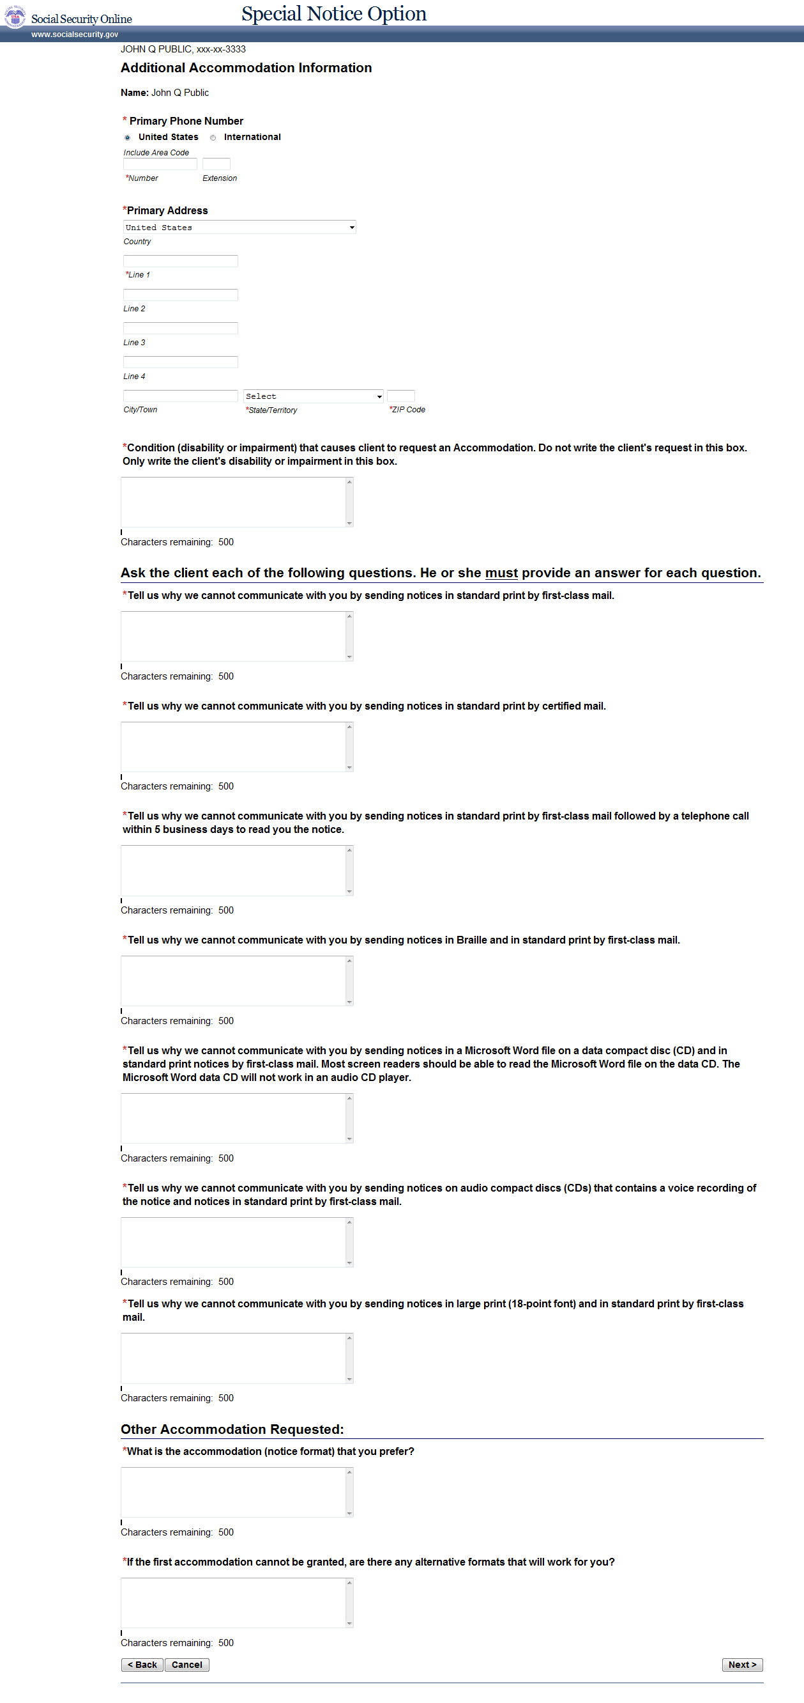
CSR040 Summary
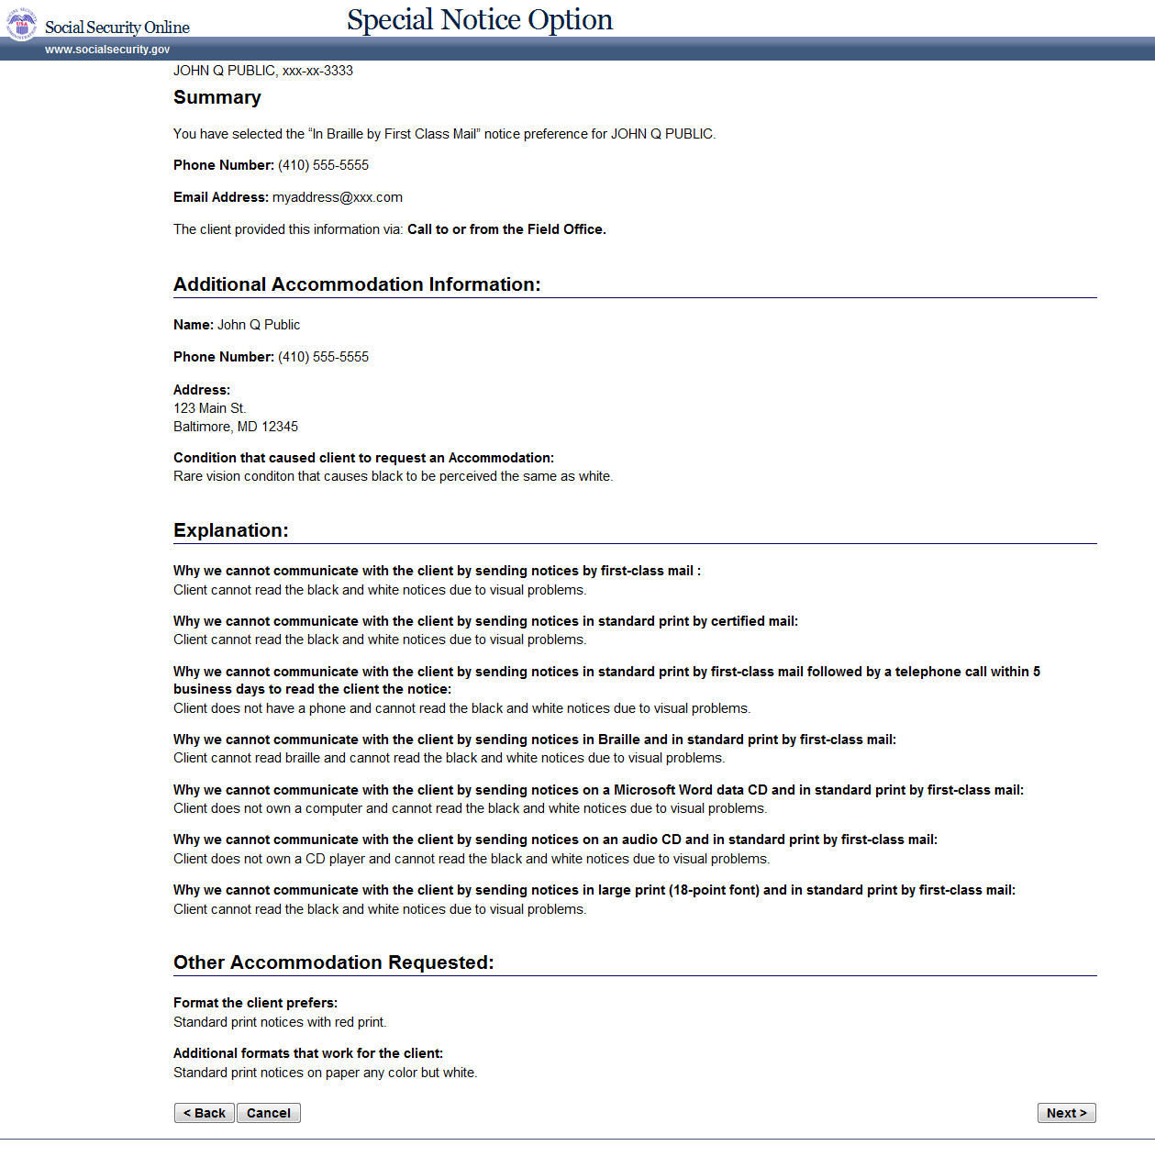

CSR050 Confirmation
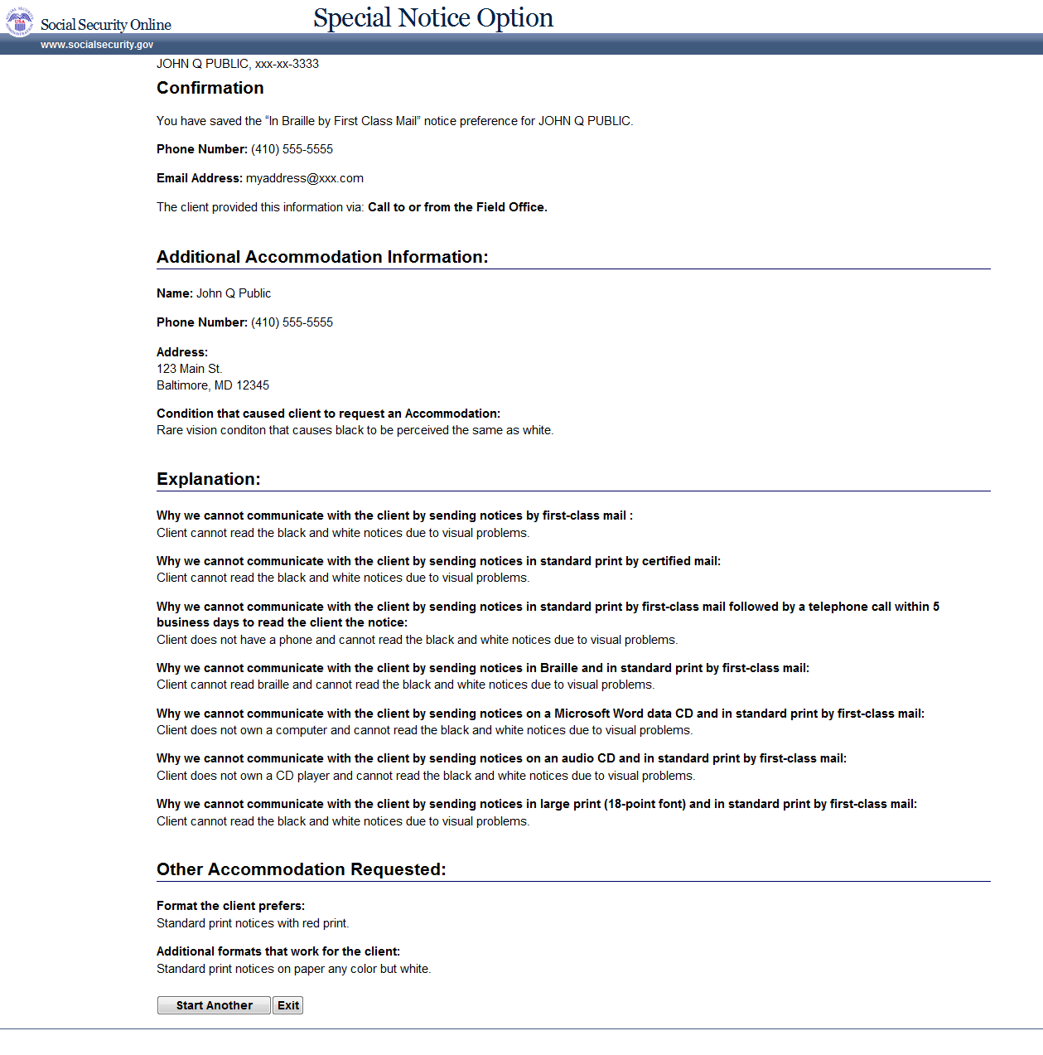

CSR070 Other Accommodation History
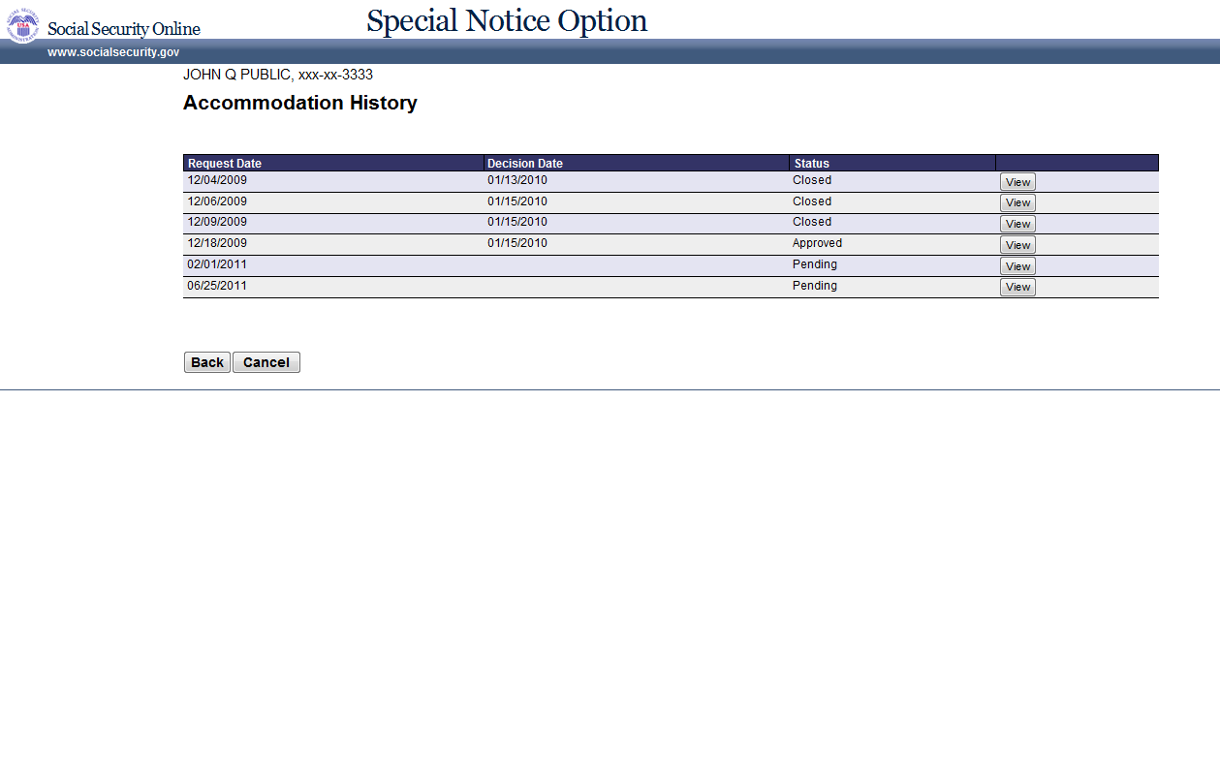

CSR080 Other Accommodation History Details
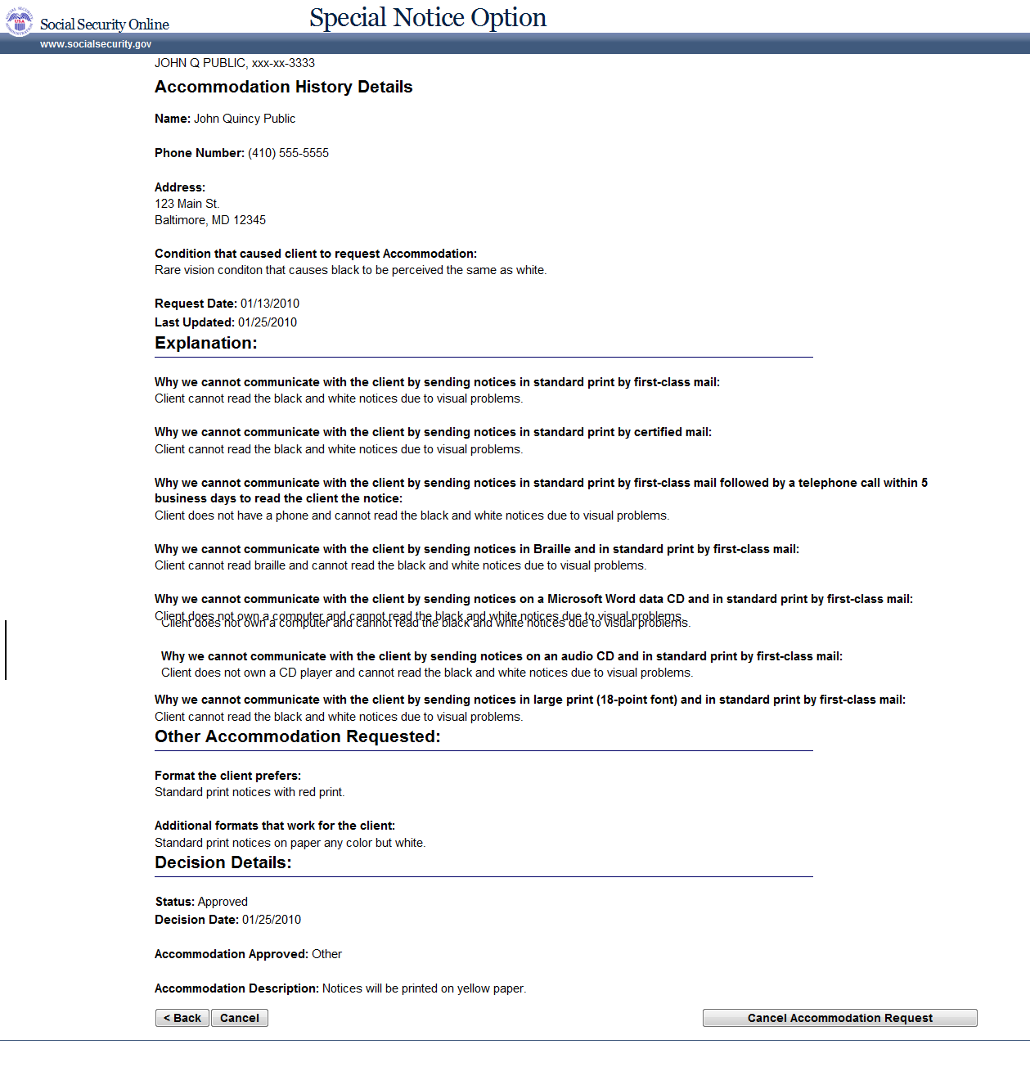

CSR020 Authenticate a Client
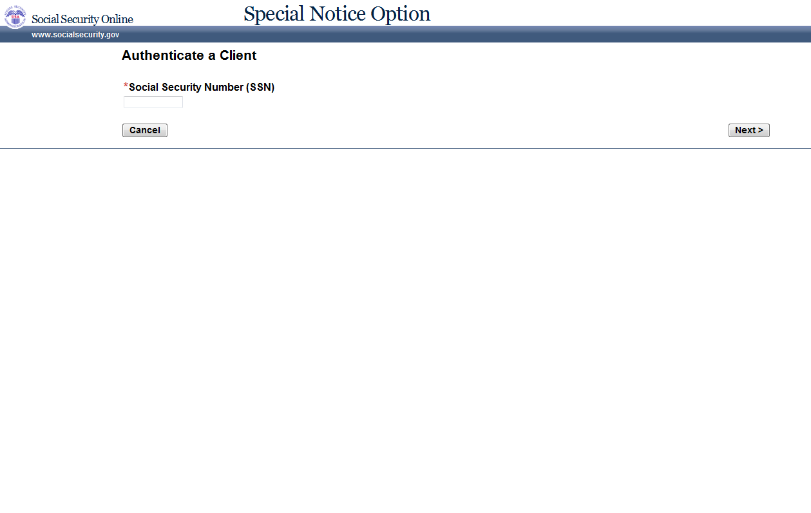

CSR030 Select Option
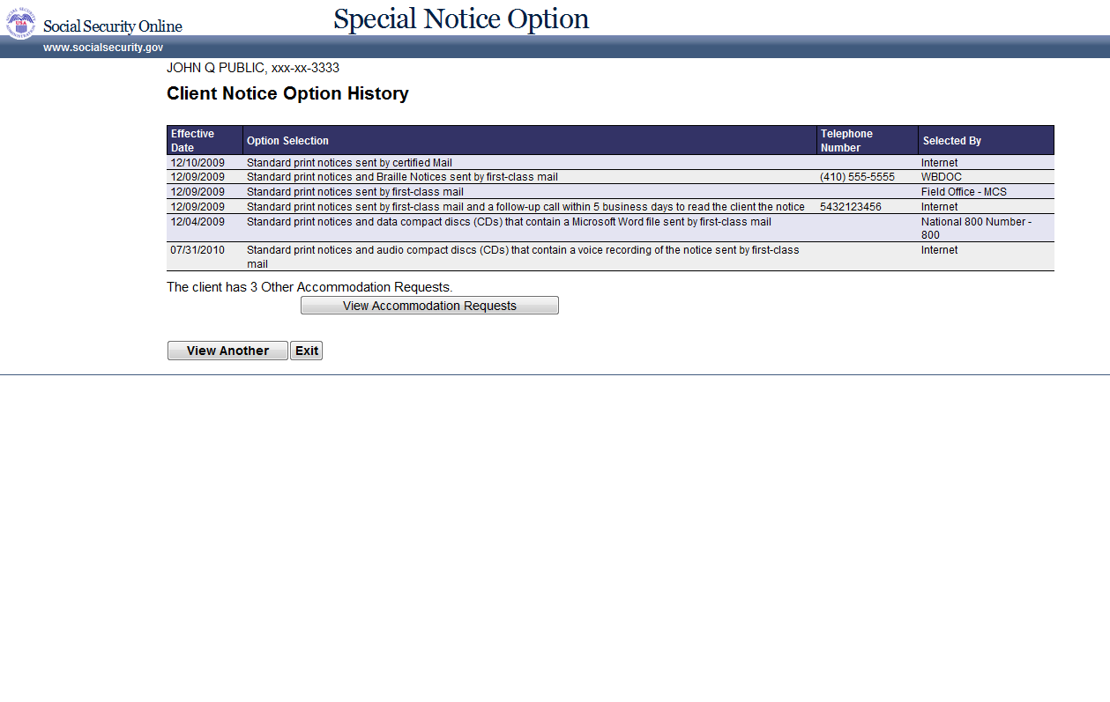

CSR070 Other Accommodation History
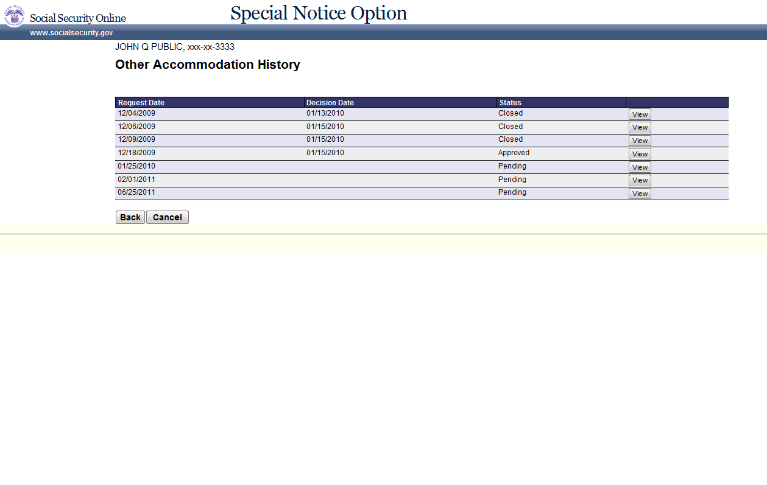

CSR080 Other Accommodation History Details
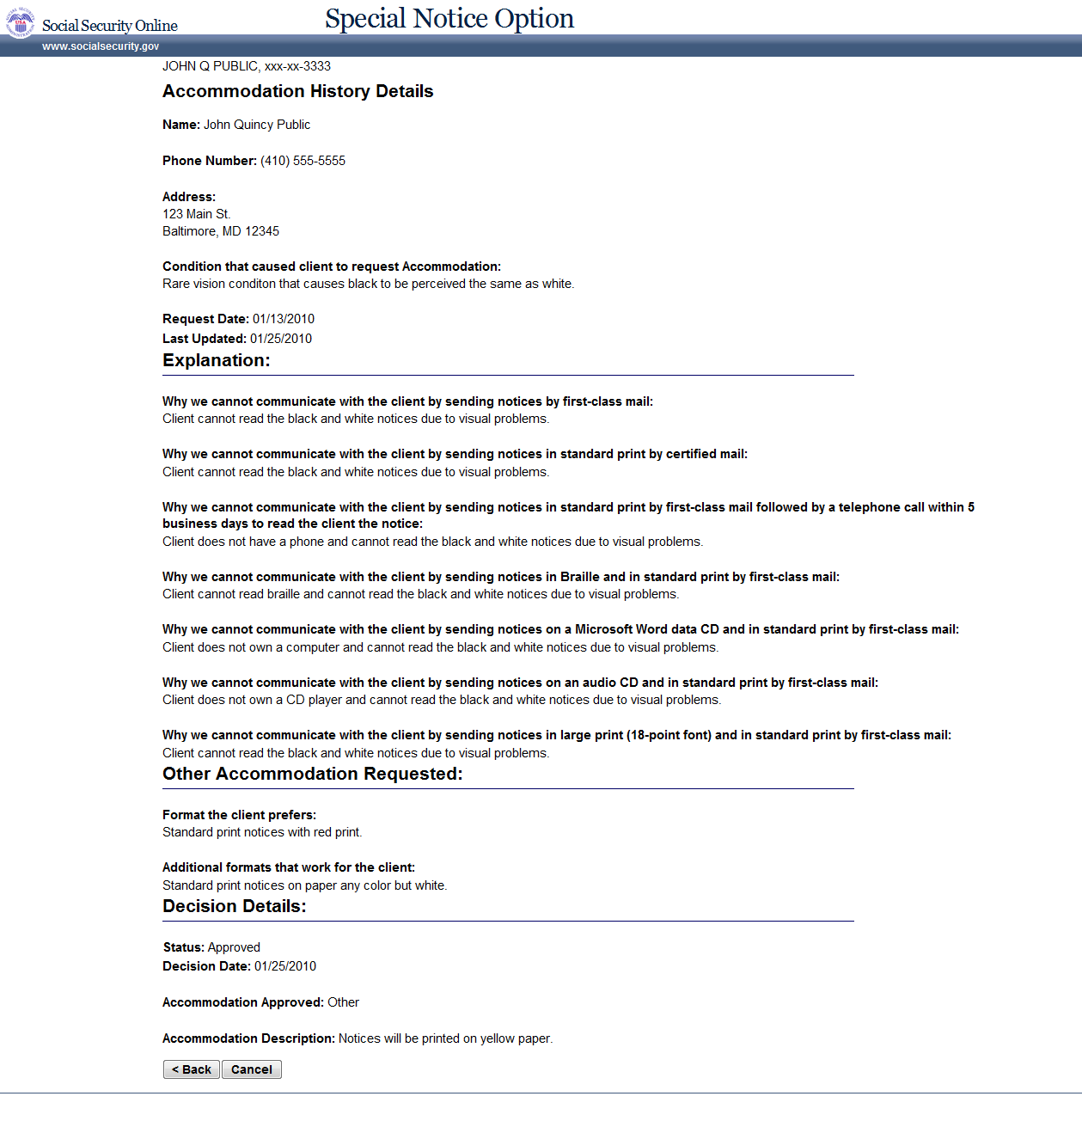

OGC020 Authenticate a Client
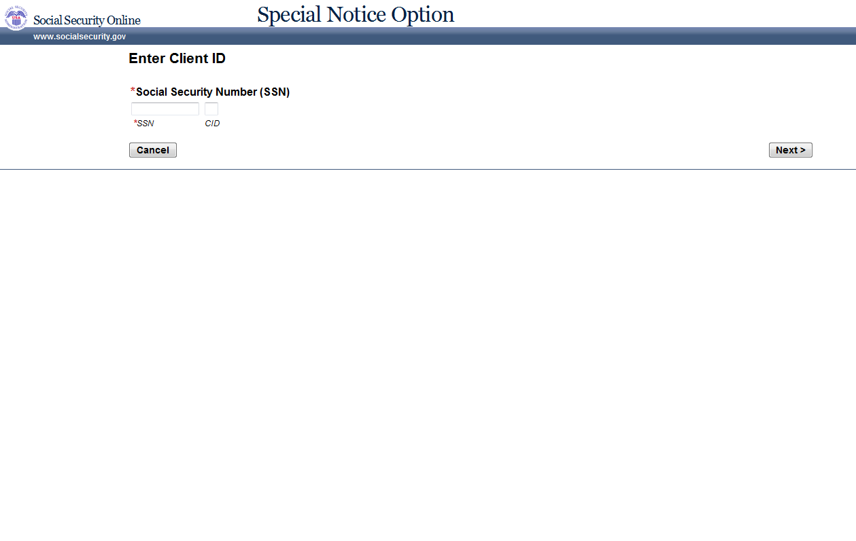

OGC070 Other Accommodation Decision History
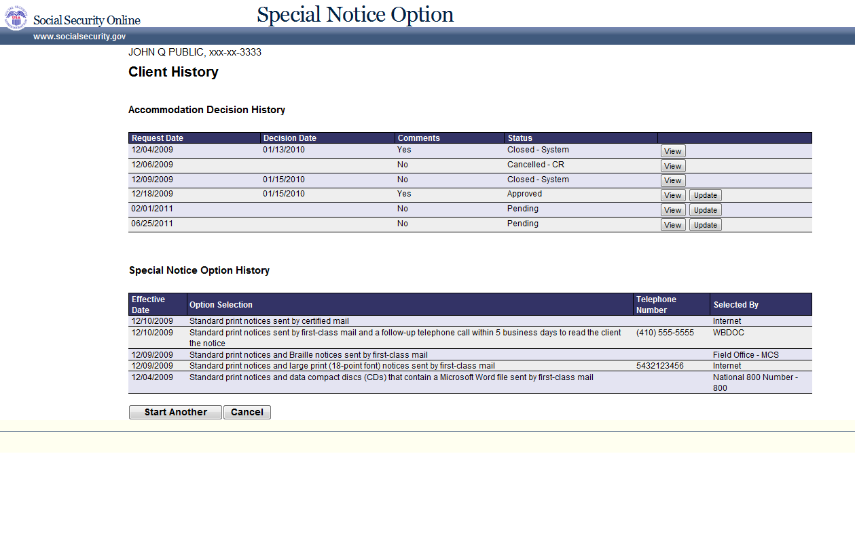

OGC080 Other Accommodation Decision Details (Update Mode)
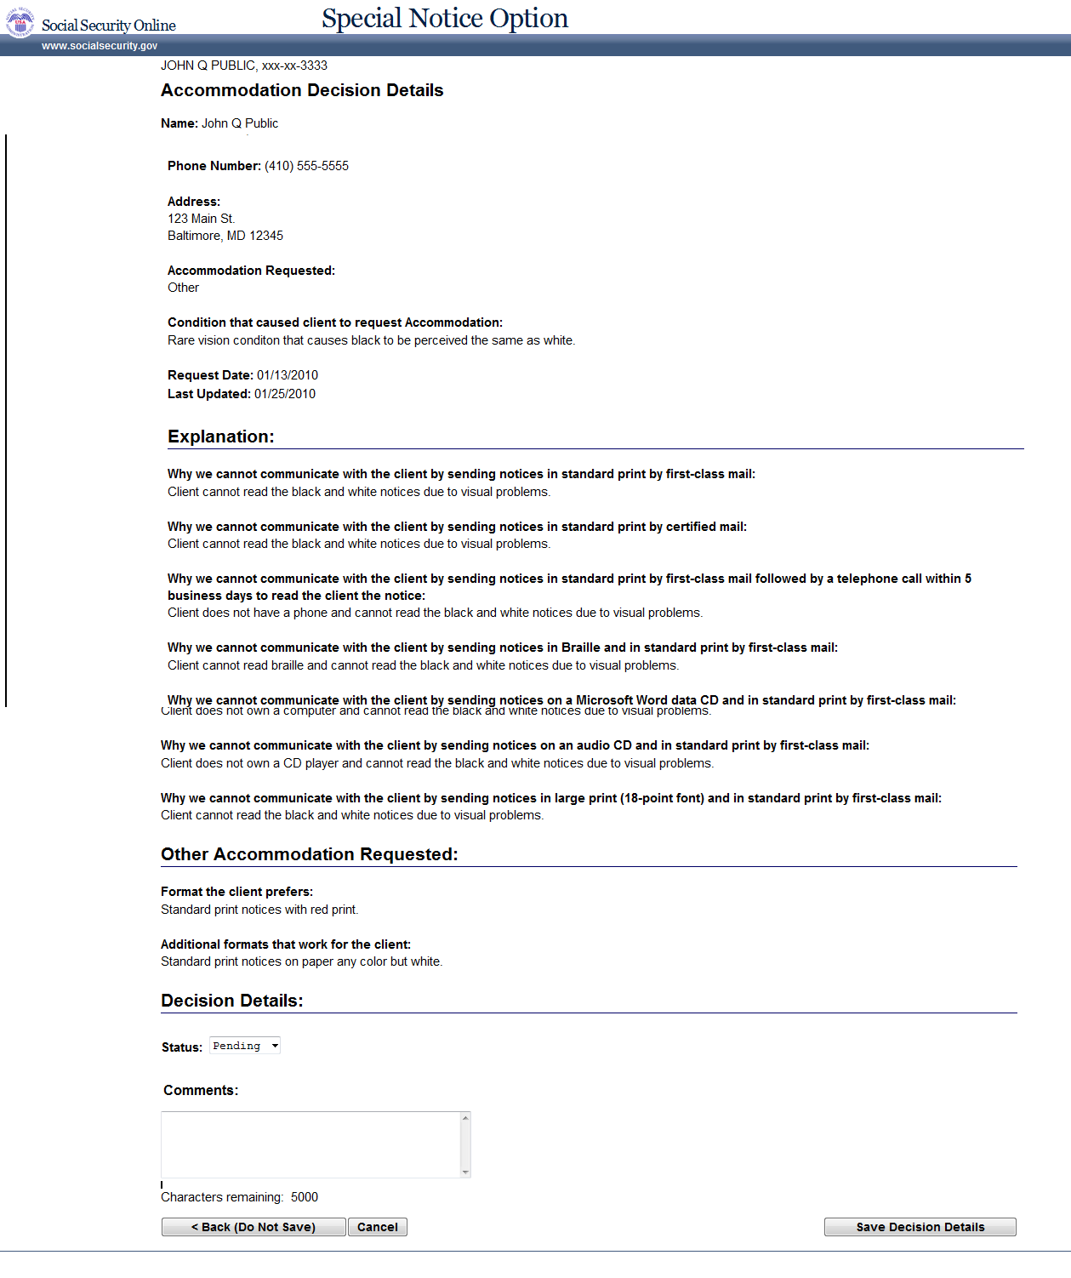

OGC080 Other Accommodation Decision Details (View Mode)
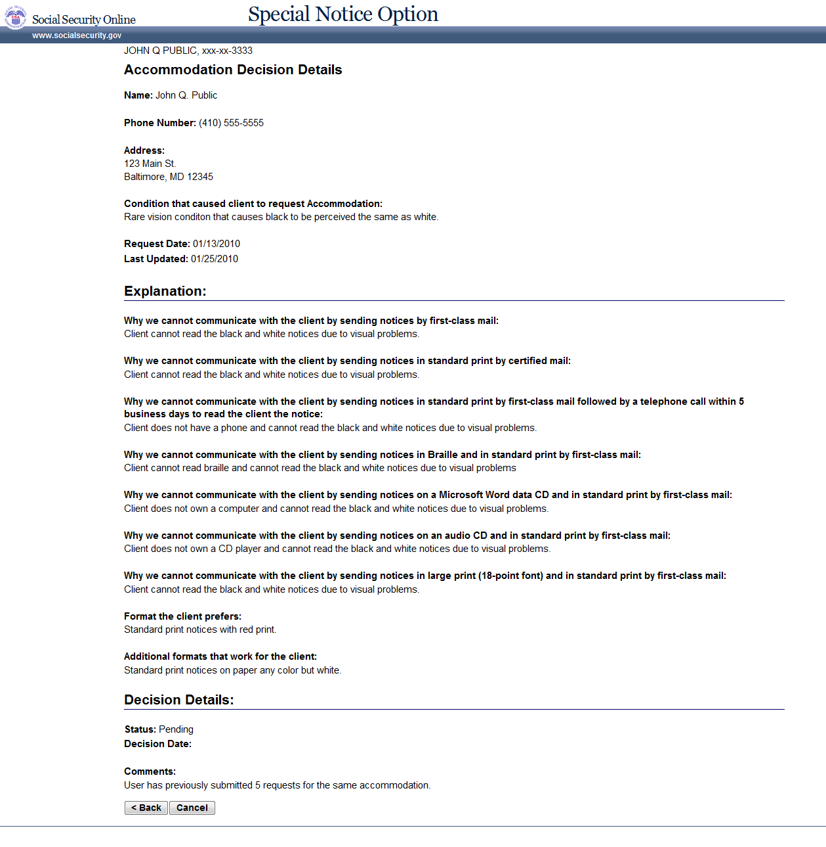

Msg021 Not Authorized
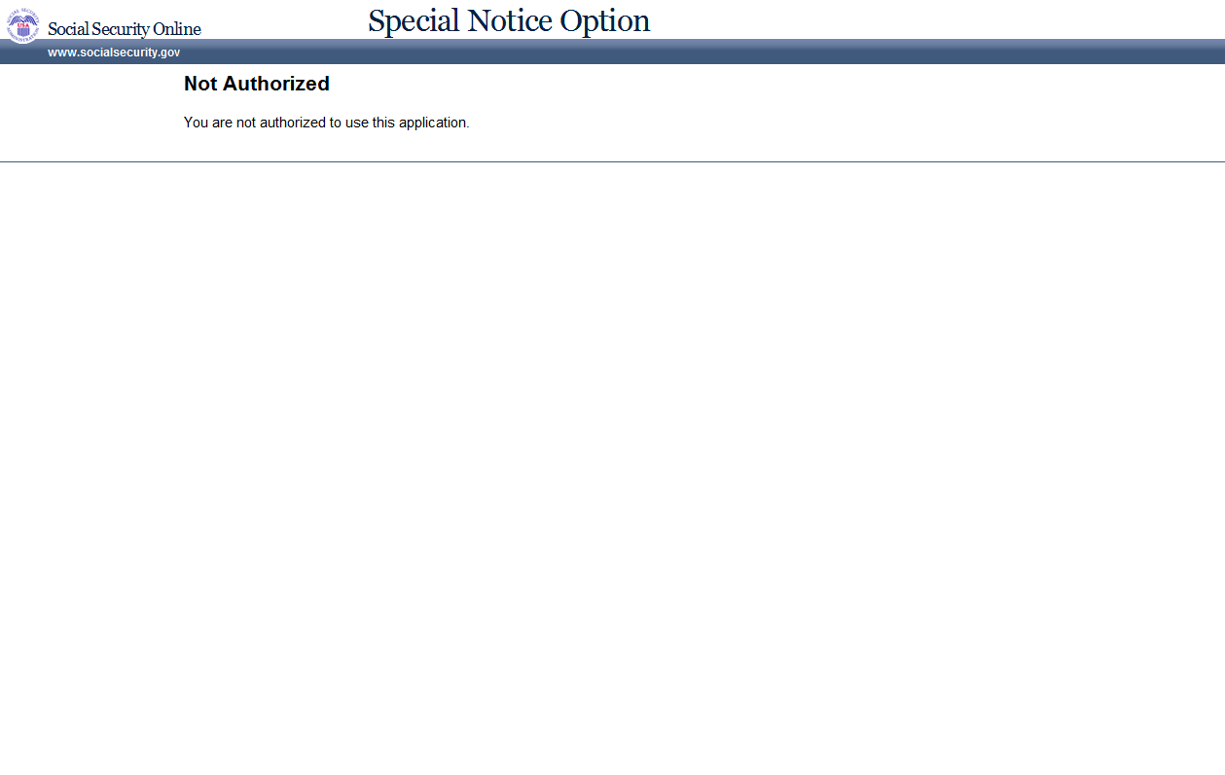

Msg026 We Cannot Process Your Request
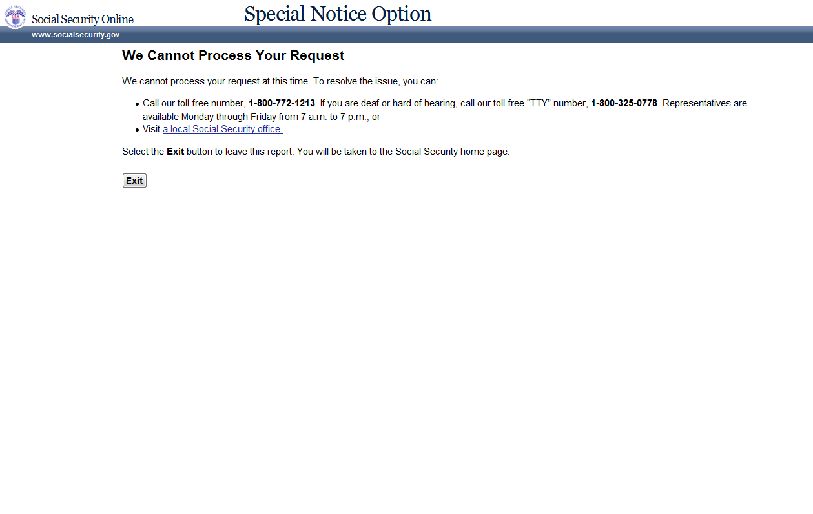

Msg027 We Cannot Process Your Request at This Time
