ACU: Screen Design
Table of Contents

1. Verify Your Identity 2
2. Verify Your Identity (NUMI Strike) 3
3. We're Sorry... 5
4. PopUp (Paperwork Reduction Act) 6
5. PopUp (Privacy Act Statement) 7

- Verify Your Identity
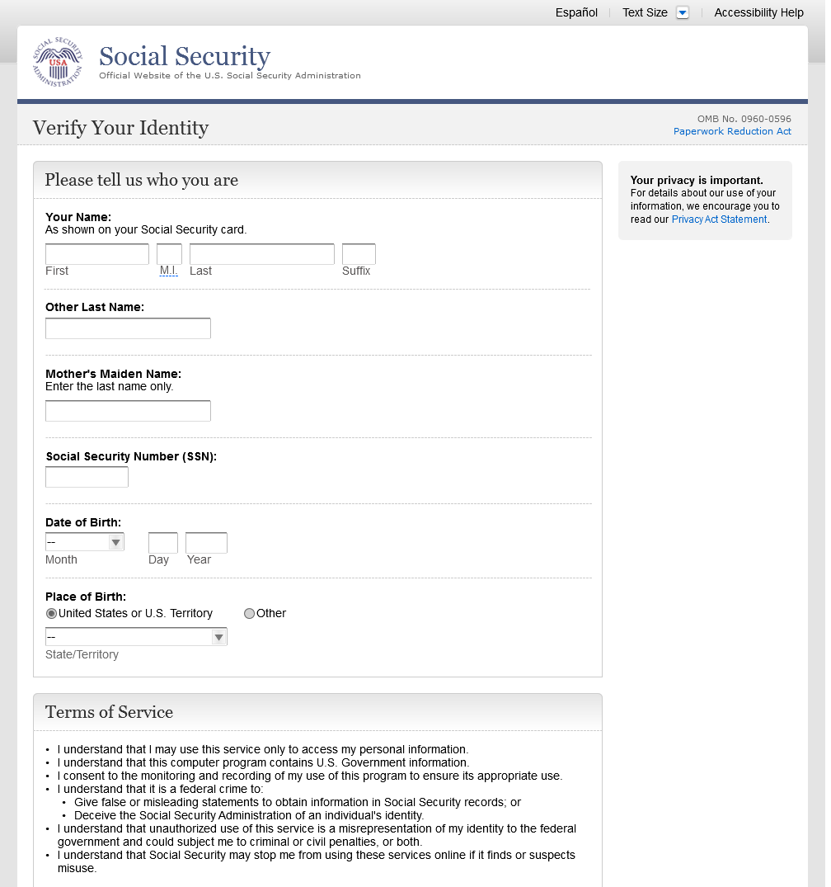
- Verify Your Identity (NUMI Strike)
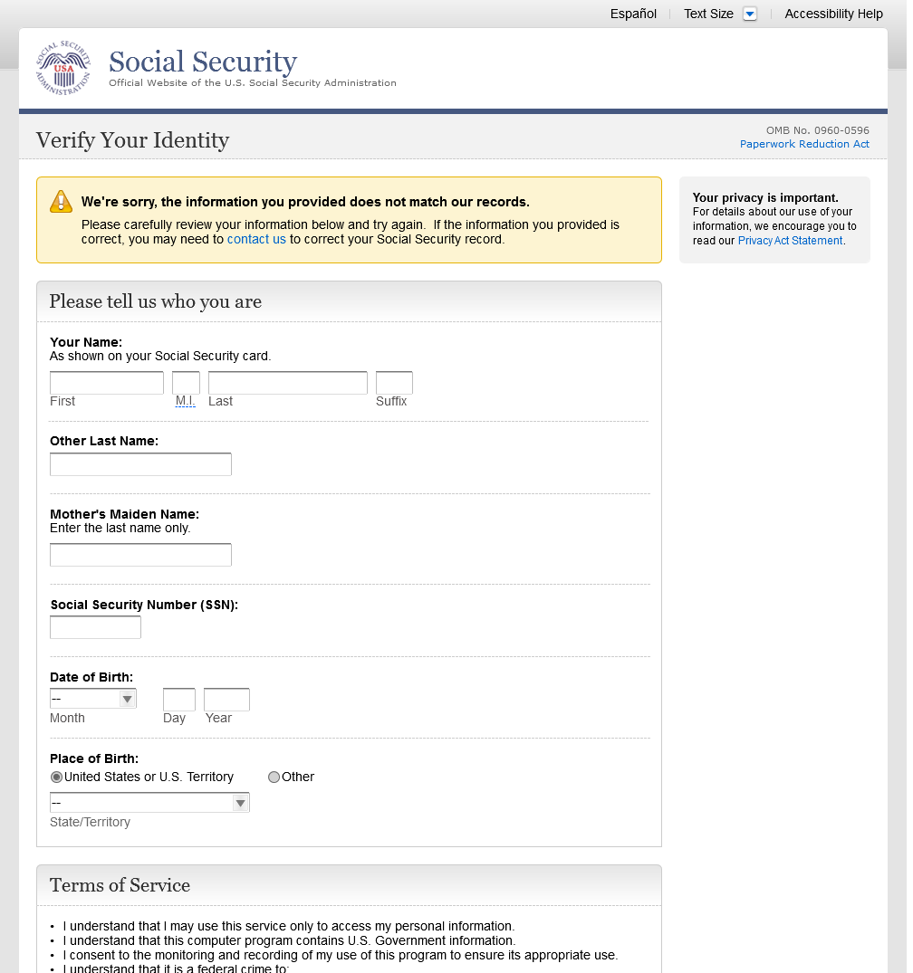
- We're Sorry...
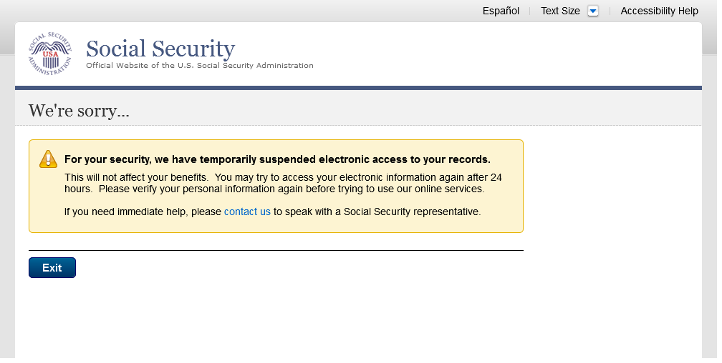
- PopUp (Paperwork Reduction Act)
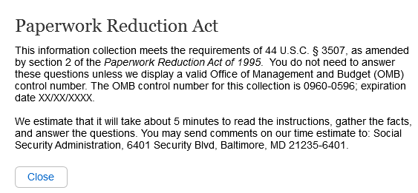
- PopUp (Privacy Act Statement)
