U.S. Department of Labor | Bureau of Labor Statistics  2 Massachusetts Avenue, NE, Room 4840  Washington, DC 20212 | 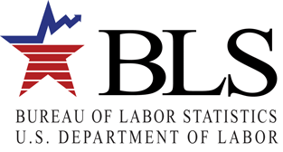
[date]

Attn: Contact_name (if missing use “Department of Accounting/Finance”)
T_name
BM_addr1
BM_addr2
BM_city, BM_state BM_zip-BM_zip_ext

Dear contact_name (if missing use “Department of Accounting/Finance”):

A few days from now, your firm will receive a Green Goods and Services Survey form from the Bureau of Labor Statistics (BLS) of the U.S. Department of Labor. Green goods and services are defined as those that benefit the environment or conserve natural resources. Examples of green goods and services are developing, building, or operating a wind, solar, or other renewable energy source facility, or manufacturing energy efficient appliances.

When you receive your form, we ask that you please complete it and mail it in promptly. We need to hear from every company, even if your company is not involved in producing green goods or services, to get an accurate picture of the economy.

The questions on the form require information about the percentage of your firm’s revenue associated with producing green goods and services. If you do not have access to this information, please identify someone in your firm who does and forward the form to that person once it arrives.

If you have any questions, please contact our helpdesk by calling toll free at [toll-free number] or by emailing [_ _______@bls.gov].

Thank you in advance for your help.

Sincerely,
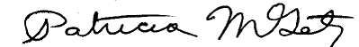

Patricia M. Getz
Assistant Commissioner
Office of Industry Employment Statistics, Office of Employment and Unemployment Statistics

