Web Repricing Application
Downtime Message Displayed at all Times (with updated repricing burden statement)
(Italicized and begins with “Maintenance activities…”)

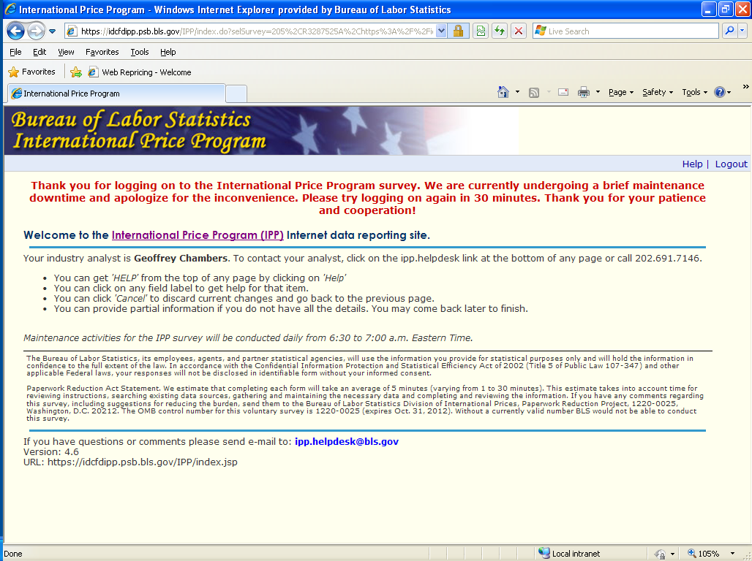
The Bureau of Labor Statistics, its employees, agents, and partner statistical agencies, will use the information you provide for statistical purposes only and will hold the information in confidence to the full extent of the law. In accordance with the Confidential Information Protection and Statistical Efficiency Act of 2002 (Title 5 of Public Law 107-347) and other applicable Federal laws, your responses will not be disclosed in identifiable form without your informed consent.
Paperwork Reduction Act Statement. We estimate that completing each form will take an average of 5 minutes (varying from 1 to 30 minutes). This estimate takes into account time for reviewing instructions, searching existing data sources, gathering and maintaining the necessary data and completing and reviewing the information. If you have any comments regarding this voluntary survey, including suggestions for reducing the burden, send them to the Bureau of Labor Statistics, Division of International Prices, 1220-0025, 2 Mass Ave NE, Washington, D.C. 20212. Without a currently valid OMB number BLS would not be able to conduct this voluntary survey.
OMB No. 1220-0225
Expires: 10/31/2012

Web Repricing Application
Downtime Message Displayed to User in System When Downtime Begins
