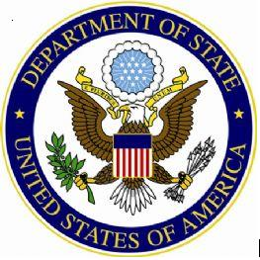

ETA Invitation Email
Dear (ETA),
The U.S. Department of State is conducting an important survey for alumni of the Fulbright English Teaching Assistantship (ETA) Program. This survey will assess the effects of the program upon ETA host institutions, host country communities, and former ETAs themselves.
Our research firm, EurekaFacts, LLC, is administering this online survey on behalf of the U.S. Department of State. To complete the survey, please click on the following link:
[insert Vovici link]
The survey takes approximately 40 minutes to complete. All responses will be kept private to the extent provided by law. Individual responses and comments will not be reported in identifiable form. Once you begin the survey, you may save your responses at any point and return to complete the remaining survey questions at a later time. The survey will be accessible until [insert closing date], so we encourage you to share your thoughts and experiences in the program with us as soon as possible!
Please do not hesitate to contact me with any additional questions or concerns. We look forward to hearing your thoughts and insights on the ETA Program!
Sincerely,
Melissa Moreland/Nitara Dandapani
ETA Survey Manager
EurekaFacts, LLC



