**Department of Veterans Affairs  
Veterans Health Administration (VHA)**

**Date: May 10, 2012**

**From: VHA OMB Liaison (10P7BFP)**

**Subject: Request for approval of revisions to OMB approved collection 2900-0198, VA Form 10-8678, Application for Annual Clothing Allowance. The program office has indicated that the revisions create no changes to the estimated burden of 10 minutes to complete the data collection instrument.**

**Justification for revision:**

The VA amended 38 CFR 3.810 (76 Federal Register 70883), Application for Annual Clothing Allowance, on November 16, 2011. The change makes VA’s clothing allowance regulations consistent with the U.S. Court of Appeals for Federal Circuit’s holding in the case of Sursely v. Peake. The change in the regulation expands the provision of only one clothing allowance to provide more than one clothing allowance to certain Veterans who meet certain qualifying criteria as outlined in the amended regulation. VA published the regulation that expanded the clothing allowance effective date as December 16, 2011. Link to the Federal Register with the final rule is [http://www.gpo.gov/fdsys/pkg/FR-2011-11-16/pdf/2011-29579.pdf](blocked::http://www.gpo.gov/fdsys/pkg/FR-2011-11-16/pdf/2011-29579.pdf).

The revised VA Form 10-8678, dated February 2012, will replace VA Form 10-8678, April 2008.

**Revisions to VA Form 10-8678 (previously dated April 2008)**

**Page 1 Instruction:**

1. **Text box:** “Important: Please read the instructions below carefully, before   
   completing the form”

Deleted

1st paragraph:

1. **Fillable field no. 4 and 5:** “4. Disability Requiring the Use of the Appliance or Medication”  
   “5. Is This Disability Service Connected, Yes or No check boxes”

Combined field 4 and 5 becomes fillable field no. 7 on page 2.

1. **Fillable field no. 6:** “Type of Appliance or Name of Medication”

Field moves to top of page 2. Remains fillable field no. 6

1. **Fillable field no. 7:** “Name and Location of VA Medical Center or other Institution   
   which Issued Appliance or Medication and Phone Number if it is not a VA Facility.

Field moves to top of page 2. Becomes fillable field no. 9

1. **Fillable field no. 8:** “Month and Year Veteran was Issued Appliance/Medication”

The word “Veteran” was removed. Field moves to top of page 2. Remains fillable field no. 8

1. **Fillable field no. 9:** “Do You Have A Power of Attorney?   
   and “yes” and “No” check boxes

Deleted

1. **Text box: “Certification…”**

Text box moved to bottom of page 2. Revised text below and added “yes” or “no” text boxes

**CERTIFICATION:** I hereby apply for annual clothing allowance under 38 U.S.C. 1162. In doing so I certify that, because of my service-connected disability or disabilities, I regularly wear or use the prosthetic or orthopedic appliance(s) described above, which tends to wear out or tear my clothing or that, for my service-connected skin condition, I regularly use the medication(s) described above, which causes permanently damage to my outer clothing. If I have multiple appliances or medications impacting a single outer-garment, the combination of these appliances and/or medications causes me to replace my garment faster than if I used a single appliance or cream. (check Yes or No box)

1. **Fillable field no. 10: “**Signature of Veteran” and “Date”

Field has been moved to bottom of page 2. Becomes fillable field no. 11.

1. **Text box: “Penalty…”**

Disclaimer has been moved to bottom of page 2

1. **Fillable fields boxes 12 thru 14:** under“For VA Use Only”

All fields moved to page 3:

No. 11 Check off boxes, Static, Non-Static, Not Entitled Deleted

No. 12 Examination/Evaluation Date is now fillable field no. 13, page 3

No. 13 Processed By, and Date box is now fillable field no. 15, page 3

No. 14 Authorized/Approved By and Date box is now fillable field no. 16 and 17, page 3

**Updates VA Form 10-8678**

**Page 1 Instructions:**

1. **Revised wording and new instructions added:**

**Revised** paragraph number 1 title and verbiage:   
*Formerly*: **WHO IS ENTITLED TO AN ANNUAL CLOTHING ALLOWANCE?**  
  
**WHO IS ELIGIBLE FOR AN ANNUAL CLOTHING ALLOWANCE?** Veterans who wear or use a qualifying prescribed prosthetic or orthopedic appliance and/or prescription medication for a service-connected disability or skin condition may be eligible for an annual clothing allowance. To be eligible, the appliance must wear or tear clothing, or medication must irreparably damage the veteran's outer-garments.

**Inclusion** paragraph 2:   
**WHO IS ELIGIBLE FOR MORE THAN ONE ANNUAL CLOTHING ALLOWANCE?** Effective December 16, 2011, Veterans who wear or use more than one qualifying prescribed prosthetic or orthopedic appliance and/or prescription medication for more than one service-connected disability or skin condition may be eligible for more than one clothing allowance. To be eligible for more than one clothing allowance, the qualifying appliances must wear or tear more than one type of article of the Veteran's clothing and/or medications must irreparably damage more than one type of the Veteran's clothing or outer-garment.

**Revised** paragraph 3: **WHAT APPLIANCES ARE INCLUDED?** Appliances such as an artificial limb, rigid brace, wheelchair, crutches or other appliance prescribed for the Veteran's **service-connected disability**. Non-rigid appliances, such as knee, ankle, or elbow sleeves are not included. Multiple appliances/devices providing similar compensation for the same disability cause damage to similar clothing items and therefore are considered as one appliance relative to clothing allowance eligibility. Examples include: 1) a hand-cycle and a wheelchair utilized by a paraplegic); and 2) a running limb and everyday walking limb used by an amputee.

**Inclusion** paragraph no. 5: **WHAT TYPES OF CLOTHING ARE INCLUDED?** Clothing such as shirts, blouses, pants, skirts, shorts and similar garments permanently damaged by qualifying appliances and/or medications are considered in clothing allowance decisions. Shoes, hats, scarves, underwear, socks, and similar garments are not included.

**Revised** paragraph no. 7: **WHEN SHOULD I EXPECT PAYMENT OF THE CLOTHING ALLOWANCE?**

Applications are accepted and processed throughout the year; however, payments for the current annual clothing allowance year are paid out between September 1 and October 31. If you have not received your payment by October 31st, please contact your local Prosthetic and Sensory Aids Service.

1. **Fillable field no. 2** “Veterans SSN”

Requests full social security number instead of last 4 digits

1. **Fillable field no. 4**  “Veterans Daytime Telephone Number”.
2. **Fillable field no. 4a**  “Evening telephone Number”
3. **Fillable field no. 4b**  “Cell phone Number”
4. **Fillable field no. 5**  “Calendar Year for Applicant”
5. **Bottom margin:** “Existing Stock of VA form 10-8678, April 2008 WILL NOT BE USED”

**Page 2 Fields added: optional Expanded columns (Veteran completes)**

1. **Fillable fields no. 6, 7, 8, 9, 10 - columns** with “examples A and B” followed by 8 fillable fields:
2. **Fillable field 2 columns flush right: “For VA Use Only Approved?**

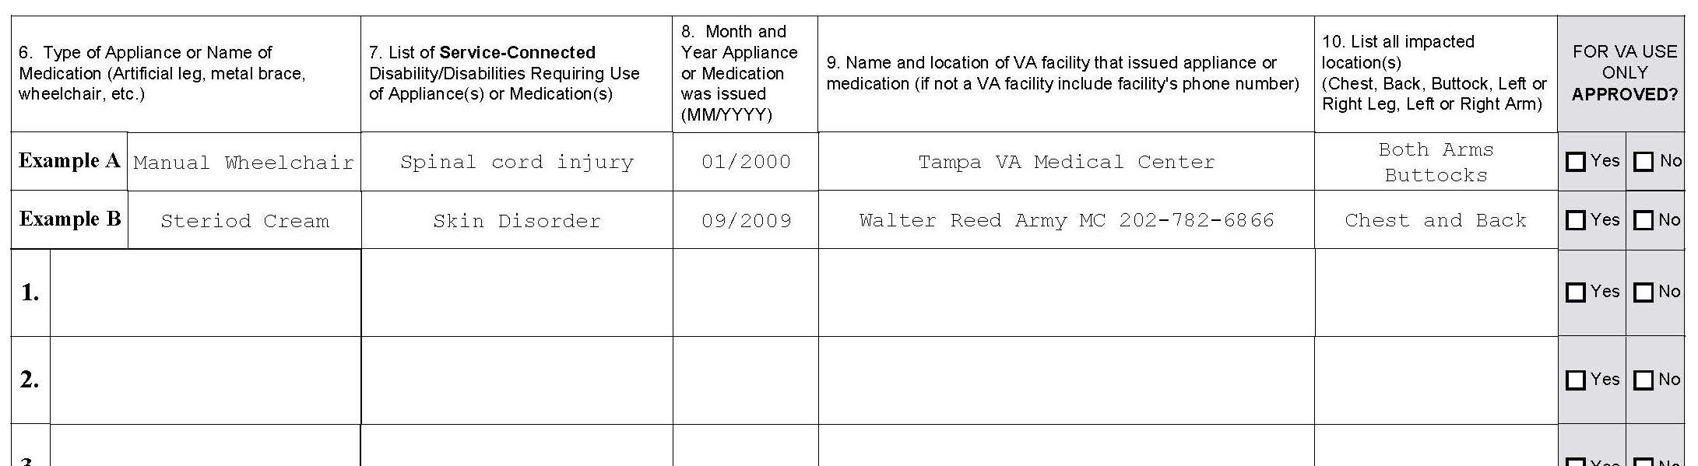

**Page 3 for VA Use Only: new page created only by the expansion of page 2.**

**New Fields added:**

1. **Field no. 12** “Amount of Clothing allowances”
2. **Field no. 14** “Notes” and wider box area for notes/description