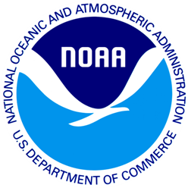

June 6, 2012

[State] Resident

(Add 1)

(Add 2)

(City), (State) (Zip)

Dear [State] Resident:

I am writing to ask you for your help in a study being conducted for the National Oceanic and Atmospheric Administration. This study is part of an effort to learn about recreational saltwater fishing activities in [State]. This survey provides vital information that is used to enhance recreational fishing opportunities for [State] residents.

For the results to be scientific, we need all households who receive this short questionnaire to complete the questionnaire and send it back, even if you **do not** fish. Your address was randomly selected from a list of all home addresses in [State], and we cannot replace you with someone else. We have enclosed a small token of appreciation as a way of saying thanks for your help.

Your answers are completely confidential and will be used for statistical purposes only in accordance with the Privacy Act of 1974. You are not required to answer any question that you feel is an intrusion of your privacy.

If you have any questions or comments about this study, we would be happy to talk with you. Please contact XXXXXXXXX at XXX-XXX-XXXX, or you can write to us at the address at the bottom of this letter.

Thank you very much for your help with this important study. Please return your completed questionnaire in the postage paid envelope provided.

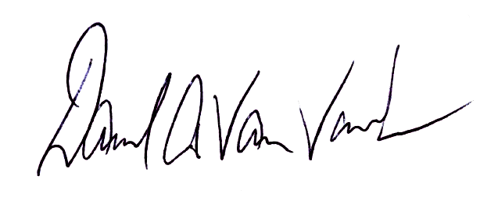Yours sincerely,

Dave Van Voorhees

Chief, Fisheries Statistics Division

NOAA Fisheries, Office of Science and Technology

[State] Resident

(Add 1)

(Add 2)

(City), (State) (Zip)

Dear [State] Resident:

A few weeks ago we sent a recreational saltwater fishing questionnaire to your household. If you have already returned the questionnaire, we thank you. If you have not returned it, we ask you to please complete the enclosed questionnaire and return it as soon as possible. For the results of this study to be scientific, we need all households who receive this short questionnaire to complete the questionnaire and send it back, even if you **do not** fish.

We are very grateful for your help. This survey is an important part of research study of recreational saltwater fishing conducted by the National Oceanic and Atmospheric Administration (NOAA). NOAA oversees many of the natural resources in coastal states and needs high quality information to improve recreational fishing opportunities for [State] residents.

Your address was randomly selected from a list of all homes in [State]. Your participation is voluntary; your answers are completely confidential and will be used only for this study in accordance with the Privacy Act of 1974.

If you have any questions about this study, we are happy to talk with you: please contact XXXXXXX at 1-XXX-XXX-XXXX. Thank you again for your generous help with this important study.

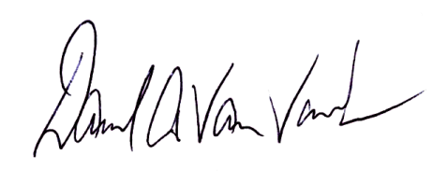Yours sincerely,

Dave Van Voorhees

Chief, Fisheries Statistics Division

NOAA Fisheries, Office of Science and Technology

|  |
| --- |
| \\Westat.com\Dfs\NOAA-ANGSURV\Data Collection\NOAA Logo\NOAA-edit1.pngJune 6, 2012  Last week we sent you a Saltwater Fishing Survey on behalf of the National Oceanic and Atmospheric Administration. If you have already completed and returned the survey, please accept our sincere thanks. If not, I encourage you to do so today.  This study is being conducted to learn more about the impact of recreational fishing on natural resources in [State]. Please know that your answers are completely confidential and will be used only for this study in accordance with the Privacy Act of 1974.  If you did not receive the survey or need another copy, please call XXXXXXXX toll-free at 1-XXX-XXX-XXXX.  Sincerely,    Dave Van Voorhees Chief, Fisheries Statistics Division NOAA Fisheries, Office of Science and Technology |
| C:\Documents and Settings\KING_H\Local Settings\Temporary Internet Files\Content.Word\NOAA-Transparent-Logo.pngSaltwater Fishing Survey  1009 Slater Rd  Suite 110  Durham, NC 27703  Proper Name  Add1  Add2  City, St Zip |



<<DATE>>

<<STATE>> Resident

<<Add 1>>

<<Add 2>>

<<City>>, <<State>> <<Zip>>

Dear <<STATE>> Resident:

I am writing to ask for your help with a survey being conducted for the National Oceanic and Atmospheric Administration (NOAA). The survey collects information about severe weather events and participation in outdoor activities. The findings from the study will be used to improve access to information about the environment and ensure the quality of marine and coastal resources.

For the results to be meaningful, we need ***all*** households who receive this short survey to complete the questionnaire and send it back in the postage-paid envelope that is provided.

Your address was randomly selected from a list of all addresses in <<STATE>>. Your participation is voluntary; your answers are completely confidential and will be used only for this study in accordance with the Privacy Act of 1974.

Someone from your household might be selected to complete a second short questionnaire within the next few months. If you have any questions about this study, we are happy to talk to you: please contact XXXXXXXX at 1-XXX-XXX-XXXX.

Thank you again for your help with this important study.

Yours sincerely,

Dave Van Voorhees

Chief, Fisheries Statistics Division

NOAA Fisheries, Office of Science and Technology



<<DATE>>

<<STATE>> Resident

<<Add 1>>

<<Add 2>>

<<CITY>>, <<State>> <<Zip>>

Dear <<STATE>> Resident,

A few weeks ago we sent a questionnaire to your household in an effort to collect information about severe weather events and participation in outdoor activities. If you have already returned the questionnaire, we thank you. If you have not returned it, we ask you to please complete the enclosed questionnaire and return it as soon as possible. For the results of this study to be scientific, we need all households who receive this short questionnaire to complete the questionnaire and send it back.

We are very grateful for your help. Your completed questionnaire will contribute to our understanding of the state’s access to information about the environment and ensure the quality of marine and coastal resources.

Your address was randomly selected from a list of all addresses in <<STATE>>. Your answers are completely confidential and will be used for statistical purposes only in accordance with the Privacy Act of 1974.

If you have any questions or comments about this study, we would be happy to talk with you. Please contact XXXXXXXX at 1-XXX-XXX-XXXX.

Thank you again for your help with this important study.

Yours sincerely,

Dave Van Voorhees

Chief, Fisheries Statistics Division

NOAA Fisheries, Office of Science and Technology

|  |
| --- |
| June 6, 2012  Last week we sent you a survey on behalf of the National Oceanic and Atmospheric Administration. If you have already completed and returned the survey, please accept our sincere thanks. If not, I encourage you to do so today.  Information collected in this study will help us to better understand how people use recreation resources in <<STATE>>. Please know that your answers are completely confidential and will be used only for this study in accordance with the Privacy Act of 1974.  If you did not receive the survey or need another copy, please call XXXXXXXX toll-free at 1-XXX-XXX-XXXX.  Sincerely,    Dave Van Voorhees Chief, Fisheries Statistics Division NOAA Fisheries, Office of Science and Technology |
| Weather and Outdoor Activities Survey  7431 College Parkway, Ste A  Fort Myers, FL 33907  <<STATE>> Resident  Add1  Add2  City, St Zip |