**Name of test:** Picture Vocabulary Test

**Estimated time burden:** 7 minutes

**Estimated number of items:** 25[1]

*Materials:*

iPad

*Description:*

This measure of receptive vocabulary is administered in a computer-adaptive format. The respondent is presented with a recorded voice saying a word and with four pictures on the computer screen; the participant is instructed to touch the picture that most closely shows the meaning of the word. The test should take 5-7 minutes; which words are presented will depend on the participant’s performance.

*Administration Instructions*:The opening instructions are read to the participants.

***Practice Items:***

As an introduction,the examiner should say:

**“Let’s look at some pictures. You’ll hear a word and see four pictures on the screen. Touch the picture that means the same as the word that was said. Some words will be easy and some will be harder. Answer as best you can.**

**If you need to hear a word again, I can play it again.**

**If you think you made a mistake and want to change your last answer, I can bring back that word and pictures. Are you ready to play?”**

If a participant has difficulty touching the screen, he/she may point and the examiner may operate the iPad. The examiner should say something like the following to the participant:  **“You can point to your choice and then I will touch the screen for you.”**

The examiner should touch the Touch-and-hold button to advance to the next screen.

***Practice item 1:***

The computer says: **“Let’s try one for practice: Banana. Touch the picture of Banana.”**

If correct, the computer says: **“That’s right!”**  The computer will automatically go to the next practice item.

If incorrect, the Banana picture will light up and the computer will say: **“This is a banana. Let’s try again.”** The examiner should allow the child up to three chances to answer this practice item correctly. After three unsuccessful attempts by the participant, the examiner should touch the picture of the banana on the child’s screen and say: “**This is a banana.”** The computer will automatically go to the next practice item.

***Practice item 2:***

The computer says: **“Let’s try another word: Spoon. Touch the picture of Spoon.”**

If correct, the computer says: **“That’s right!”**

If incorrect, the Spoon picture will light up and the computer will say: **“This is a spoon. Let’s try again.”** The examiner should allow the participant up to three chances to correctly answer this practice item. After three unsuccessful attempts by the participant, the examiner should touch the picture of the spoon and say: “**This is a spoon.”**

Before going on, the examiner should review the task with the child, saying:

**“Remember, you will hear a voice say a word and then you will see four pictures. One of the pictures will show what the word means. Touch the picture and you will hear a new word and see four more pictures. Again, touch the picture that shows what the word means. If you don’t know, make your best guess. Any questions?”** The examiner should answer the questions**.**

***Test items:***

The examiner says: **“Now, let’s try some more. Tell me when you are ready.”** Examiner should touch the Touch-and-hold button to advance to the next screen.

The recording will say the words introduced with the following instructions: **“Touch the picture of….”** The items will continue in this format until the test is completed.

**Sample screenshots:**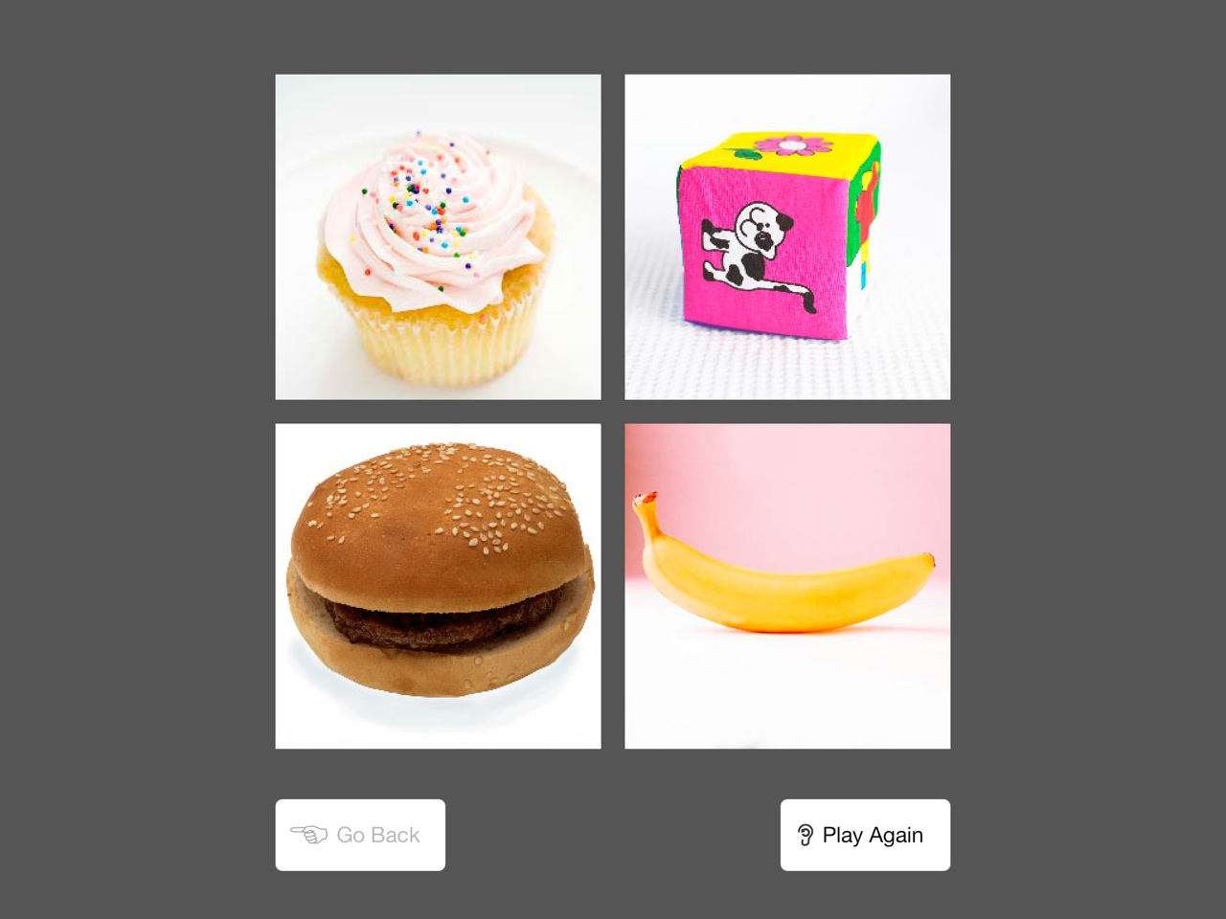

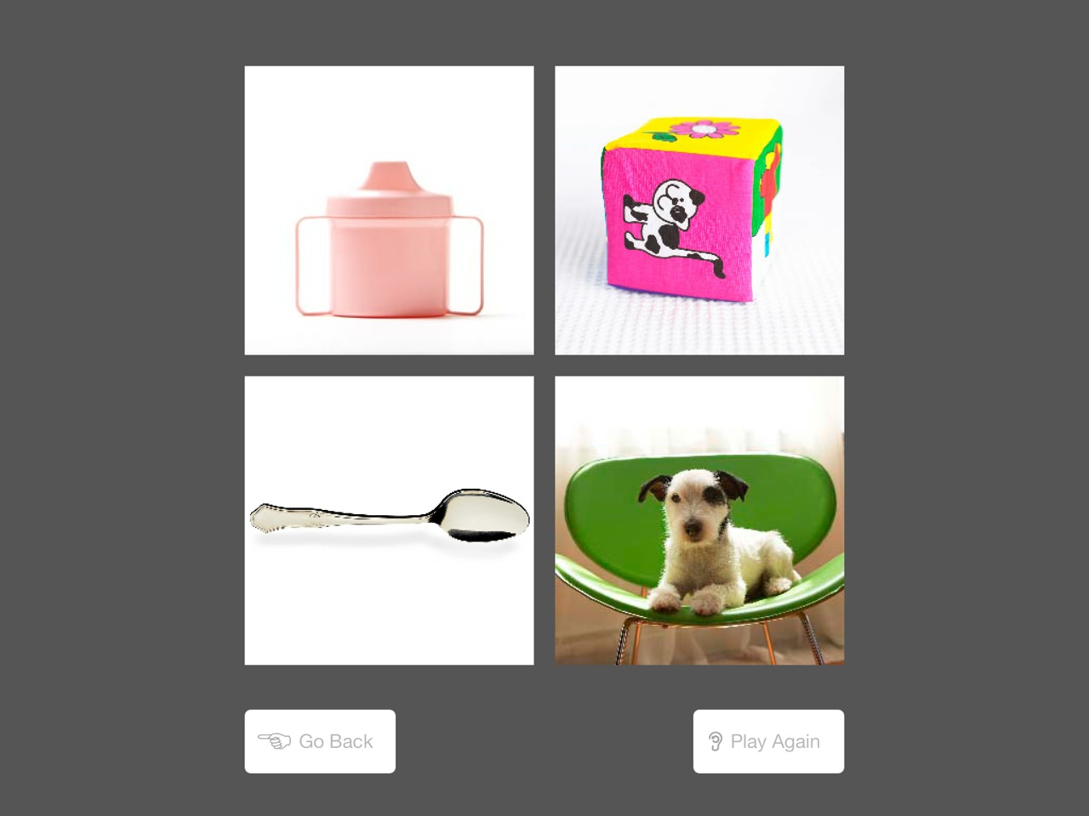

**Complete bank of items (only a small selection of which are administered to any one participant; administered in either English and Spanish):**

baby

money

flower

hat

foot

fish

train

bed

apple

cow

candy

egg

animal

house

door

book

child

paper

table

car

play

tree

eat

doctor

chair

dress

fireman

snake

mask

leaf

fly

guitar

bus

orange

sick

ride

party

airplane

star

balloon

tent

fun

rocket

wet

water

crayon

run

trash

stick

coat

ocean

back (of)

belt

big

crib

tractor

zoo

riding

nap

under

trophy

triangle

bucket

blanket

queen

angry

brush

shovel

log

diamond

yogurt

rose

open

pan

jewelry

railroad

roof

broom

jar

instrument

tricycle

porch

yard

castle

melted

stage

hive

lotion

tortoise

envelope

luggage

royal

wand

cut

gold

cactus

pyramid

hilarious

net

lighthouse

metal

cliff

shore

sculpture

carry

buy

plastic

boil

calm

carriage

palace

giggle

antenna

windmill

cottage

boulder

launch

spattered

ferocious

journal

tutor

crate

shatter

fancy

herd

camouflaged

arctic

dissolved

beside

exhibit

elastic

stubborn

acrobat

zodiac

scholar

cattle

cable

stampede

equation

unstable

festive

fellowship

engraved

blueprint

lounging

molten

drought

bouquet

souvenir

braid

voyage

transport

citrus

pamphlet

startled

utensil

tusk

snarl

weld

discouraged

monument

intersection

corroded

creek

quills

orchard

instruct

construct

ripple

barricade

trench

consume

lobby

port

broth

perch

swift

figurine

diagram

prohibit

gavel

absorb

decrepit

excavate

knickknack

fragment

hangar

debris

mine

pillars

tethered

boulevard

knead

residential

satchel

acoustic

offspring

cove

hedge

tattered

marsh

indicate

depot

fabricate

vortex

dune

ladle

judiciary

glum

slit

cascade

flimsy

transact

disarray

attire

transparent

tarnished

quartet

cubicle

tote

desolate

descend

summit

mend

confine

masonry

quarrel

brawny

irate

compress

celestial

frigid

minute

haul

distinguished

flamboyant

shimmer

tranquil

submerged

incinerate

bestow

noxious

vineyard

barren

pageantry

shabby

refurbish

labyrinth

lethargic

wallowing

rural

horizontal

cleave

oxidized

odometer

peak

ledger

jovial

panorama

morsel

thicket

melancholy

silhouette

quibble

ravine

congestion

sentry

receptacle

refuse

sumptuous

adhere

ensemble

trend

plumage

manger

bureau

plethora

striated

arid

burly

sapling

frothy

orifice

turbulent

fiery

abode

encumber

hodgepodge

perusal

trinket

idle

embellish

wilt

flaccid

luster

revel

comrade

scorched

glower

beacon

indisposed

amiable

helix

foal

concave

deluge

gregarious

inclement

opulent

cherubic

pachyderm

knoll

hovel

erode

cosmopolitan

coalesce

precipice

memento

feral

sustenance

domicile

malefactor

hydroponics

zenith

fissure

effervescent

infuse

spry

throng

disconsolate

monarch

obstreperous

jowl

tarpaulin

hurl

ellipse

wary

scintillating

surly

slat

verdant

quagmire

chaff

matron

buffoon

quadruped

parry

affable

anomalous

bolster

sinuous

resplendent

delineation

edifice

concomitant

ruminate

mirth

shorn

recess

reap

alms

iridescent

balustrade

atoll

gibe

islet

paucity

progeny

prone

detritus

didactic

lassitude

tractable

potable

repast

truculent

truncate

abrade

bucolic

baubles

pennant

jocular

onerous

trivet

redoubtable

munificence

egress

diadem

torpor

ebullience

histrionic

desiccated

buffet

disparate

pecuniary

firmament

cataract

fulminate

fecund

hirsute

natty

prodigious

1.