5.3 PHS Fellowship Supplemental Form
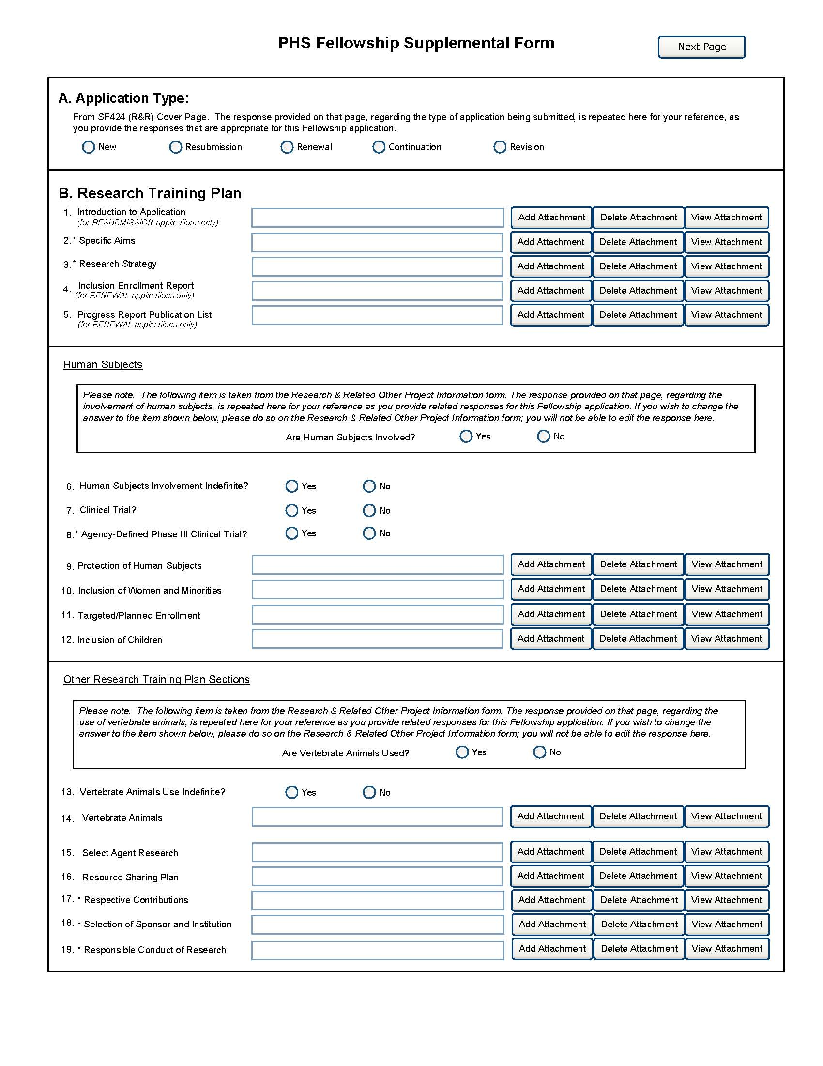
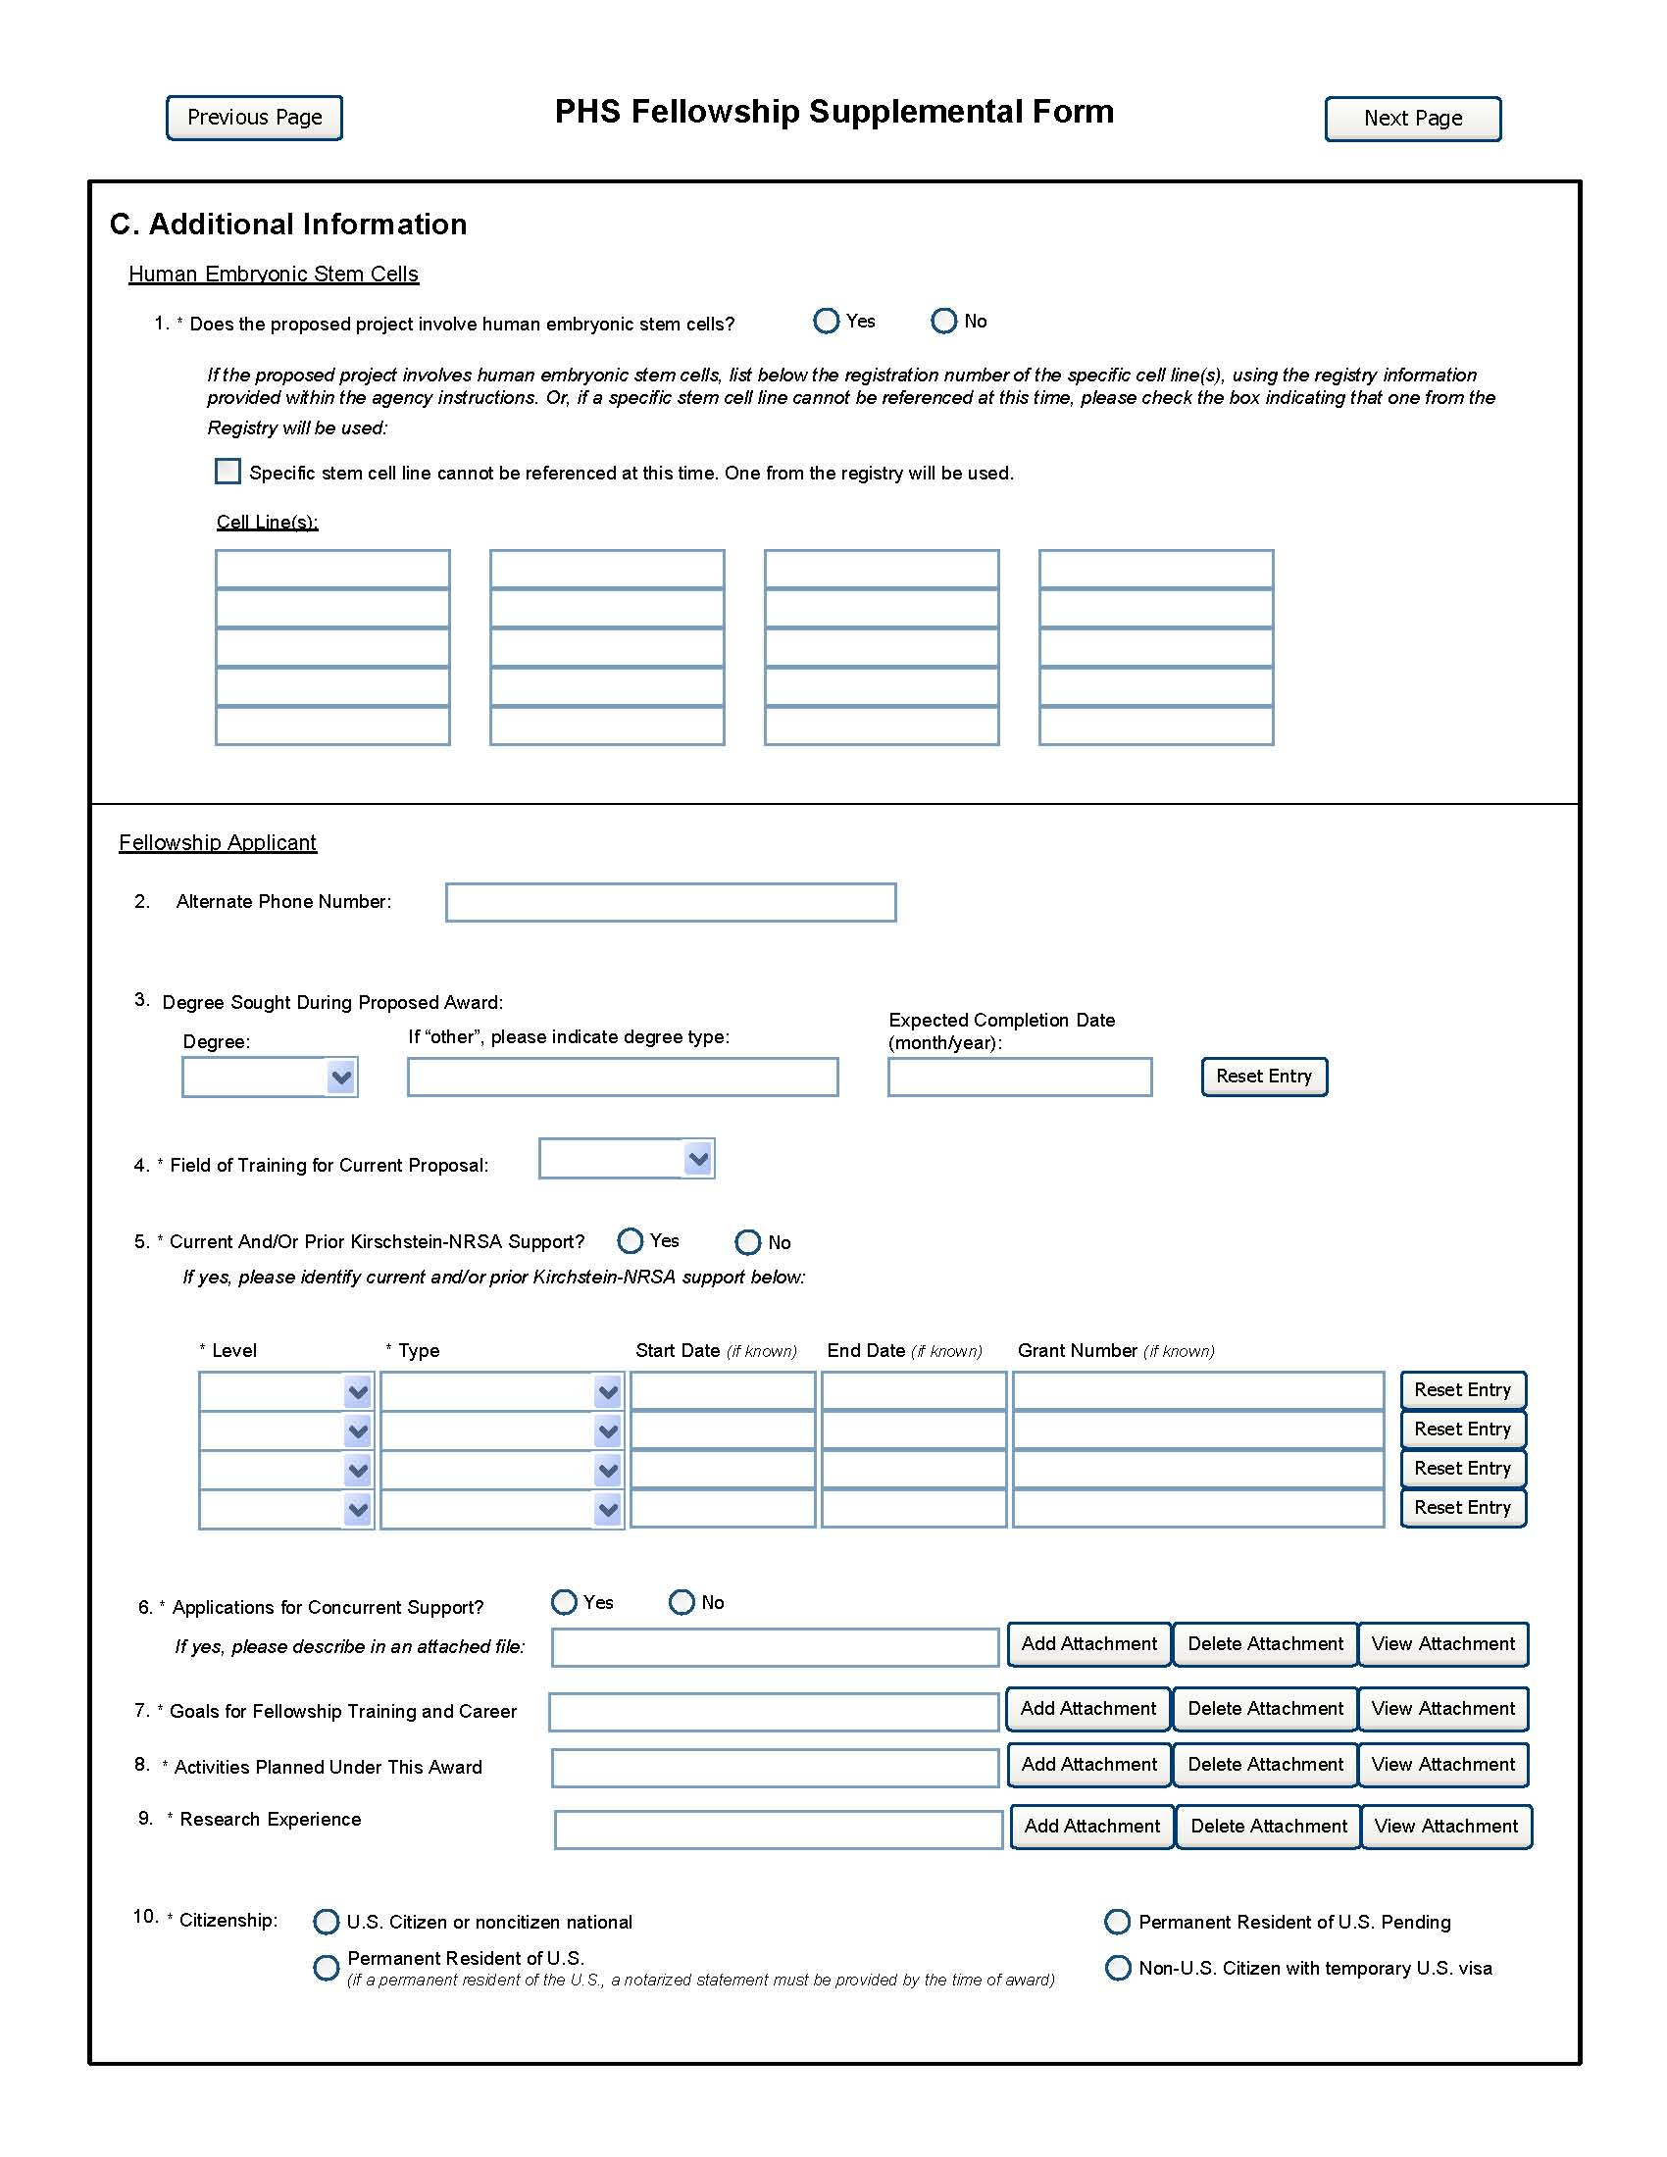
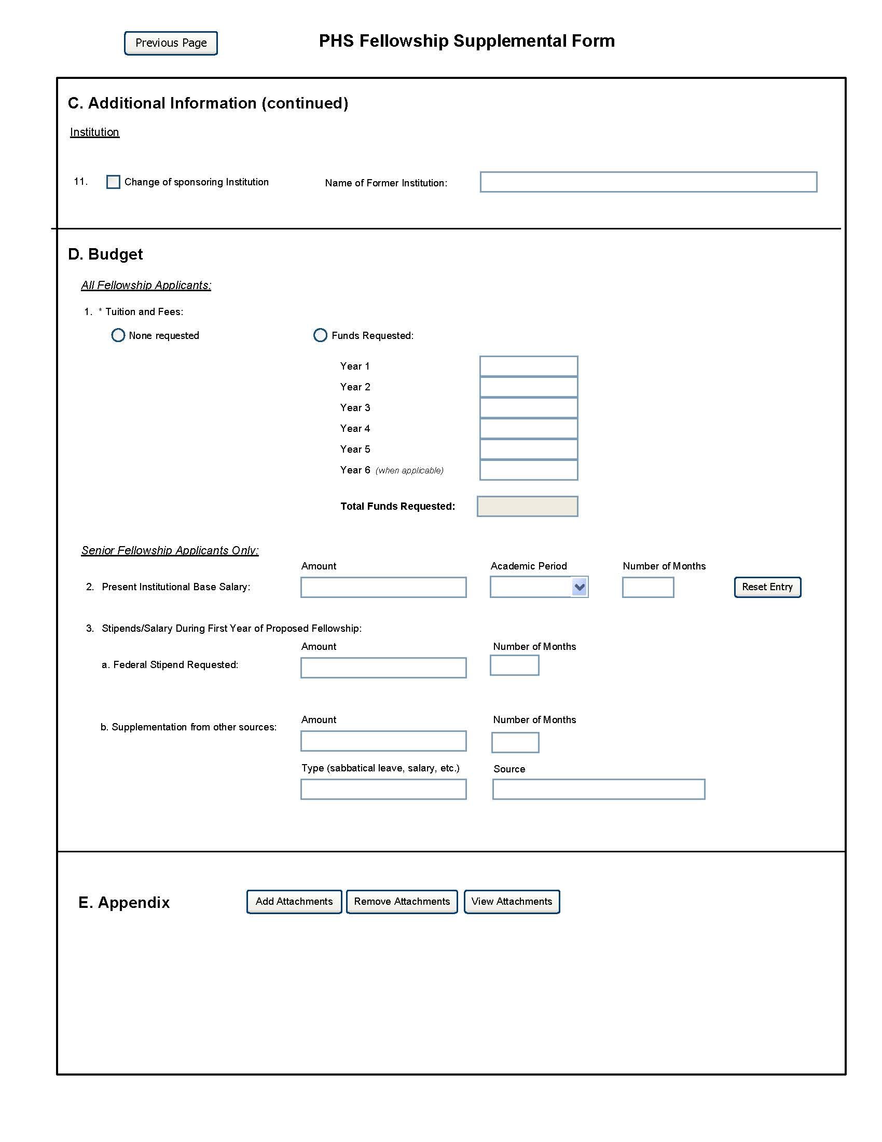
It is strongly recommended that fellowship applicants and sponsors speak with a PHS Program Official for Institute or Center (IC) specific guidance before preparing this application. A list of contacts specifically for extramural training at the NIH ICs can also be found at: http://grants.nih.gov/training/ tac_training_contacts.doc. For AHRQ, see http://www.ahrq.gov/fund/training/trgstaff.htm. Individuals always are encouraged to check these websites for the most current contact information.
Note: Required fields on the PHS Fellowship Supplemental Form are noted with an asterisk(*).

Field Name | Instructions
A. Application Type | This field is pre-populated from the SF424 (R&R) Cover Component. Corrections to this field must be made in that component.
B. Research Training Plan | The Research Training Plan should include sufficient information needed for evaluation of the project, independent of any other document (e.g., previous application). Be specific and informative, and avoid redundancies. This section should be well-formulated and presented in sufficient detail that it can be evaluated for both its research training potential and scientific merit. It is important that it be developed in collaboration with your sponsor, but it should be written by you, the fellowship applicant.  Research Training Plan Attachments  (Also, see Section 2.3.2 - Creating PDFs for Text Attachments and Section 2.6 - Format Specifications for Text (PDF) Attachments of the SF424(R&R) Application Guide)  Although many of the sections of this application are separate PDF attachments, page limitations referenced in the instructions and/or funding opportunity announcement must still be followed. Agency validations will include checks for page limits (and use of appropriate font). Some accommodation will be made for sections that, when combined, must fit within a specified limitation.  NIH and other PHS agencies require all text attachments to the SF424(R&R) application forms to be submitted as PDF files.  Text attachments should be generated using word processing software and then converted to PDF using PDF generating software. Avoid scanning text attachments to convert to PDF since that causes problems for the agency handling the application. Scanning paper documents, without the proper Optical Character Recognition (OCR) process, will hamper automated processing of your application for NIH analysis and reporting.  Do not include any information in a header or footer of the attachments. A header will be system-generated that references the name of the PD/PI. Page numbers for the footer will be system-generated in the complete application, with all pages sequentially numbered.  Since a number of reviewers will be reviewing applications as an electronic document and not a paper version, fellowship applicants are strongly encouraged to use only a standard, single-column format for the text. Avoid using a two-column format since it can cause difficulties when reviewing the document electronically.  Full-sized glossy photographs of material such as electron micrographs or gels must only be included within the page limitations of the Research Strategy section. The maximum size of images to be included should be approximately 1200 x 1500 pixels using 256 colors. Figures must be readable as printed on an 8.5 x 11 inch page at normal (100%) scale.  Investigators must use image compression such as JPEG or PMG. Do not include figures or photographs as separate attachments either in the Appendix or elsewhere in the application.  Separate Attachments  Separate attachments have been designed for the Research Training Plan sections to maximize automatic validations conducted by the eRA system. When the application is received by the agency, all of the Research Training Plan sections will be placed in the appropriate order so that reviewers and agency staff will see a single cohesive Research Training Plan.  While each section of the Research Training Plan needs to be attached separately, fellowship applicants are encouraged to construct the Research Training Plan as a single document, separating sections into distinct PDF attachments just before uploading the files. In this way the fellowship applicant can better monitor formatting requirements such as page limits. When validating for page limits, the eRA Commons will not count the white space created by breaking the text into separate files for uploading.  When attaching a PDF document to the actual forms, please note you are attaching an actual document, not just pointing to the location of an externally stored document. Therefore, if you revise the document after it has been attached, you must delete the previous attachment and then reattach the revised document to the application form. Use the “View Attachment” button to determine if the correct version has been attached.  Page Limitations  All applications for funding must be self-contained within specified page limitations. Agency validations will include checks for page limits. Some accommodation will be made for sections that when combined must fit within a specified limitation. Note that while these computer validations will help minimize incomplete and/or non-compliant applications, they do not replace the validations conducted by Agency staff. Applications found not to comply with the requirements may be delayed in the review process.  The following page limits apply to fellowship applicants only, unless specified otherwise in the FOA. All page limits include all tables, graphs, figures, diagrams and charts.  - Introduction – resubmissions and revisions only; limited to one page.  - Specific Aims – limited to one page.  - Research Strategy – the three sections of the Research Strategy (Significance, Innovation, and Approach) together are limited to six pages.  Be succinct and remember that there is no requirement to use all six pages allotted to the Research Strategy.  Note that the Research Training Plan PDF may include graphic images of gels, micrographs, photographs, etc,; however these images may not be included in the Appendix (except when part of a qualifying publication).  Unless otherwise specified in a PHS solicitation, Internet website addresses (URLs) may not be used to provide information necessary to the review, except for reference citations, because reviewers are under no obligation to view the Internet sites. Moreover, reviewers are cautioned that they should not directly access an internet site as it could compromise their anonymity.  Note: Begin each text section of the Research Training Plan with a section header (e.g., Introduction, Specific Aims, Research Strategy, etc.).  Research Training Plan of Resubmission Applications  A resubmission application must include substantial changes. If the summary statement cites weaknesses specifically to the Research Training Plan, identify these changes in the resubmitted Research Training Plan clearly by bracketing, indenting, or changing typography, unless the changes are so extensive as to include most of the text. This exception should be explained in the Introduction. Do not underline or shade changes. Application processing may be delayed or the application may be returned if it does not comply with all of these requirements.  Include sufficient information to permit an effective review without reviewers having to refer to any previous application.
1. Introduction to Application (Resubmission Applications Only) | Attach for all resubmission applications an Introduction of no more than one page that summarizes the substantial additions, deletions, and changes. The Introduction must also include responses to criticisms and issues raised in the summary statement for the previous application.  First time (new) applications should not include an Introduction unless specified in the FOA.
2. Specific Aims | State concisely the broad, long-term objectives and the goal of the specific research proposed, e.g., to test a stated hypothesis, create a novel design, solve a specific problem, challenge an existing paradigm or clinical practice, address a critical barrier to progress in the field, or develop new technology.  Specific Aims are limited to one page.
3. Research Strategy | Organize the Research Strategy in the specified order using the instructions provided below. Start each section with the appropriate section heading—Significance, Innovation, Approach.  (a) Significance - Briefly describe the background leading to the present application, critically evaluate existing knowledge, and specifically identify the gaps that the project is intended to fill.  - Explain why the proposed research endeavor is significant.  - Describe how the concepts, methods, technologies, treatments, services, or preventative interventions that drive this field will be affected if the proposed aims are achieved.  (b) Innovation - Fellowship applications should not include an Innovation section unless specified in the FOA.  (c) Approach - Preliminary Studies. Use this section to provide an account of preliminary studies, if any, that are pertinent to this application. Preliminary data should be limited to that required to show feasibility of the research approach and to provide experimental support for your hypotheses.  When applicable, provide a succinct account of published and unpublished results, indicating progress toward their achievement.  For Postdoctoral and Senior Fellowship applications, include any courses that you plan to take to support the research training experience.  Renewal Applications.  Renewal applications for individual fellowships are rare. You should consult with your program official before preparing such an application.  For renewal/revision applications, provide a Progress Report as part of the Approach section. Provide the beginning and ending dates for the period covered since the last competitive review. Summarize the specific aims of the previous project period and the importance of the findings, and emphasize the progress made toward their achievement. Explain any significant changes to the specific aims and any new directions including changes resulting from significant budget reductions.  A list of publications, manuscripts accepted for publication, patents, and other printed materials should be included in Section 5; do not include that information here.  If the renewal application involves clinical research, then you must report on the enrollment of research subjects and their distribution by ethnicity/race and sex/gender. See Part II, Section 4.3 for more detailed instructions on completing the Targeted/Planned Enrollment Tables for reporting race and ethnicity data for subjects in clinical research.  - Describe the research design, conceptual or clinical framework, methodologies, and analyses to be used to accomplish the specific aims of the project. Include how the data will be collected, analyzed and interpreted.  - Discuss potential difficulties, limitations of the proposed procedures, and alternative strategies to achieve the aims.  - Describe the sequence/timeline of experiments, tests, and/or computations involved.  Indicate any procedures, situations, or materials that may be hazardous to personnel and the precautions to be exercised.
4. Inclusion Enrollment Report (for RENEWAL applications only) | In the rare instance that you are submitting a renewal application, and it involves clinical research, then you must report on the enrollment of research subjects and their distribution by ethnicity/race and sex/gender using the Inclusion Enrollment Report of each protocol. (Not part of the page limitations of the Research Training Plan.)
5. Progress Report Publication List (for RENEWAL applications only) | In the rare instance when you are submitting a renewal application, list the title and complete references to all appropriate publications and manuscripts accepted for publication. (Not part of the page limitations of the Research Training Plan.)  List the titles and complete references to all appropriate publications, manuscripts accepted for publication, patents, and other printed materials that have resulted from the project since it was last reviewed competitively. For NIH applications only, when citing articles that fall under the NIH Public Access Policy, http://publicaccess.nih.gov/, were authored or co-authored by the fellowship applicant and arose from NIH support, provide the NIH Manuscript Submission reference number (e.g., NIHMS97531) or the Pubmed Central (PMC) reference number (e.g., PMCID234567) for each article. If the PMCID is not yet available because the Journal submits articles directly to PMC on behalf of their authors, indicate “PMC Journal – In Process.” A list of these journals is posted at: http://publicaccess.nih.gov/submit_process_journals.htm.  Citations that are not covered by the NIH Public Access Policy, but are publicly available in a free, online format may include URLs or PMCID numbers along with the full reference (note that copies of these publications are not accepted as appendix material).
Human Subjects | Prefilled from the Research and Related Other Project Information form. If activities involving human subjects are not planned at any time during the proposed project at any performance site, skip the remainder of the block and continue to Other Research Training Plan Sections. If you have indicated “Yes” for Human Subjects involvement, consult with your Sponsor and Administrative Officials at the Sponsoring Institution before completing this section. Human subjects requirements may apply even if you are obtaining specimens/data from collaborators or if you are subcontracting the human research to another organization. For all research involving human subjects, a part of the peer review process will include careful consideration of protections from research risks, as well as the appropriate inclusion of women, minorities, and children. The Scientific Review Group (SRG) will assess the adequacy of safeguards of the rights and welfare of research participants, and the appropriate inclusion of women, minorities, and children, based on the information in the application. The evaluation of the inclusion plans will be factored into the overall score that the SRGs award for scientific and technical merit of the application. Much of the information on the protection of human subjects that you are required to provide in the Fellowship application is identical to information that you will be required to provide for IRB review at your own institution.  Do not use the protection of human subjects section to circumvent the page limits of the Research Strategy.
6. Human Subjects Involvement Indefinite? | Check “Yes” if at the time of application plans to involve human subjects are unknown. If an award is made, the fellow may not participate in human subjects research until an updated research training plan is submitted and approved by the awarding component. Such a plan must be developed in consultation with the sponsor. Certification of the date of IRB approval must also be submitted before the fellow can participate in human subjects research.
7. Clinical Trial | Check the “Yes” or “No” box to indicate whether the project is a clinical trial. The NIH defines a clinical trial as a prospective biomedical or behavioral research study of human subjects that is designed to answer specific questions about biomedical or behavioral interventions (drugs, treatments, devices, or new ways of using known drugs, treatments, or devices).
8. Agency-Defined Phase III Clinical Trial? | Check the “Yes” or “No” box to indicate whether the project is an NIH-defined Phase III clinical trial. An NIH-defined Phase III clinical trial is a broadly based prospective Phase III clinical investigation, usually involving several hundred or more human subjects, for the purpose of either evaluating an experimental intervention in comparison with a standard or control intervention or of comparing two or more existing treatments. Often the aim of such investigation is to provide evidence leading to a scientific basis for consideration of a change in health policy or standard of care. The definition includes pharmacologic, non-pharmacologic, and behavioral interventions given for disease prevention, prophylaxis, diagnosis, or therapy. Community trials and other population-based intervention trials are also included.
9. Protection of Human Subjects | Attach a description of risks to the human research subjects. Describe the details of their proposed involvement, including whether the research material will be obtained from living human subjects in the form of specimens, records, or data. Describe who will have access to subject identities and other identifiers that would permit linkages to the subjects. Describe the potential risks and benefits of the research to the subjects and others. See Part II, Supplemental Instructions for Preparing the Human Subjects Section of the Research Training Plan.  To assist in preparing the section on Protection of Human Subjects, six possible scenarios are provided in Section 2. Scenarios. All research projects will fall into one of these six scenarios. To help determine if proposed research that only involves the use of coded human data or biological specimens is human subjects research, refer to this flow chart: http://grants.nih.gov/grants/policy/hs/PrivateInfoOrBioSpecimensDecisionChart.pdf. Determine which scenario the proposed research falls into, then go to the specific instructions applicable to that scenario in Section 3. Instructions for Preparing the Section on Protection of Human Subjects.  Data and Safety Monitoring Plan. If your research includes a clinical trial, you must provide a Data and Safety Monitoring Plan. Provide a general description of a monitoring plan that you plan to establish as the overall framework for data and safety monitoring.  Data and Safety Monitoring Boards. For each proposed clinical trial, NIH requires a data and safety monitoring plan that describes oversight and monitoring to ensure the safety of participants and the validity and integrity of the data. The level of monitoring should be commensurate with the risks and the size and complexity of the clinical trial.  Institutional Review Board (IRB). Prior to the accrual of human subjects, a detailed data and safety monitoring plan must be submitted to the fellowship applicant’s IRB and to the funding entity for approval. Adverse events must be reported to the IRB, the NIH funding Institute or Center, and other appropriate offices or agencies. This policy requirement is in addition to any monitoring requirements imposed by 45 CFR Part 46. NIH policy specifically requires the establishment of a Data and Safety Monitoring Board (DSMB) for multi-site clinical trials involving interventions that entail potential risk to the participants, and generally for Phase III clinical trials.
10. Inclusion of Women and Minorities | Attach information to address, at a minimum, the following four points:  1. The targeted/planned distribution of subjects by sex/gender and racial/ethnic groups for each proposed study or protocol using the format in the Targeted/Planned Enrollment Table. (Instructions for completing this table are provided below.) If you are using existing specimens and/or data that does not meet the criteria for Exemption 4 and you do not have access to information on the distribution of women and minorities, so state and explain the impact on the goals of the research as part of the rationale that inclusion is inappropriate (item 3 below). Alternatively, you may describe the women and minority composition of the population base from whom the specimens and/or data will be obtained. Include the Targeted/Planned Enrollment Table in this section.  2. A description of the subject selection criteria and rationale for selection of sex/gender and racial/ethnic group members in terms of the scientific objectives and proposed study design. The description may include, but is not limited to, information on the population characteristics of the disease or condition under study.  3. A compelling rationale for proposed exclusion of any sex/gender or racial/ethnic group (see examples below).  4. A description of proposed outreach programs for recruiting sex/gender and racial/ethnic group members as subjects.  See Part II, Supplemental Instructions for Preparing the Human Subjects Section of the Research Training Plan.  Additional Instructions and Requirements When NIH-Defined Phase III Clinical Trials Are Proposed. If your proposed research includes an NIH-Defined Phase III Clinical Trial, the section on Inclusion of Women and Minorities also must address whether you expect to find clinically important sex/gender and/or race/ethnicity differences in the intervention effect. The discussion may include supporting evidence and/or data derived from prior animal studies, clinical observations, metabolic studies, genetic studies, pharmacology studies, and observational, natural history, epidemiology and other relevant studies. Your discussion of expected sex/gender and/or race/ethnicity differences in intervention effect must include selection and discussion of one of the following analysis plans:  - Plans to conduct valid analyses to detect significant differences in intervention effect among sex/gender and/or racial/ethnic subgroups when prior studies strongly support these significant differences among subgroups, or  - Plans to include and analyze sex/gender and/or racial/ethnic subgroups when prior studies strongly support no significant differences in intervention effect between subgroups. (Representation of sex/gender and racial/ethnic groups is not required as subject selection criteria, but inclusion is encouraged.), or  - Plans to conduct valid analyses of the intervention effect in sex/gender and/or racial/ethnic subgroups (without requiring high statistical power for each subgroup) when the prior studies neither support nor negate significant differences in intervention effect between subgroups.  For additional guidance on creating this section, see the above reference.
11. Targeted/ Planned Enrollment (Clinical Research Only) | For Clinical Research, place the Target/Planned Enrollment Table(s) under the heading "Inclusion of Women and Minorities," immediately in front of the heading "Inclusion of Children." See Part II, Supplemental Instructions for Preparing the Human Subjects Section of the Research Training Plan.
12. Inclusion of Children | For the purpose of implementing these guidelines, a child is defined as an individual under the age of 21 years (for additional information see http://grants.nih.gov/grants/funding/children/children.htm and http://grants.nih.gov/grants/guide/notice-files/not98-024.html).  Attach either a description of the plans to include children or, if children will be excluded, a justification for the exclusion. When children are involved in research, the Additional Protections for Children Involved as Subjects in Research (45 CFR Part 46 Subpart D) apply and must be addressed in the “Human Subjects Research and Protection from Risks” subheading.  See Part II, Supplemental Instructions for Preparing the Human Subjects Section of the Research Training Plan.
Other Research Training Plan Sections | Consult with your Sponsor and Administrative Officials at the Sponsoring Institution before completing Items 13 through 17 and 19.
Are Vertebrate Animals Used? | Prefilled from the Research and Other Project Information form. If activities involving vertebrate animals are not planned at any time during the proposed project at any performance site, indicate no and skip items #13 and #14.
13. Vertebrate Animals Use Indefinite? | If the sponsoring institution has an approved Animal Welfare Assurance on file with the NIH Office of Laboratory Animal Welfare (OLAW) but, at the time of application, plans for the involvement of vertebrate animals are so indefinite that IACUC review and approval are not feasible, check "Yes." If an award is made, vertebrate animals may not be involved until a verification of the date of IACUC approval has been submitted to the NIH IC or AHRQ.
14. Vertebrate Animals | If you have responded “Yes” to the question “Are Vertebrate Animals Used?” attach the information requested below. Failure to address the following elements will result in the application being designated as incomplete and it will be grounds for the PHS either to defer the application from the peer review round or to have a potentially negative effect on the application’s priority score. Under the “Vertebrate Animals” heading address the following five points. In addition, when research involving vertebrate animals will take place at a collaborating site(s) or other performance site(s), provide this information before discussing the five points. Although no specific page limitation applies to this section of the application, be succinct.  1. Provide a detailed description of the proposed use of the animals in the work outlined in the “Research Strategy” section. Identify the species, strains, ages, sex, and numbers of animals to be used in the proposed work.  2. Justify the use of animals, the choice of species, and the numbers to be used. If animals are in short supply, costly, or to be used in large numbers, provide an additional rationale for their selection and numbers.  3. Provide information on the veterinary care of the animals involved.  4. Describe the procedures for ensuring that discomfort, distress, pain, and injury will be limited to that which is unavoidable in the conduct of scientifically sound research. Describe the use of analgesic, anesthetic, and tranquilizing drugs and/or comfortable restraining devices, where appropriate, to minimize discomfort, distress, pain, and injury.  5. Describe any method of euthanasia to be used and the reasons for its selection. State whether this method is consistent with the recommendations of the Panel on Euthanasia of the American Veterinary Medical Association. If not, present a justification for not following the recommendations.
15. Select Agent Research | The Public Health Security and Bioterrorism Preparedness and Response Act of 2002 (P.L. 107-188) is designed to provide protection against misuse of select agents and toxins whether inadvertent or the result of terrorist acts against the United States homeland or other criminal acts. The Act was implemented, in part, through regulations published by CDC at 42 CFR 73 <http://www.cdc.gov/od/sap/docs/ 42cfr73.pdf>, Select Agents and Toxins.  As a term of award, grantees who conduct research involving Select Agents (see 42 CFR 73 for the list; and 7 CRF 331 and 9 CFR 121 for the relevant animal and plant pathogens) are reminded that they must complete registration with CDC (or USDA, depending on the agent) before using NIH funds. No funds can be used for research involving Select Agents if the final registration certificate is denied.  In addition to the above requirements, research involving both select agents and recombinant DNA is also subject to the NIH Guidelines for Research Involving DNA Molecules (NIH Guidelines). A copy of the NIH Guidelines is posted at the following URL: http://www4.od.nih.gov/oba/rac/guidelines/guidelines.html and may be obtained from the NIH Office of Biotechnology Activities, 6705 Rockledge Drive, Suite 750, Bethesda, MD 20892, 301-496-9838.  For additional information regarding Select Agent research, see the following websites maintained by NIH, CDC, and USDA:  NIH Office of Extramural Research Select Agent Information: http://grants.nih.gov/grants/policy/select_agent/  Center for Disease Control Select Agent Program: http://www.cdc.gov/od/sap/index.htm  If any of the activities proposed in your application involve the use of Select Agents at any time during the proposed project period, either at the applicant organization or at any other performance site, attach the following information. Failure to address the following elements will result in the application being designated as incomplete and it will be grounds for the PHS either to defer the application from the peer review round or to have a potentially negative effect on the application’s priority score. Address the following three points for each site at which Select Agent research will take place. Although no specific page limitation applies to this section, be succinct.  1. Identify the Select Agent(s) to be used in the proposed research.  2. Provide the registration status of all entities* where Select Agent(s) will be used. • If the performance site(s) is a foreign institution, provide the name(s) of the country or countries where Select Agent research will be performed. *An “entity” is defined in 42 CFR 73.1 as “any government agency (Federal, State, or local), academic institution, corporation, company, partnership, society, association, firm, sole proprietorship, or other legal entity.”  3. Provide a description of all facilities where the Select Agent(s) will be used. • Describe the procedures that will be used to monitor possession, use and transfer of Select Agent(s). • Describe plans for appropriate biosafety, biocontainment, and security of the Select Agent(s). If you are responding to a specific funding opportunity announcement, address any requirements specified by the solicitation. Reviewers will assess the information provided in this Section, and any questions associated with Select Agent research will need to be addressed prior to award.
16. Resource Sharing Plan | NIH considers the sharing of unique research resources developed through NIH-sponsored research an important means to enhance the value and further the advancement of the research. When resources have been developed with NIH funds and the associated research findings published or provided to NIH, it is important that they be made readily available for research purposes to qualified individuals within the scientific community. See Part III, 1.5 Sharing Research Resources.  Sharing Model Organisms. If the development of model organisms is anticipated, attach a description of a specific plan for sharing and distributing unique model organism research resources or state appropriate reasons why such sharing is restricted or not possible. For many individual fellowships it is anticipated that plans of this nature would have already been reported to the NIH by your sponsor in his/her research application. When this has occurred, indicate so in this section and include the appropriate grant number. For additional information on this policy, see Sharing Model Organisms Policy and see the NIH Model Organism for Biomedical Research Website at: http://www.nih.gov/science/models/ and NIH Guide Notices OD-04-042: http://grants.nih.gov/grants/guide/notice-files/NOT-OD-04-042.html, and OD-04-066: http://grants.nih.gov/grants/guide/notice-files/NOT-OD-04-066.html.  Genome-Wide Association Studies (GWAS): Regardless of the amount requested, fellowship applicants seeking funding for a genome-wide association study are expected to provide a plan for submission of GWAS data to the NIH-designated GWAS data repository, or provide an appropriate explanation why submission to the repository is not possible. A genome-wide association study is defined as any study of genetic variation across the entire genome that is designed to identify genetic associations with observable traits (e.g., blood pressure or weight) or the presence or absence of a disease or condition. For further information see Policy for Sharing of Data Obtained in NIH Supported or Conducted Genome-Wide Association Studies (NOT-OD-07-088) and http://grants.nih.gov/grants/gwas/.
17. Respective Contributions | Attach a description, limited to no more than one page, of the collaborative process between you and your sponsor/co-sponsor in the development, review, and editing of this research training plan. Do not include the respective roles in accomplishing the proposed research.
18. Selection of Sponsor and Institution | 1. Explain why the sponsor, co-sponsor (if any), and institution were selected to accomplish the research training goals.  2. Doctorate or Current Institution. (For postdoctoral and senior fellows only) Since training is expected to broaden a fellow's perspective, postdoctoral fellowship applicants requesting training at either their doctorate institution or at the institution where they have been training for more than a year must explain why further training at that institution would be valuable. Individuals applying for Senior Fellowships who are requesting training at the institution at which they are employed should provide a similar explanation.  3. Foreign Institution. If you are proposing a research training experience at a foreign institution, show that the foreign institution and sponsor offer special opportunities for training that are not currently available in the United States. Key factors in the selection of a foreign institution should be described. If applicable, the need for and level of proficiency in reading, speaking, and comprehending the foreign language should be addressed.
19. Responsible Conduct of Research | Note: No award will be made if an application lacks this component.  Every fellow must receive instruction in the responsible conduct of research (http://grants.nih.gov/grants/guide/notice-files/not92-236.html). Applications must include a description, limited to no more than one page, of the sponsoring institution’s plans to provide and the fellowship applicant’s plans for obtaining instruction in the responsible conduct of research, including the rationale, subject matter, appropriateness, format, frequency and duration of instruction. The amount and nature of faculty participation must be described. The plan will be discussed after the overall determination of merit, so that the review panel's evaluation of the plan will not be a factor in the determination of the priority score. The plan will be judged as acceptable or unacceptable. The acceptability of the plan will be described in an administrative note of the summary statement. Regardless of the priority score, an application with an unacceptable plan will not be funded until the fellowship applicant provides a revised acceptable plan. Staff in the NIH awarding component will judge the acceptability of the revised plan.  In most cases, the fellowship applicant’s plan for Responsible Conduct of Research will include participation in an established course or seminar series, as either an instructor or a student (for-credit or non-credit). If the institution does not offer a course or seminar series that fulfills the Responsible Conduct of Research requirement, the fellowship applicant may lead or participate in a discussion group in lieu of a formal activity. If neither option is possible, the fellowship applicant may obtain on-line instruction in Responsible Conduct of Research. Suggested topics for courses, seminars, and discussion groups include conflict of interest, responsible authorship, policies for handling misconduct, data management, data sharing, policies regarding the use of animals and/or human subjects, and institutional vs. individual responsibilities for scientific integrity. Courses, seminars, and discussion groups taken to fulfill the Responsible Conduct of Research requirement need not cover all of these topics but should include a majority of them.
C. Additional Information
1. Human Embryonic Stem Cells | Indicate “Yes” if the proposed research involves human embryonic stem cells. See http://stemcells.nih.gov/index.asp for a definition of human embryonic stem cells. If the proposed project involves human embryonic stem cells, list in this section the registration number of the specific cell line(s) from the stem cell registry found at: http://stemcells.nih.gov/research/registry/eligibilityCriteria.asp. If a specific stem cell line cannot be referenced at the time of application submission, check the box provided to indicate that one from the registry will be used.  NOTE: In agreeing to the required assurances, the duly authorized representative of the applicant organization certifies that if research using human embryonic stem cells is proposed, the applicant organization will be in compliance with the “Notice of Extended Receipt Date and Supplemental Information Guidance for Applications Requesting Funding that Proposes Research with Human Embryonic Stem Cells” (http://grants.nih.gov/grants/guide/notice-files/NOT-OD-02-006.html). See http://stemcells.nih.gov/index.asp for additional information on stem cells, and http://stemcells.nih.gov/policy/guidelines.asp for Federal policy statements and guidelines on federally funded stem cell research.
Fellowship Applicant

2. Alternate Phone Number | Enter an alternate phone number (e.g., cell phone) where the fellowship applicant can be reached on matters relating to this application for fellowship support. This should be a different number than provided in the PD/PI contact information in the Cover Component.
3. Degree Sought During Proposed Award | Complete if applicable. Completion of the degree requirements should be coordinated with the sponsor. The fellowship applicant must select the degree from the drop down menu and also enter the month and year of the expected completion date. If the degree is not on the drop down menu, please mark “Other” and indicate the type of degree in the space provided.
4. Field of Training for Current Proposal | Indicate the proposed area of research training according to the Fields of Training (FOT) codes listed in the drop down menu. Provide the FOT code that best describes the proposed area of research training from the FOT codes listed in the instructions. Select the subcategory descriptor, unless the broader category (in bold uppercase) fits best. If the FOT listing does not provide a good descriptor, select “Other.” (This information is used for reporting purposes only and is not used for study section assignments.)
5. Current or Prior Kirschstein-NRSA Support? | If “Yes”, identify the current and/or prior Kirschstein-NRSA support from the drop down menu, up to four entries. Define level of support as either predoctoral or postdoctoral level (not the level of experience). The type of support is either individual fellowship or institutional research training grant indicated on the drop down menu. Enter the start and end dates (if known) of the support (month, day, and year) and the grant number (if known) of the current and/or prior support (e.g., T32 GM123456 or F31 HL345678).  An individual cannot receive more than 5 years of cumulative predoctoral Kirschstein-NRSA support and 3 years cumulative postdoctoral Kirschstein-NRSA support (the total of Institutional Grants and Individual Fellowships) without a waiver from the NIH IC. The NIH ICs have different policies on waiving the statutory limits on support. Therefore, the fellowship applicant must request a waiver from the probable funding IC before requesting a period of support that would exceed these limits. The fellow’s sponsor and a sponsoring institution official must endorse the request, and it must include justification and specify the amount of additional support for which approval is sought. Individuals seeking additional support beyond the third year of postdoctoral support are strongly advised to consult with their awarding IC Program Officer before submitting a waiver request. It is important to read carefully the applicable FOA that may have an overall approval to exceed these limits (e.g., the F30 combined M.D./Ph.D. program allows for up to 6 years of predoctoral support).  Promptly report to the NIH IC to which this application is assigned any additional NRSA support received while this application is pending.
6. Applications for Concurrent Support? | Check the appropriate answer, indicating “Yes” if the fellowship applicant has applied or will be applying for other support that would run concurrently with the period covered by this application. Include the type, dates, source(s) and amount in the attachment document. The fellowship applicant must promptly report to the NIH IC to which this application is assigned, or AHRQ, any support resulting from other such applications.
7. Goals for Fellowship Training and Career | The fellowship applicant must add an attachment (limited to 1 page) describing his/her overall career goals, and explain how the proposed research training will enable the attainment of these goals. Identify the skills, theories, conceptual approaches, etc. to be learned or enhanced during the award.
8. Activities Planned Under This Award | The fellowship applicant must add an attachment (limited to 1 page) describing by year the activities (research, coursework, etc.) he/she will be involved in under the proposed award and estimate the percentage of time to be devoted to each activity, based on a normal working day for a full-time fellow as defined by the sponsoring institution. The percentage should total 100 for each year. Also, briefly explain activities other than research and relate them to the proposed research training.  For postdoctoral fellowships (F32), do not exceed three years. For senior fellowships (F33) do not exceed two years. Predoctoral fellowships (F31), including fellowship applicants for the M.D./Ph.D. (F30) program may reflect up to six years if allowed by the applicable FOA.
9. Research Experience | Summarize your research experience (limited to 2 pages) in chronological order.  Advanced graduate students, who have (or will have) completed their comprehensive examinations by the time of award must also include a narrative of their doctoral dissertation (may be preliminary). If you have no research experience, list other scientific experience. Do not list academic courses.  In summarizing their research experience, Postdoctoral and Senior Fellowship applicants should include the areas studied and conclusions drawn.  Postdoctoral fellowship applicants should also specify which areas of research were part of their thesis or dissertation and which, if any, were part of a previous postdoctoral project.
10. Citizenship | Fellowship applicants must check the appropriate box. To be eligible for a Kirschstein-NRSA Individual Fellowship (F30, F31, F32, F33), the fellowship applicant must be a U.S. citizen, a non-citizen national, or have been lawfully admitted to the U.S. for permanent residence before the award is issued. U.S. non-citizen nationals are persons born in lands that are not States but are under U.S. sovereignty, jurisdiction, or administration, e.g., American Samoa. Individuals on temporary student visas are not eligible for NRSA support.  If the fellowship applicant has been lawfully admitted for permanent residence, i.e., is in possession of a Permanent Resident Card (USCIS Form I-551) or other legal verification of such status, the fellowship applicant should check the “Permanent Resident of U.S.” box. Before the award is issued, a permanent resident will be required to submit a notarized statement that a licensed notary has seen the fellowship applicant’s valid Permanent Resident Card (USCIS Form I-551) or other valid verification from the U.S. Immigration and Naturalization Service of legal admission to the U.S.  If the fellowship applicant is a non-citizen of the U.S. who has applied for, but not yet been granted legal admission to the U.S. as a permanent resident, the applicant should check the “Permanent Resident of U.S. Pending” box, understanding that no award will be issued until such time as the required permanent residency has been established and the required documentation submitted to NIH or AHRQ.  If the fellowship applicant is applying for a non-NRSA fellowship program supported by the NIH, for which citizenship or permanent residency is not required (e.g., Fogarty International Center programs), the fellowship applicant must have in his/her possession a valid visa allowing him/her to remain in the U.S. (or in a foreign research training setting, if applicable) long enough to be productive on the proposed fellowship project. It is the responsibility of the sponsoring institution to determine and retain documentation indicating that the individual fellowship applicant’s visa will allow him/her to reside in the proposed research training setting for the period of time necessary to complete the proposed fellowship. The fellowship applicant should check the “Non-U.S. Citizen with temporary U.S. visa” box. Verification may be requested by the NIH IC prior to issuance of an award. In general, it is highly recommended that all non-U.S. citizens adhere to specific requirements as stated in the FOA or contact the appropriate individual listed on the FOA.
Institution
11. Change of Sponsoring Institution | The fellowship applicant must indicate if this application is being submitted with a change of sponsoring institution. If the fellowship applicant checks the box, the name of the former sponsoring institution must be provided.
D. Budget
All Fellowship Applicants:  1. Tuition and Fees: | All fellowship applicants should list the estimated costs of tuition and fees. Postdoctoral and senior fellowship applicants should list the costs associated with courses planned that support the research training experience and are identified and described in the attachment for the Research Strategy section of the Research Training Plan in Section B. If no tuition and fees are being requested, check the box provided.  In accordance with NIH NOT-OD-06-093 released August 18, 2006, funds to offset the costs of health insurance (self or family, as appropriate) are included in the standard Institutional Allowance, and not to be requested as part of Tuition and Fees.
Senior Fellowship Applicants Only:  2. Present Institutional Base Salary: | Senior fellowship applicants must provide their present base salary and indicate the period of time on which the salary is determined (e.g., academic year of 9 months, full-time 12 months, etc. The number may not be more than 12, but may include a decimal indicating partial months (e.g., 9.5).
Senior Fellowship Applicants Only:  3. Stipend/Salary During First Year of Proposed Fellowship: | a. Federal Stipend Requested:  Fellowship applicants must insert the stipend being requested for the initial period of support and the number of months.  b. Supplementation from other sources:  Fellowship applicants should enter the anticipated amount and the length of time associated with the amount. Enter also the type of supplementation expected (e.g., salary, sabbatical leave, etc.) and the source of such funding.
E. Appendix | Only one copy of appendix material should be included.  A maximum of 10 PDF attachments is allowed in the Appendix. Grants.gov defaults to a maximum of 10 separate attachments. If more than 10 appendix attachments are needed, combine the remaining information into attachment #10. Note that this is the total number of appendix items, not the total number of publications. Publications that are publicly accessible must not be included in the appendix. When allowed there is a limit of three publications that are not publicly available (see below for further details and check the FOA for any specific instructions), though not all fellowship activity codes allow publications to be included in the appendix.  Do not use the Appendix to circumvent the page limitations of the Research Strategy section of the Research Training Plan.  Appendix material may not appear in the assembled application in the order attached, so it is important to use filenames for attachments that are descriptive of the content. A summary sheet listing all of the items included in the appendix is also encouraged but not required. When including a summary sheet, it should be included in the first appendix attachment. Applications that do not follow the appendix requirements may be delayed in the review process.  New, resubmission, renewal, and revision applications may include the following materials in the Appendix:  - Publications – No longer allowed as appendix materials except in the circumstances noted below. Fellowship applicants may submit up to 3 of the following types of publications:  - Manuscripts and/or abstracts accepted for publication but not yet published: The entire article should be submitted as a PDF attachment.  - Manuscripts and/or abstracts published, but a free, online, publicly available journal link is not available: The entire article should be submitted as a PDF attachment.  - Patents directly relevant to the project: The entire document should be submitted as a PDF attachment.  Do not include unpublished theses, or abstracts/manuscripts submitted (but not yet accepted) for publication.  - Surveys, questionnaires, and other data collection instruments; clinical protocols, and informed consent documents may be submitted in the Appendix as necessary.  - For materials that cannot be submitted electronically or materials that cannot be converted to PDF format (e.g., medical devices, prototypes, DVDs, CDs), fellowship applicants should contact the Scientific Review Officer for instructions following notification of assignment of the application to a study section. Fellowship applicants are encouraged to be as concise as possible and submit only information essential for the review of the application.  Items that must not be included in the appendix:  - Photographs or color images of gels, micrographs, etc. are no longer accepted as Appendix material. These images must be included in the Research Training Plan PDF. However, images embedded in publications are allowed.  - Publications that are publicly accessible. For such publications, the URL or PMC submission identification numbers along with the full reference should be included as appropriate in the Bibliography and References cited section, the Progress Report Publication List section, and/or the Biographical Sketch section.

Once all data have been entered, click the Close Form button at the top of the form or use the scroll bar to scroll up. You will be returned to the Grant Application Package screen. To remove a document from the Submission box, click the document name to select it and then click the Move Form to Delete button. This will return the document to the Mandatory Documents Submission List or Optional Documents Submission List.

