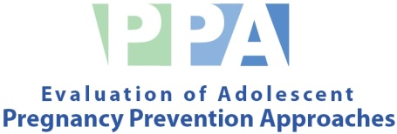
Form Approved
OMB No. 0990-0382
Expiration date xx/xx/20xx

Form Approved
OMB No. 0990-NEW
Expiration date xx/xx/20xx

OMB No. 0990-
- Exp. Date XX/XX/20XX

Dear Parent or Guardian:

The U.S. Department of Health and Human Services is conducting an important study of ways to reduce teen pregnancy. The Evaluation of Adolescent Pregnancy Prevention Approaches (PPA) will provide communities like yours with clear information on program effectiveness. We are requesting your permission for your child to participate in the study.
[SCHOOL] is taking part in this study, and students, including your child, are invited to participate. Half of the schools in the study will be randomly selected to take part in an abstinence education program called WAIT Training. In the other half of the schools, students will take part in a class on diet and exercise. Researchers from Mathematica Policy Research, Inc. and Communicate LLC will survey youth from all schools in the study three times over the next few years, beginning in September 2011. These surveys will ask about families, friends, attitudes, knowledge and activities, including sexual activity, drug use and alcohol use. The researchers will also gather information from schools about participants’ grades, attendance, and test scores. Your child may also be invited to participate in a focus group.
All information collected in the study will be kept private to the extent possible by law. Your child’s name will not be attached to the answers he or she gives, and no unauthorized person will see his or her answers. However, if your child tells us that he or she is going to hurt him or herself or is being hurt by someone else, we will take the necessary steps to ensure his or her safety.
Participation in the study is voluntary. If you agree that your child can participate, your child can still stop participating later. If any questions in the surveys make your child uncomfortable, he or she can refuse to answer those questions.
We hope you agree with us that it is important to learn about effective ways to prevent teen pregnancy through studies like this. Please let us know whether or not you will allow your child to be in the study by completing and signing the attached form and returning it to your child’s teacher within a week.
If you have any questions about the program curriculum, please call Sue Morden at 850-668-3700. If you have questions about the PPA study or about your child’s participation, please call Melissa Thomas at 1-888-864-6416. Study and program materials are also available for you to review at [SCHOOL].

Sincerely,
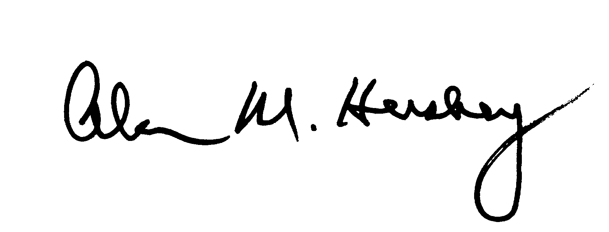

Alan Hershey, Study Director

THE PAPERWORK REDUCTION ACT OF 1995
Public reporting burden for this collection of information is estimated to average 5 minutes per response, including the time for reviewing instructions and signing the form. An agency may not conduct or sponsor, and a person is not required to respond to, a collection of information unless it displays a currently valid OMB control number.

Form Approved
OMB No. 0990-0382
Expiration date xx/xx/20xx

Form Approved
OMB No. 0990-NEW
Expiration date xx/xx/20xx
- Exp. Date XX/XX/20XX

EVALUATION OF ADOLESCENT PREGNANCY PREVENTION APPROACHES
Sponsored by the United States Department of Health and Human Services
Parent Consent Form₂
[SCHOOL]/[District] Public Schools
I have read the attached information sheet describing the study. By signing this form, I am:
□giving my permission □not giving permission

for my son or daughter, _______________________________, to participate in the study.
Print Child’s Name

I understand that, as part of the study, information for all study youth can be collected from school records, surveys, and focus groups. By signing this form, I am giving my permission for information to be gathered from my son or daughter for use in this study, which will be conducted by researchers at Mathematica Policy Research, Inc. and Communicate LLC. I further understand that all information on my child will be kept private and used only for the purposes of the study. If I have questions about my child’s rights as a research volunteer, I can call Melissia Billarrial at Public/Private Ventures, toll-free at 1-800-755-4778, extension 4482.

Parent/Guardian Signature: _________________________________ Date: _______________

Child’s Name: ___________________________ Child’s Date of Birth: _____ / ______ / _____ Month Day Year

I give permission for the school to provide access to the following administrative data for my son or daughter (please check yes or no for each):

Administrative Data for 2010-11, 2011-12, and 2012-13 Yes No
School attendance record □ □
Course grades □ □
Standardized test scores □ □
Student directory information (school, address and phone) □ □

Please fill in the following information. We will use your contact information only if we need your help in completing a survey with your child. Thank you.

Parent/Guardian Name: __________________________________________

Street Address: _________________________________________________ Apartment: ____________

City: _______________________________________ Zip Code: ________________

Telephone: (_____) ____ - __________ Home Email: _____________________________________
(_____) ____ - __________ Work
(_____) ____ - __________ Cell

Parents please be aware that under the Protection of Pupil Rights Act. 20 U.S.C. Section 1232(c)(1)(A), you have the right to review a copy of the questions asked or materials that will be used with your child. If you would like to do so, you should contact Melissa Thomas toll-free at 1-888-864-6416 to obtain a copy of the questions or materials.

WE NEED YOUR ANSWER, WHETHER IT IS YES OR NO.
PLEASE RETURN THIS FORM TO YOUR CHILD’S TEACHER WITHIN A WEEK.
THANK YOU!

Form Approved
OMB No. 0990-0382
Expiration date xx/xx/20xx

Form Approved
OMB No. 0990-NEW
Expiration date xx/xx/20xx

OMB No. 0990-
- Exp. Date XX/XX/20XX

STATEMENT OF ASSENT

EVALUATION OF ADOLESCENT PREGNANCY PREVENTION APPROACHES (PPA)

(Sponsored by the United States Department of Health and Human Services)

An adult at _______________has explained to me the Evaluation of Adolescent Pregnancy Prevention Approaches (PPA). I was told that I have been selected to be a part of the study and that my parents/guardians have agreed to my participation. The study was described to me and any questions I had were answered. I understand I will be asked to complete several surveys and that the information I provide is private and will not be provided to people outside of the study or shown to my parents or teachers. However, if I say that I am going to hurt myself or someone else, or that someone is hurting me, someone on the study team will take steps to make sure that I am safe. I also understand that I do not have to answer any questions that make me feel uncomfortable.

If I have questions about my rights as a research volunteer, I can call Melissia Billarrial at Public/Private Ventures, toll-free at 1-800-755-4778, extension 4482. I understand that participation is voluntary, and I agree to participate in the study. I understand that I am allowed to stop participating in the study at any time, without penalty.

_________________________ _________________________ _______________
Name Signature Date

Email: _________________________________________

Cell phone: ( ) _________ - ______________
Area code

---------------------------------------------------------------------------------------------------------------

I certify that the staff members assigned to explain the study to participants were trained to do so in terms participants would understand.

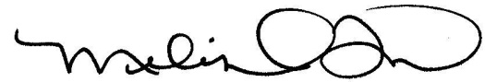
_______________________________________
Melissa Thomas
Survey Director
Signature Date

THE PAPERWORK REDUCTION ACT OF 1995
Public reporting burden for this collection of information is estimated to average 2 minutes per response, including the time for reviewing instructions and signing the form. An agency may not conduct or sponsor, and a person is not required to respond to, a collection of information unless it displays a currently valid OMB control number.

