**Non-Substantive Change Request JUSTIFICATION for Data Validation – OMB Control Number 1205-0448**

**Background:** States and grantees receiving funding under WIA Title IB, Wagner-Peyser Act, TAA, and the Older Americans Act are required to maintain and report accurate program and financial information (WIA section 185 (29 U.S.C. 2935) and WIA Regulations 20 CFR 667.300(e)(2); Wagner-Peyser Act section 10 (29 U.S.C. 49i), Older Americans Act section 503(f)(3) and (4) (42 U.S.C. 3056a(f)(3) and (4)), and TAA Regulations 20 CFR 617.57). Further, all states and grantees receiving funding from ETA and the Veterans’ Employment and Training Service are required to submit reports or participant records and attest to the accuracy of these reports and records.

The Department’s Office of Inspector General (OIG) conducted an audit of WIA performance data oversight from July 2000 through October 2001. The audit, released in September 2002, found that, “Because of insufficient local, state, and Federal oversight, the Employment and Training Administration (ETA) has little assurance that the state-reported WIA performance outcomes data are either accurate or verifiable.” The OIG recommended that states should validate reported data using rigorous validation methodology. To address the concerns raised by the OIG and to meet the Agency’s goal for accurate and reliable data, ETA implemented a data validation requirement in order to ensure the accuracy of data collected and reported on program activities and outcomes.

ETA developed a process, the Data Reporting and Validation System (DRVS), for validating data submitted by states and grantees and maintains a set of validation tools – software and instructional user handbooks – that states and grantees can use to validate data, and it has been approved under the Paperwork Reduction Act (PRA).

On May 6, 2011 a Notice of Action was issued by the Office of Management and Budget (OMB) reauthorizing with revisions the collection of information related to OMB control number 1205-0448 — The data validation requirement. The system’s new expiration date is May 31, 2014. As part of the February 25, 2011 information collection request, ETA indicated (page 3) that it was in the process of updating the DRVS software with the goal of making it a more efficient web-based application.

**Non-substantive Change Request:** ETA has completed redesigning and is currently testing its Electronic Data Reporting and Validation System (E-DRVS) and seeks approval to conduct data validation using the updated software according to the timeframes identified above. As a practical matter, the new E-DRVS uses the exact same methodologies for both report and data element validation that OMB approved May 5, 2011. The software has been updated to take full advantage of a web-based platform whereby States will upload their individual record files to E-DRVS over a secure link, and the software will build the required reports and draw the sample automatically.

The current DRVS software had to be installed and maintained across the State systems. That software is considerably slower and requires distributed updates and installations (including the provision of technical assistance) every time an update is released. Under the new system, updates and installation will occur once. States will no longer need to install updates; nor will they need to dedicate specific computers to this task. Finally, the speed of the software’s validation process will be increased dramatically.

**E-DRVS Implementation Timelines:** ETA seeks approval to implement the revised E-DRVS software for the Workforce Investment Act (WIA) and Wagner-Peyser (WP) program reporting, effective the first quarter of Program Year (PY) 2012 (submission due November 15, 2012), for the Trade Act Participant Reporting (TAPR) and Workforce Investment Streamlined Participant Reporting (WISPR), effective the quarter ending December 31, 2012 (submission by February 15, 2013), and the National Farmworkers Job Program (NFJP), effective the quarter ending March 31, 2013 (submission by May 15, 2013). ETA is phasing in the implementation of the programs to minimize the costs associated with software development. Reliance on this approach reduces the number of developers needed to produce the software. This approach also takes advantage of the fact that the developers become more efficient at producing the software for the remaining programs as more refined knowledge and expertise have been developed via the development of the earlier programs.

User manuals have been made available for the WIA and WP programs as these programs are the first ETA will implement. The remaining manuals (TAPR, WISPR, and NFJP) will be provided upon completion, as the E-DRVS contract schedules the creation of the manuals in conjunction with the development of the software. As such, the manuals for TAPR, WISPR, and NFJP have not yet been created.

**Structure of E-DRVS (test server):**

As indicated above, E-DRVS is currently being tested. While the final look of the system may change, the following screen shots provide an overview of how the system will look. Furthermore, these screen shots show identical functionality with respect to the old DRVS.

1. The following screenshot shows where States will obtain access to the E-DRVS.

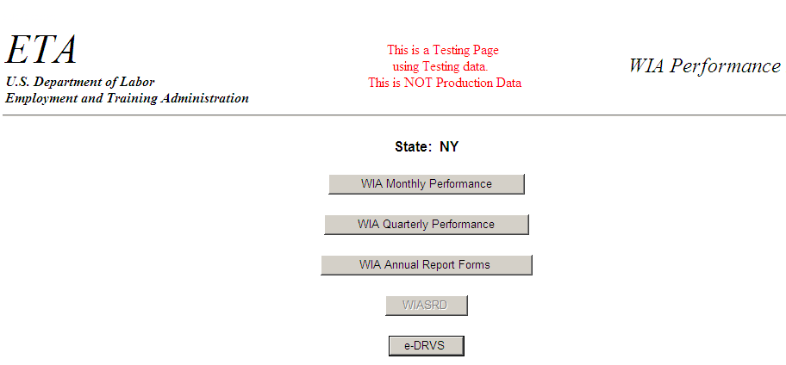

1. The following screenshot shows where States will upload a file.

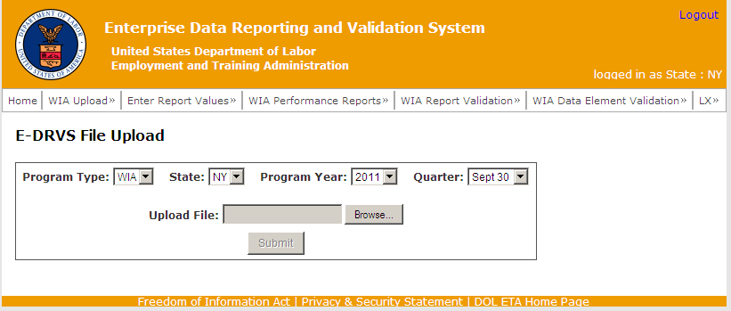

1. The following screenshot shows where States will approve the submission.

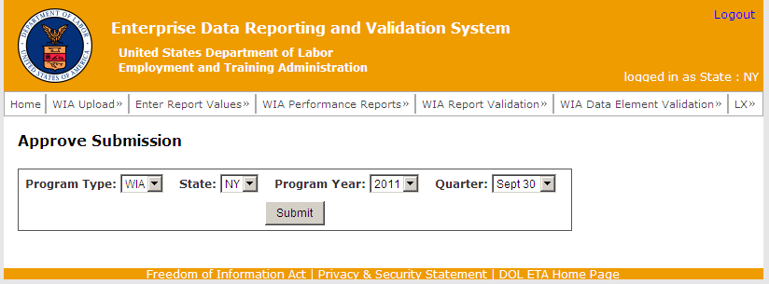

1. The following screenshot shows where States will access the reports.

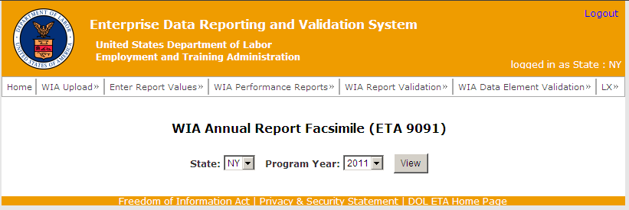

1. The following screenshot shows where States will upload obtain their report validation results

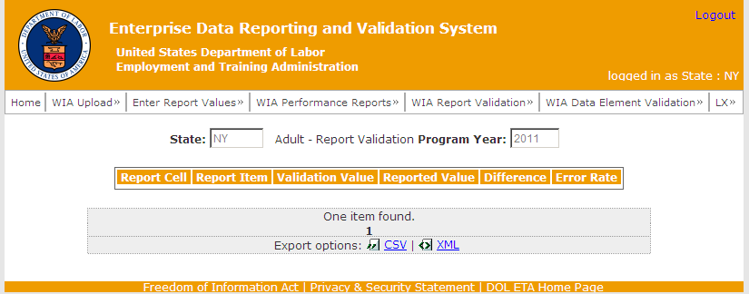

1. The following screenshot shows where States will draw their data element validation sample.

