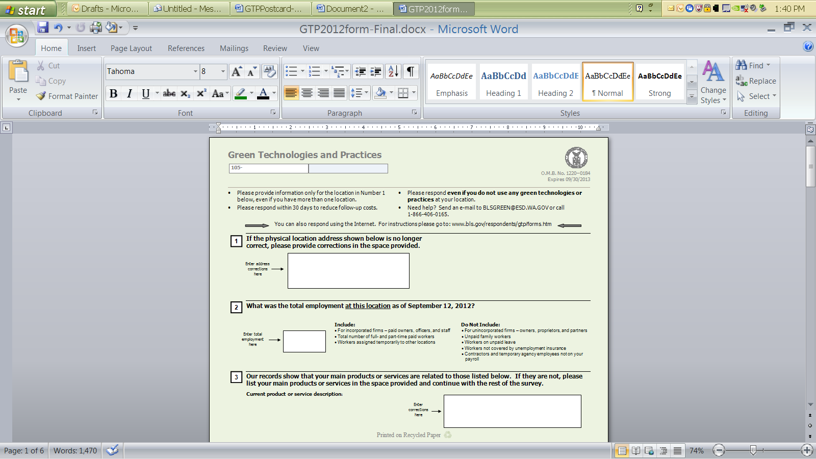

**THIRD REQUEST**

Dear Employer,

We need your help! We recently asked you to complete a survey about green technologies and practices that your business uses, but we haven’t heard from you yet.

Even if your business does not use these types of technologies and practices, we still need to hear from you to produce accurate statistics for the United States. You will need your account number and temporary password to report your data on line. This information is printed on the front of your survey form and also on the front of this card directly above your company name and address. Your account number begins with 105- and your temporary password begins with Gtp. There are several ways to report before we call you:

* By mail: Return your completed survey form in the postage-paid envelope
* On the Internet: <https://idcf.bls.gov>
* By email: Send a blank e-mail to [GTP@IDCF.BLS.GOV](mailto:GTP@IDCF.BLS.GOV) to receive a fillable form.
* By phone: 1-866-406-0165

If you have a question, please send an e-mail to [BLSGREEN@ESD.WA.GOV](mailto:BLSGREEN@ESD.WA.GOV)

Thank you! The information you provide will be used for statistical purposes only.

Washington State Employment Security Department (WAESD)

is conducting this survey on behalf of the Bureau of Labor Statistics



**THIRD REQUEST**

Dear Employer,

We need your help! We recently asked you to complete a survey about green technologies and practices that your business uses, but we haven’t heard from you yet.

Even if your business does not use these types of technologies and practices, we still need to hear from you to produce accurate statistics for the United States. You will need your account number and temporary password to report your data on line. This information is printed on the front of your survey form and also on the front of this card directly above your company name and address. Your account number begins with 105- and your temporary password begins with Gtp. There are several ways to report before we call you:

* By mail: Return your completed survey form in the postage-paid envelope
* On the Internet: <https://idcf.bls.gov>
* By email: Send a blank e-mail to [GTP@IDCF.BLS.GOV](mailto:GTP@IDCF.BLS.GOV) to receive a fillable form.
* By phone: 1-866-406-0165

If you have a question, please send an e-mail to [BLSGREEN@ESD.WA.GOV](mailto:BLSGREEN@ESD.WA.GOV)

Thank you! The information you provide will be used for statistical purposes only.

Washington State Employment Security Department (WAESD)

is conducting this survey on behalf of the Bureau of Labor Statistics

**DOL_bw_seal_ai.eps**

**US Department of Labor**

**Bureau of Labor Statistics**

**2 Massachusetts Ave, NE Room 2135   
Washington, DC 20212**

**DOL_bw_seal_ai.eps**

**US Department of Labor**

**Bureau of Labor Statistics**

**2 Massachusetts Ave, NE Room 2135   
Washington, DC 20212**