Housing Collection Instrument Screen Shots
Last Modified: July 16, 2012

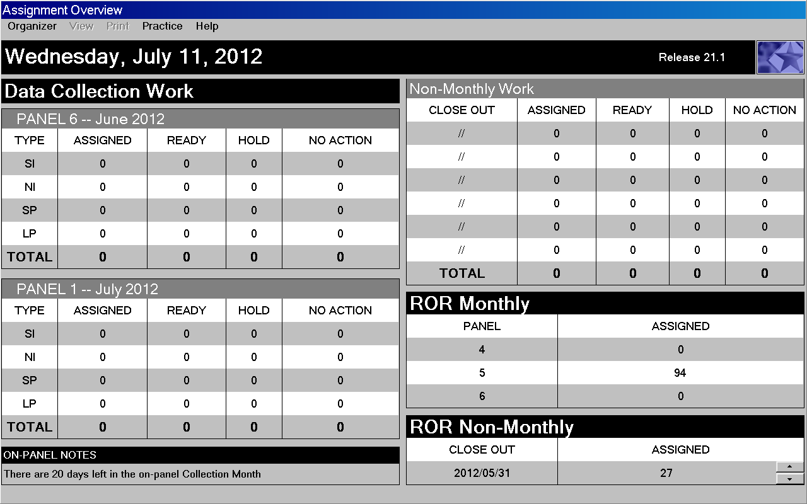

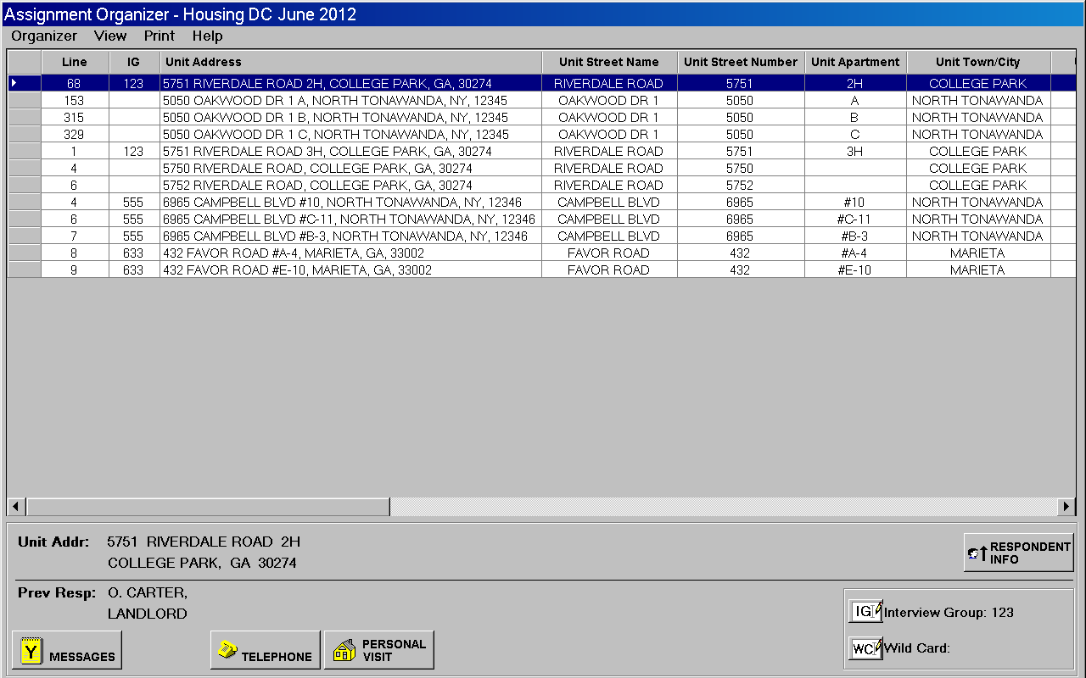

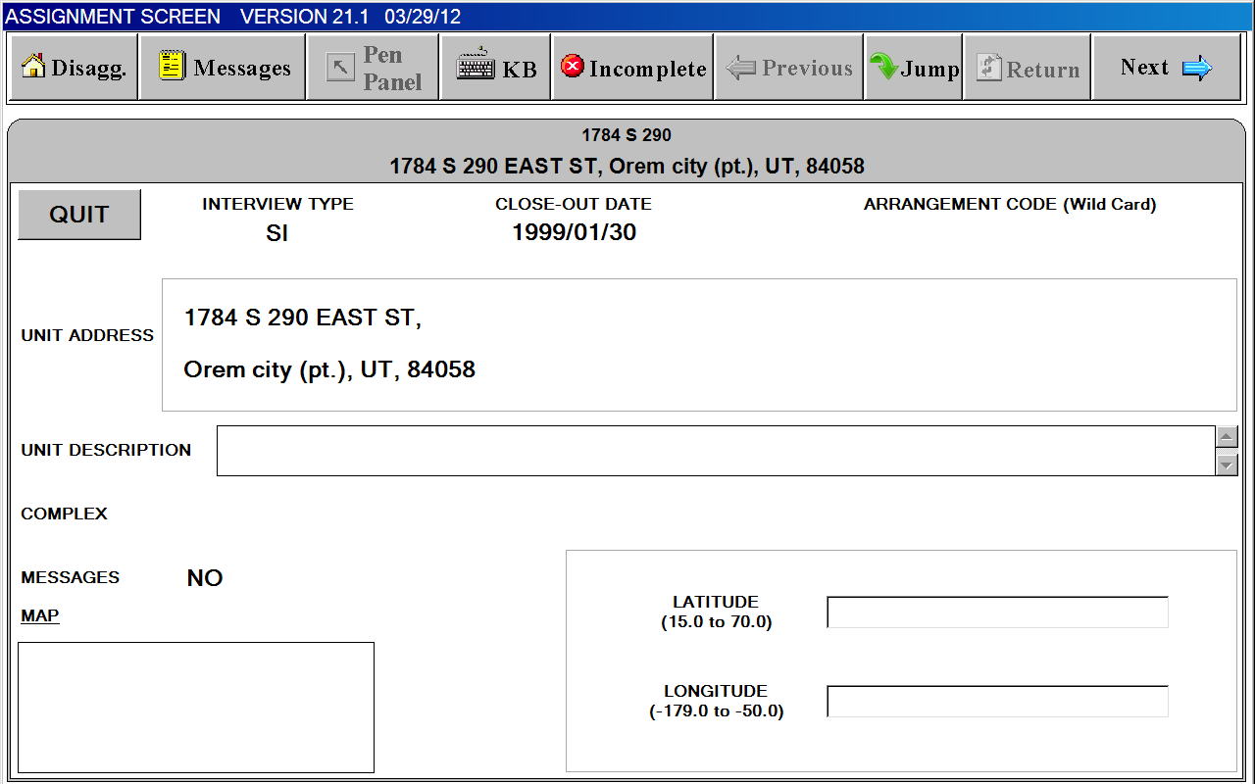

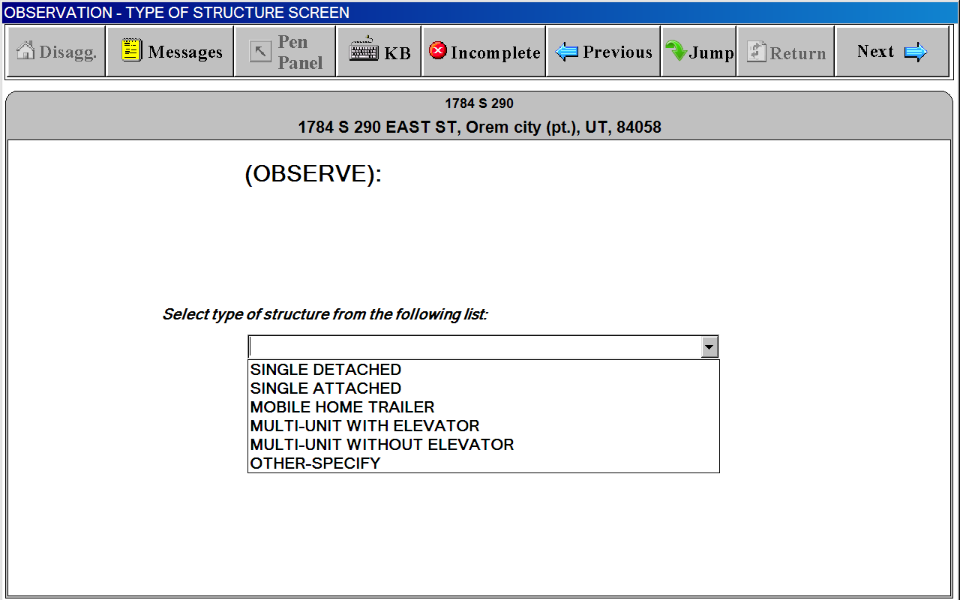

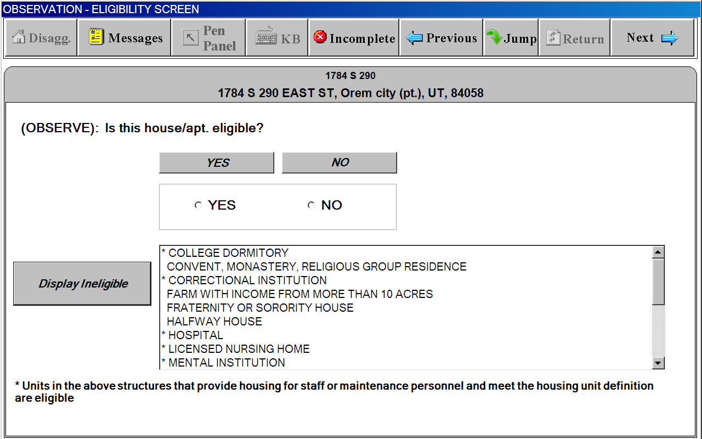

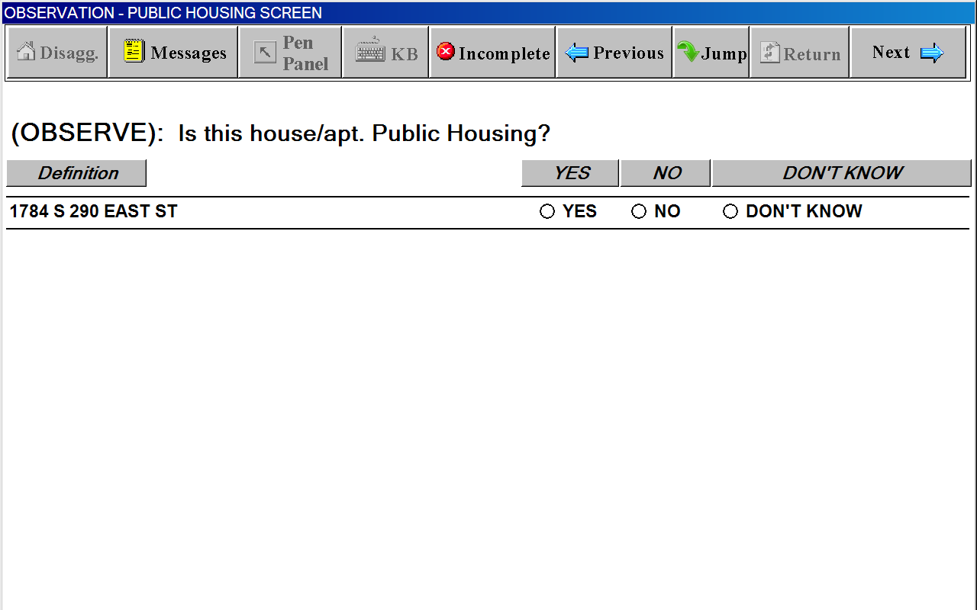

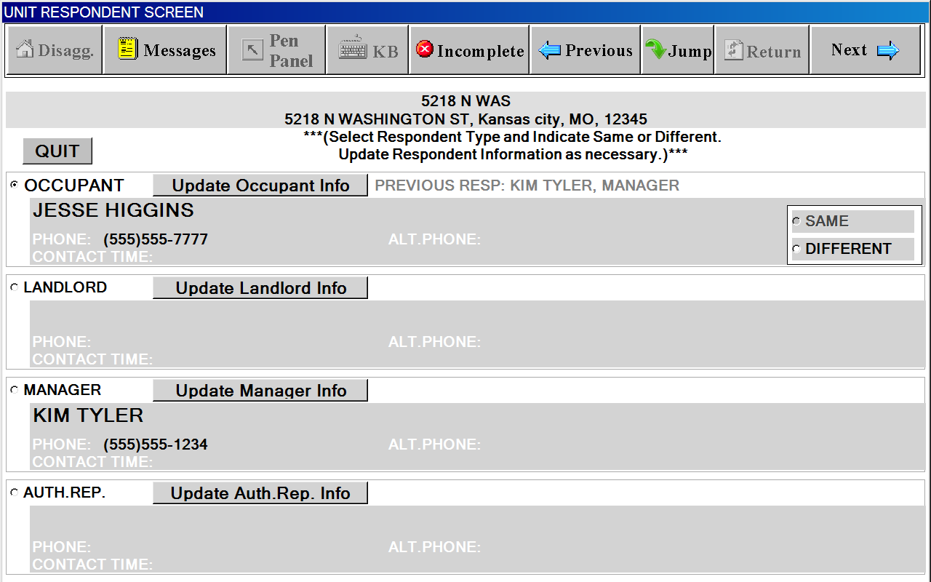

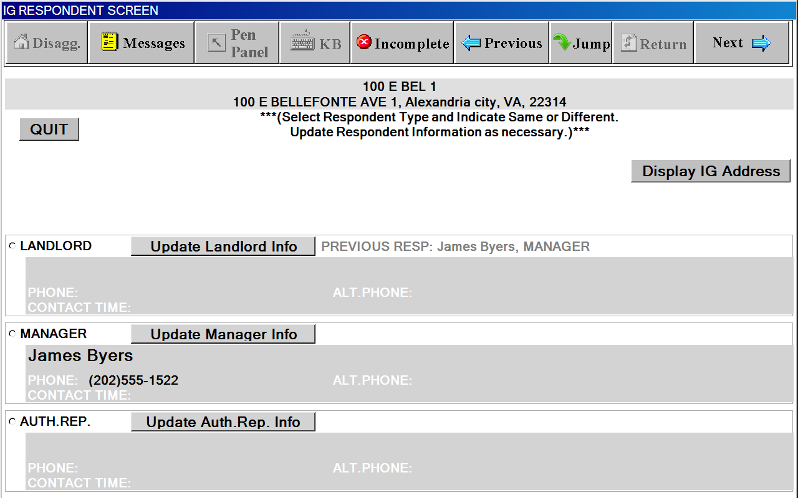

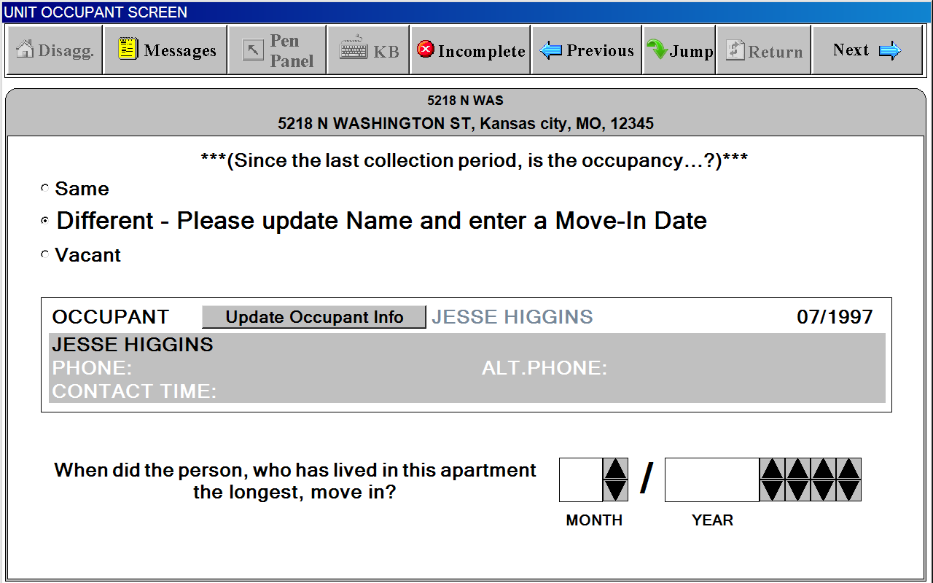

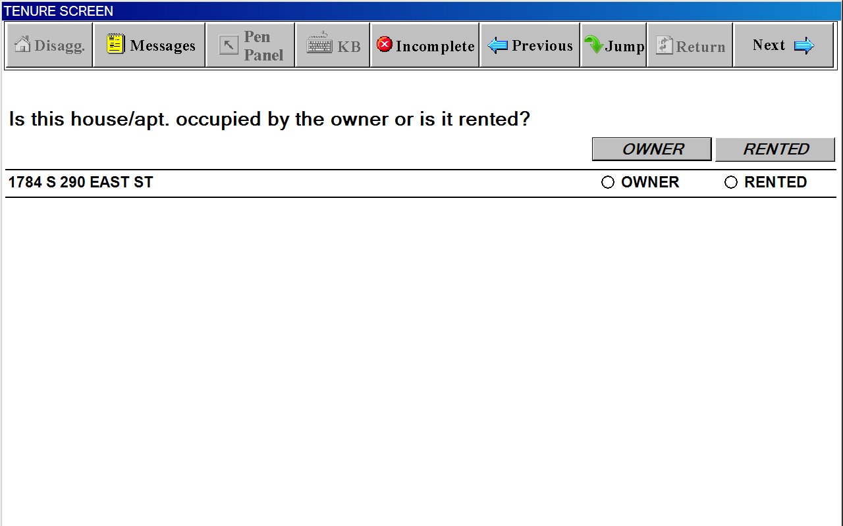

PUBLIC HOUSING SCREEN
(not from Observation)
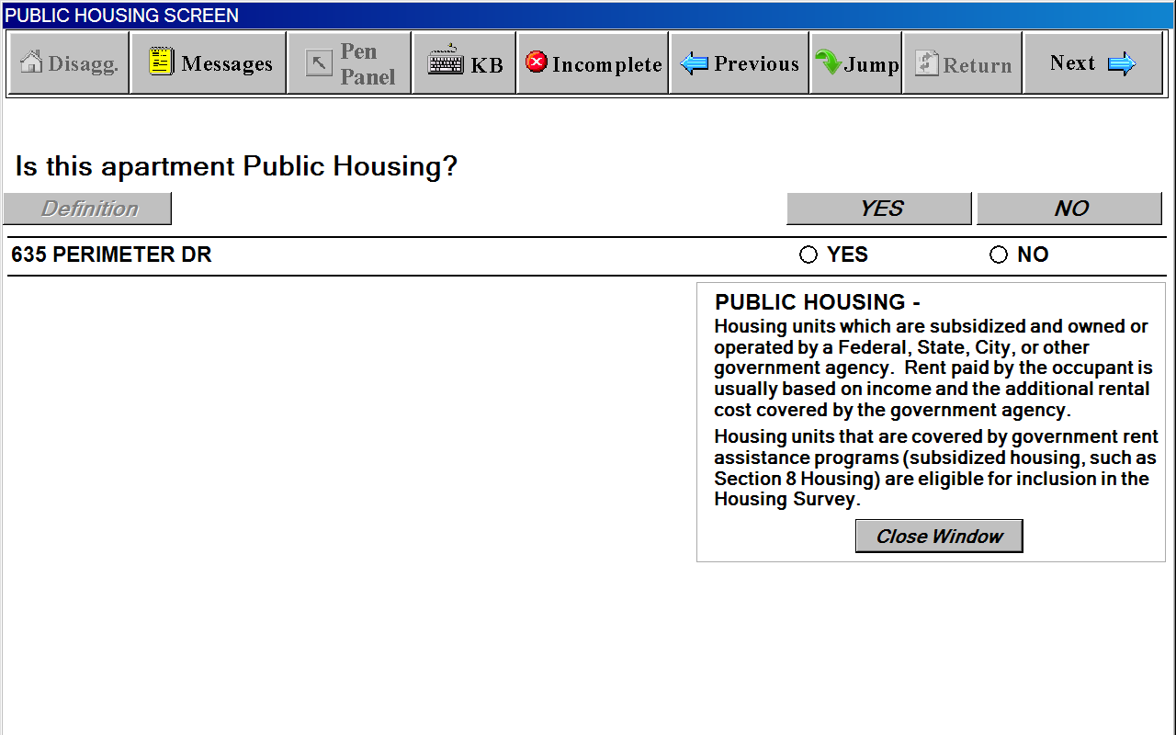

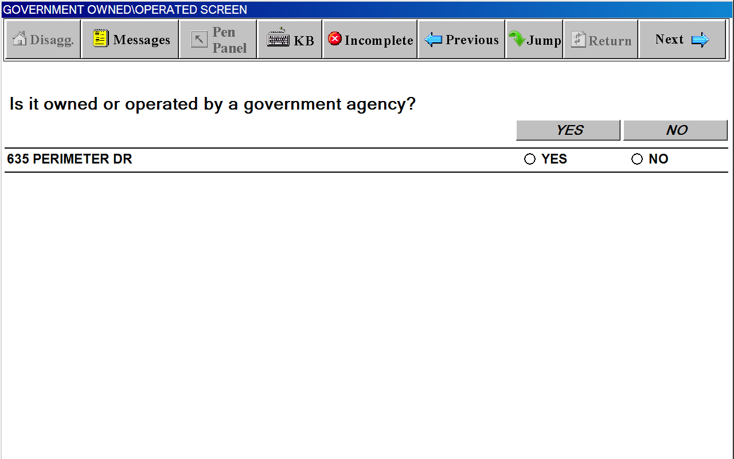

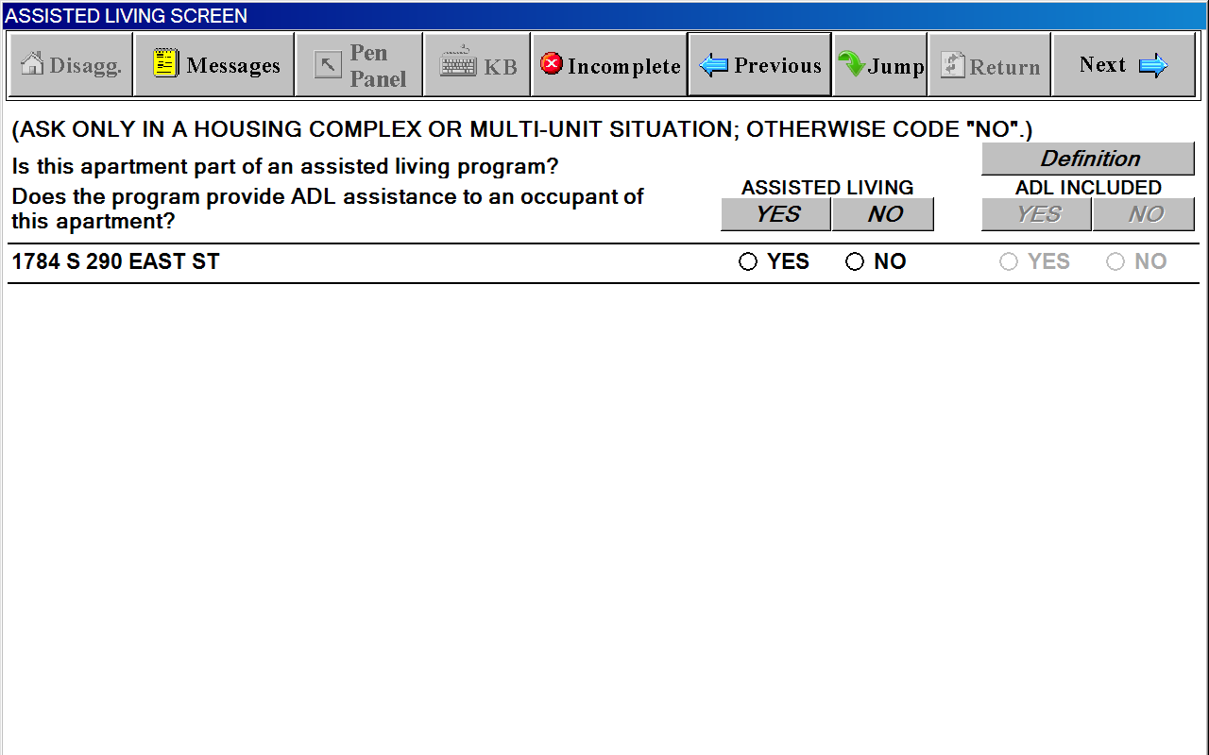

Definitions Window for ASSISTING LIVING SCREEN
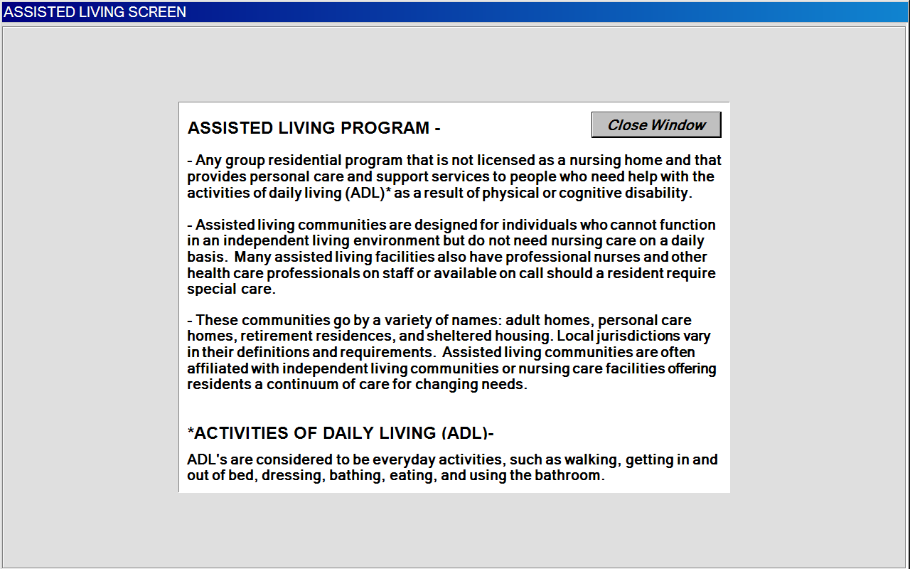

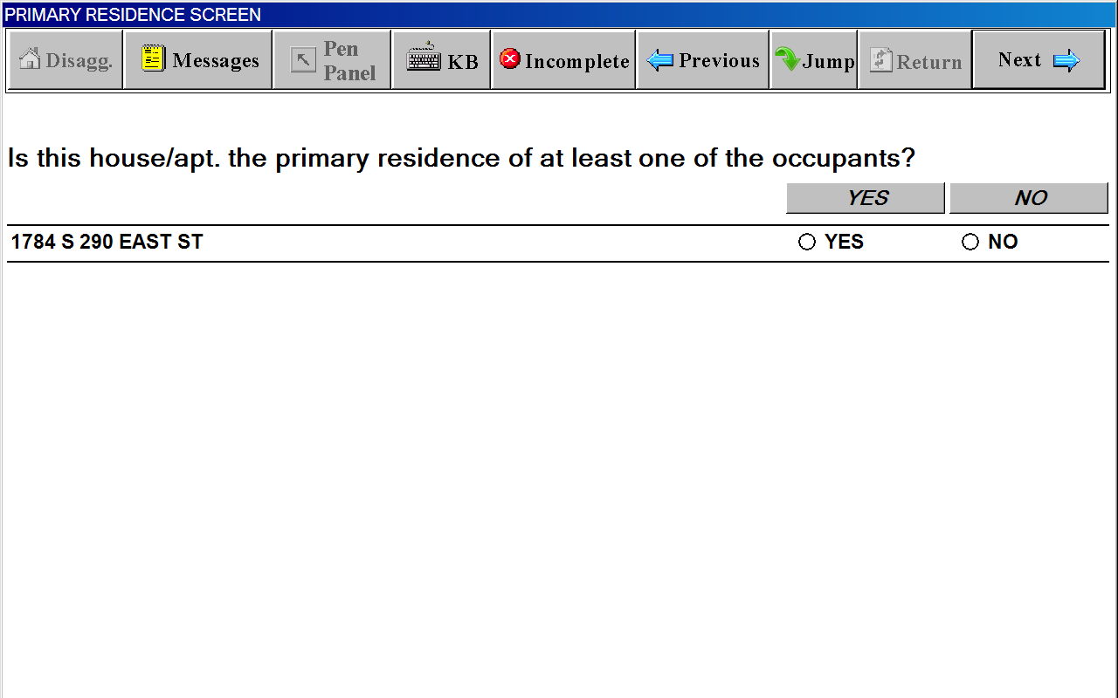

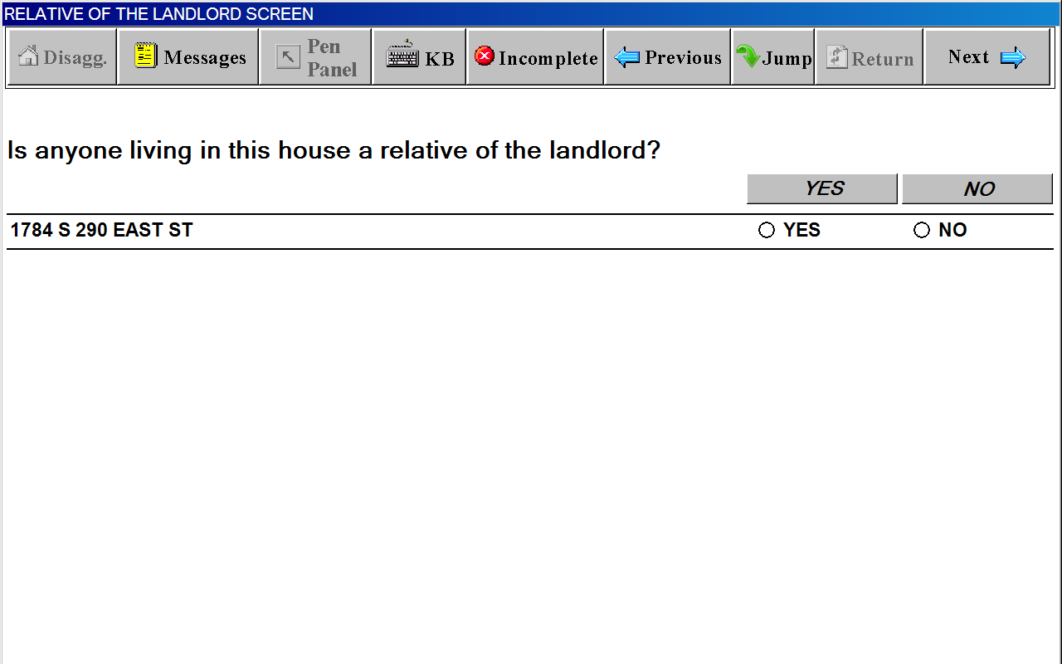

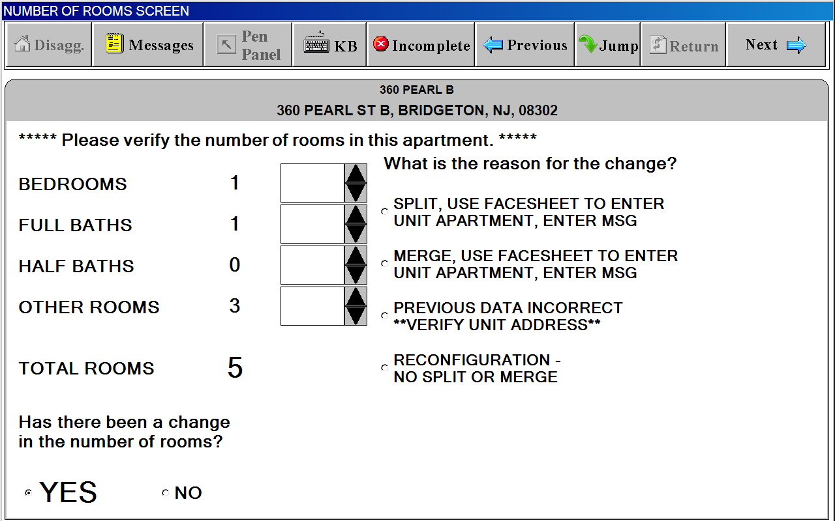

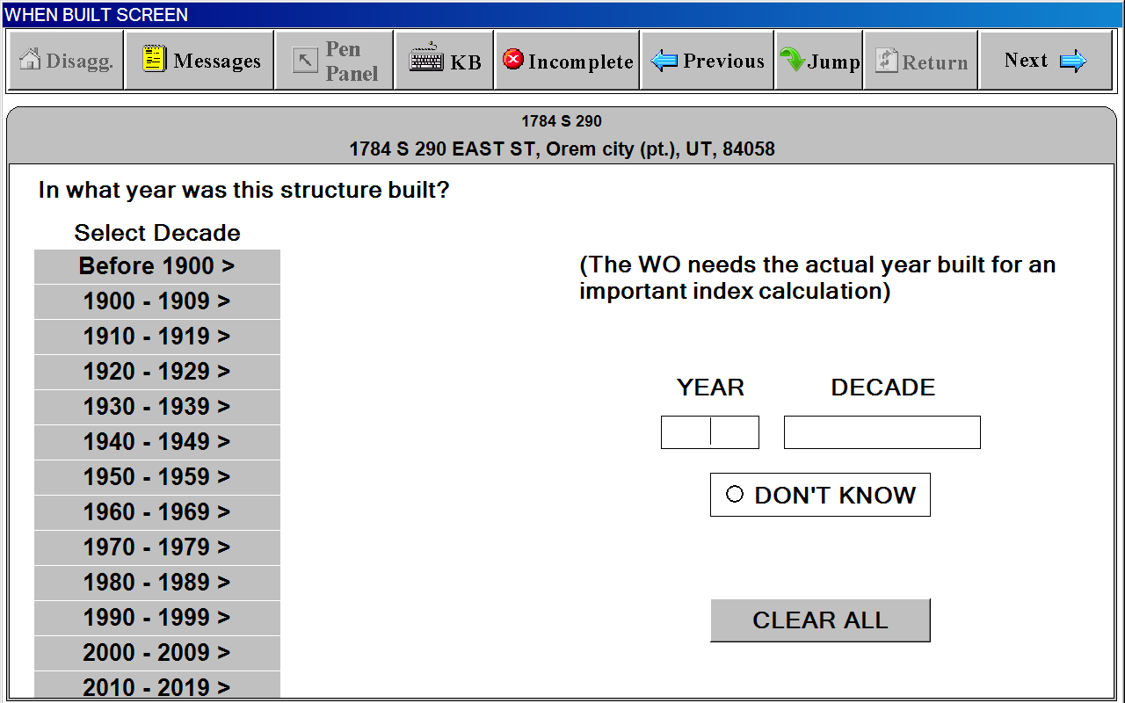

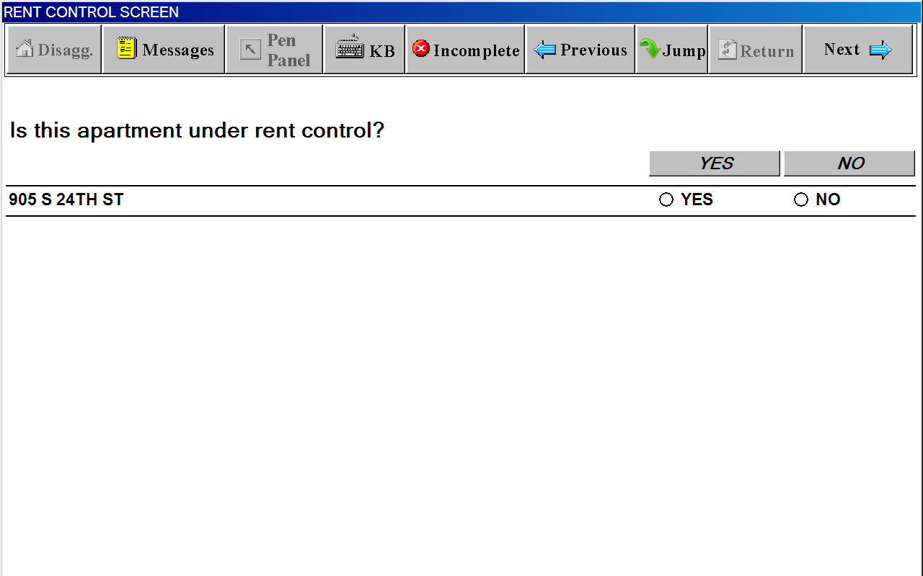

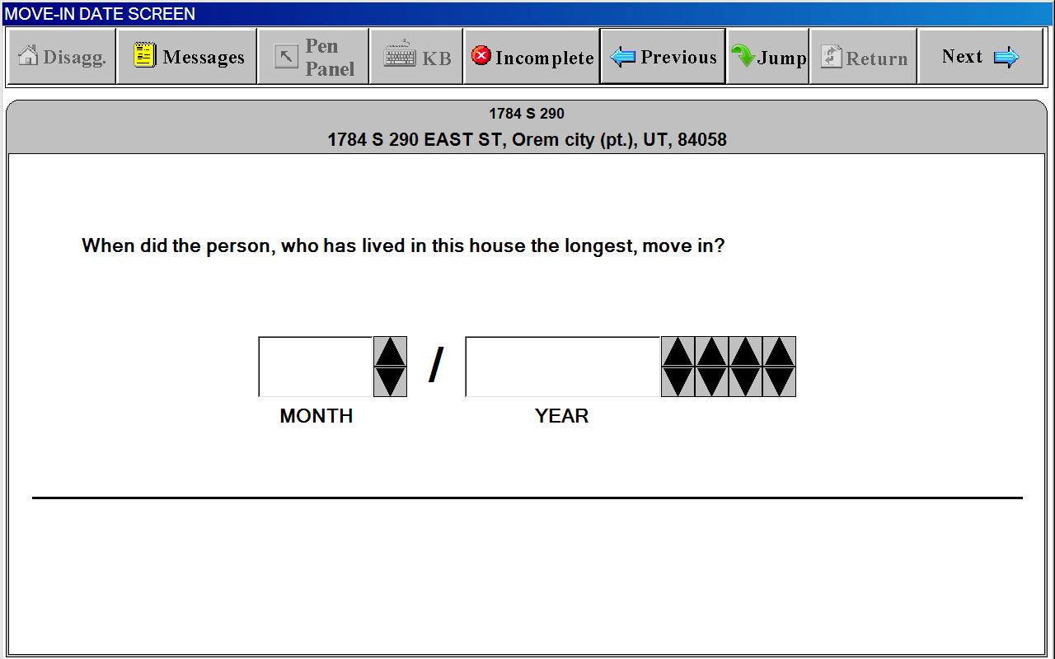
RENT POD

“Respondent/Occupant” Window
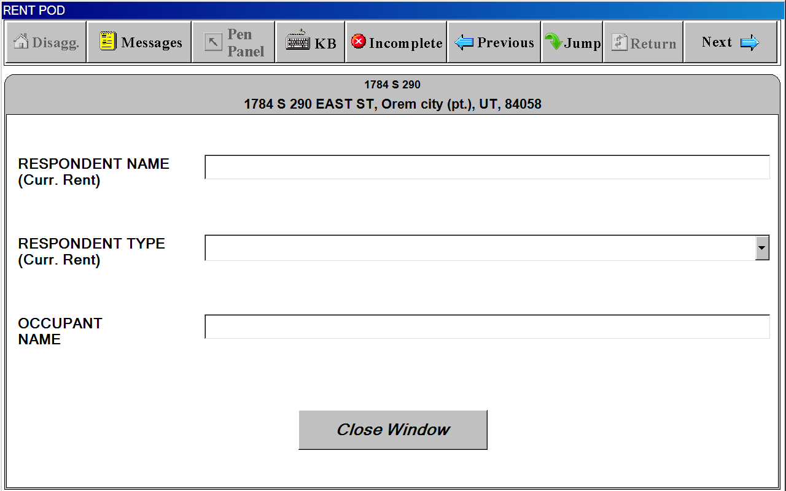

RENT POD

“Rent Amount”
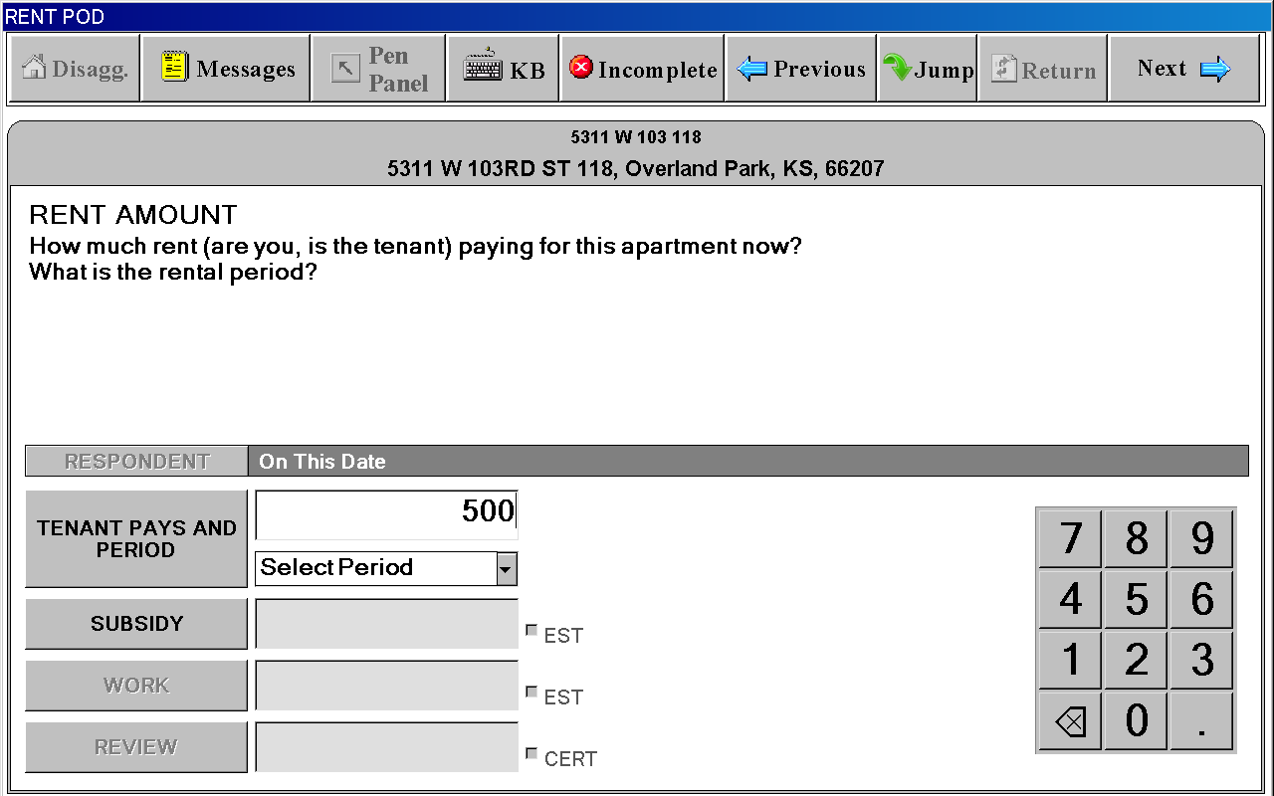
RENT POD

“Subsidy”
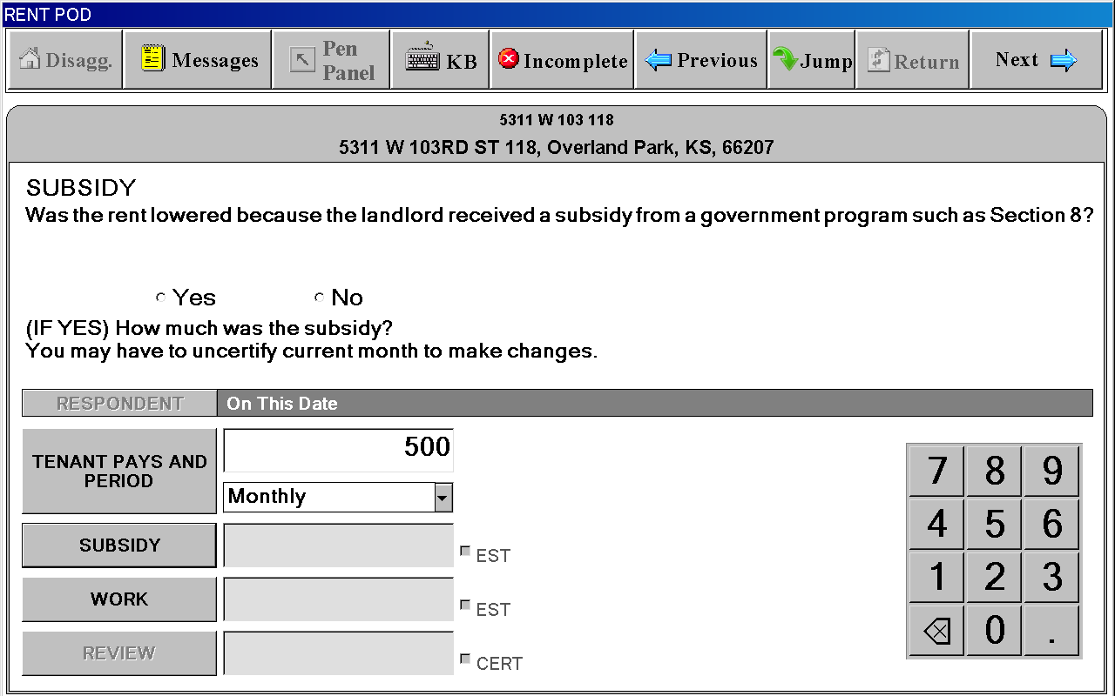
RENT POD

“Work Reduction”
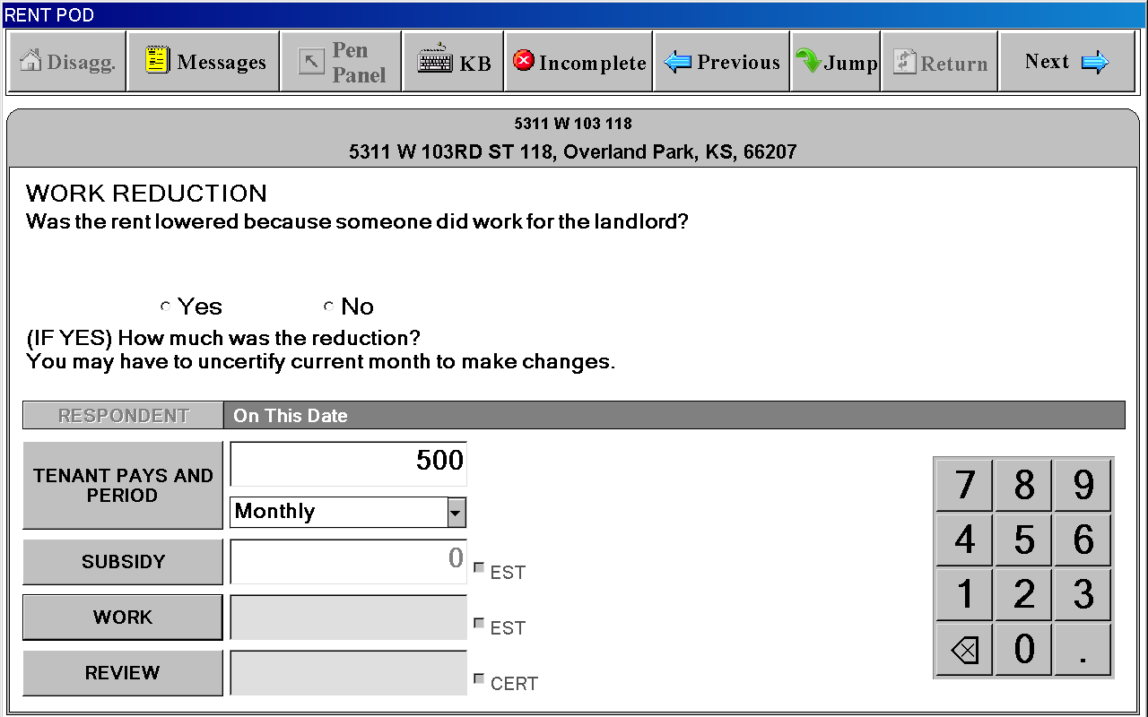
RENT POD

“Review”
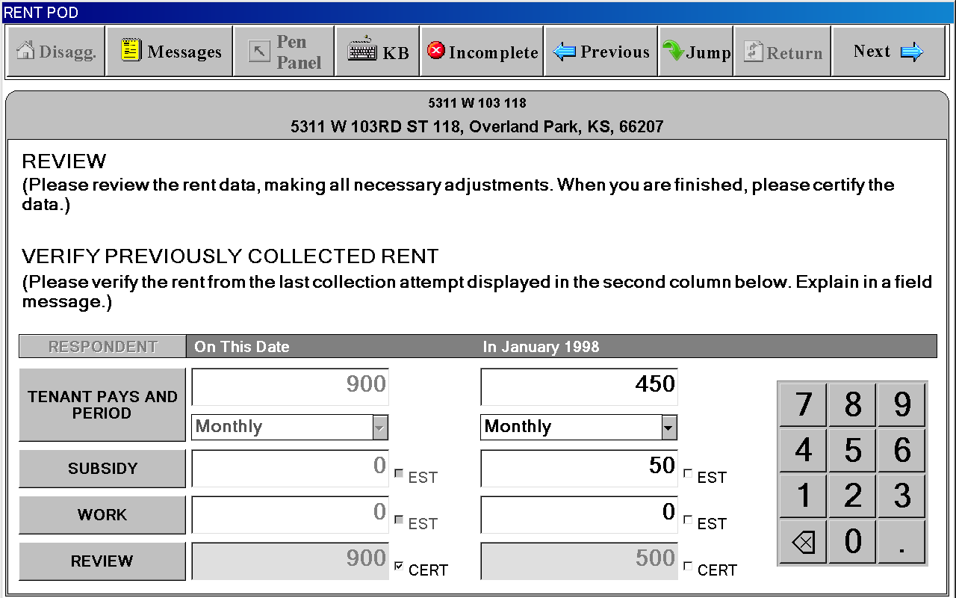
EXTRA CHARGES SCREEN

“Extra Charges” Tab
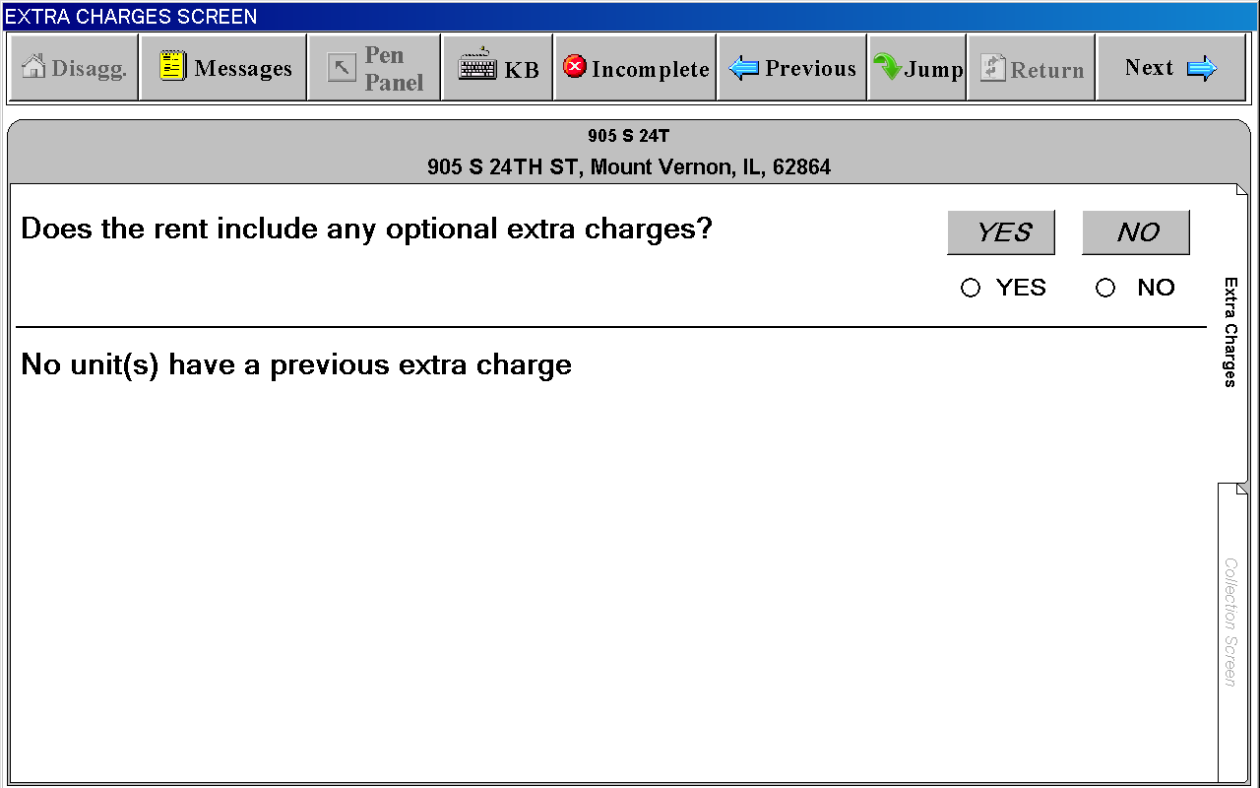
EXTRA CHARGES SCREEN

“Collection Screen” Tab – SELECT EXTRA CHARGE” Window
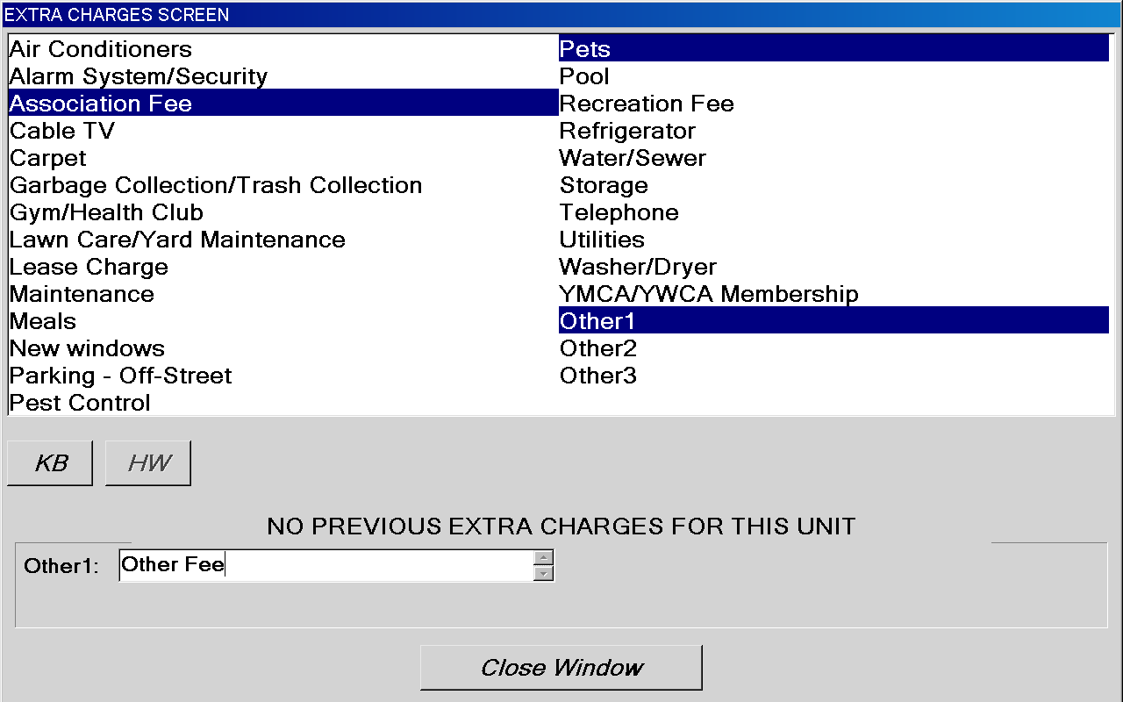
EXTRA CHARGES SCREEN

“Collection Screen” Tab - Amount
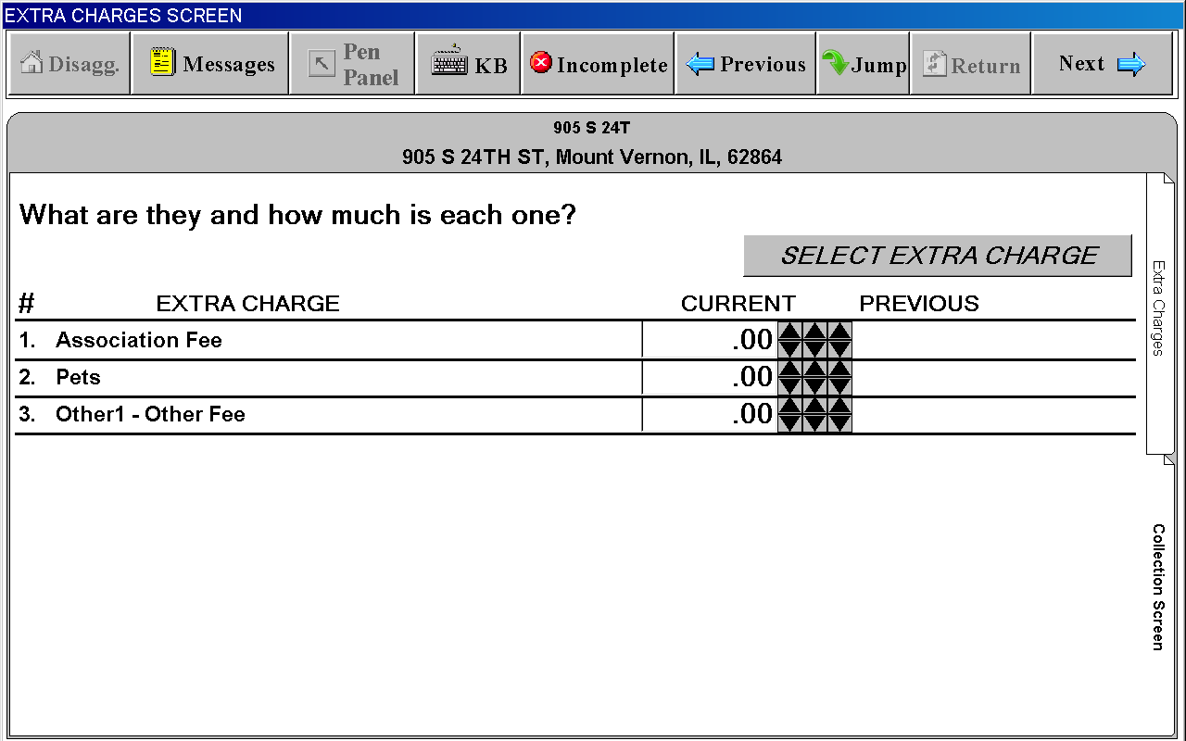
SP CHANGES SCREEN

(“last interview” date is filled in with actual month and year)
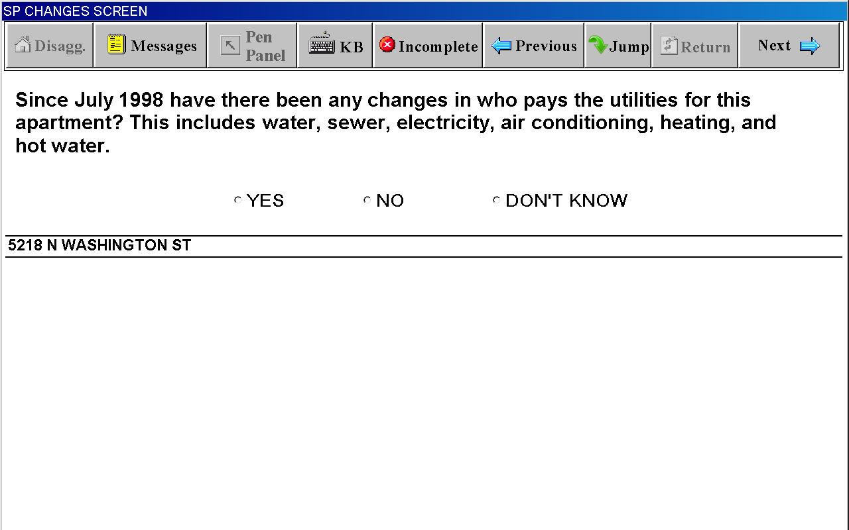

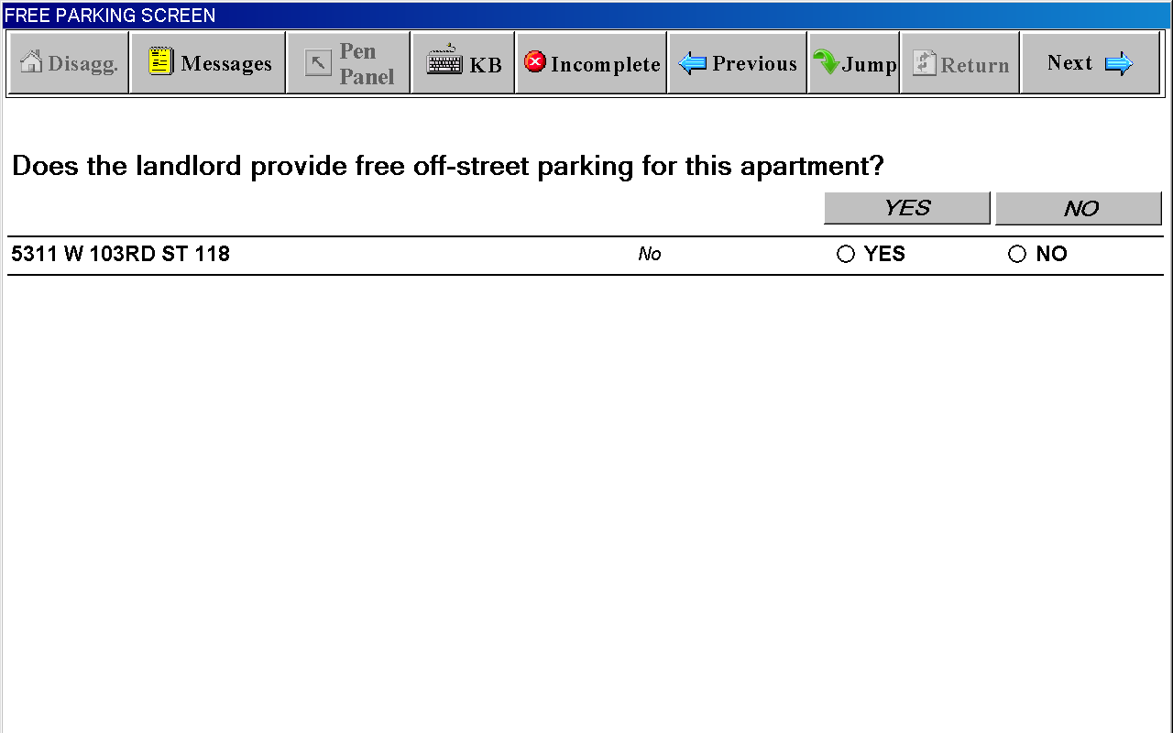

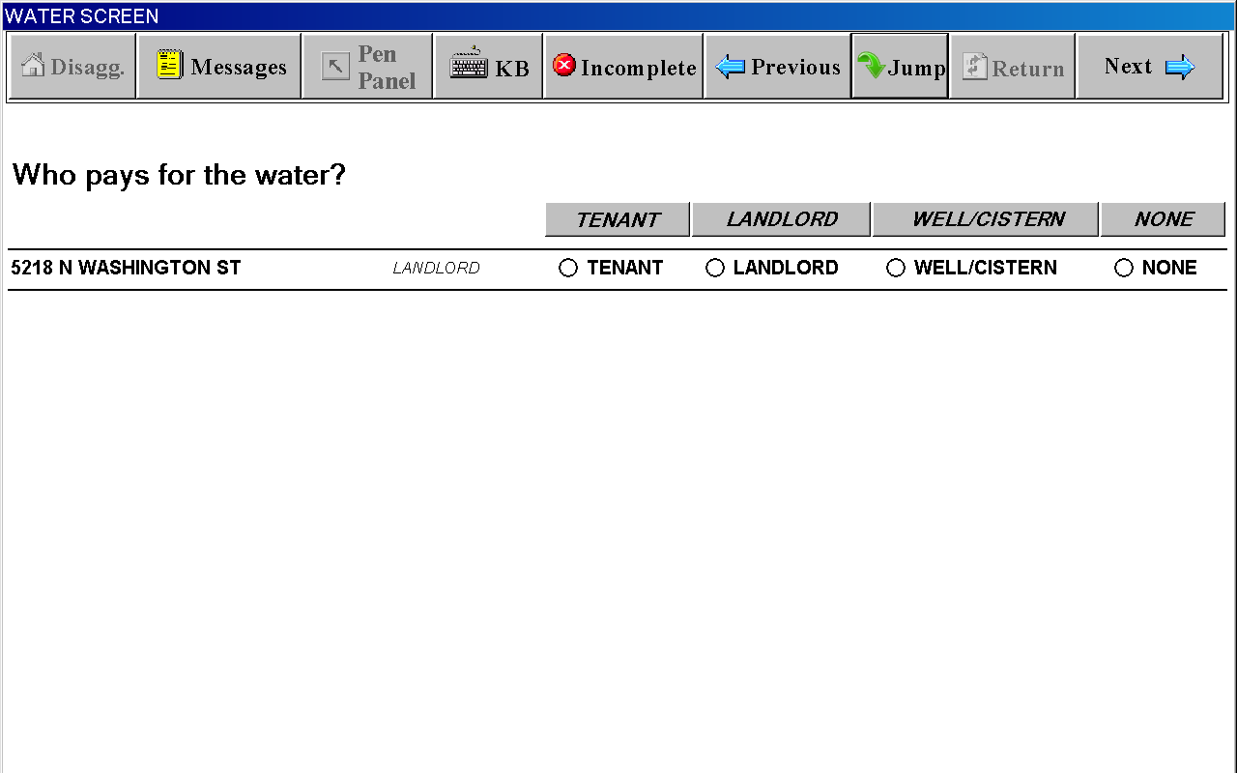

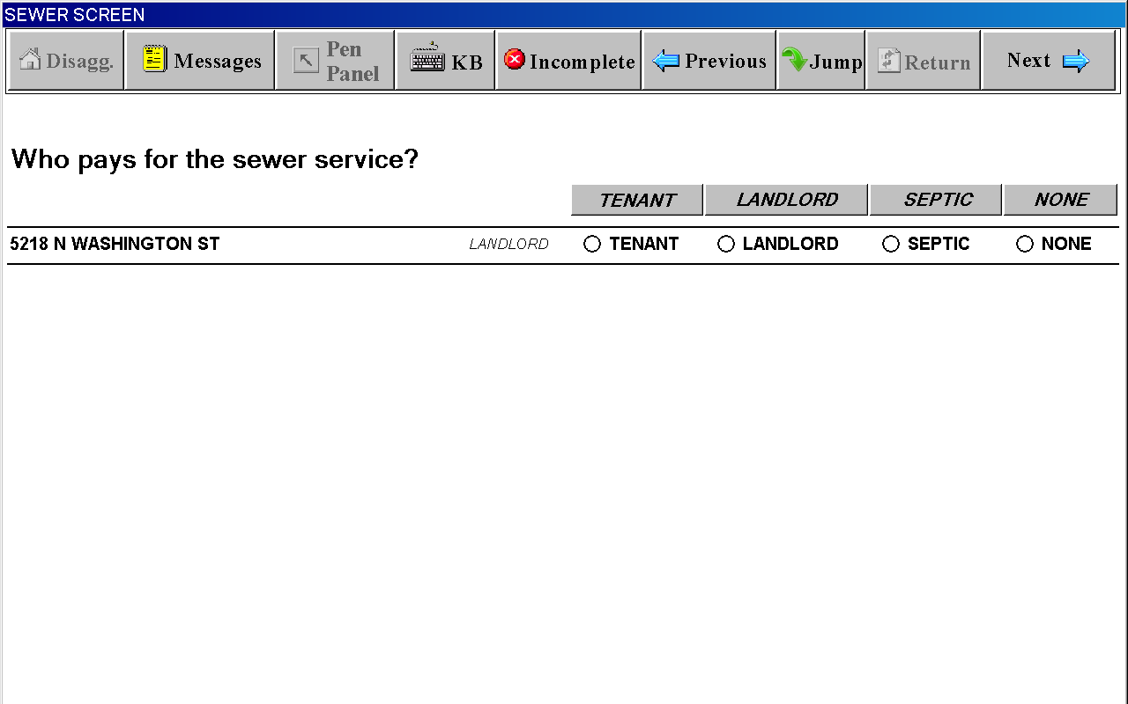

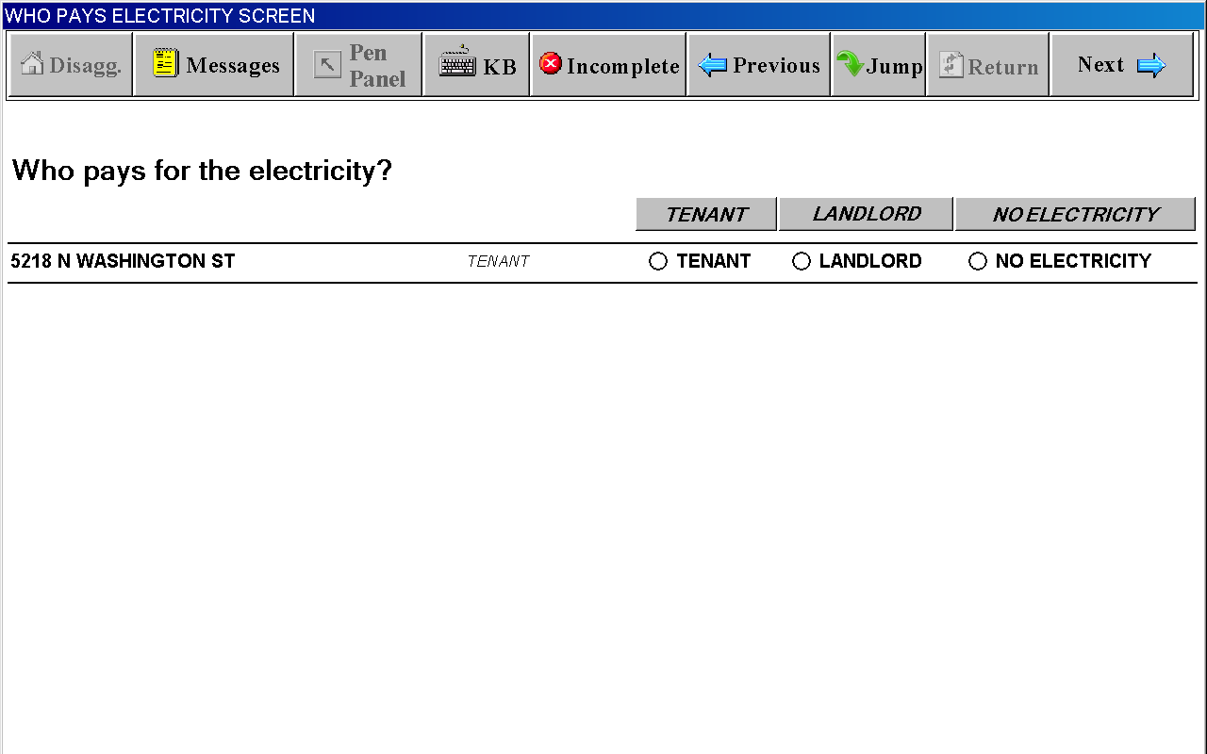

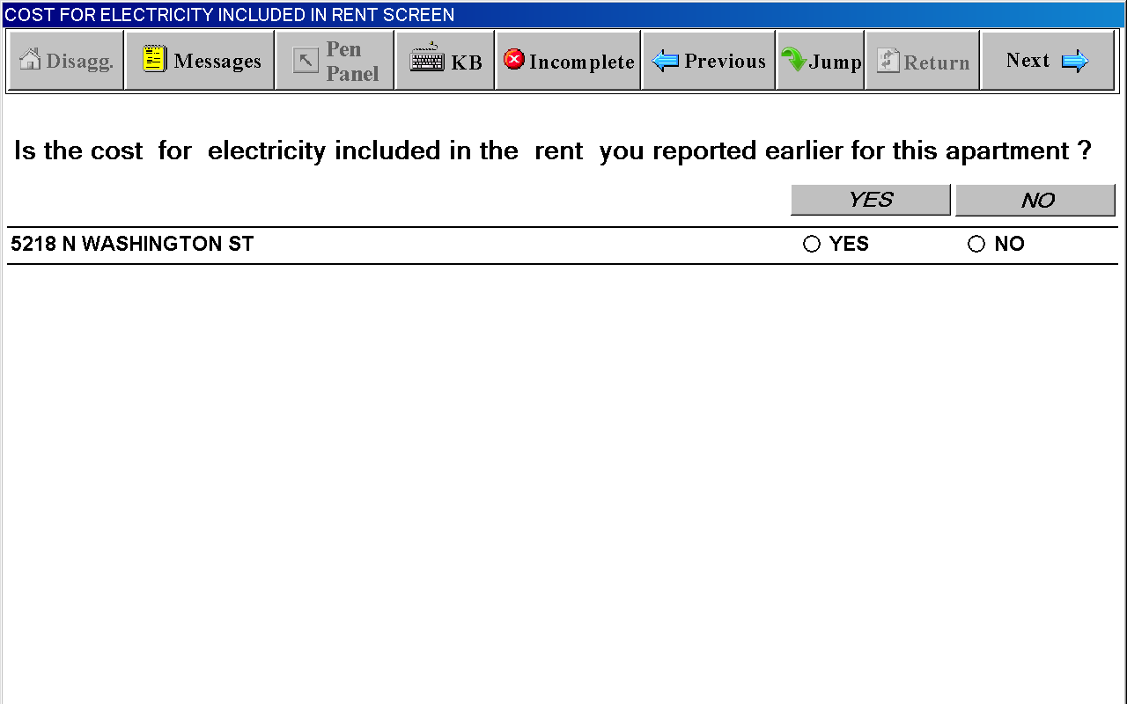

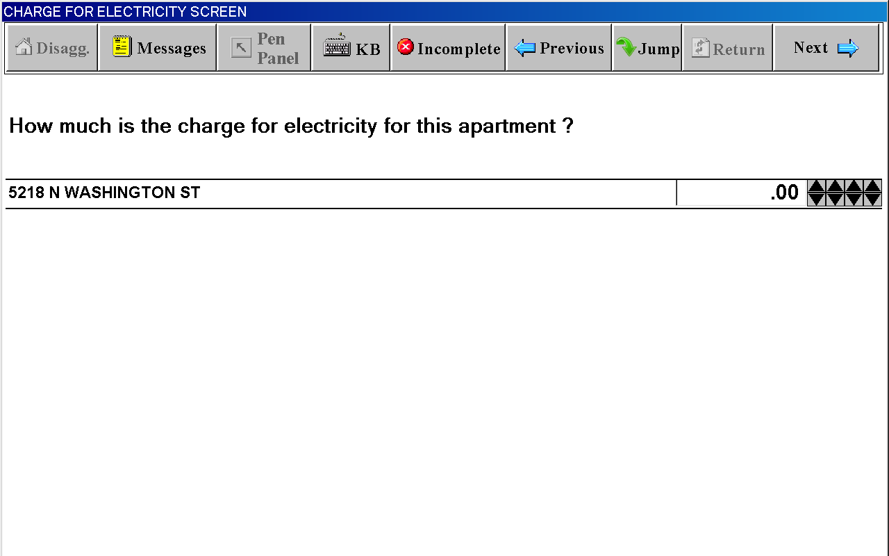

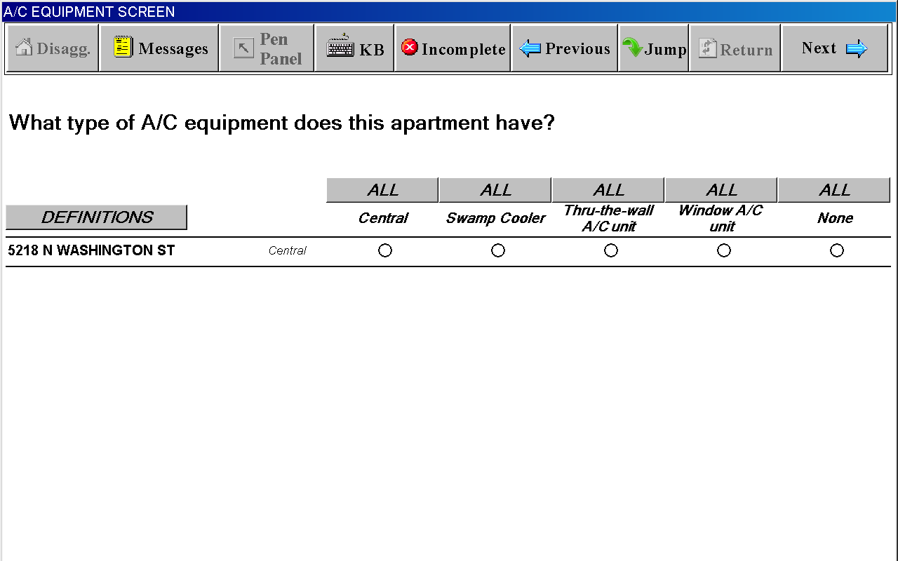
Definitions Window for A/C EQUIPMENT SCREEN
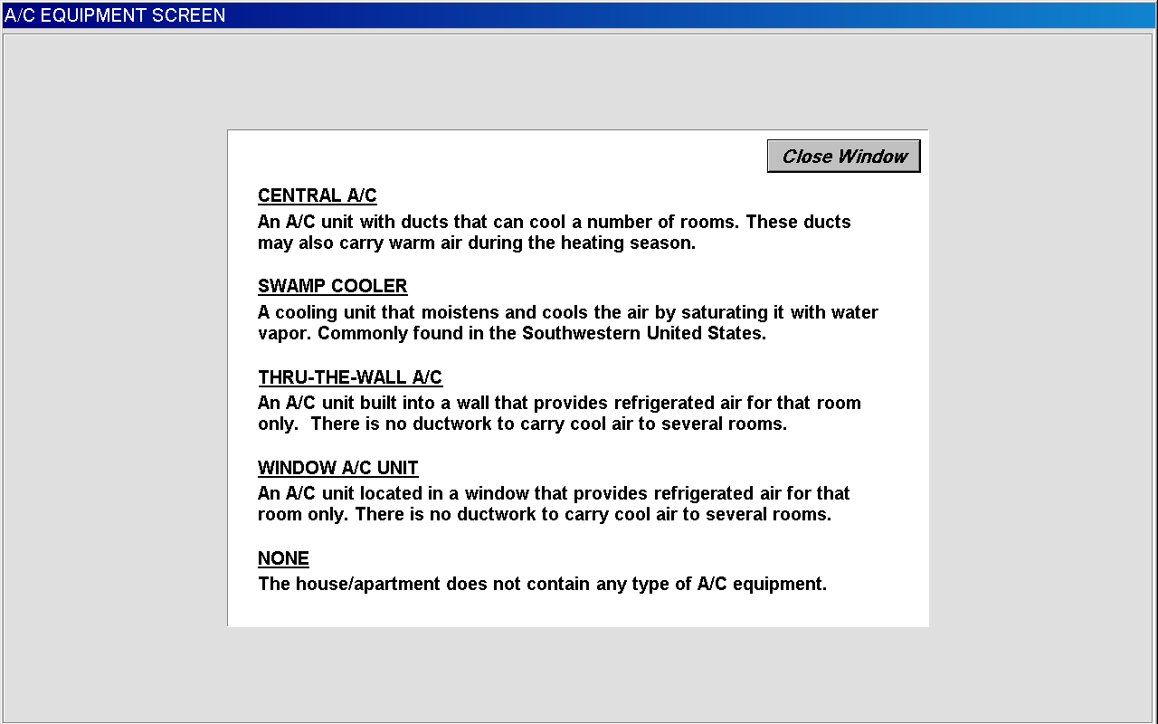

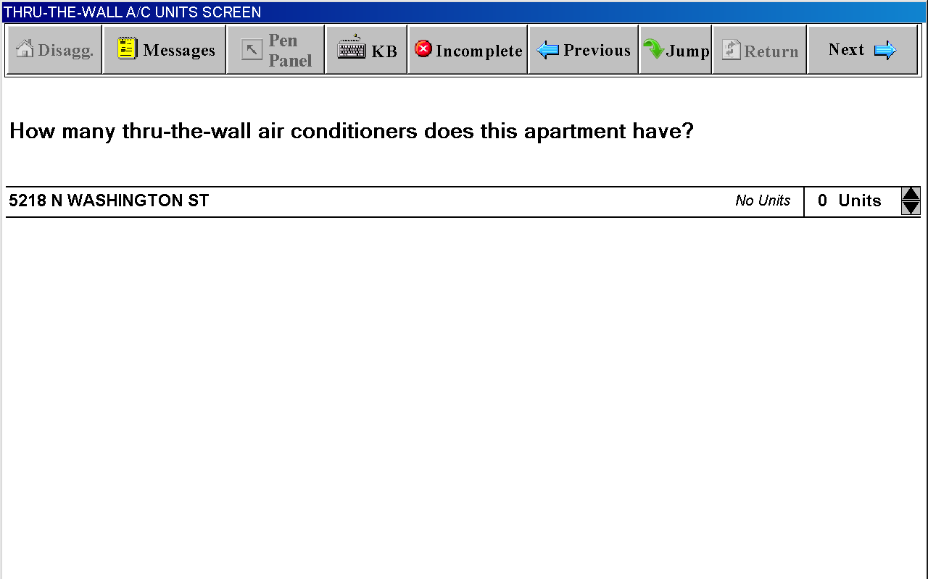

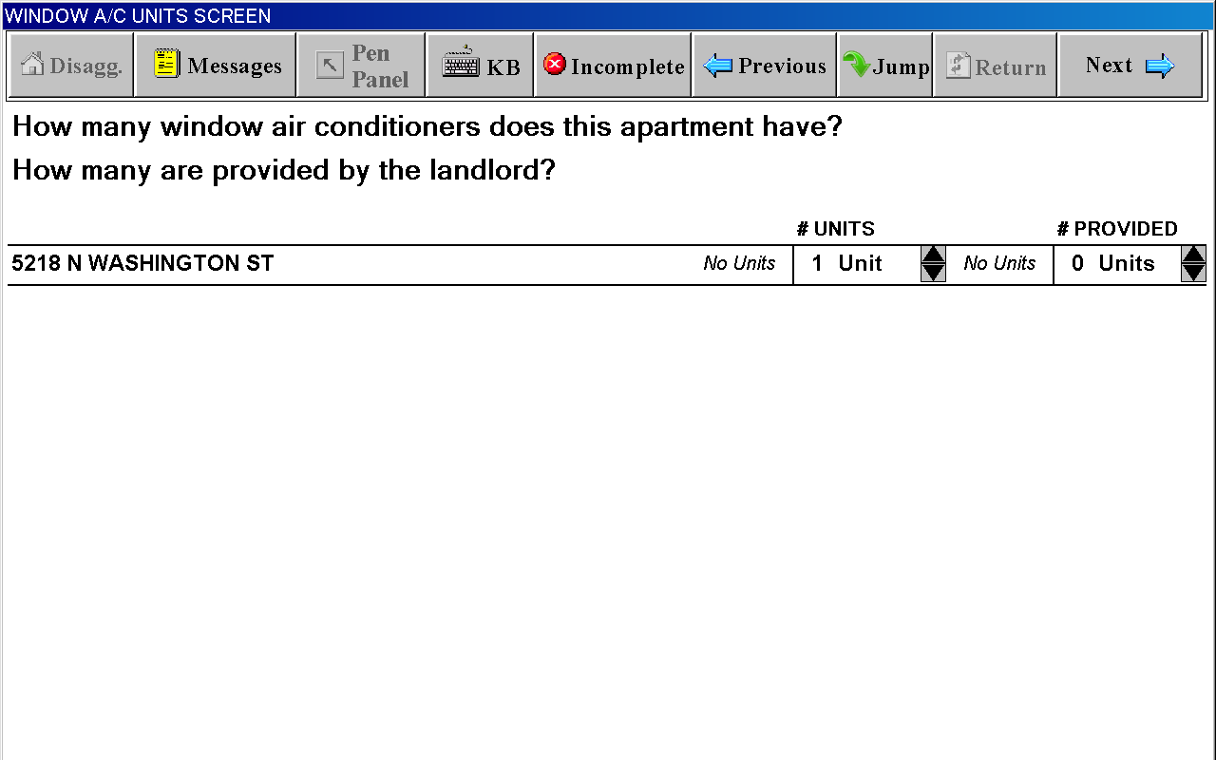

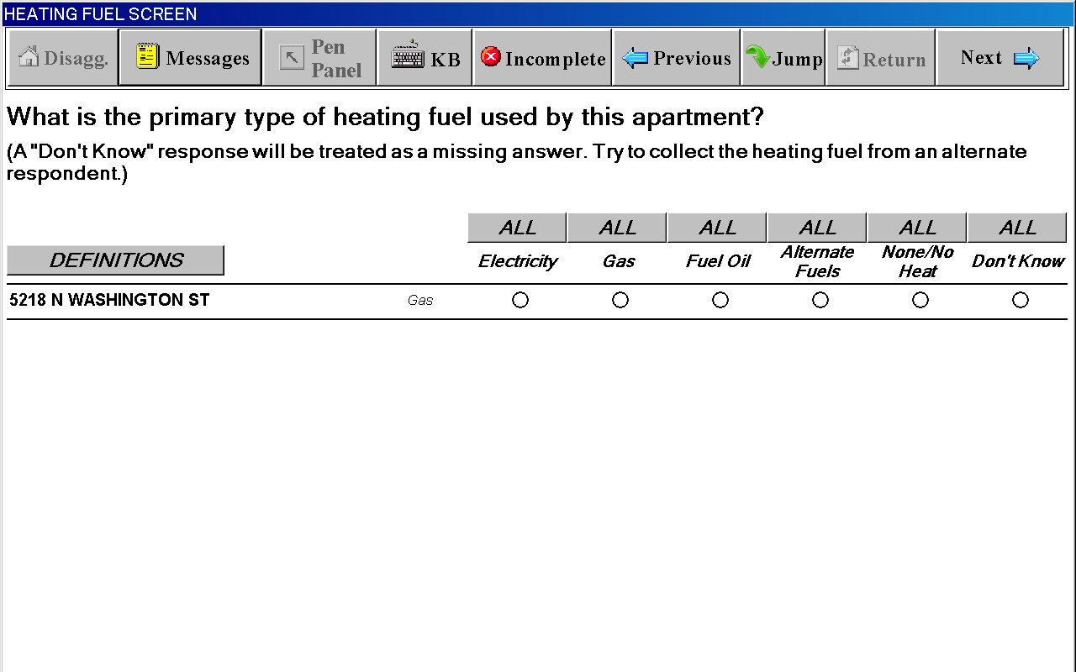
Definitions Window for HEATING FUEL SCREEN
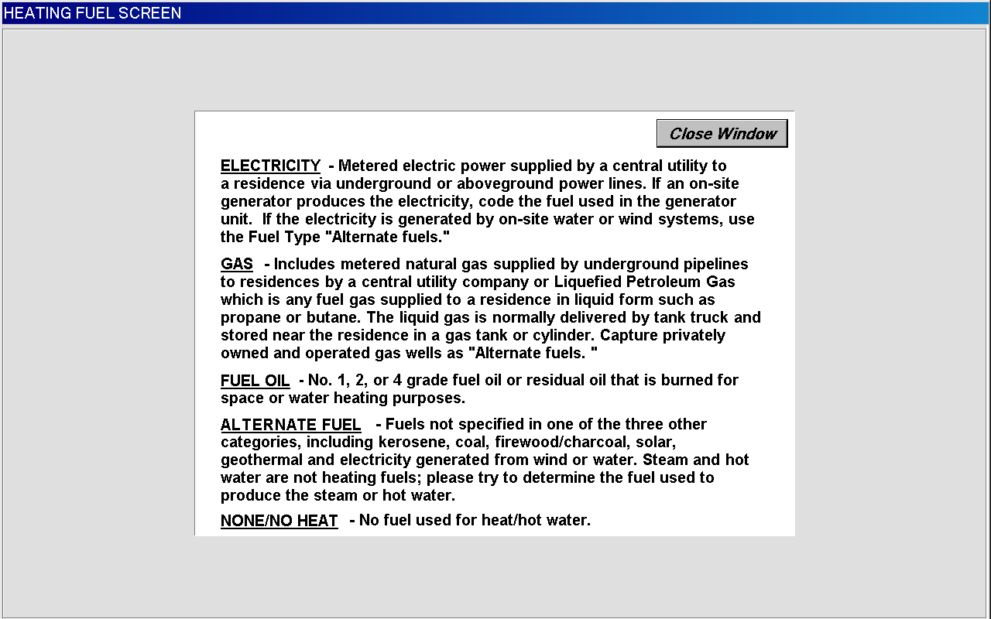
WHO PAYS FOR HEATING FUEL SCREEN

(wording substituted with selected fuel, such as “gas”, “fuel oil” or
“alternate fuel”)
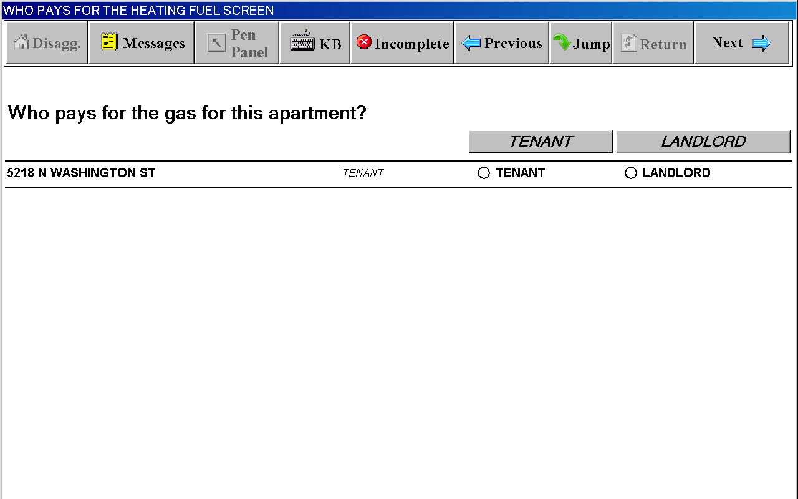
COST FOR HEATING FUEL INCLUDED IN RENT SCREEN

(wording substituted with selected fuel, such as “gas”, “fuel oil” or
“alternate fuel”)
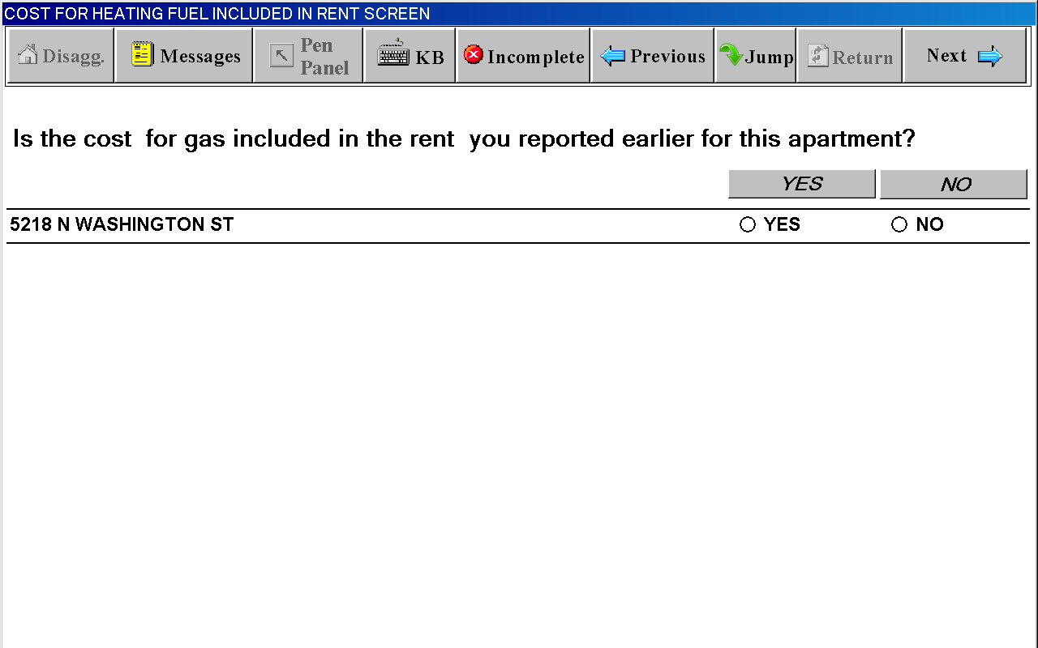
CHARGE FOR HEATING FUEL SCREEN

(wording substituted with selected fuel, such as “gas”, “fuel oil” or
“alternate fuel”)
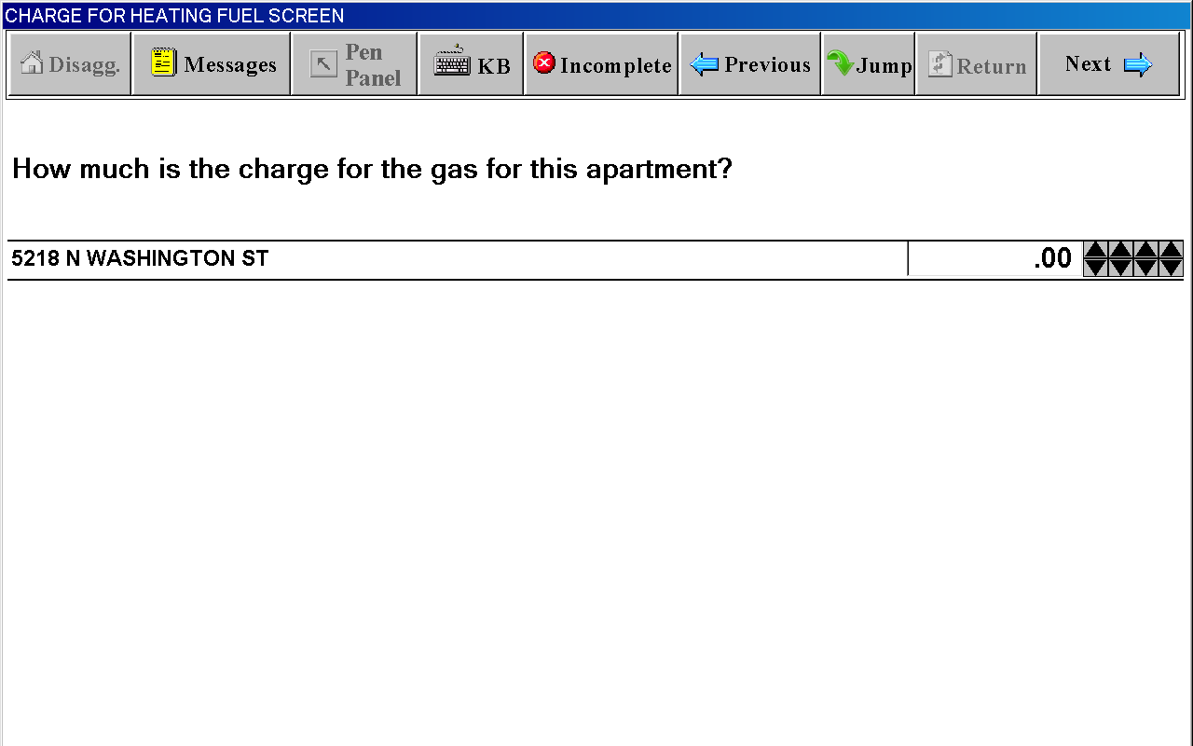

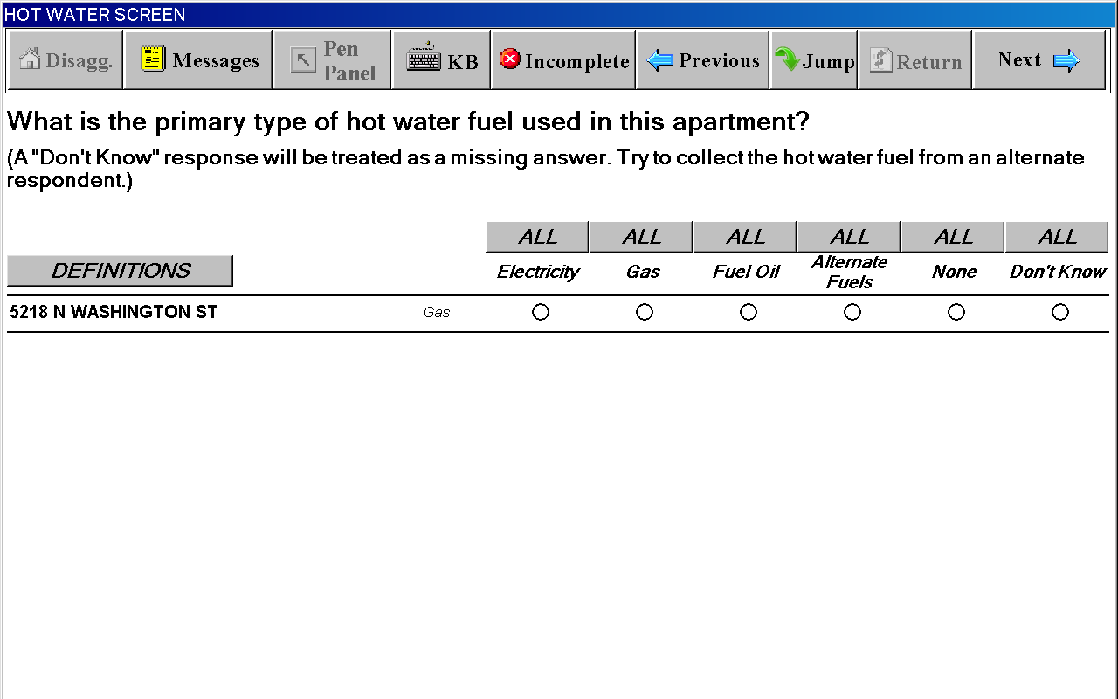
Definitions Window for HOT WATER SCREEN
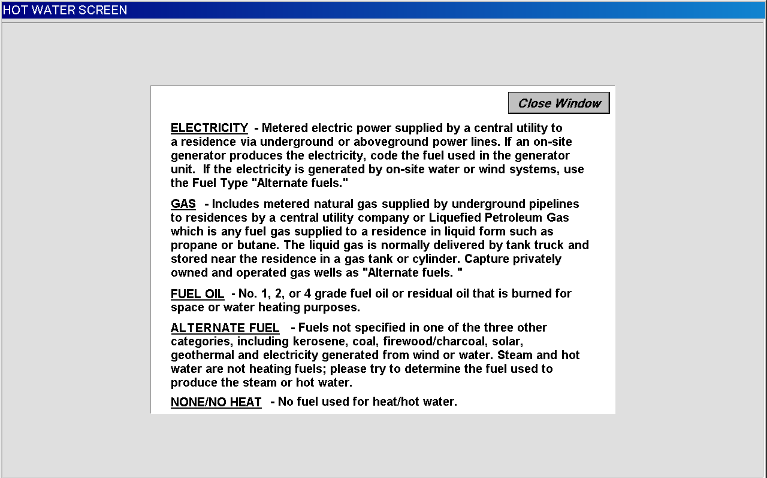
WHO PAYS FOR THE HOT WATER FUEL SCREEN

(wording substituted with selected fuel, such as “gas”, “fuel oil” or
“alternate fuel”)
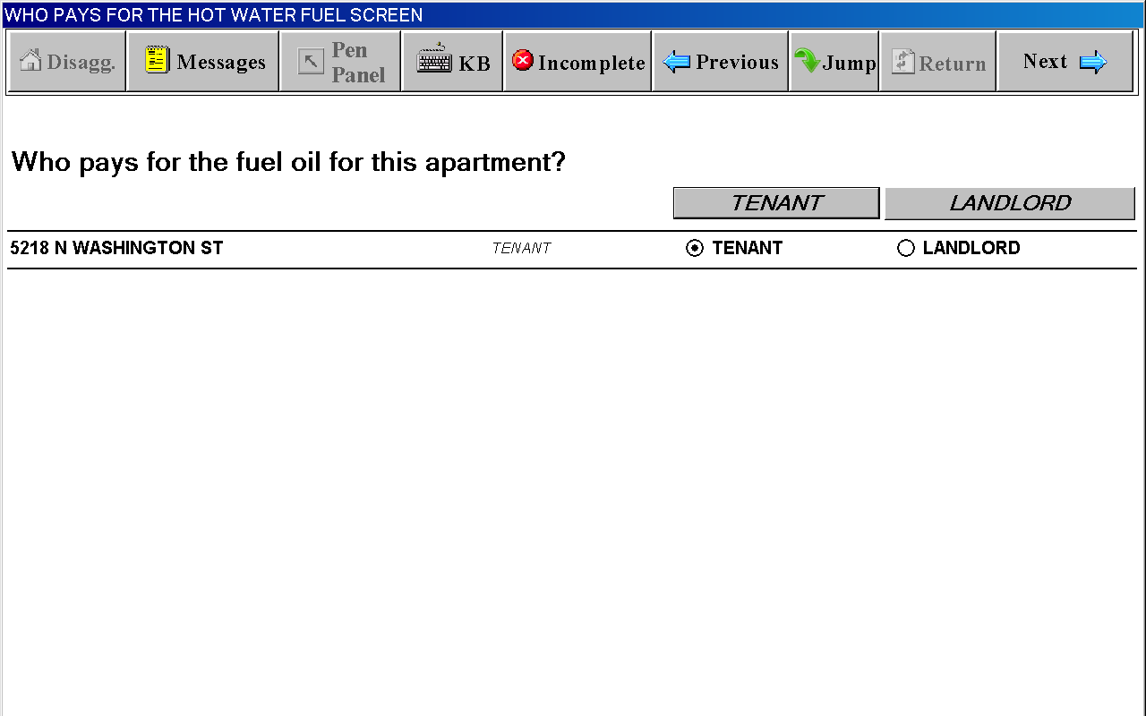
COST FOR HOT WATER FUEL INCLUDED IN RENT SCREEN

(wording substituted with selected fuel, such as “gas”, “fuel oil” or
“alternate fuel”)
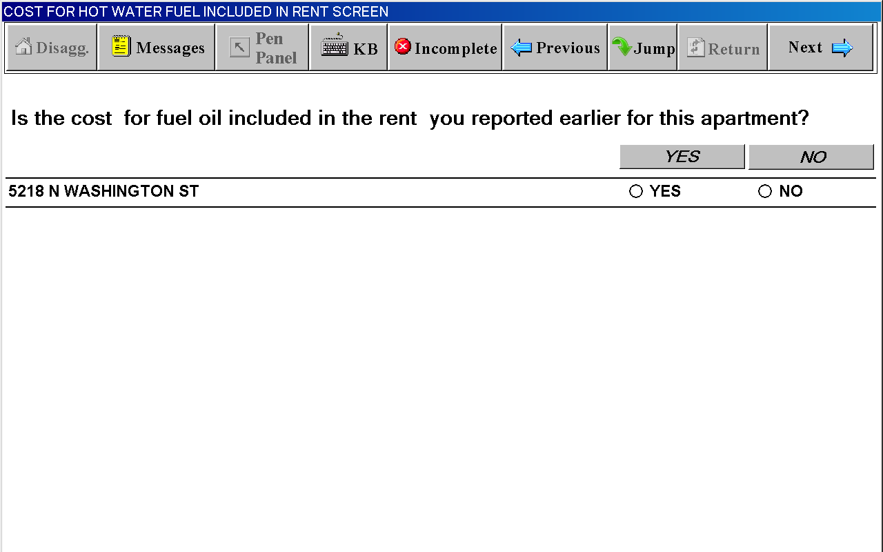
CHARGE FOR HOT WATER FUEL SCREEN

(wording substituted with selected fuel, such as “gas”, “fuel oil” or
“alternate fuel”)
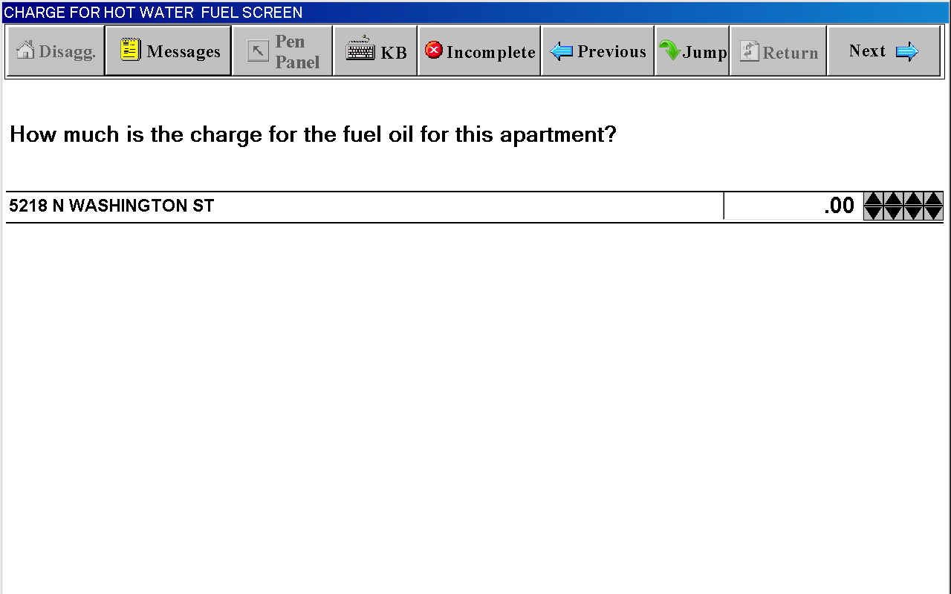
INCOMPLETE INTERVIEW POD DURING SCOPE DETERMINATION
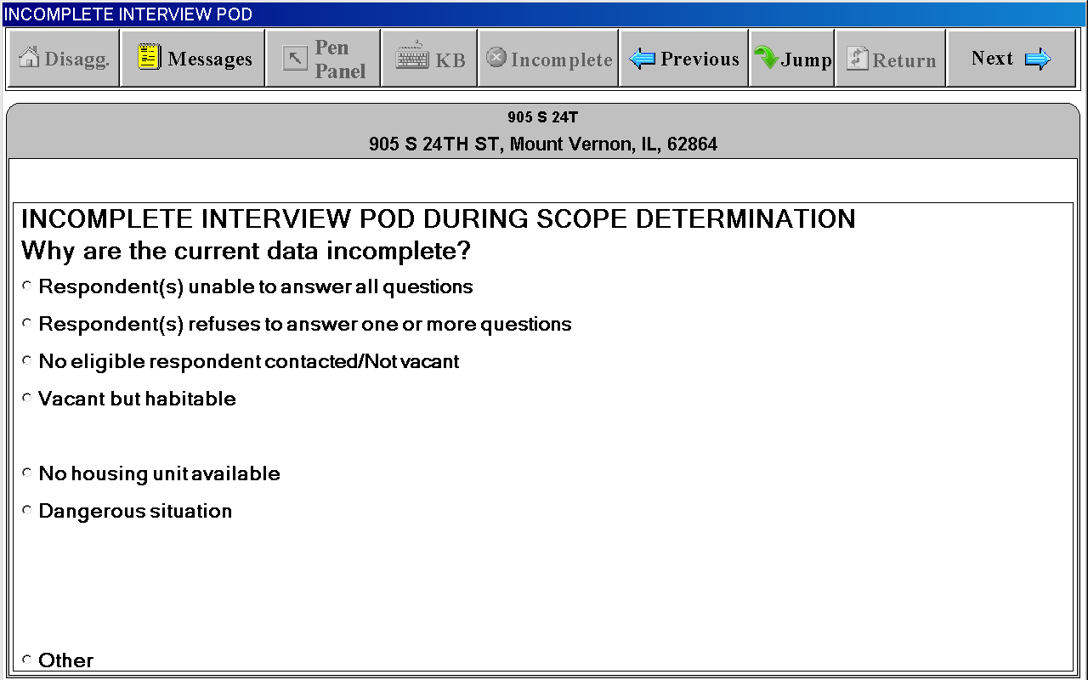
INCOMPLETE INTERVIEW POD DURING INITIATION/PRICING
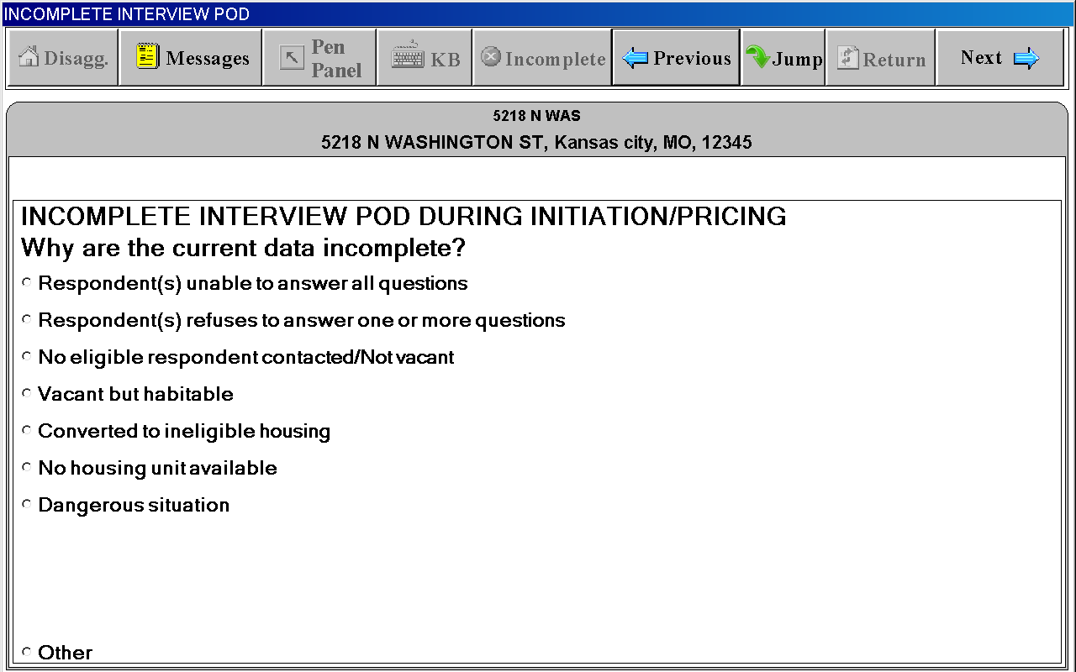
UNIT SI FACESHEET and UNIT FACESHEET
basically have the same content but different screen titles

“Unit” Tab
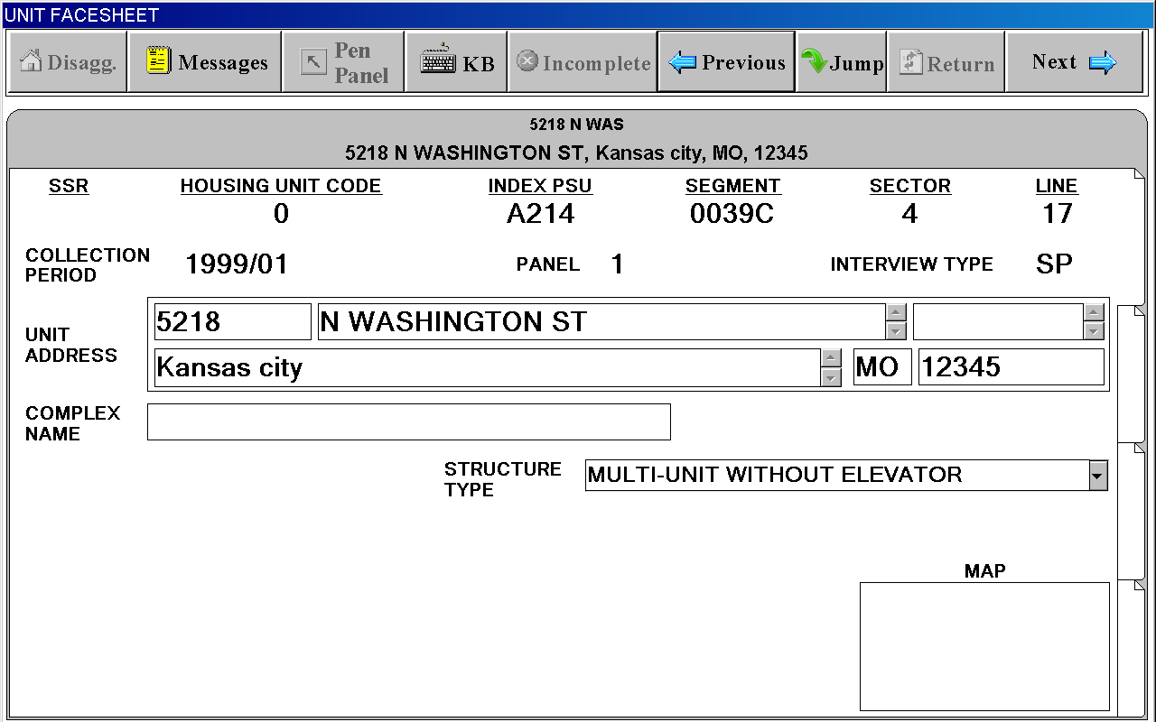
UNIT SI FACESHEET and UNIT FACESHEET
basically have the same content but different screen titles

“Occ/Resp/EA” Tab
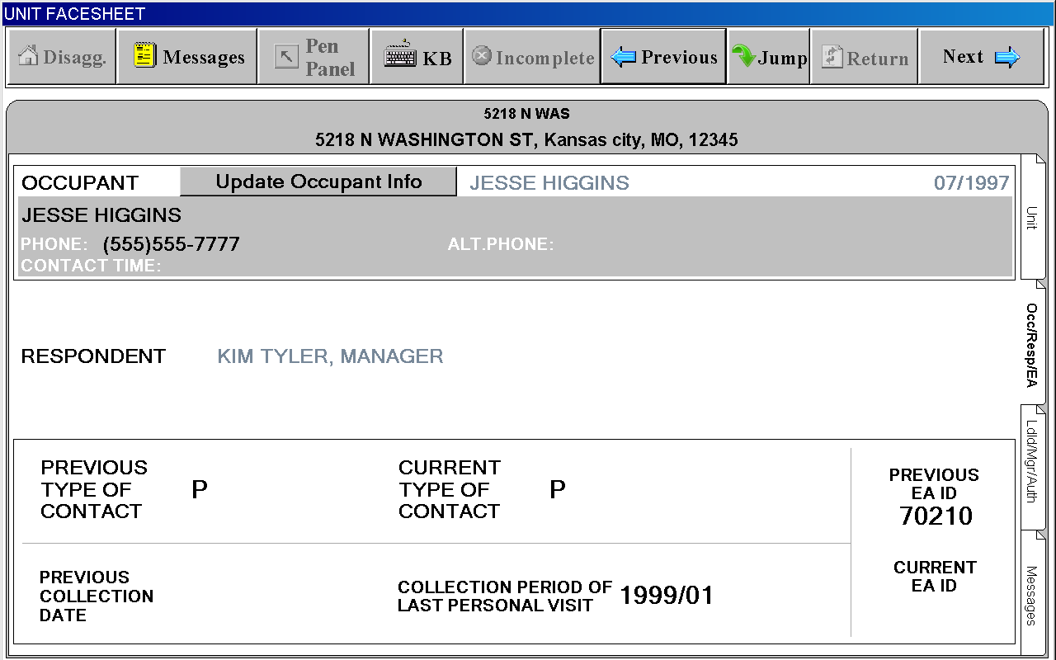
UNIT SI FACESHEET and UNIT FACESHEET
basically have the same content but different screen titles

“Ldld/Mgr/Auth.” Tab
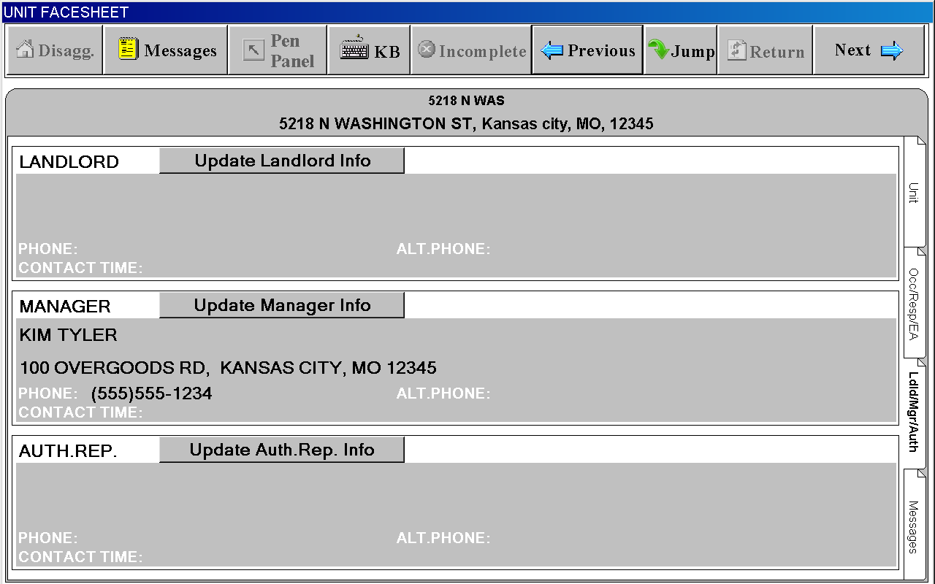
UNIT SI FACESHEET and UNIT FACESHEET
basically have the same content but different screen titles

“Messages” Tab
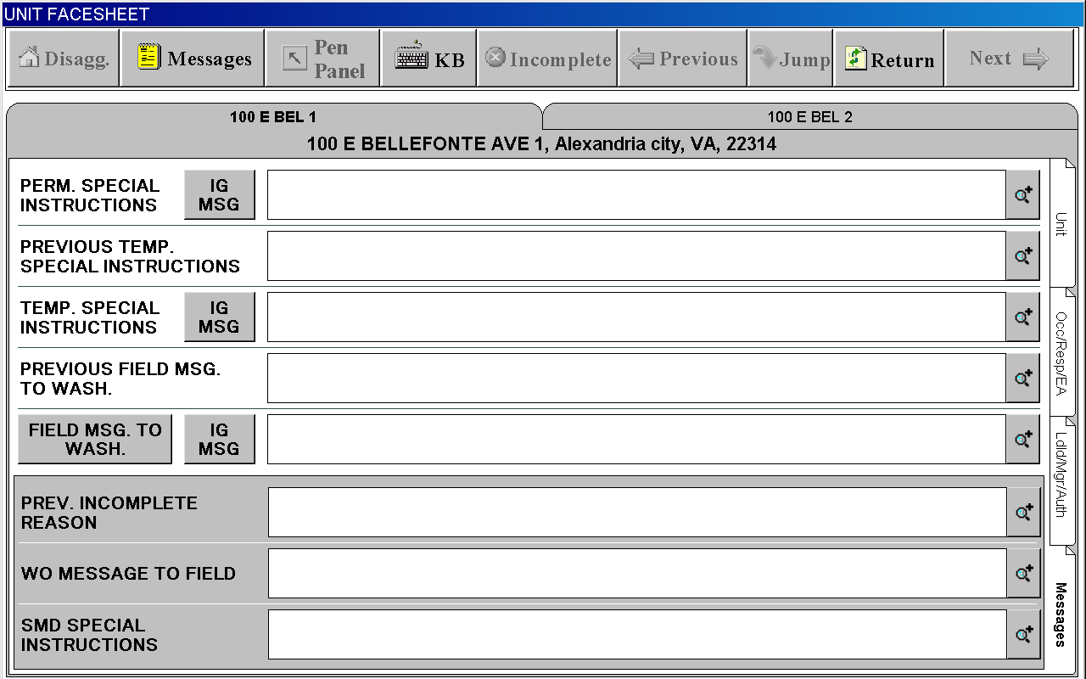

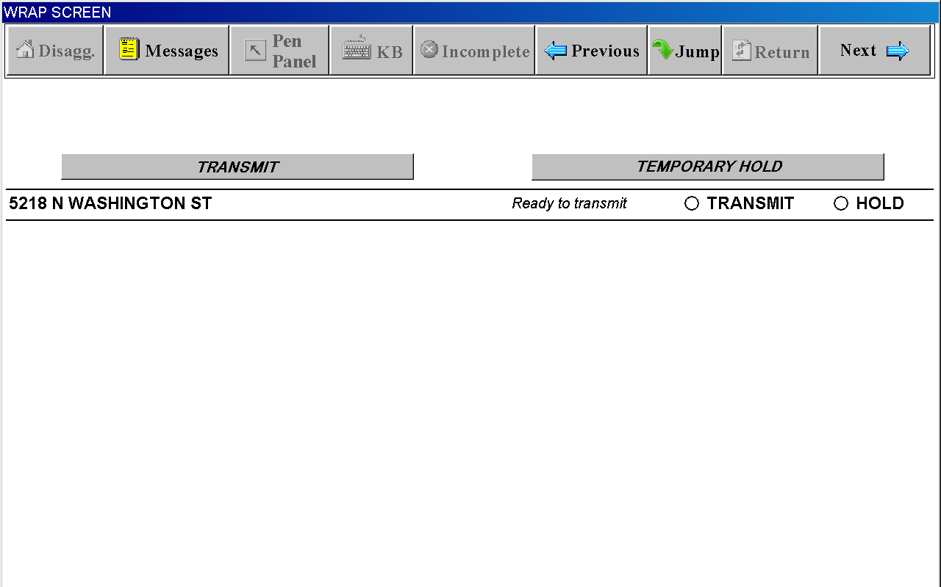
JUMP Screen with JUMP MENU
