Touchtone Reporting Instruction Sheet

This page is a quick reference on how to report your data using our Touchtone system. If you have any questions, please call the help number provided on your collection form. Please remember to use the report number printed at the top of your form when reporting.

HOW TO REPORT
Please call the toll-free Touchtone phone number to report your data. The Touchtone system will answer your call and ask you to enter your report number and each data item on your report form. The system will repeat each entry for confirmation. An example follows:

TOUCHTONE REPORTING STEPS

To begin reporting, dial toll-free 1-800-877-7715
Touchtone System: | Your Response:
1 "Thank you for calling the Current Employment Statistics Reporting System. Please enter your report number." | Press the NINE digits of your report number (shown at the top of your form).
2 "Your report number is… Press 1 to confirm, 0 to reenter." | Press 1 if correct, 0 if incorrect.
3 "Enter the number of the month of your report." | For January press 01, for February press 02..., for October press 10..., for December press 12.
4 "You are reporting for (name of month)." | Press 1 if correct, 0 if incorrect.
5 Enter your employee count and women employee count. | Enter your data for each item: For example, to report 25 employees press 2 then 5, followed by #. Note: the system will repeat all entries for confirmation.
6 "Enter a code to explain large changes to your data or press # to continue." [This question is repeated in case you need to enter 2 codes to explain the change to your data]. | Select codes from the bottom of the form to explain large changes to your data.
7 “To enter data for another report number, press 1. If you are finished, please press zero.” | Press 1 or 0 as appropriate.

Tips To Save You Time
- Press # after completing entry for the data item (employee count).  - Press # to skip over a data item for which you do not report, or if the data item is not available. | - Press * after your last reported data item to confirm the entry and skip to the end of the interview.  - You may enter data for all individual reports with a single call.

Instructions for Filling out Your New CES Form
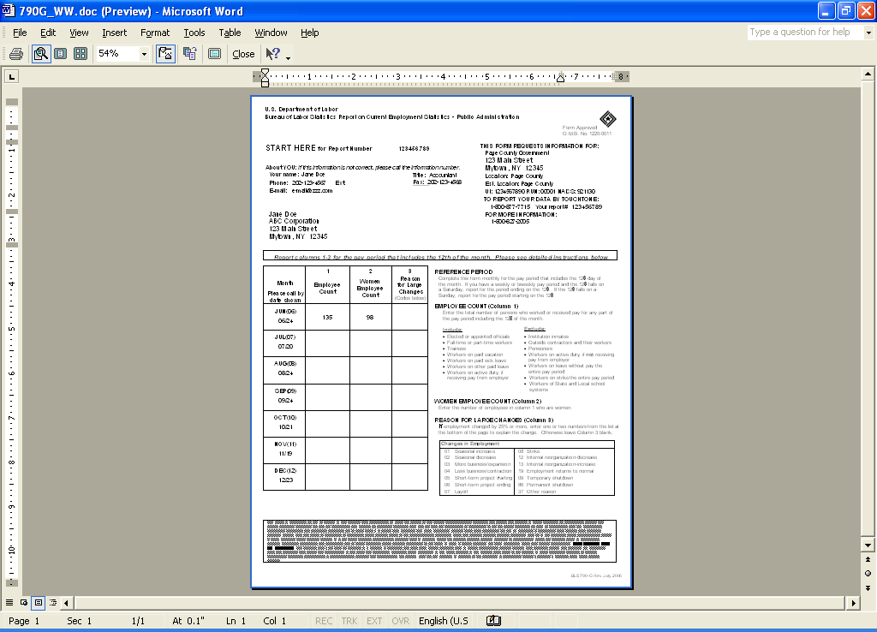
Enter one or two codes to indicate a reason for large changes in your data reported. The codes are listed at the bottom of the form.
Your CES report number
Report for All Workers for the pay period that includes the 12th of the month.
Report the data requested for this location
Enter the number of employees from Column 1 who are women.

