SUPPORTING STATEMENT B
FOR
COAST GUARD LIVING MARINE RESOURCES (LMR)
ENFORCEMENT SURVEY

B) Statistical Methods

In the service of promoting law enforcement effectiveness and informing policy decisions, the United States Coast Guard (USCG) is undertaking a Survey on the Effectiveness of Coast Guard Living Marine Resources (LMR) Enforcement, or LMR Enforcement Survey. The LMR Enforcement Survey concerns U.S. commercial, charter, and recreational marine fishermen from each coastal region impacted by various USCG LMR enforcement efforts.

The purpose of the LMR Enforcement Survey is to collect information on public perceptions of the effectiveness of Coast Guard enforcement of laws and regulations relating to fisheries, marine protected resources and other protected species. The information will be incorporated into a contracted study of the deterrent effect of the Coast Guard’s LMR enforcement program. Information collected will be analyzed to determine respondent perceptions of the effectiveness of a variety of USCG law enforcement efforts (including boardings, inspections, and observations by aircraft or surface vessels) in deterring illegal activities, prevalence of violation behavior, and other factors that may affect compliance behavior, including perceived probabilities of detection and punishment of violations (both formal/official and informal/social). Data will be analyzed for differentiation of responses by several dimensions including major fishery components (e.g. commercial, charter, recreational), fishery type, geographic area, and other factors. The results will help characterize critical dynamics of the deterrence value of various USCG LMR enforcement efforts, which will inform enforcement resource allocation decisions.

Respondent Universe and Sampling Methods

The universe for the LMR Enforcement Survey is all U.S. marine fishing permit holders and registered saltwater recreational fishermen from each coastal region. We estimate there are approximately 24,000 current permit holders.

The universe of the intended audience for the LMR Enforcement Survey includes:
- Commercial fishing permit holders,
- Charter fishing permit holders, and
- Recreational marine fishers

The universe does not include:
- Permit holders that fish in fresh water, and
- Permit holders operating non-U.S. flagged vessels

Marine fishing permit holders will be identified from publically available information found in NOAA National Marine Fishery Service registries. We estimate there are approximately 24,000 current permit holders. An additional reminder notice may also be sent to the approximately 6000 individuals for whom there is a record of a citation, warning or vessel boarding by law enforcement during the past three years, with the aim of increasing the response rate for individuals for whom there is some recent indication of possible non-compliance behavior.

Based on response rates reported in two recent mail surveys of fishing regulation compliance and perceptions of enforcement in several fisheries (Shaw 2005; King et al. 2009) we anticipate a response rate of approximately 30 percent from the survey after mailings of the letters of notification. While King et al. (2009) had response rates from 40% to 48%, depending on the fishery, Shaw (2005) had a 27% response rate in the one fishery they targeted. We do not plan to send as many reminder letters as King et al. and Shaw, due to budget limitations, so we expect to have somewhat lower response rates.

Procedures for the Collection of Information

The LMR Enforcement Survey will be posted online via the Federal Register. Respondents may complete the survey using any Web browser. The LMR Enforcement Survey is intended to be administered once.

As previously mentioned, the LMR Enforcement Survey targets all current US marine fishing permit holders and registered saltwater recreational fishermen, without further sample selection nor stratification, with the aim of achieving the highest possible number of responses and statistical significance of results.

  - Design Considerations
The survey content has been designed to elicit reports of individual fisher behavior from the perspective of compliant versus non-compliant activity. The survey is highly subjective and relies on the respondent to approximate and assess behavior and perceptions observed in their fishing community.

Previous research has employed Conventional/Economic Models of Deterrence (King et al. 2009) or Traditional Deterrence Theory (Shaw 2005) to quantitatively assess the monetary risks and rewards to fishermen of illegal fishing. For example, King and Sutinen (2010) estimate that for fishers in the North East Groundfish Fishery (NEGF), the average expected monetary cost of a violation penalty is approximately one-fifth of the expected monetary gain, resulting in net economic incentives to violate regulations.

Evidence suggests that many (but not all) fishers comply with fishery regulations even when the balance of economic risks and rewards favor violation (King et al. 2009). Such compliance behavior may be driven by fishers’ attitudes and values regarding the importance of sustainability of the fishery, perception of legitimacy of enforcement efforts and management systems, and other social or moral issues beyond mere short-term risk/reward considerations, as consistent with Non-economic Models of Compliance and Modern/Enhanced Compliance Theory (Shaw 2005; King et al. 2009). However, when increasing economic pressures reduce the ability of a fishing operation to stay profitable with only legal fishing, or when fishers do not feel that enforcement efforts or management systems are legitimate and do not have sufficient value in maintaining the sustainability of a fishery, then compliance rates can decline as fishers increase illegal fishing efforts to make at least some profit before the fish are all gone (King et al. 2009). Therefore, maintaining the sustainability of fisheries depends in part on fishers’ compliance, which can depend in turn on fishers’ violation risk/reward perceptions as well as their attitudes and values.

This survey is intended to help assess fishers’ regulation violation risk/reward perceptions as well as their attitudes and values regarding compliance. The results of this survey will be used to assess and analyze current perceived levels of compliance, risk/reward factors, social or moral compliance factors, the overall compliance effectiveness of various current USCG enforcement activities, and the likely compliance effectiveness of new technologies, for each US fishery. The survey seeks to gauge fishers’ perceptions of both social factors regarding compliance and violation risk/reward factors. The survey also involves quantitative estimates of fishers’ economic risks and reward of violation, using information from the survey as well as from other sources.

Following the framework of King and Sutinen (2010), we will assess fishers’ economic risks and rewards of fishing beyond legal limits primarily in terms of the fishers’ expected benefits (revenues) and costs (penalties) of non-compliance. In this framework, if the expected benefits are greater than the costs of illegal fishing, the fisher has economic incentive to fish illegally. Adapting King and Sutinen (2010) slightly, we define the net benefits to the fisher per fishing trip as the expected benefits of noncompliance minus the expected costs of penalties, or

$$NB= \left(F_{illegal}·A_{total}\right)-\left(P_{detection}∙P_{penalty}∙A_{assessed}∙F_{settled}\right)$$
Where
NB = Net benefits ($ per trip)
F_{illegal} = Fraction of total harvest in the fishery that is intentionally taken illegally
A_{total} = Total amount of revenue earned by both legal and illegal fishing activity per trip ($ per trip)
P_{detection} = Probability of illegal fishing being detected either during or after the trip
P_{penalty} = Probability of being prosecuted and having to face a penalty, if detected
A_{assessed} = Amount of average “assessed penalty” for this violation ($ per penalty)
F_{settled} = Fraction of the average “assessed penalty” that is actually paid in the average “final settlement”

As an example of the use of the equation, King and Sutinen use survey results to provide the following estimates for the North East Groundfishing Fishery: F_{illegal} = 18.5%; A_{total} = $30,000; P_{detection} = 32.5%; P_{penalty} = 33.1%; A_{assessed} = $20,455; and F_{settled} = 0.53. Therefore the net benefits to the noncompliant fisher are equal to $\left(0.185 ·\$30,000\right)-\left(0.325 ∙0.331∙\$20,455∙0.53\right)$, or $\left(\$5,550\right)-\left(\$1,166\right)$, which comes to $4,384 per trip for the estimated net benefits of noncompliance. Because the expected benefits of $5,550 exceed the expected costs of $1,166, the fisher has a short-term economic incentive to fish beyond legal limits.

  - Online Data Collection
Sample Processing and Management: As mentioned previously, LMR Enforcement Survey data collection will be accomplished via an online survey. The US Coast Guard has access to the current marine fishing permit database. To facilitate the pre-solicitation mailing, records obtained from the database will be provided in standardized format, and will contain at least the mailing address. To help preserve anonymity and confidentiality of responses, neither the online LMR Enforcement Survey, nor notification letters sent by mail, will contain unique identification numbers to track survey responses.

Document Preparation: Due to the large volume of notifications to be sent, a professional mail printing and collation service will be utilized. The pre-solicitation notification and instructions to access the online survey will be formatted, printed, sorted and posted through this service.

Online Survey Preparation: USCG has an in-house platform called Vovici that will be used to host the survey. To access the online survey, the respondent will follow a link posted to the Federal Register. Data reported by respondents will be subsequently posted to the Federal Register. Questions will be numbered and sections marked in such a way to provide an intuitive path for the respondent.

Data Collection Protocol: The online survey protocol will consist of an initial contact through physical mail notification (aforementioned), and the online survey interface accessed through the Federal Register. Specific steps are outlined below:

All U.S. marine fishery permit holders, with contact information, will be mailed in an advance letter introducing the survey. This letter will identify the Coast Guard as the sponsor of the survey, explain how the data will be used, and encourage respondent cooperation. The letter will communicate the importance of the survey for improving fishery enforcement efforts on behalf of the USCG and the benefits of survey participation. Potential respondents will be informed that their participation is voluntary. These letters will be:
- Printed in black and white with the USCG logo;
- Printed with contact information from the USCG Office of Law Enforcement for respondents who have questions about the survey;
- The letters will be mailed in a “flat” mailing at the bulk USPS rate;
- Within three days of the notification letter, the survey will be available to access online.

Within four weeks of the first pre-solicitation mailing; budget permitting, an additional reminder postcard may also be sent to the approximately 6,000 individuals for whom there is a record of a citation, warning or vessel boarding by law enforcement during the past three years, with the aim of increasing the response rate for individuals for whom there is some recent indication of possible non-compliance behavior.

Online Survey Results Processing and Data Entry: Results collected online will be processed by ABS Group Consulting on a weekly basis from the opening and closing period of the survey.

Data Collection Tracking System: ABS Group Consulting will create a Microsoft Access database to store survey data.

  - Quality Control
Table B.1: Quality Control Procedures

Survey Step | Quality Control Procedures
Input of Mail Data | - Mailing addresses entered by data entry staff will be verified at 100 percent through the use of double data entry as well as custom range and logic checks incorporated into the data entry system.
Printing of Mail Surveys | - Printing will be completed by a professional printing service that will print large volumes very quickly, at good quality and at low cost. Accuracy of insertion (i.e., address information on all mailed pieces) will be checked by hand for at least 10 percent of the total outgoing pieces
Programming Web Survey | - Visual review of every question (100%)  - Data from submitted surveys will be processed within five business days.

Methods to Maximize Response Rates and Deal with Non-response

To maximize response rates, we will have designed survey systems for online data collection that seek to obtain every possible response without the need for respondents to retain mailed paper survey forms until they find a convenient time to respond. The initial and follow-up letter of notification of online posting of the survey is one means that will be used to increase the response rate. In addition, as a means to promote timely survey response, we will state in the pre-solicitation letters we will mail to potential respondents that upon completing the online survey, respondents will be given the opportunity to enter a raffle for a series of prizes as described in A.9. To statistically account for non-response, ABS Consulting will adjust the final data obtained regarding the population of permitted fishermen and the population of participants in the survey based on the standards outlined in the OMB guidelines for statistical surveys.

Tests of Procedures or Methods to be Undertaken

In the process of designing the survey, we have performed reviews of survey items with subject matter experts at the USCG, NOAA and at ABS Group Consulting, to gauge and improve understandability and completion time of the survey. We do not plan further testing nor experimentation regarding survey items nor data collection methods.

Individuals Consulted on Statistical Aspects and Individuals Collecting or Analyzing the Data

The contractor responsible for the data collection and analysis (including statistical analysis) is ABS Group Consulting located at 1525 Wilson Boulevard, Suite 625, Arlington, Virginia 22209. Ms. Sue Kim of ABS Group Consulting is the project lead for this contract.

The office responsible for initiating and overseeing the LMR Enforcement Survey is the U.S. Coast Guard Office of Law Enforcement, 2100 2nd St SW, Washington, DC 20001. LT Meaghan Brosnan is the office point of contact for this issue.

References

King, D. M., E. Price, A. Van Buren, C. Shearin, K. J. Mengerink, R. D. Porter, J. G. Sutinen, A. Rosenberg and J. H. Swasey (2009). An Economic, Legal and Institutional Assessment of Enforcement and Compliance in Federally Managed U.S. Commercial Fisheries, A Report supported by the Lenfest Ocean Program.

King, D. M. and J. Sutinen (2010). "Rational noncompliance and the liquidation of Northeast groundfish resources." Marine Policy 34(1): 7-21.

Kuperan, K. and J. Sutinen (1998). "Blue Water Crime: Deterrence, Legitimacy, and Compliance in Fisheries." Law & Society Review 32(2).

Shaw, R. (2005). Enforcement and Compliance in the Northeast Groundfish Fishery: Perceptions of Procedural Justice in Fishery Management, the Effects of Regulatory Methods, and Prospects for Compliance. Environmental and Natural Resource Economics, University of Rhode Island. PhD.

Appendix A – LMR Deterrence Study

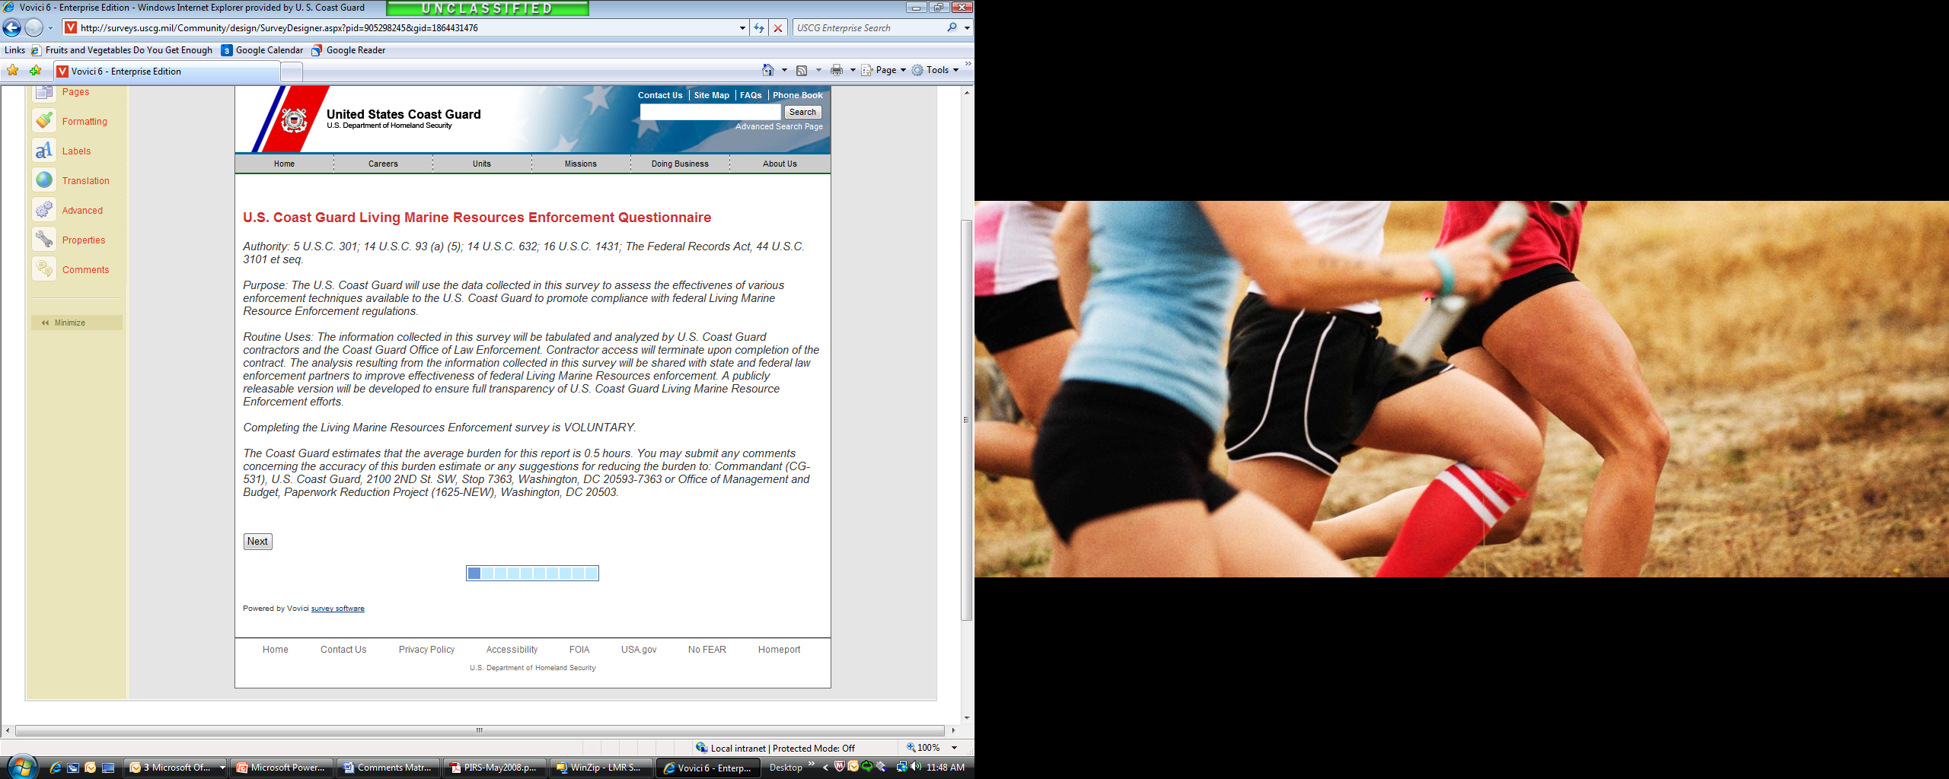
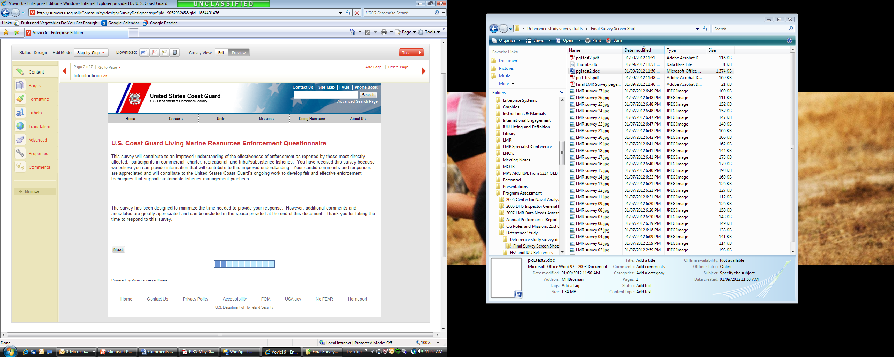
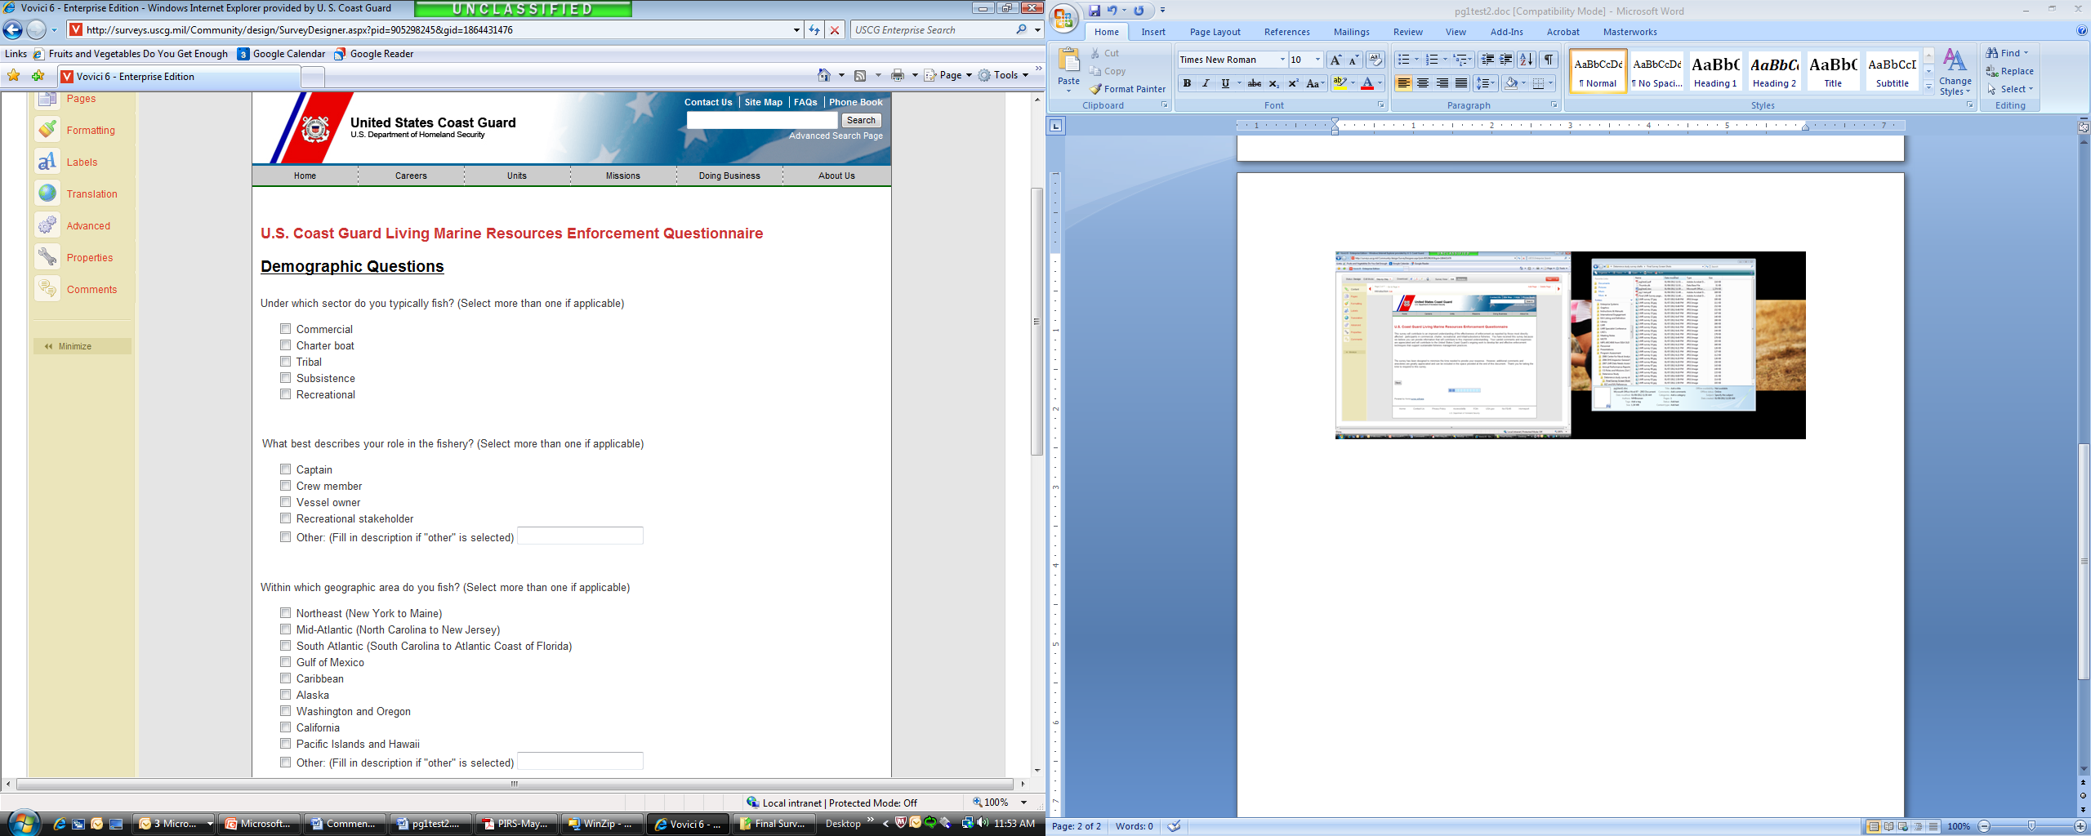
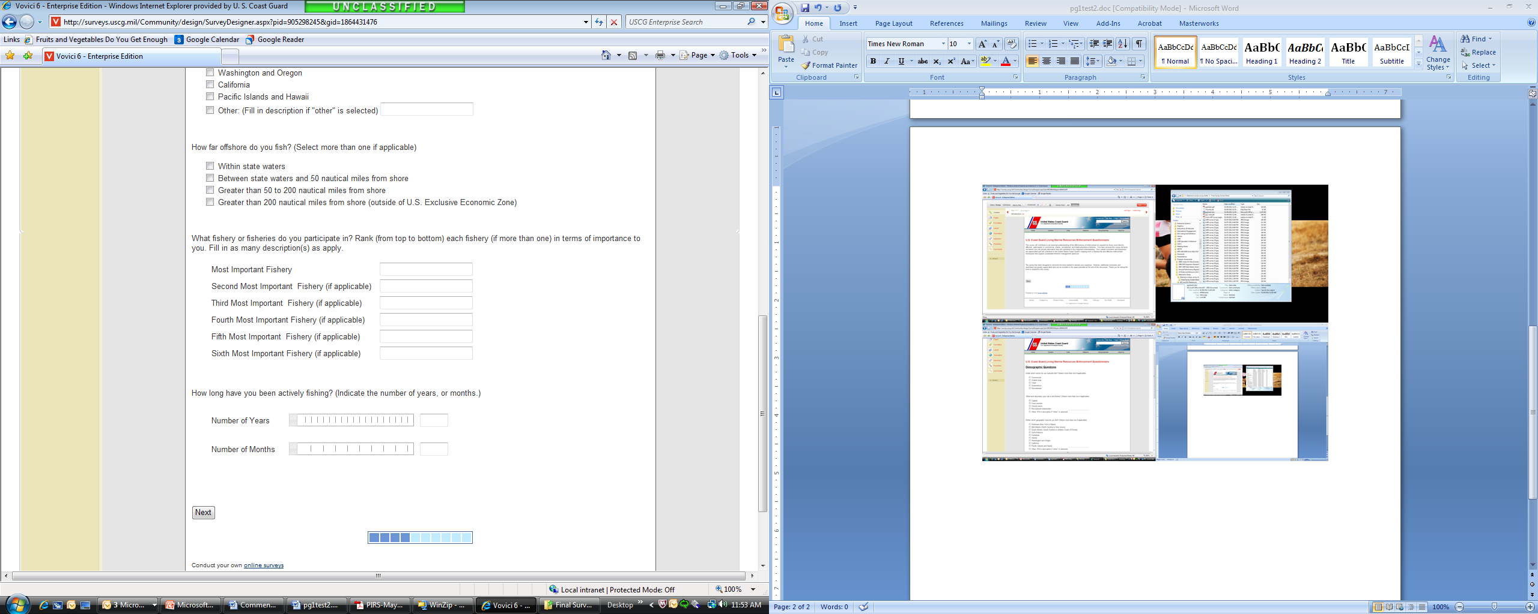
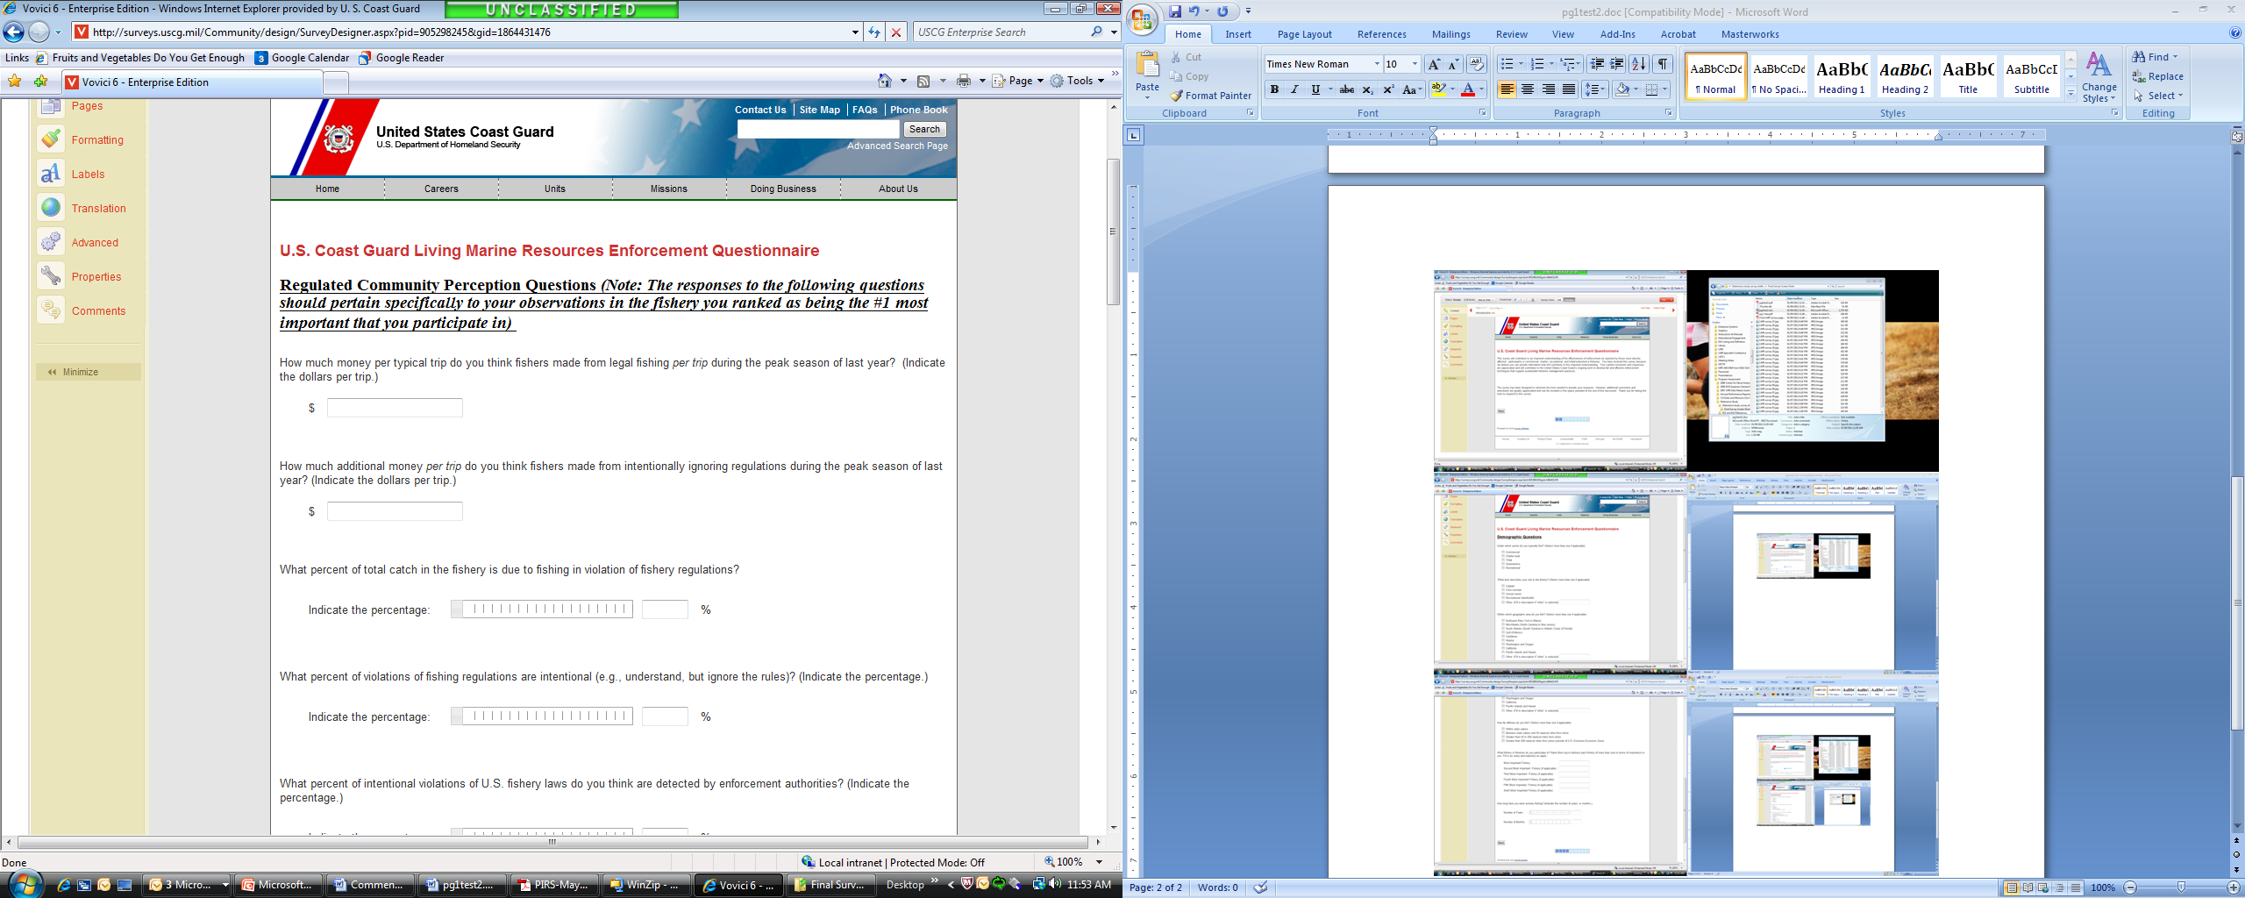
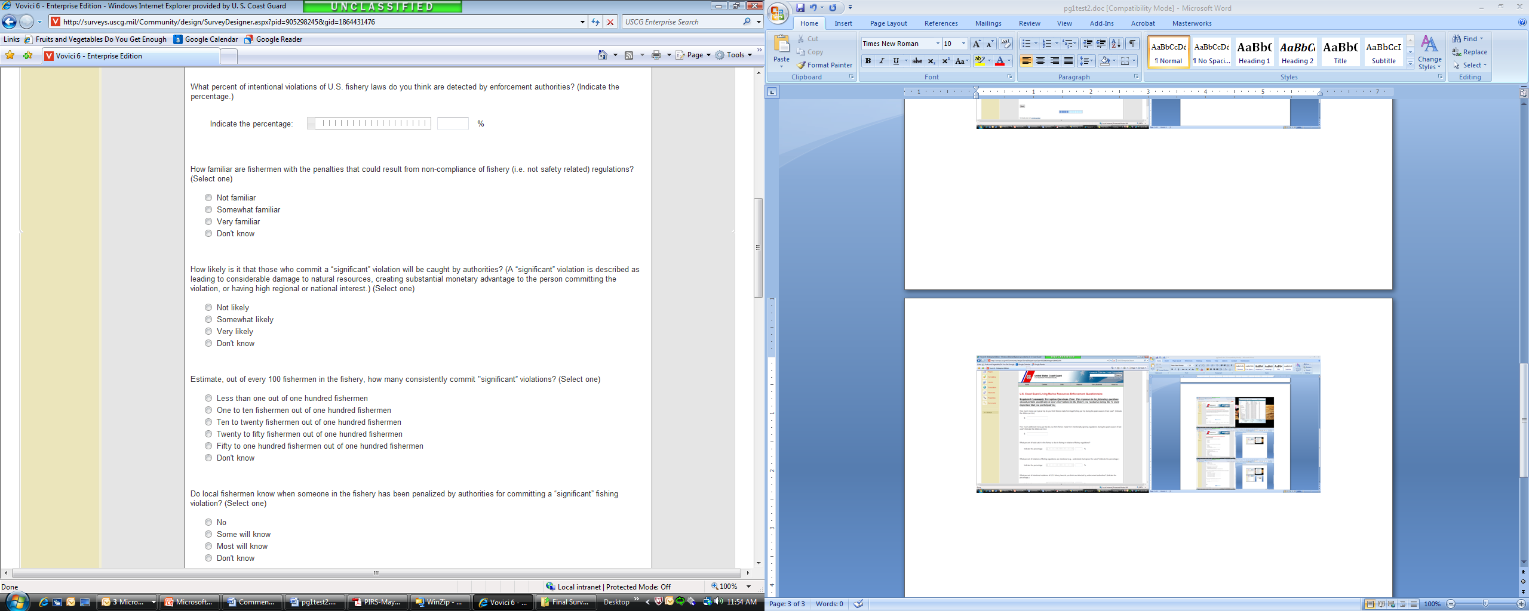
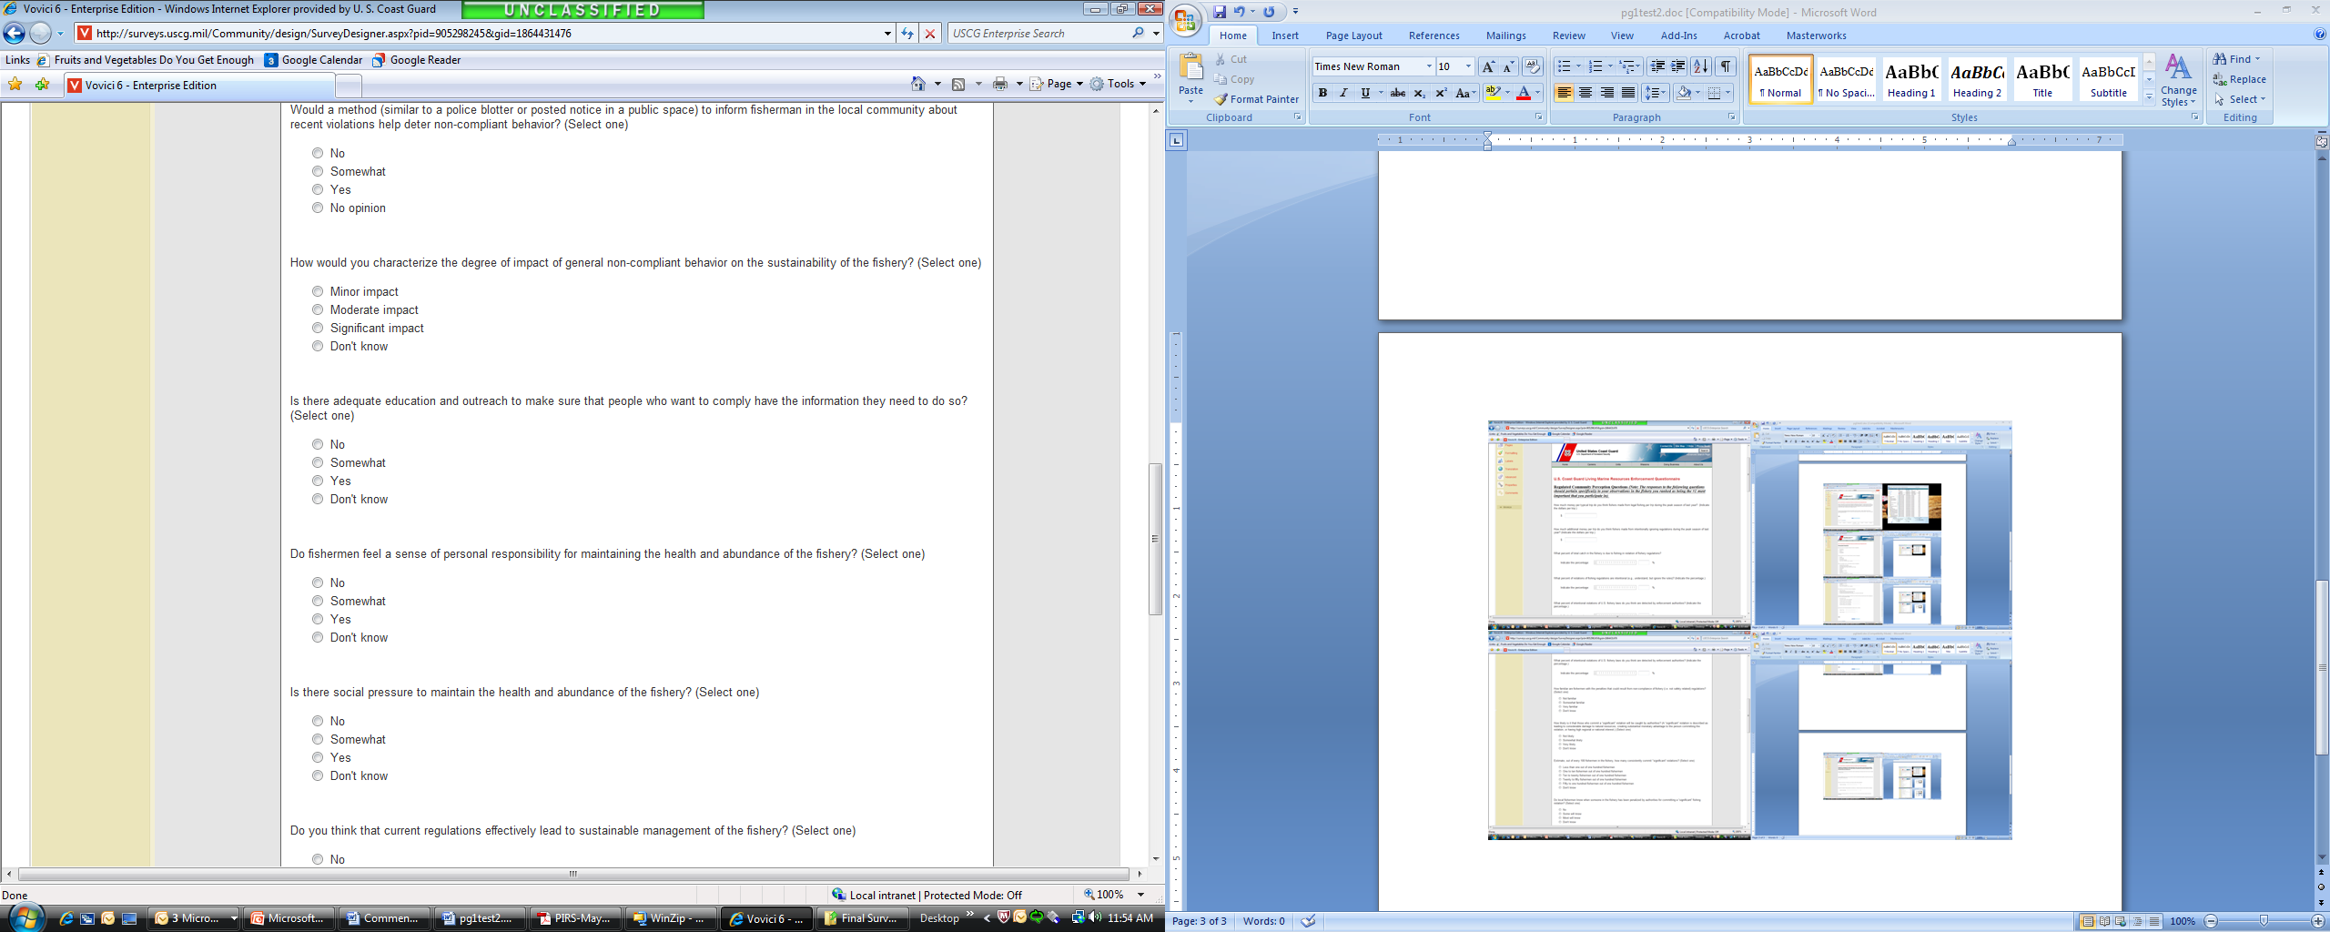
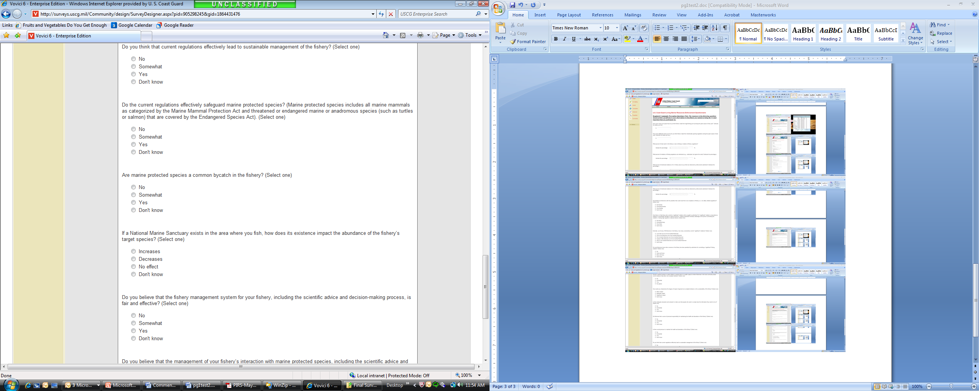
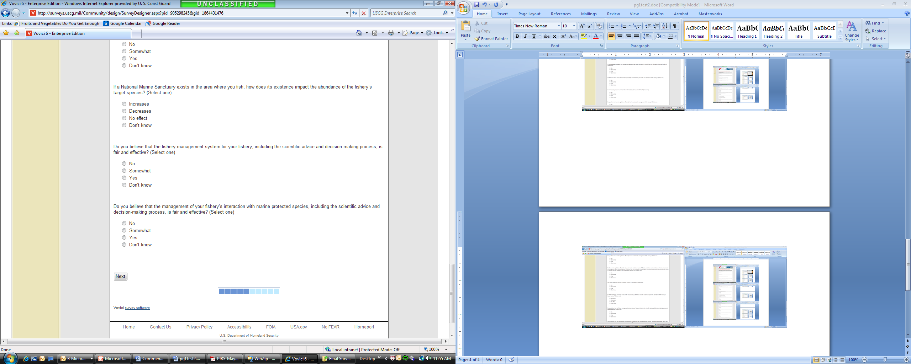
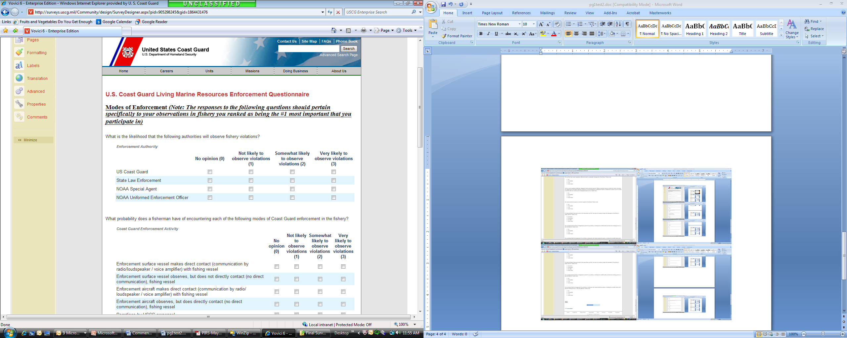
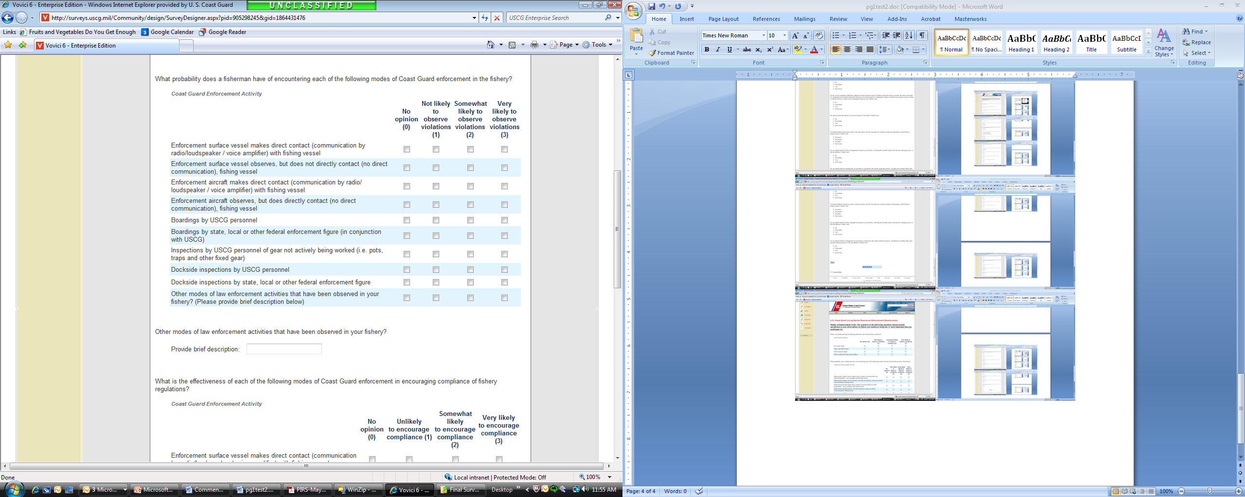
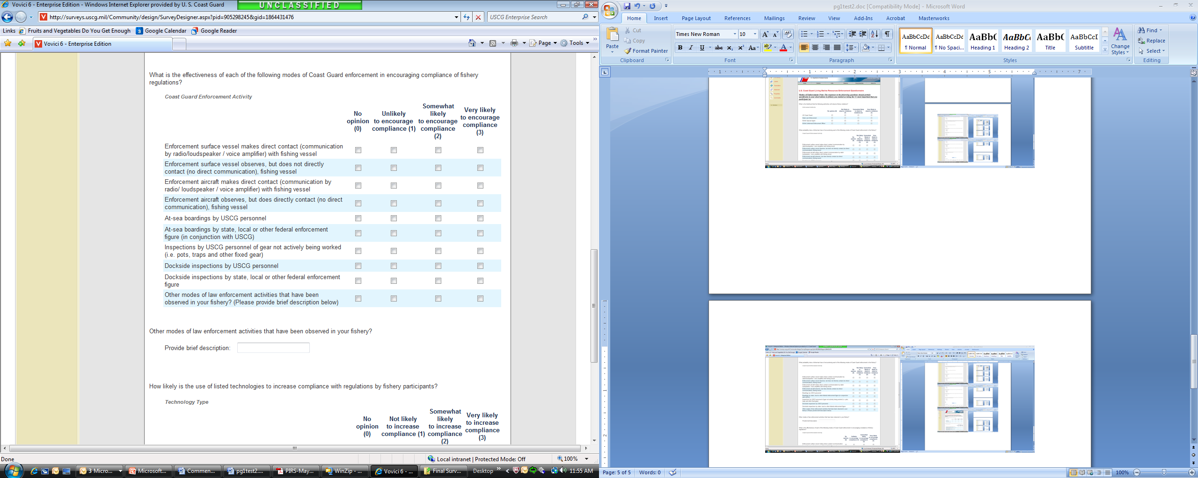
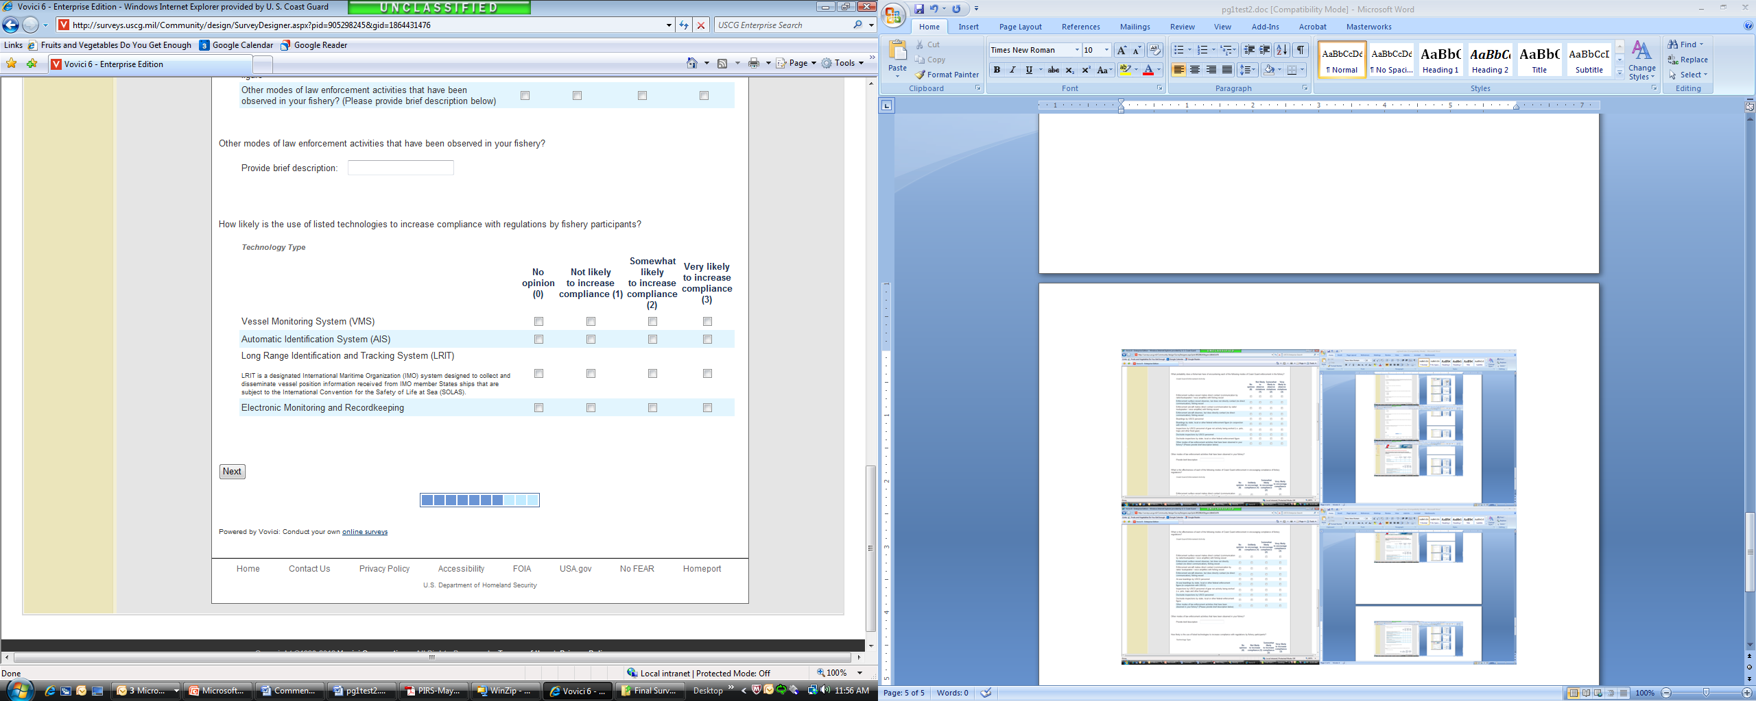
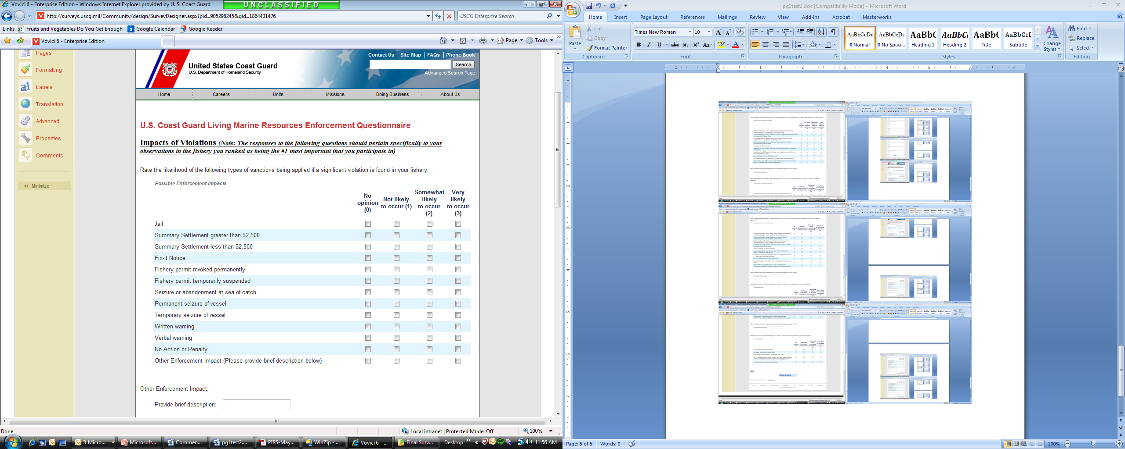
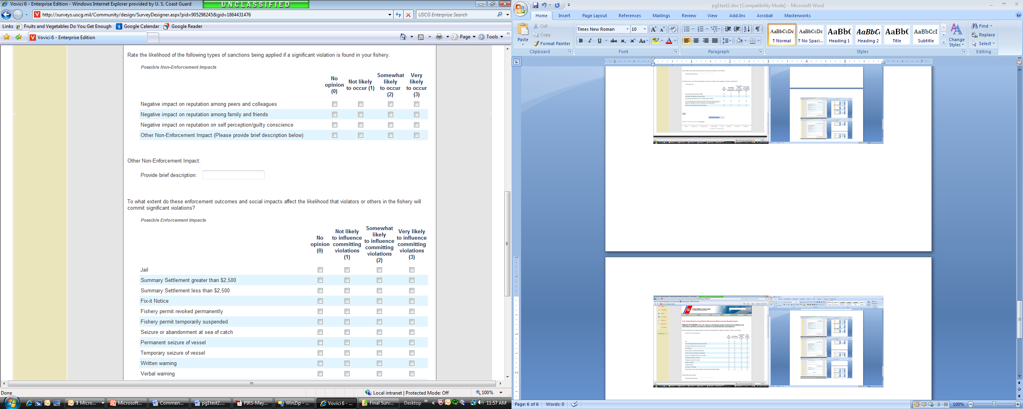
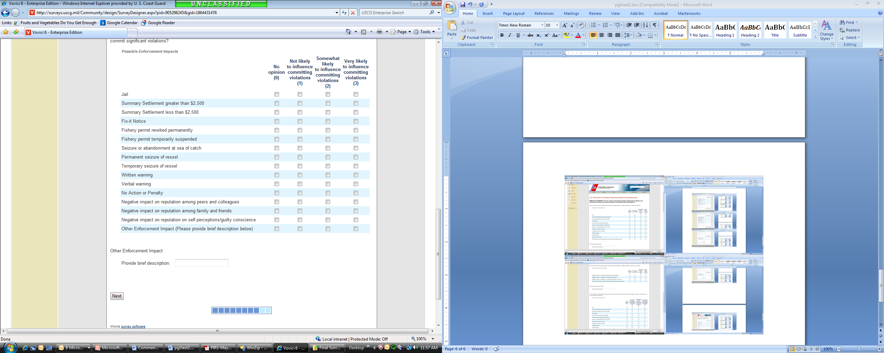
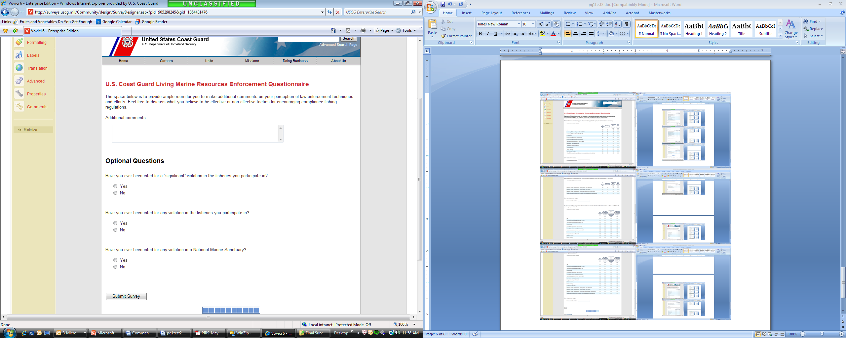

Appendix B – Select Applicable Regulations with Text

Homeland Security Act of 2002 (P.L. 107-296)
SEC. 888. PRESERVING COAST GUARD MISSION PERFORMANCE.
(a) DEFINITIONS.—In this section:
(1) NON-HOMELAND SECURITY MISSIONS.—The term ‘‘non-homeland security missions’’ means the following missions of the Coast Guard:
(A) Marine safety.
(B) Search and rescue.
(C) Aids to navigation.
(D) Living marine resources (fisheries law enforcement).
(E) Marine environmental protection.
(F) Ice operations.
(2) HOMELAND SECURITY MISSIONS.—The term ‘‘homeland security missions’’ means the following missions of the Coast Guard:
(A) Ports, waterways and coastal security.
(B) Drug interdiction.
(C) Migrant interdiction.
(D) Defense readiness.
(E) Other law enforcement.

Magnuson-Stevens Fishery Conservation and Management Act (P.L. 94-265)
SEC. 311. ENFORCEMENT 16 U.S.C. 1861
(a) RESPONSIBILITY.—The provisions of this Act shall be enforced by the Secretary and the Secretary of the department in which the Coast Guard is operating. Such Secretaries may, by agreement, on a reimbursable basis or otherwise, utilize the personnel, services, equipment (including aircraft and vessels), and facilities of any other Federal agency, including all elements of the Department of Defense, and of any State agency, in the performance of such duties.

Government Performance and Results Act (P.L. 103-62)
Sec 1115. Performance plans
(a) In carrying out the provisions of section 1105(a)(29), the Director of the Office of Management and Budget shall require each agency to prepare an annual performance plan covering each program activity set forth in the budget of such agency. Such plan shall-
(1) establish performance goals to define the level of performance to be achieved by a program activity;
(2) express such goals in an objective, quantifiable, and measurable form unless authorized to be in an alternative form under subsection (b);
(3) briefly describe the operational processes, skills and technology, and the human, capital, information, or other resources required to meet the performance goals;
(4) establish performance indicators to be used in measuring or assessing the relevant outputs, service levels, and outcomes of each program activity;
(5) provide a basis for comparing actual program results with the established performance goals; and
(6) describe the means to be used to verify and validate measured values.

