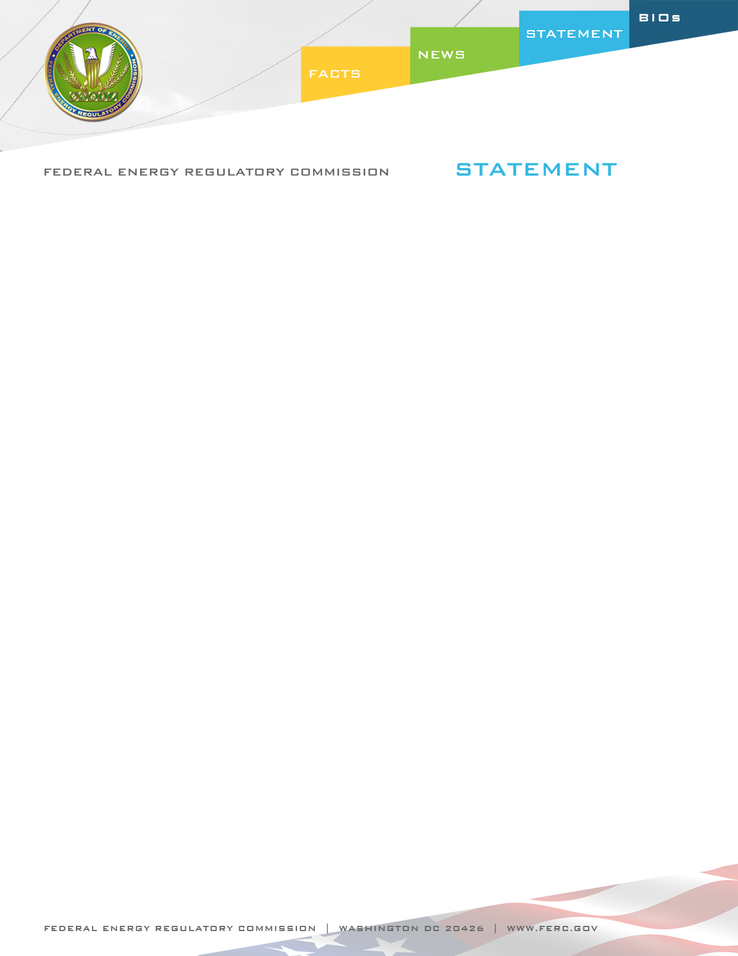

Docket Nos. RM12-6-000 and RM12-7-000
Item No. E-4

June 21, 2012
Chairman Jon Wellinghoff

Statement of Chairman Jon Wellinghoff on
NERC’s Revised Definition for Bulk Electric System

“Today’s order represents another step in the refinement of the definition of the Bulk Electric System. Since we first relied on NERC’s initial definition in Order No. 693, and again in directing NERC to refine the definition in Order No. 743, the Commission has continued to work with NERC to establish a definition that provides certainty to industry, yet is flexible enough to exclude facilities that are not necessary for reliably operating the grid.

In today’s order, we propose to approve NERC’s bright-line threshold of 100 kV or higher and specific configurations to be included and excluded in the definition of the Bulk Electric System, as well as NERC’s proposed exception procedure to add and remove elements from the definition. I look forward to reviewing the comments on this NOPR, and in continuing to work with NERC to refine the definition so that the Commission and NERC can focus on those facilities which ensure the reliability of the grid.”

