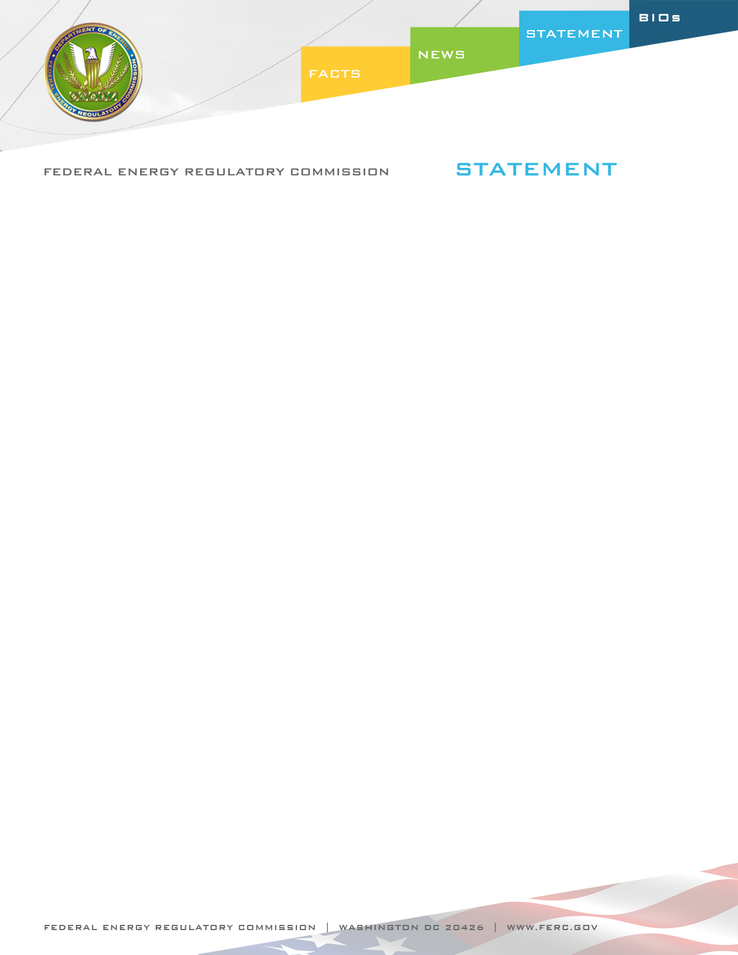

Docket Nos. : RM12-6-000 and RM12-7-000
Item No.: E-4

June 21, 2012
Commissioner John R. Norris

Statement of Commissioner John R. Norris on
NERC’s Revised Definition for Bulk Electric System

“I’m pleased to support today’s Notice of Proposed Rulemaking (NOPR) addressing the North American Electric Reliability Corporation’s (NERC) new definition of the bulk electric system, along with accompanying changes to the NERC Rules of Procedure.

Certain aspects of the process that led us to today’s NOPR show how the Commission and NERC can and must work together to carry out our responsibilities under section 215 of the Federal Power Act. By way of background, in Order No. 693, and later in the Order No. 743 proceedings, the Commission expressed concern that the existing definition of bulk electric system (carried over from the pre-Energy Policy Act of 2005 voluntary standards) may not encompass all of the facilities necessary for operating an interconnected electric transmission network. Order No. 743 also offered recommendations for how to address our stated concerns, but did not dictate that those particular recommendations be adopted. We allowed for alternative proposals, so long as they equally addressed our concerns.

Today’s NOPR proposes to find that the proposals submitted by NERC satisfy our concerns and meet the statutory requirements for approval. This is a significant achievement for NERC and its stakeholders. I want to emphasize two aspects of how we got here that I think serve as examples of how the Commission and NERC can, working together, effectively meet reliability challenges.

First, it is important to emphasize that NERC promptly responded to the concerns expressed in Order No. 743 with the proposals before us today. While there has been criticism of the length of time it can take NERC to complete reliability standards work, NERC and the industry stakeholders involved in this effort are to be commended for their speedy and thorough response. We have done our best to provide an equally speedy and thorough reply in this NOPR, which is also important. Diligence in working through identified concerns is critical to satisfying the responsibilities entrusted to FERC and NERC, as the Electric Reliability Organization (ERO), by Congress.

Second, I would note that the proposals submitted by NERC do not conform in every way to the recommendations we offered in Order No. 743. However, the NOPR proposes to find that those aspects of the proposal that differ from our guidance are an equally efficient and effective alternative. It is important that the Commission give alternatives to our guidance fair consideration, and we have done that here.

Let me also highlight one issue in the NOPR on which we seek comment. The proposed bulk electric system definition relies on a 100 kV “bright line” threshold, along with certain expressly defined inclusions and exclusions, as a proxy for determining whether elements should be designated as part of the bulk electric system. NERC also proposed an exception process, through which individual system elements or facilities can be excluded or included in the bulk electric system.

The ultimate goal here is to ensure that all facilities impacting the reliability of the interconnected transmission network are captured within the bulk electric system rubric and subject to mandatory reliability standards. While utilizing a bright line threshold to determine what facilities and elements are within the bulk electric system has significant advantages, it can also leave out critical facilities that fall below that threshold. The September 2011 reliability events in Southern California displayed how important lower voltage, sub-100 kV facilities can be to the reliability of the broader interconnected grid in certain circumstances.

Thus, while proposing to approve the exception process, the NOPR seeks comment on how sub-100 kV facilities will be assessed for possible inclusion in the bulk electric system. The NOPR correctly emphasizes that Regional Entities, planning authorities, reliability coordinators, transmission operators, transmission planners, balancing authorities, and owners of system elements, as the entities with “on the ground” expertise of the system elements in their purview, bear primary responsibility for analyzing sub-100 kV elements and facilities and seeking to include in the bulk electric system any that are necessary for reliable operations.

These entities take their reliability obligations seriously, and I am certain they will conduct a thorough analysis of sub-100 kV elements in their local and regional areas. We also seek comment, however, on the potential roles of NERC and the Commission in assessing sub-100 kV facilities, including asking whether there are instances where the Commission should take more affirmative steps to itself designate such facilities as part of the bulk electric system. While I do not favor top down approaches to reliability matters, I also recognize that there may be rare circumstances where NERC and/or the Commission, in performing their statutory responsibilities, discover sub-100 kV elements or facilities that should be included in the bulk electric system. The Southern California outages of last year are one example.

Developing and enforcing mandatory reliability standards for the bulk power system is a huge task. I believe we will have a more sustainable mandatory reliability standards program, and ultimately a more reliable grid, if we work closely and cooperatively with NERC. We might eventually get to the same reliability goals working on our own or dictating results from the top down, but it will likely take longer and certainly be less efficient. Moreover, as I have said many times, Congress established a different paradigm in section 215 of the Federal Power Act, giving the Commission a different scope of authority and placing us in a public-private partnership with NERC. For these reasons, I am always sensitive to the Commission’s appropriate place in this paradigm, and cognizant that stretching the scope of our section 215 authority or establishing adversarial processes can work against our shared reliability goals. I thus will be keenly interested in comments on the potential role of the Commission in designating facilities for inclusion in the bulk electric system.”

