**SUPPORTING STATEMENT FOR PAPERWORK REDUCTION ACT SUBMISSIONS**

***Study of the Involvement of Veterans and Military Families in National Service***

**B. Statistical Methods**

B1. Respondent Universe and Sampling Methods

The aim of this study is to conduct exploratory research to understand the successes and challenges of CNCS-funded programs and projects that involve veterans and military families as national service participants and service beneficiaries. The goals of the project are to identify effective models and strategies that CNCS programs and projects have developed for engaging and serving veterans and military families, as well as gather critical information that may be used to inform CNCS’ strategies for increasing the involvement of veterans and military families and improving the effectiveness of national service as a means of meeting the particular needs of these populations.

The data collection activity proposed for this study includes telephone interviews with the directors (or other appropriate and knowledgeable staff members) for an estimated 100 CNCS-funded programs and projects that proposed substantial or strategic efforts to involve veterans and/or military families as national service participants and/or beneficiaries. An initial list of potential programs and projects for the sample was drawn from among three of CNCS’ grant programs (AmeriCorps State and National, AmeriCorps VISTA, and Senior Corps). The list included 172 programs and projects and was based on an initial survey of program grant application reviews and CNCS program staff.

As the next step, Westat, the research firm contracted for the study, carried out a comprehensive review of application proposals for all 172 programs and projects in order to identify those programs and projects that had described substantial and/or strategic efforts to engage and/or serve veterans and/or military families. As a result of this review, 85 programs and projects were selected for interviews.

In a final step, the list of identified program and projects was shared with the appropriate CNCS program staff to verify program and project contact information and check whether any programs or projects should be added or removed from the list. Based on program staff feedback, we have refined the list to include a 90 programs and projects, including 31 AmeriCorps State and National grant recipients, 28 AmeriCorps VISTA grant recipients, and 25 Senior Corps grant recipients, as well as 6 that have received grants from both AmeriCorps State and National and VISTA. We anticipate that a small number of additional program and projects may be identified during the course of the data collection, and therefore expect approximately 100 programs and projects in the interview sample.

B2. Procedures for Collection of Information

Once OMB clearance is obtained, the list of programs and projects in the interview sample will be sent to the relevant CNCS program staff. Program staff in the state offices will contact those AmeriCorps VISTA and Senior Corps projects in their state to give them initial notification that they have been identified for the study and will be contacted in the coming months to complete an interview. In the following week, CNCS will send, by email, a letter from CNCS program director and the director for research and evaluation to each of the selected programs and projects, inviting them to participate in the study with Westat staff (see Appendix A, *Invitation Letter*). In addition to the letter, CNCS will include a list of Frequently Asked Questions (FAQs) that provides the programs and projects with information regarding the content and purpose of the interview, the length and frequency of the interview, and contact information for those with further questions (see Appendix B, *Frequently Asked Questions*). Letter recipients are under no obligation to participate and participation in the study will have no effect on funding decisions. Selected program participants have the option to schedule an interview time or opt out of the study by calling the toll-free number provided in the FAQs. Otherwise, Westat will begin to contact selected program and projects within a week after the letter has been sent, in order to schedule a time for the interview.

While all efforts will be made to minimize the need to request further information beyond the initial interview, Westat may seek clarifications from respondents. In such cases, requests for clarifications will be initiated via email from Westat; however, respondents will not be obligated to respond. In addition, the respondents will be provided with a contact phone number and email if they choose to provide further clarification of their own accord.

Telephone interviews with directors of the programs and projects will be conducted from the Westat office in Rockville, Maryland. Telephone interviews are anticipated to begin in June 2012 and to be completed by September 2012. Interviews will be conducted by senior members of the Westat team that has been awarded the contract to conduct this study.

We anticipate that all interviews will last approximately 50 minutes and expect no more than 100 individuals to be interviewed.

B3. Methods to Maximize Response Rates and Deal with Non-response

Given the qualitative nature of this research and the purposive, non-statistical sampling used to identify the sample of respondents for the interview, “response rates,” which use statistical values based on the percentage of a selected sample that participates in the study, are not applicable to this study. A more appropriate way to think about this topic is in terms of “willingness to cooperate” with the study team. That is, for any individual contacted by a study team member, how willing is s/he to agree to participate in an interview for this project? And if s/he agrees, how likely is it that the individual will actually be available at the appointed time?

There are several factors in the design of the study that lead us to expect a high level of respondent cooperation with the study team. First, the purposive sampling strategy that we have used means that those programs and projects that will be asked to participate in the interview have already expressed an explicit intention in making significant and/or strategic efforts to involve veterans and/or military families in their national service activities. As a result, they have an invested interest in the study objectives and are likely to directly benefit from the findings.

Second, initial contact for the study will come from CNCS staff, by email and phone, and selected programs and projects will be informed of the purpose and content of the interviews before being contacted by the study team. Third, selected program and projects will have the option of scheduling an interview time that is most convenient for them, as well as designate an alternate contact with appropriate knowledge of the program to complete the interview. Fourth, Westat will designate a member of the study team to serve as an interview scheduler to facilitate finding a convenient time for interviews.

B4. Tests of Procedures or Methods to be Undertaken

The study team members collaborated to ensure that the interview guide covers the main topics of interest to the study. The study team received feedback on the protocol from CNCS staff members, including those most familiar with programs and projects that involve veterans and military families, as well as Westat staff members outside of the study team.

Furthermore, the interview protocol has been pretested with five of the program and projects identified for the study sample. Based on the findings from the pretest, we have made some adjustments to the instrument, which provide screening questions for organizations that serve as intermediaries, refine question prompts to direct respondents to focus on those activities that are specific to veterans and military families, and reformat the protocol layout to make it more user-friendly for the interviewers. In response to a comment received during the 60-day public notice period, we have also added one question intended to gather information on practices that programs and projects have found effective in meeting the specific needs of veterans who serve as national service participants.

Importantly, the protocol is not intended to serve as a verbatim survey instrument – our experience has demonstrated that interviewees may need questions reworded slightly in order to provide a relevant answer. In addition, and quite common to qualitative research, participants may introduce new topics to the discussion that are relevant, but that the study team had not anticipated prior to beginning data collection. The interview protocol thus provides a basic structure for team members to follow, but also allows sufficient flexibility to explore emergent topics, as appropriate.

B5. Individuals Consulted on Statistical Aspects and Individuals Collecting and/or Analyzing Data

The information for this study is being collected on the behalf of CNCS by the research consulting firm, Westat, 1600 Research Boulevard, Rockville, MD 20850. With CNCS’ oversight, Westat is responsible for the study design, data collection, analysis, and report preparation. The Project Director for Westat is Cynthia Robins, 301-738-3524.

APPENDIX A

Invitation Letter

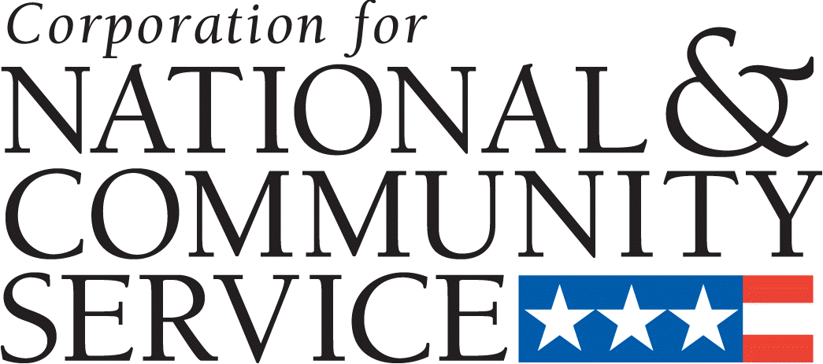

[Date]

Dear [Grantee Contact]:

We are pleased to let you know about a study that we are undertaking, Understanding the Involvement of Veterans and Military Families in National Service. Through a contract with the research firm, Westat, we are conducting the study of current CNCS programs and projects to better understand how organizations like yours are using national service to achieve your goals in meeting the needs of veterans and military families. The study will be inclusive of AmeriCorps State and National, VISTA, and Senior Corps programs. The findings will be used to inform the creation of resources that can assist programs and projects in strengthening the role of national service in engaging and serving veterans and military families.

Your [AmeriCorps program/VISTA project/Senior Corps project], [Program Name], is among those that have been selected to take part in the study. [AmeriCorps programs/VISTA projects/Senior Corps projects] that agree to participate in the study will be contacted by Westat to complete a phone interview within the next month. During the interview, which will take approximately 50 minutes, a Westat researcher will ask about your program development, strategies for engaging and/or serving veterans and military families, any empirical evidence you have been able to collect that demonstrates effectiveness and impact, and suggested ways that CNCS could better assist your efforts going forward. Enclosed with this letter is more information on the interview process, including contact information for the study researchers.

Participation in the study is voluntary, and we hope that you choose to take part so that your experiences can help us to identify ways that we can better assist national service programs and projects to engage and serve veterans and military families. With your help, we can build a solid base for our work through real-world examples.

Thank you for all of your efforts in meeting the needs of our veterans and military families through national service.

In Service,

[Program Director Name] Kimberly Spring

Director, [Program Name] Project Manager, Office of Strategy and Special Initiatives

APPENDIX B

Frequently Asked Questions

**STUDY OF THE INVOLVEMENT OF VETERANS AND MILTIARY FAMILIES IN NATIONAL SERVICE**

**FREQUENTLY ASKED QUESTIONS**

**Why is CNCS conducting this study?**

CNCS is conducting this study in order to obtain a comprehensive understanding of how national service is meeting the needs of veterans and military families. Through the study, we hope to be able to identify promising practices and models for national service programs and projects that engage and/or serve veterans and military families. The findings will be used to inform the creation of resources that can assist programs and projects to strengthen the role of national service in meeting the needs of veterans and military families.

**What questions will I be asked?**

CNCS has worked with a contract research organization, Westat, to develop an interview guide that will be used with all respondents. Your interviewer will ask you questions about the history of your program that is engaging veterans and/or military families, details about how you have successfully engaged this population, as well as any evaluation data you may have demonstrating the effectiveness of your program’s efforts.

**How was I selected for the study?**

Following a review of applications for projects that had a component addressing the needs of veterans and military families, we have selected those programs and projects that demonstrate significant and strategic efforts to engage and/or serve veterans and military families through their national service projects.

**Who is Westat?**

Westat is a large social science research company that is known internationally for conducting large-scale surveys for Federal clients. CNCS has a one-year contract with Westat to conduct this study.

**How will Westat and CNCS use the data?**

The goal of the study is to improve and strengthen the capacity of CNCS national service programs to meet the needs of veterans and military families. Westat analysts will review the interviews for information about “what’s working well,” as well as ways of addressing some of the common challenges that grantees have faced. Best practices, as well as lessons learned, will be extracted and used to inform the creation of resources that can assist programs and projects to strengthen the role of national service in engaging and serving veterans and military families. These resources will be made available through the National Service Resource Center.

**Where and when will the resources be available?**

We anticipate that the resources will be made available to the national service field through the online National Service Resource Center around late fall of 2012 or winter of 2013.

**If I want to arrange a time for the interview, whom do I call?**

You may contact Westat staff member Cindy Rubenstein by telephone at 1-800-937-8281, extension 5174 or email: cindyrubenstein@westat.com. Otherwise, Westat will begin to contact selected programs and projects by phone in the coming weeks to complete the interview.

**When will the interviews be conducted?**

Interviews will take place between June and September, 2012.

**How long will each interview take?**

We anticipate that the interview will take approximately 50 minutes.

**Is this a one-time interview or will Westat contact me several times?**

This study will interview selected grantees only one time. All efforts will be made to minimize the need for subsequent requests; however, Westat may follow-up with a respondent for clarification. Requests for clarifications will be initiated via an email from Westat. You are under no obligation to respond to clarification requests.

**What if I don’t want to participate?**

Participation is voluntary. You are under no obligation to be interviewed and participation will have no effect on funding. You may opt out of the interview at any time by calling Westat staff member Cindy Rubenstein at 1-800-937-8281, extension 5174.

**What if I would like for someone other than me to do the interview?**

If you believe there is another member of your organization who can speak knowledgably about your program you may contact Cindy Rubenstein at 1-800-937-8281, extension 5174 to change the contact person for the interview.

**Whom can I contact if I have more questions?**

The Westat coordinator is Cindy Rubenstein. She can be reached at: [cindyrubenstein@westat.com](mailto:xxxxx@westat.com) or 1-800-937-8281, extension 5174.

The CNCS Project Officer is Kimberly Spring. She may be reached at: [kspring@cns.gov](mailto:kspring@cns.gov)