ATTACHMENT I – IN-DEPTH INTERVIEW SCRIPT FOR PARTNERS
RECRUITING INTRODUCTION
(This will be used to schedule the actual interviews. If a participant would like to participate at the time of the initial call, FH/GMMB interviewers will move into the actual in-depth interview).

Hello! My name is _____ and I’m with Fleishman-Hillard, a communications firm, calling on behalf of the U.S. Department of Agriculture or USDA, the Food and Nutrition Service (FNS). How are you today?

May I speak with _________?

As you may already know, USDA has contracted with us to conduct telephone interviews with its program partners. Results from the interviews and other research will help rebrand USDA Commodities, increase stakeholders’ awareness, and let stakeholders and the public know about the benefits of the program.

I’m calling to follow-up on a letter you should have received this week outlining the goals of the study and explaining that we’d be calling to schedule an interview with you as part of this effort. Does this sound familiar?

IF NO: The letter basically said that USDA has contracted with my company, Fleishman-Hillard, to explain the program and the many recent improvements it has made. Would you like me to send you a copy of this letter?

We’d like to schedule an interview with you sometime in the next few weeks at a time that is most convenient for you. The interview will last approximately 40 minutes. Your input will be invaluable. Your participation is strictly voluntary and there are no penalties for not participating. Would you be willing to participate?

IF NO: Thank you.

IF YES: Great! Is there a day and time that will work best for you?

RECORD DAY AND TIME.

Because we want to show you some creative concepts, we would like to e-mail you some information prior to the telephone interview. You will need to have a computer with Internet access at the time of the interview. May I have your e-mail address? IF NECESSARY: We can send this information to you via regular U.S. mail in the event you do not have access to a computer. If you would prefer this, please provide your mailing address. We will not share or release it to anyone else except as required by law. We are treating all information related to this study as confidential.
RECORD RESPONSE.
Great. We will give you a call on (DATE) ________ at (TIME) ________.

We will send a reminder e-mail prior to our scheduled time. Thank you for your time and willingness to help with this important project.

INTERVIEW INTRODUCTION TO THOSE WITH A SCHEDULED APPOINTMENT:

Hello! My name is ___ calling from Fleishman-Hillard regarding USDA Commodities. We talked a few days/weeks ago about conducting an interview at this time. Is now still a convenient time for you?

- IF NO: ARRANGE A NEW APPOINTMENT TIME AND ALSO CONFIRM RECEIPT OF MATERIALS: Before I hang up, I want to verify that you received the materials I sent to you via email (or regular U.S. mail). IF NOT RECEIVED, MAKE NOTE TO RESEND.

- IF YES: Before we begin, I want to verify that you received the materials I sent to you via e-mail (or regular U.S. mail). IF NOT RECEIVED, FIND OUT IF RESPONDENT IS AT HIS/HER COMPUTER AND CAN RECEIVE MATERIALS. IF NOT ABLE TO RECEIVE EMAIL AND DOESN’T HAVE MATERIALS, ARRANGE A NEW INTERVIEW TIME AND RESEND MATERIALS.

BEGIN INTERVIEW:

Let’s get ready to start our interview. Once you have located the materials, let me know, but please do not open these until I ask you to do so.

I have a number of questions to ask you about different aspects of USDA Commodities and the National School Lunch Program. Please keep in mind that there are no right or wrong answers – any feedback or thoughts that come to mind during the interview are important to us and greatly appreciated.
Please know that your comments are strictly confidential and neither your name nor your organization’s name will ever be linked to your responses.
I do need to read the Office of Management and Budget (OMB) burden statement to you.
READ OMB BURDEN STATEMENT: According to the Paperwork Reduction Act of 1995, no persons are required to respond to a collection of information unless it displays a valid OMB control number. The valid OMB control number for this information collection is 0584-0524. The time required to complete this information collection is estimated to take no more than 60 minutes per response, including the time for reviewing instructions, searching existing data sources, gathering and maintaining the data needed, and completing and reviewing the collection of information.
Send comments regarding this burden estimate or any other aspect of this collection of information, including suggestions for reducing this burden, to: U.S. Department of Agriculture, Food and Nutrition Service, Office of Research and Analysis, 3101 Park Center Drive, Room 1014, Alexandria, VA 22302 (0584-0524).
This interview should take approximately 40 minutes to complete. Do you have any questions before we begin?
Great! If you agree, let’s get started.
USDA COMMODITIES
- First, let’s spend a little time talking about USDA Commodities. In your own words, what is the purpose of this program? RECORD VERBATIM.

- In what capacity have you interacted with this program, if at all? RECORD VERBATIM.

- In your opinion, what are the benefits or strengths of USDA Commodities? RECORD VERBATIM.

- And what weaknesses or drawbacks do you associate with USDA Commodities? RECORD VERBATIM.

- As best as you recall, what contributions does USDA Commodities make to the National School Lunch Program? RECORD VERBATIM.

- What are your thoughts or opinions, or what do you think of the relationship between USDA Commodities and agriculture? Does this relationship pose any challenges? What are the benefits?
SCHOOL LUNCHES
- Let’s talk briefly about the lunches schools provide to students. What words or adjectives would you use to generally describe the food used in school lunches? RECORD VERBATIM.

- Now I’m going to read a number of statements to get your opinion of the foods typically served in today’s school cafeterias. After I read each statement, please tell me the extent to which you agree or disagree with it.
AFTER EACH STATEMENT, SAY: Do you strongly agree, agree, neither agree nor disagree, disagree or strongly disagree with this statement?
STATEMENT | Strongly Agree | Agree | Neither Agree nor Disagree | Disagree | Strongly Disagree
Overall, the foods served by school cafeterias are nutritious. | 5 | 4 | 3 | 2 | 1
School cafeterias tend to provide students with a variety of nutritious food options. | 5 | 4 | 3 | 2 | 1
Parents and students tend to assume the foods served in cafeterias are nutritious. | 5 | 4 | 3 | 2 | 1
Students usually make healthy food choices when purchasing meals at school. | 5 | 4 | 3 | 2 | 1
NATIONAL SCHOOL LUNCH PROGRAM
- Please tell me your role and your organization’s role with USDA Commodities as it relates to the National School Lunch Program?
YOUR ROLE:

ORGANIZATION’S ROLE:

- Before we begin our discussion about the National School Lunch Program, I’d like you to rank, in order of importance to you, a few topics about the foods and meals provided by schools. After I read a list of topics, we’ll discuss. READ LIST:
Which topic is most important in regards to the National School Lunch Program? In other words, which topic is the most important for you to know about? Second most important? Third? Fourth? And which is least important? REREAD LIST AS APPROPRIATE.
Rank | Topic
 | Food Safety and Standards
 | Nutrition Benefits
 | American Grown
 | Healthy Choices
 | Meals at a Good Value
 | Foods that Taste Good

- Why did you rank TOPIC as most important?

- Why did you rank TOPIC as least important?

- What topics, if any, are missing from this list?

- In your opinion, what are the barriers, if any, for schools to participating in the National School Lunch Program?

- In your opinion, what are the barriers, if any, for children to participating in the National School Lunch Program?

I want to spend the rest of our time talking about a number of creative concepts that may be used in rebranding USDA Commodities. As you may know, rebranding is the process by which a service developed with one brand is changed and marketed with a different identity. This process may involve changes to the brand’s logo, name, image, and marketing and/or advertising strategy. The purpose of rebranding USDA Commodities is to increase key stakeholders’ awareness of recent improvements to the program and change these stakeholders’ perceptions of the program in general. We’ll be reviewing a number of concepts, and I’d like your feedback on them.

- As I just mentioned, we are working with USDA on a rebranding and communications effort. This may include changing the name of the program.
What are your thoughts or reactions to the USDA considering a name change for USDA Commodities? PROBE: Do you like or dislike this idea? Why? RECORD VERBATIM.
- I’d like your opinions and thoughts on a number of potential new names for the program. After I read each name, I’d like you to use a 5-point scale, where 5 means you “like it a lot” and 1 means you “do not like it at all.” ROTATE NAMES.
PROGRAM NAME | Like A Lot  “5” | Like  “4” | Neither Like Nor Dislike  “3” | Do Not Like  “2” | Do Not Like At All “1” | Not Sure
USDA Foods | 5 | 4 | 3 | 2 | 1 | 6
USDA Nutritious Choices | 5 | 4 | 3 | 2 | 1 | 6
USDA Healthy Choices | 5 | 4 | 3 | 2 | 1 | 6
USDA Wholesome Options | 5 | 4 | 3 | 2 | 1 | 6
USDA Nutritious Foods | 5 | 4 | 3 | 2 | 1 | 6
USDA Nutritious Options | 5 | 4 | 3 | 2 | 1 | 6

- I’ll read the names one more time. This time I’d like you to tell me which one you think will do the best job of describing USDA Commodities in the future. ROTATE NAMES.
1 | USDA Foods
2 | USDA Nutritious Choices
3 | USDA Healthy Choices
4 | USDA Wholesome Options
5 | USDA Nutritious Foods
6 | USDA Nutritious Options

- Why did you choose this name? RECORD VERBATIM.

- Which one do you think best describes a program that helps provide access to healthy foods? ROTATE NAMES.

1 | USDA Foods
2 | USDA Nutritious Choices
3 | USDA Healthy Choices
4 | USDA Wholesome Options
5 | USDA Nutritious Foods
6 | USDA Nutritious Options
IF DIFFERENT RESPONSE THAN ANSWER TO PRIOR NAME CHOICE IN Q18, ASK Q21:
- Why did you pick the name ___ in response to this question, but the name ___ in response to my first question? RECORD VERBATIM.

- Any thoughts or ideas about other potential program names?
TAGLINES
- A tagline is a memorable phrase that sums up the tone and position of a brand. An example is Nike’s, “Just Do It.” With this in mind, I want to read a number of potential taglines that may be used to help describe USDA Commodities. After I read each tagline, I’d like you to use a 5-point scale, where 5 means you “like it a lot” and 1 means you “do not like it at all,” to tell me how much you like each one.

TAGLINE | Like A Lot  “5” | Like  “4” | Neither Like Nor Dislike  “3” | Do Not Like  “2” | Do Not Like At All “1” | Not Sure
Healthy Choices. American Grown. | 5 | 4 | 3 | 2 | 1 | 6
Growing a Healthy America | 5 | 4 | 3 | 2 | 1 | 6
Growing America’s Future | 5 | 4 | 3 | 2 | 1 | 6
From Farms to Families | 5 | 4 | 3 | 2 | 1 | 6
Choices for a Healthy Life | 5 | 4 | 3 | 2 | 1 | 6

- I will read the taglines one more time. This time I’d like you to tell me which one you think does the best job of describing USDA Commodities.
Healthy Choices. American Grown.
Growing a Healthy America
Growing America’s Future
From Farms to Families
Choices for a Healthy Life

- Why did you choose this one? RECORD VERBATIM.

- Which one do you think best describes a program that helps provide access to nutritious foods?
Healthy Choices. American Grown.
Growing a Healthy America
Growing America’s Future
From Farms to Families
Choices for a Healthy Life

IF DIFFERENT RESPONSE THAN ANSWER TO PRIOR CHOICE IN Q24, ASK Q27:
- Why did you pick the tagline ___ in response to this question, but the tagline ___ in response to my first question? RECORD VERBATIM.

MESSAGES
- Now, to what extent do you find each of the following statements to be most inspiring to you and the work you do in relation to USDA Commodities?
AFTER EACH MESSAGE: Is this extremely inspiring, very inspiring, somewhat inspiring, not very inspiring, or not at all inspiring?
STATEMENT | Extremely Inspiring | Very Inspiring | Somewhat Inspiring | Not Very Inspiring | Not At All Inspiring | Not Sure
When more Americans are able to eat right, our nation thrives. That’s why USDA purchases high-quality, American-grown foods for a variety of [INSERT PROGRAM NAME] programs, including the National School Lunch Program. USDA provides a wide variety of nutritious foods that are lower in sugar, salt, and fat. And you can feel confident knowing these foods are safe and support the Dietary Guidelines for Americans and MyPyramid. USDA goes to great lengths to ensure America’s future is a healthy one. | 5 | 4 | 3 | 2 | 1 | 6
The world’s best foods are grown on American farms. We believe everyone should have access to these quality food choices because they are key to good health. That’s why USDA purchases a wide variety of nutritious foods that are lower in sugar, salt, and fat. And they meet USDA’s high food safety standards. Then we distribute these foods across the nation through [INSERT PROGRAM NAME] programs for adults, families, and children—including the National School Lunch Program. USDA helps connect people who grow good food and those who need it. | 5 | 4 | 3 | 2 | 1 | 6
Nutritious food choices are essential to a healthy life. That’s why USDA works with American farmers to purchase high-quality foods for the National School Lunch Program and other [INSERT PROGRAM NAME] programs. We offer a wide variety of nutritious foods that are low in salt, sugar, and fat, which support the Dietary Guidelines for Americans and MyPyramid. When we help people eat right, we help them get the most out of life. | 5 | 4 | 3 | 2 | 1 | 6

- I want to read each statement one more time. This time I’d like you to tell me which statement is most likely to help change people’s perceptions or opinions about USDA Commodities.
READ ALL STATEMENTS: Which statement do you think is most likely to help change people’s negative opinions about USDA Commodities?
1 | When more Americans are able to eat right, our nation thrives. That’s why USDA purchases high-quality, American-grown foods for a variety of [INSERT PROGRAM NAME] programs, including the National School Lunch Program. USDA provides a wide variety of nutritious foods that are lower in sugar, salt, and fat. And you can feel confident knowing these foods are safe and support the Dietary Guidelines for Americans and MyPyramid. USDA goes to great lengths to ensure America’s future is a healthy one.
2 | The world’s best foods are grown on American farms. We believe everyone should have access to these quality food choices because they are key to good health. That’s why USDA purchases a wide variety of nutritious foods that are lower in sugar, salt, and fat. And they meet USDA’s high food safety standards. Then we distribute these foods across the nation through [INSERT PROGRAM NAME] programs for adults, families, and children—including the National School Lunch Program. USDA helps connect people who grow good food and those who need it.
3 | Nutritious food choices are essential to a healthy life. That’s why USDA works with American farmers to purchase high-quality foods for the National School Lunch Program and other [INSERT PROGRAM NAME] programs. We offer a wide variety of nutritious foods that are low in salt, sugar, and fat, which support the Dietary Guidelines for Americans and MyPyramid. When we help people eat right, we help them get the most out of life.

- For what reasons did you choose this answer? RECORD VERBATIM.

LOGOS
- In the e-mail I sent you, there is a document titled “Logos”. Please open this document. As you can see, we have developed a few logos for USDA Commodities. Please take a moment and review each logo.
Based on your initial reaction, I’d like to know how much you like each one. Using our five-point scale, where 5 means you “like it a lot” and 1 means you “do not like it at all,” please tell me how much you like each logo.
LOGO |  | Like A Lot “5” | Like  “4” | Neither Like Nor Dislike “3” | Do Not Like “2” | Do Not Like At All  “1” | Not Sure
Logo 1  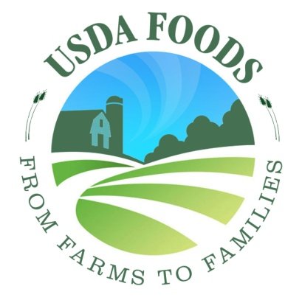 |  | 5 | 4 | 3 | 2 | 1 | 6
Logo 2  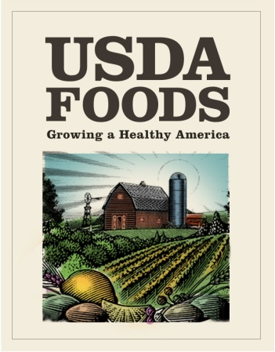 |  | 5 | 4 | 3 | 2 | 1 | 6
Logo 3  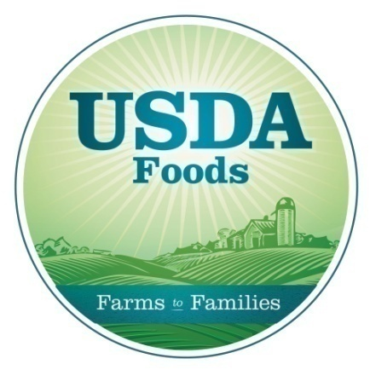 |  | 5 | 4 | 3 | 2 | 1 | 6
 | Logo 4  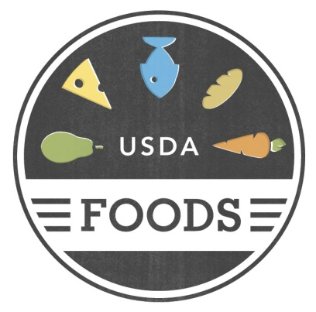 | 5 | 4 | 3 | 2 | 1 | 6
 | Logo 5  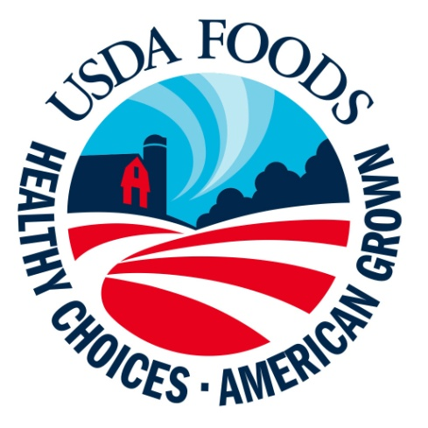 | 5 | 4 | 3 | 2 | 1 | 6

- Looking at all five logos, which one do you think will do the best job of describing USDA Commodities in the future?
1 | Logo 1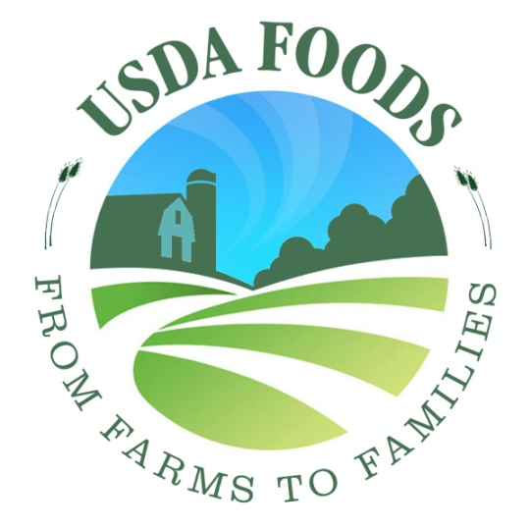
2 | Logo 2 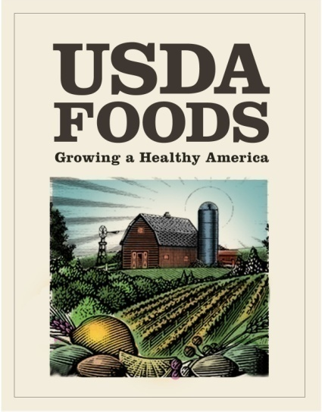
3 | Logo 3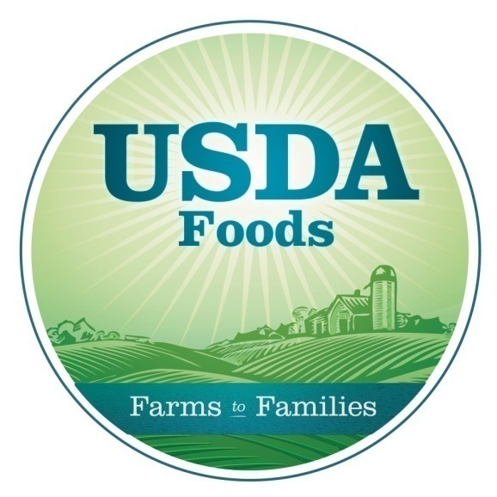
4 | Logo 4
5 | Logo 5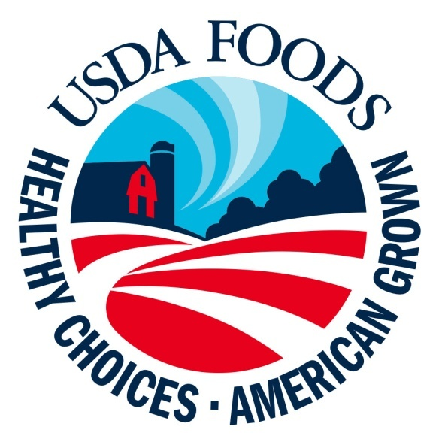

- Why did you choose this logo? RECORD VERBATIM.

- The last creative concept I’d like your input on is an informational video. I attached a file in the e-mail I sent titled “USDA Commodities Video”. The purpose of this video is to provide schools and parents information about the benefits of USDA Commodities. Please take a moment and watch this video clip.
Based on the clip you saw, how would you rate this video in terms of informing parents and schools about the benefits of the USDA Commodities program? Would you rate it as:
5 | Excellent
4 | Very good
3 | Good
2 | Fair
1 | Poor

- And how would you rate it in terms of encouraging key audiences such as parents/guardians, child nutrition professionals, teachers and school administrators, to learn more about the USDA Commodities program? Would you say it is:
5 | Extremely encouraging
4 | Very encouraging
3 | Somewhat encouraging
2 | Not very encouraging
1 | Not at all encouraging

- After viewing this video, would you say your opinion of the USDA Commodities is: ALLOW ONLY ONE RESPONSE
3 | More positive than before viewing the video,
2 | The same as before viewing the video
1 | Less positive than before viewing the video

COMMUNICATION VEHICLES
- What do you see as your role in helping communicate the benefits and purpose of the USDA Commodities program to other stakeholder audiences, including school districts, PTAs, and child nutrition professionals? RECORD VERBATIM.

- And what type of information, if any, would you like to receive from USDA Commodities?

- To what extent are you willing to be an advocate of the program? By advocate, I mean willing to talk about the benefits of the program to school officials and/or parents, or willing to distribute informational materials. Would you say you are:
5 | Extremely willing
4 | Very willing
3 | Somewhat willing
2 | Not very willing
1 | Not at all willing

- When receiving information about USDA Commodities, how would you most prefer to receive this information? ALLOW MULTIPLE RESPONSES.
1 | Industry publications
2 | E-Newsletters
3 | Brochures/pamphlets
4 | Blogs
5 | Web Site
6 | E-mail
7 | Meetings, conferences, presentations
8 | Webinars
9 | Other:

- To help us better understand the information sources you use on regular basis to obtain information about the nutrition and the food industry in general, please tell me which of the following sources you use:

1 | Local radio news broadcasts
2 | National radio news broadcasts
3 | Local TV news broadcasts
4 | National TV news broadcasts
5 | Local newspapers
6 | National newspapers
7 | Magazines
8 | Internet search engines such as Google or Yahoo!
9 | Health and/or nutrition Web sites
10 | Government Web sites
11 | Internet news sites such as CNN.com
12 | Blogs and/or online discussion groups
13 | Professional journals
14 | Professional associations
15 | Colleagues, co-workers
16 | Friends, neighbors, family members

- Those are all the questions I have. Do you have any other thoughts or comments you’d like share regarding anything we’ve discussed?

Thank you for your time!
RECORD:
RESPONDENT NAME:
ORGANIZATION:
TELEPHONE:
DATE:
INTERVIEWER:
LENGTH:

