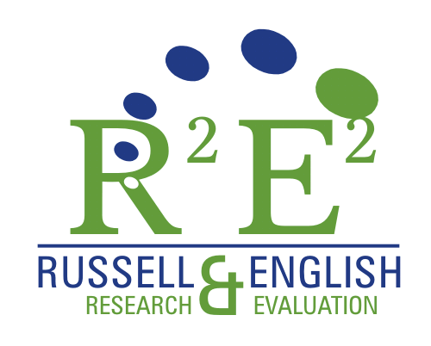
27982 Red Pine Court
Valencia, CA 91354
Tel: (800) 825 9602/(661)296 8581
Fax: (661) 296 8582
scgwer@aol.com
susan@r2e2evaluation.com

Date

Teacher name, Grade
School Name
Street Address
City, State, Zip

Dear ________ (teacher name),

Thank you for agreeing to administer the Parent/Caregiver Posttest Survey as part of the pilot test of the USDA’s The Great Garden Detective Adventure curriculum¹. After all evaluation activities have been completed (Teacher Implementation Logs, Student Survey Posttest, Parent Survey Posttest, and Teacher Posttest Interview), you will receive a stipend in the amount of $100.00.

Enclosed you will find the following items:
- Survey Administration Protocol (to be reviewed by you).
- A classroom set of the Parent/Caregiver Posttest Surveys with a packet of seeds attached to each.
- Classroom Participation Form (to be completed by you).
- A return envelope.

Please administer the survey at the conclusion of the pilot test. Once the survey has been administered, place the completed surveys and Classroom Participation Form in the return envelope. The materials need to be mailed on or before (DATE).

If you have any questions about completing the logs, please feel free to call me at (800) 825-8602, or email me at susan@r2e2evalution.com.

Sincerely,

Susan Russell, EdD, MSPH
Director

USDA/FNS OMB Contr0l No. 0584-0524; ICR ref. No 201008-0584-001- Project: Team Nutrition Gardens Formative Research

Parent/Caregiver Posttest Survey
The Great Garden Detective Adventure

Survey Administration Protocol Highlights

Survey Administrator: Classroom Teacher

Overview of survey administration:

- Administer this survey after you have completed teaching all of the lessons in the curriculum.
- Distribute the survey to all students in your classroom.
- Do not distribute the survey on a Friday. Please distribute the survey to all students at the same time.
Distributing the Survey
- Distribute the survey to each student.
- Read aloud to students:
Say: “The U.S. Department of Agriculture has asked for your parent or caregiver to complete this survey about the nutrition education you’ve been receiving in class. It’s important that you take this survey home and give it to one of your parents or caregivers tonight. Tell them to complete it and return it to you. You need to return the completed survey to me on (date), your parent or caregiver should keep the pack of seeds.”

Directions for returning surveys
- Complete the Classroom Participation Form (attached).
- Place the completed surveys and Classroom Participation Form in the return envelope provided. Mail the envelope on or before (DATE).

Classroom Participation Form
The Great Garden Detective Adventure
Parent/Caregiver Posttest Survey

School:
- (Name)
- (Name)
- (Name)

Grade:

3rd

4th

