OMB Control # 0584-0524
Expiration Date: 04/30/2013

Attachment D2 – Post-Test Survey Instruments for Students
Grades 1 – 6

Prepared by


Prepared for
JMH Education
January 2012

Research undertaken to inform the development of nutrition education materials for the U.S. Department of Agriculture Food and Nutrition Service

OMB BURDEN STATEMENT: According to the Paperwork Reduction Act of 1995, no persons are required to respond to a collection of information unless it displays a valid OMB control number. The valid OMB control number for this information collection is 0584-0524. The time to complete this information collection is estimated as 17 minutes, including the time for reviewing instructions and completing the information.

Survey for Students in Grades 1 and 2

[To be read and guided by classroom teacher]
Directions: The following questions ask about the food you eat. There is no right or wrong answer, so please be honest.

1. Yesterday, did you eat any vegetables?
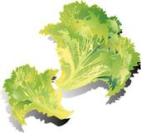

a ____No, I didn’t eat any vegetables
b ____Yes, I ate vegetables 1 time yesterday
c ____Yes, I ate vegetables 2 times yesterday
d ____Yes, I ate vegetables 3 times yesterday

2. Yesterday, did you eat any fruit? (This does not include fruit juice)
a ____No, I didn’t eat any fruit
b ____Yes, I ate fruit 1 time yesterday
c ____Yes, I ate fruit 2 times yesterday
d ____Yes, I ate fruit 3 times yesterday

3. Yesterday, did you drink any milk or eat any yogurt?
a. ____No, I didn’t eat or drink any milk or yogurt
b ____Yes, I drank milk or ate yogurt 1 time yesterday
c ____Yes, I drank milk or ate yogurt 2 time yesterday
d ____Yes, I drank milk or ate yogurt 3 time yesterday

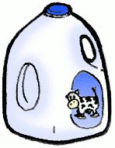

4. Yesterday, did you drink any soda, lemonade, fruit punch, or sports drinks?

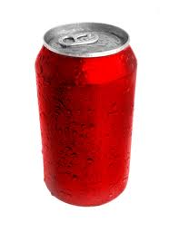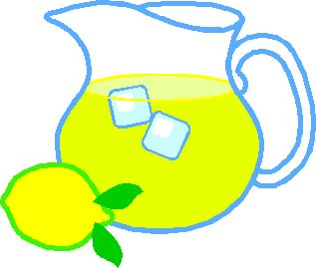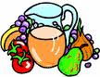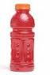
a ____No, I didn’t drink any of these drinks
b ____Yes, I drank 1 of those drinks yesterday
c ____Yes, I drank 2 of those drinks yesterday
d ____Yes, I drank 3 of those drinks yesterday

4. Yesterday, did you eat any sweet foods such as cake, cookies, or candy?

a ____No, I didn’t eat any sweets
b ____Yes, I ate sweets 1 time yesterday
c ____Yes, I ate sweets 2 times yesterday
d ____Yes, I ate sweets 3 times yesterday

5. Yesterday I played, rode my bike or walked for a total of one hour.
a. Yes________
b. No_________

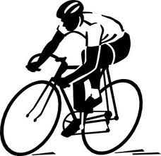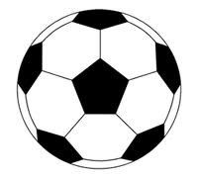

6. Put a around the foods that are in the Vegetable Group.
circle
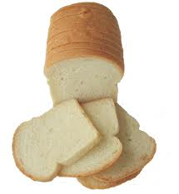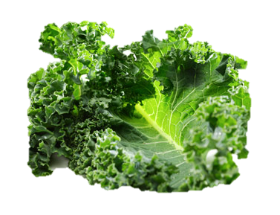
White Bread Carrot Banana Kale Grapes Cheese Peas

circle
7. Put a around the foods that are Whole Grains in the Grains Group.

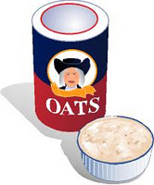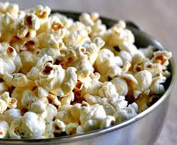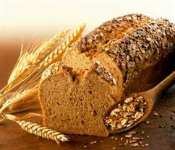

Whtie Bread Oatmeal Cheese Peas Pop Corn Banana Whole Wheat Bread

8. Put a around the foods that are in the Fruit Group.
circle

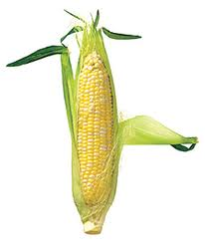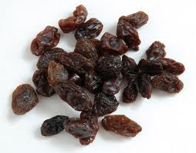

Corn Orange Raisins Apple Chicken Blueberries Whole Wheat Bread

9. Put a around the foods that are in the Protein Foods Group.
circle
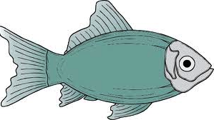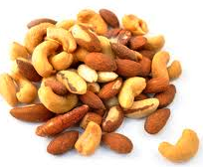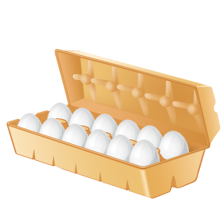

Beans Milk Fish Nuts Kale Banana Eggs

10. Put a around the foods that are in the Dairy Group.
circle

Beans Milk Cheese Apple Yogurt Doughnut Whole Wheat Bread

11. To help you eat smart to play hard, what foods are the best choices?
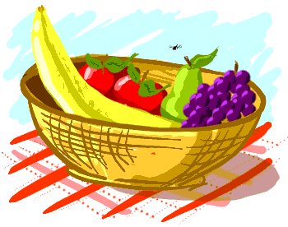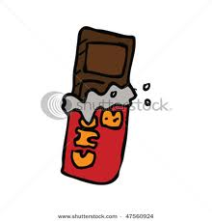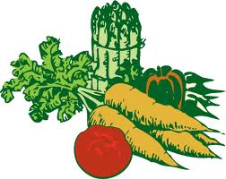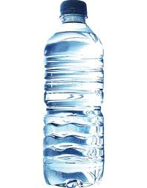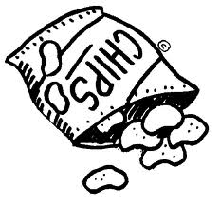
Soda Fruit Candy Vegetables Water Chips

12. Please write the letter (A,B,C,D,E) to match the plate section with the right food group:

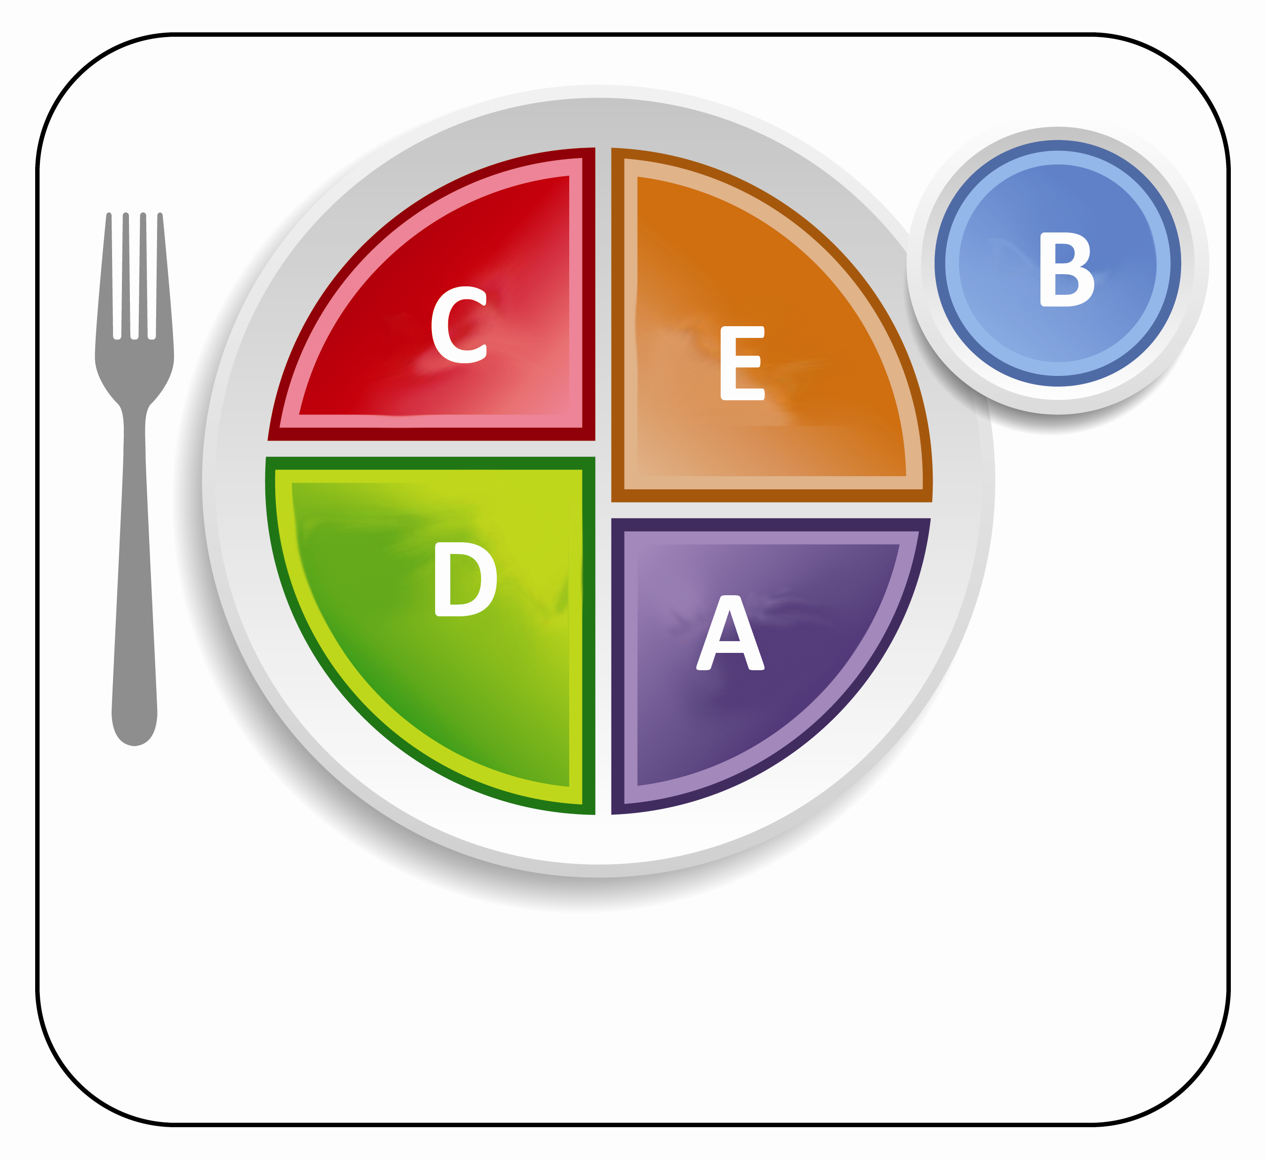

Grains ______

Vegetables ______
Fruits _______

Dairy ______

Protein Foods _______

13. In the last month, have you talked about healthy eating habits with your family?
___Yes
___No

14. How do you feel about eating vegetables?
Awesome! Good I don’t mind Not very excited. Unhappy

15. How do you feel about eating fruits?
Awesome! Good I don’t mind Not very excited. Unhappy

16. How did the nutrition lessons make you feel?

Awesome! Good I don’t mind Not very excited. Unhappy

17. How much did you enjoy the nutrition (or MyPlate) songs?

Awesome! Good I don’t mind Not very excited. Unhappy

18. How much did you enjoy Plate-O?
Awesome! Good I don’t mind Not very excited. Unhappy

OMB BURDEN STATEMENT: According to the Paperwork Reduction Act of 1995, no persons are required to respond to a collection of information unless it displays a valid OMB control number. The valid OMB control number for this information collection is 0584-0524. The time to complete this information collection is estimated as 17 minutes, including the time for reviewing instructions and completing the information.

Survey for Students in Grades 3 and 4

[To be read and guided by classroom teacher]
Directions: The following questions ask about foods and about exercise and activity level. There is no right or wrong answer, so please be honest.

1. Yesterday, did you eat any vegetables?
a ____No, I didn’t eat any vegetables
b ____Yes, I ate vegetables 1 time yesterday
c ____Yes, I ate vegetables 2 times yesterday
d ____Yes, I ate vegetables 3 times yesterday

2. Yesterday, did you eat any fruit? (This does not include fruit juice)
a ____No, I didn’t eat any fruit
b ____Yes, I ate fruit 1 time yesterday
c ____Yes, I ate fruit 2 times yesterday
d ____Yes, I ate fruit 3 times yesterday

3. Yesterday, did you eat any whole grains like whole wheat bread, brown rice or whole grain cereal?
a ____No, I didn’t eat any foods made from grain
b ____Yes, I ate whole grain foods made from grain 1 time yesterday
c ____Yes, I ate whole grain foods made from grain 2 times yesterday
d ____Yes, I ate whole grain foods made from grain 3 times yesterday

4. Yesterday, did you drink any milk or eat any yogurt?
a. ____No, I didn’t eat or drink any dairy products
b ____Yes, I drank milk or ate yogurt 1 time yesterday
c ____Yes, I drank milk or ate yogurt 2 time yesterday
d ____Yes, I drank milk or ate yogurt 3 time yesterday

5. Yesterday, did you eat any sweets, like cookies, candy, cake or brownies?
a ____No, I didn’t eat any sweets
b ____Yes, I ate sweets 1 time yesterday
c ____Yes, I ate sweets 2 times yesterday
d ____Yes, I ate sweets 3 times yesterday

6. Yesterday, how much time did you spend doing something active like playing a sport, dancing, riding a bike, running or walking?
a. ____I spent less than 15 minutes doing these things
b.____I spent more than 15 minutes
c. ____I spent more than 30 minutes
d.____I spent more than 45 minutes
e.____I spent more than an hour

circle
7. Put a around the foods that are in the Vegetable Group.

White Bread Carrot Banana Kale Grapes Cheese Peas

circle
8. Put a around the foods that are Whole Grains in the Grains Group.

Whtie Bread Oatmeal Cheese Peas Pop Corn Banana Whole Wheat Bread

circle
9. Put a around the foods that are in the Fruit Group.

Corn Orange Raisins Apple Chicken Blueberries Whole Wheat Bread

circle
10. Put a around the foods that are in the Protein Foods Group.

Beans Milk Fish Nuts Kale Banana Eggs

circle
11. Put a around the foods that are in the Dairy Group.

Beans Milk Cheese Apple Yogurt Doughnut Whole Wheat Bread

12. Please write the letter (A,B,C,D,E) to match the plate section with the right food group:

Grains ______

Vegetables ______
Fruits _______

Dairy ______

Protein Foods _______

13. What is the name of the picture above? __________________________________

14. In the last month, have you talked about healthy eating habits with your family?
___Yes
___No

15. Please put a check next to the statements below that you agree with:
- True/False - It’s important to eat fruits and vegetables that are different colors during the week.
- True/False - Low-fat (1%) or fat-free milk and yogurt help build strong bones.
- True/False - Eating a healthy breakfast helps you learn and be your best.
- True/False - White rice is a whole grain.

16. Think about the nutrition lessons you have been doing over the last few weeks. Name 3 things you liked about the lessons?
1.___________________________________________________________________________________________________________ 2.___________________________________________________________________________________________________________ 3.___________________________________________________________________________________________________________

17. If you could make them better for other students like you, what changes would you make? List 3 changes.
1.___________________________________________________________________________________________________________ 2.___________________________________________________________________________________________________________ 3.___________________________________________________________________________________________________________

18. Name 3 things you learned from the lessons that you didn’t know before.
1.___________________________________________________________________________________________________________ 2.___________________________________________________________________________________________________________ 3.___________________________________________________________________________________________________________

19. How much did you like the songs from the lessons?
_____ I Liked it a lot
_____ I Liked it a little
_____ I didn’t like it very much
_____ I didn’t like it at all

20. How much did you like the Plate-O charater?
_____ I Liked it a lot
_____ I Liked it a little
_____ I didn’t like it very much
_____ I didn’t like it at all

OMB BURDEN STATEMENT: According to the Paperwork Reduction Act of 1995, no persons are required to respond to a collection of information unless it displays a valid OMB control number. The valid OMB control number for this information collection is 0584-0524. The time to complete this information collection is estimated as 17 minutes, including the time for reviewing instructions and completing the information.

Survey for Students in Grades 5 and 6

[To be read and guided by classroom teacher]
Directions: The following questions ask about foods and about exercise and activity level. There is no right or wrong answer, so please be honest.

1. Yesterday, did you eat any vegetables?
a ____No, I didn’t eat any vegetables
b ____Yes, I ate vegetables 1 time yesterday
c ____Yes, I ate vegetables 2 times yesterday
d ____Yes, I ate vegetables 3 times yesterday

2. Yesterday, did you eat any fruit? (This does not include fruit juice )
a ____No, I didn’t eat any fruit
b ____Yes, I ate fruit 1 time yesterday
c ____Yes, I ate fruit 2 times yesterday
d ____Yes, I ate fruit 3 times yesterday

3. Yesterday, did you eat any whole grains like whole wheat bread, brown rice or whole grain cereal?
a ____No, I didn’t eat any foods made from whole grains
b ____Yes, I ate foods made from whole grains 1 time yesterday
c ____Yes, I ate foods made from whole grains 2 times yesterday
d ____Yes, I ate foods made from whole grains 3 times yesterday

4. Yesterday, did you drink any milk or eat any yogurt?
a. ____No, I didn’t eat or drink any milk or yogurt
b ____Yes, I drank milk or ate yogurt 1 time yesterday
c ____Yes, I drank milk or ate yogurt 2 times yesterday
d ____Yes, I drank milk or ate yogurt 3 times yesterday

5. Yesterday, did you eat any sweets, like cookies, candy, cake or brownies?
a ____No, I didn’t eat any sweets
b ____Yes, I ate sweets 1 time yesterday
c ____Yes, I ate sweets 2 times yesterday
d ____Yes, I ate sweets 3 times yesterday

6. Yesterday, did you eat any of the following foods that were high in salt (sodium)?
(hot dogs, bacon, sausage cheesy foods like pizza, luncheon/deli meats, frozen dinners,or salty snacks like pretzels or chips)

a ____No, I didn’t eat any foods that were high in salt (sodium)
b ____Yes, I ate foods that were high in salt (sodium) 1 time yesterday
c ____Yes, I ate foods that were high in salt (sodium) 2 times yesterday
d ____Yes, I ate foods that were high in salt (sodium) 3 times yesterday

7 Yesterday, how much time did you spend doing something active like playing a sport, dancing, riding a bike, running or walking?

a ____I spent less than 15 minutes doing these things
b ____I spent more than 15 minutes
c ____I spent more than 30 minutes
d ____I spent more than 45 minutes
e ____I spent more than an hour

8. Please answer whether the following statements are True of False:

- True/False - It’s important to eat fruits and vegetables that are different colors during the week.
- True/False - Low-fat (1%) or fat-free milk and yogurt help build strong bones.
- True/False - Eating a healthy breakfast helps you learn and be your best.
- True/False - White rice is a whole grain.

9. Please name the six main nutrients?

1) _____________________ 2)______________________ 3)_________________________
4)______________________ 5)______________________ 6)_________________________

10. Please write the letter (A,B,C,D,E) to match the plate section with the right food group:

Grains ______

Vegetables ______
Fruits _______

Dairy ______

Protein Foods _______

11. What is the name of the picture above? __________________________________

12. In the last month, have you talked about eating healthy foods with your family?
___Yes
___No

Chocolate Chip Cookies Cheese Flavored Crackers Potato Chips Yogurt 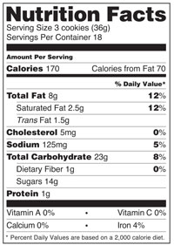 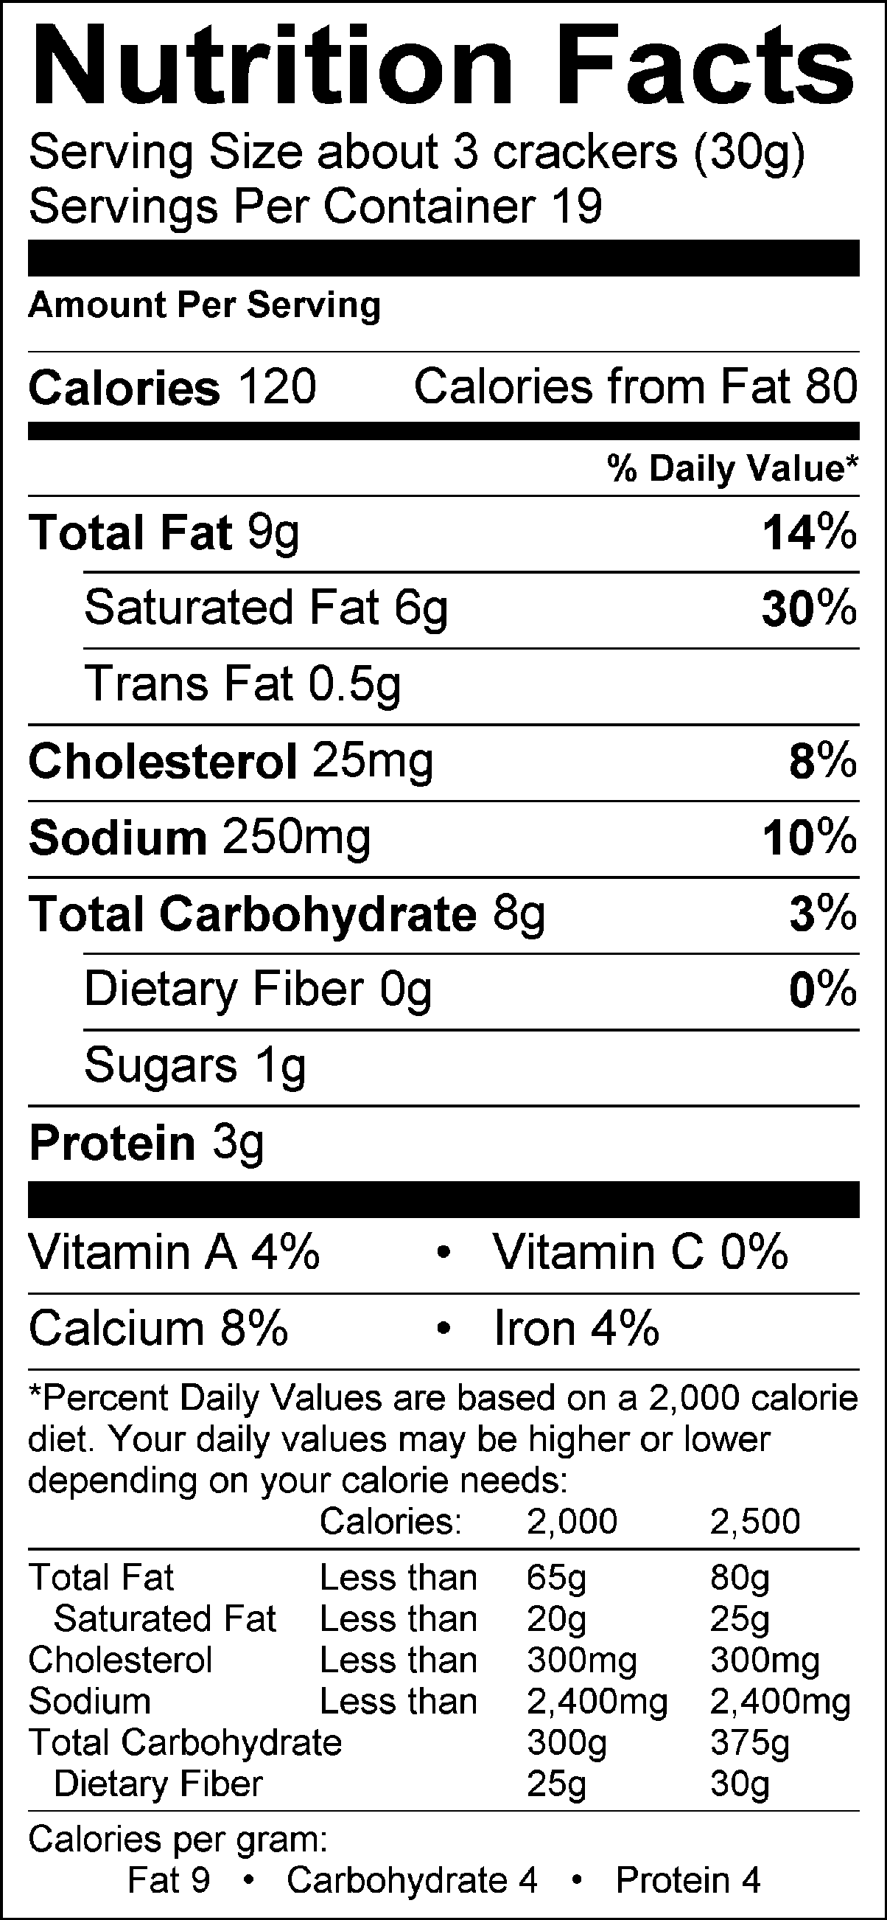 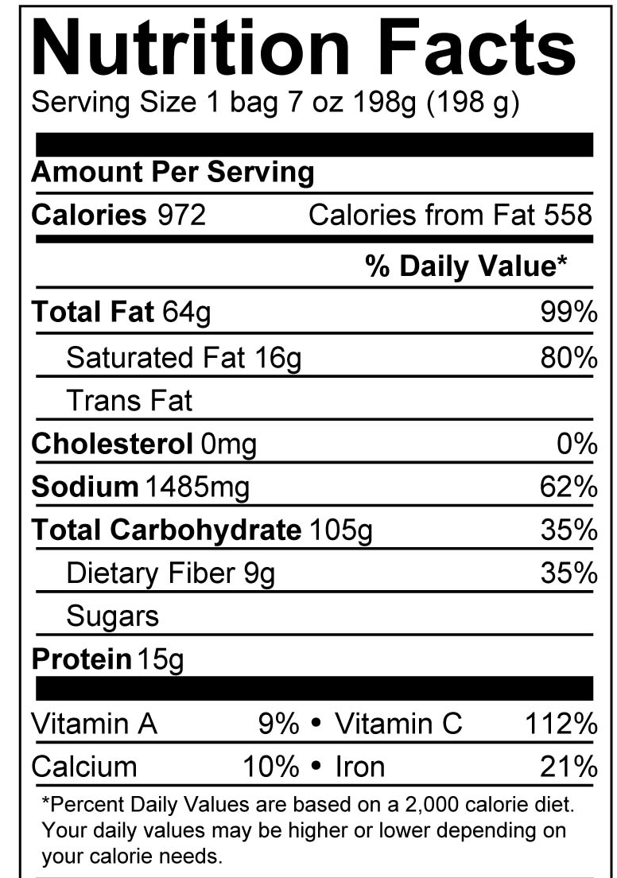 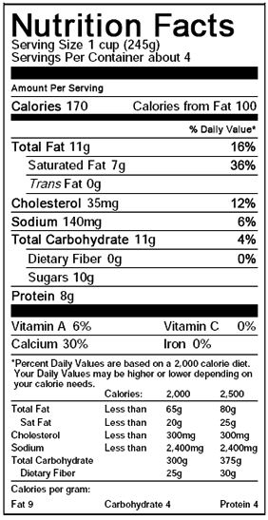
_________________________________ __________________________________ ___________________________________ ___________________________________
Please look over the nutrition labels above and complete the following fill in the blanks:

13. Please use the lines above to label which food group each snack belongs to.
14. Which snack has the most sodium per serving size? ____________________________.
15. Which snacks has the most calcium per serving size?___________________________________________________.
16. Which snack do you think is the healthiest? [please mention at least 2 reasons you think it’s a healthier option] _______________________________________________________________________________________________________________________________________________________
_____________________________________________________________________________________________________________________________________________________________________________________________________________________________________________________________________________________________________________

