OMB Control # 0584-0524

Expiration Date: 04/30/2013

**OMB BURDEN STATEMENT**:  According to the Paperwork Reduction Act of 1995, no persons are required to respond to a collection of information unless it displays a valid OMB control number.  The valid OMB control number for this information collection is 0584-0524. The time to complete this information collection is estimated as 35 minutes, including the time for reviewing instructions and completing the information.

**Attachment C1: Message Handout – Whole Grains and Supporting Content**

**WG1.**

**Give yourself and those you love the goodness of whole grains.**

Make at least half of the grains you eat whole grains – such as bread, tortillas, pasta and cereals. Whole grains are good for your heart and digestion, and can help you maintain a healthy weight and good overall health.

**WG2.**

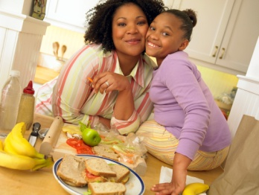

**Whole grains make a difference.**Whole grains help keep your heart healthy and are good for digestion and a healthy weight. Choose foods with “100% whole wheat” or “100% whole grains” on the label. Or check the ingredient list to see if the word “**whole**” is before the first ingredient listed (for example, *whole* wheat flour). If it is, it’s whole-grain.

**WG3.**

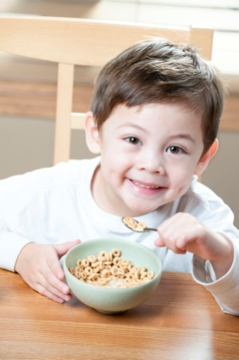

**Start them early with whole grains.**

It’s easy to get your kids in the habit of eating and enjoying whole grains if you start when they are young. Whole grains give your kids B vitamins, minerals and fiber to help them be strong and healthy.

**WG4.**

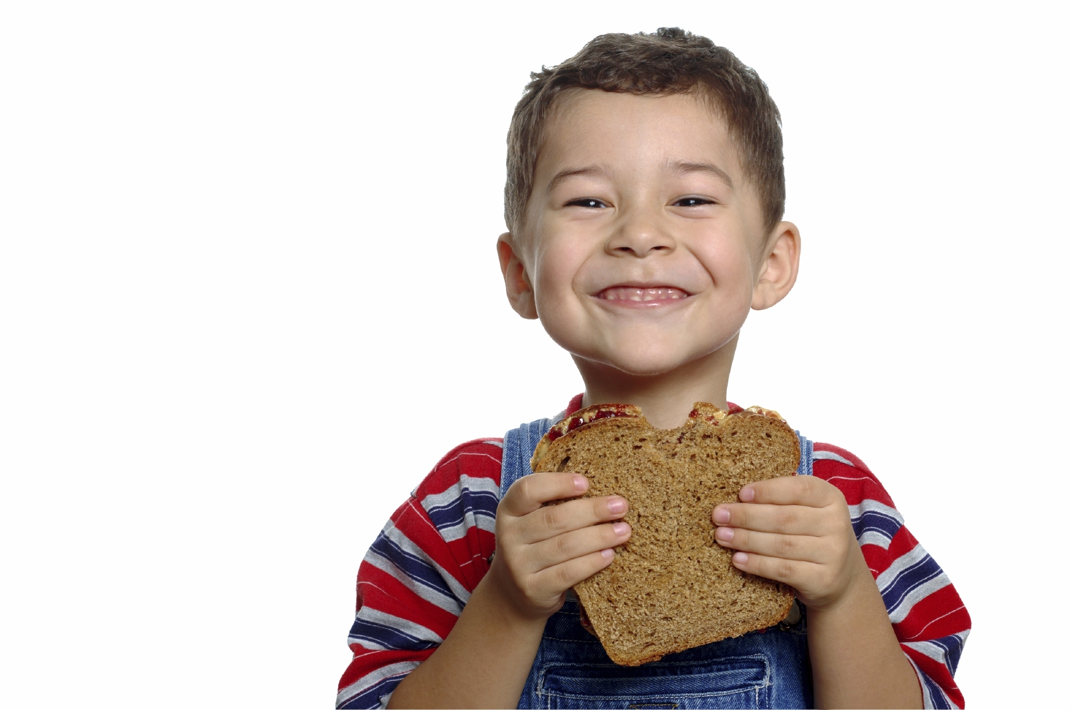 **Happy kids. Happy tummies.**

Serve your little ones a whole grain versions of their favorite bread, cereal or pasta. It’s a simple way to help them eat more whole grains. And, eating more whole grains that are higher in fiber can make potty time easier.

**WG1a.**



**One Mom’s Story:**

**Discovering the Goodness of Whole Grains**

When I asked my doctor what simple change I could make in my diet to improve my health, she said, “Switch to whole-grain versions of foods like bread, cereal, pasta, and crackers. Whole grains will help your family have a healthy heart and body weight and better digestion. They also can help reduce the risk of type 2 diabetes. That means better overall health for the whole family.” So, I started thinking about the grains my family eats, especially the kids. I decided it was worth it to make a few small changes for our health. Now I’m buying oatmeal, brown rice, whole-grain cereals and 100% whole-grain bread. To be honest, making the switch was easier than I thought. It took a little time, but now we are all enjoying the goodness of whole grains.

**WG1b.**

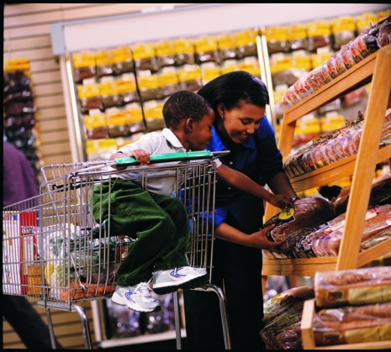

**How to Tell If It Is a Whole Grain?**

Make sure you buy the real thing. It’s worth it to know that your family will get the healthy goodness of whole grains. Because some foods that seem to be whole grains may not be, it’s important to know what to look for. Here are some tips that work:

* **Choose foods that are naturally whole grains**: Some foods are always whole grains, like oatmeal, brown rice, wild rice and popcorn.
* **Check the information on the package**: Buy bread, cereal, tortillas, and pasta with “100% Whole Grain” or “100% Whole Wheat” on the package.

Foods with the following words on the label are usually *not* 100% whole-grain products.

* + - 100% wheat
    - Multi-grain
    - Contains whole grain
    - 7 grains
    - Cracked wheat
    - Made with whole grains
    - Made with whole wheat
    - Bran
* 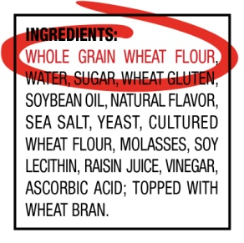**Check the ingredient list**: Take a few seconds to see if the food is made from whole grains. Look for the word “whole” before the first ingredient. Some examples of whole-grain ingredients include:
  + brown rice
  + buckwheat
  + bulgur
  + graham flour
  + oatmeal
  + quinoa
  + rolled oats
  + whole-grain barley
  + whole-grain corn
  + whole oats
  + whole rye
  + whole wheat
  + wild rice
* **Colors can be misleading.** Foods like breads, pasta, rice, and tortillas that are dark in color may not be 100% whole-grain foods. And, some lighter color grain foods may be 100% whole-grain foods, such as “100% White Whole Wheat” bread. To make sure a food is a whole-grain food, check the ingredients using the tips above.

**WG1c.**

|  |  |
| --- | --- |
| **Give it Try!** Can you tell which food is a whole-grain food based on the ingredients? Look for the word “whole” before the first ingredient. | |
|  |  |
|  | 1. **Bread** Ingredients: Wheat Flour, Malted Barley Flour, Niacin, Iron, Riboflavin, Folic Acid |
|  | 1. **Tortilla** Ingredients: Whole Wheat Flour, Soybean Oil, Salt, Corn, Starch, Wheat Starch |
|  | 1. **Dry Cereal** Ingredients: Whole Corn Meal, Whole Grain Oats, Corn Starch, Canola Oil, Cinnamon, Brown Sugar |
|  | 1. **Cracker** Ingredients: Whole Grain Brown Rice Flour, Sesame Seeds, Potato Starch, Safflower Oil, Quinoa Seeds, Flax Seeds, Salt |
|  | 1. **Roll** Ingredients: Unbleached Enriched Wheat Flour, Sugar, Salt, Soybean Oil, Oat Bran, Yellow Corn Meal, Salt, Barley, Rye |

*Answer: b, c and d are whole grains because they list ‘whole’ grains.* **WG1d.**

**Whole Grains: How Much Is Enough Each Day?**

**Q. How much whole grains should my family eat every day?**

**A:** In general, most family members need to eat about 6-8ounces of grains daily, such as bread, cereal, rice, pasta, and tortillas. Younger kids (age 8 or less) need a little less – about 3-5 ounces. A good rule of thumb is that *at least half* of these grains should be *whole grains*. So, that’s about 3 ounces of whole grains for adults each day, and 1 ½ to 2 ½ ounces for younger kids age 8 years or less. (Some active children may need more calories and therefore more grains.)

**WG1e**

**Q. What counts as an ounce of whole grains?**

**A:** Here are a few easy examples:

* 1 regular slice of whole-grain bread
* 1 cup dry ready-to-eat whole-grain cereal flakes
* ½ cup of cooked brown or wild rice, oatmeal or whole grain pasta
* 1 whole-grain tortilla (6” diameter)
* 1 pancake (5” diameter) made with whole-grain flour
* A small whole-grain muffin

**WG1f.**

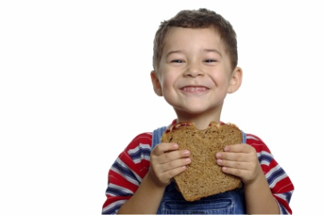

**Q. How can I fit the recommended amount of whole grains into my family’s day?**

**A:** Here are some easy ways to include whole-grain foods in your meals throughout the day. Each food shows the amount and the number of ounces of whole grains it equals. Remember that children age 8 or less need a total of about 3-5 ounces of grains each day, so make half of these (about 1 ½ to 2 ½ ounces) whole grains!* The total amount of grains adults and older kids need is about 6-8 ounces so they need about 3 – 3 ½ ounces of whole grains each day.

**WG1g.**

|  |  |  |  |
| --- | --- | --- | --- |
| ***Different Ideas for Whole Grains at Every Meal*** | | | |
| **Breakfast** | **Lunch** | **Snack** | **Dinner** |
| * One cup of whole-wheat cereal flakes (**1 ounce**) with fat-free or low-fat milk * ½ cup cooked oatmeal (**1 ounce**) topped with a favorite fruit and a little sugar or honey * One regular slice of whole-grain toast (**1 ounce**) with a slice of low-fat cheese | * Two regular slices of whole-wheat bread (**2 ounces**) as part of a sandwich (each regular slice of bread is one ounce) * One small whole-grain tortilla (**1 ounce**) sprinkled with low-fat cheese and veggies * 1/2 cup cooked brown rice (**1 ounce**) with stir fry | * Five whole-grain crackers (**1 ounce**) with low-fat cheese and apple slices * Three cups of popped corn ** (**1 ounce**) * 1/2 cup of dry whole- grain cereal flakes (**1/2 ounce**) mixed into low-fat yogurt | * One cup of cooked brown or wild rice (**2 ounces**) with chili and beans * One cup of cooked whole-grain pasta (**2 ounces**) with tomato sauce * One small whole-grain dinner roll (**1 ounce**) |

** Popped corn is a choking risk for children under 4 years old.

**WG2a.**

**Whole Grains and Your Family’s Health**

Whole grains are rich sources of vitamins, minerals, fiber and other nutrients that help keep your kids healthy and strong. Make sure your kids get the goodness of this “whole” nutrition every day. Here is just some of what whole grains can do for your kids:

c



a

*The minerals in whole grains help maintain normal muscles, nerves and a healthy immune system.*

*Whole grains help fuel kids’ days by providing and helping them maintain energy.*

d.

b

*Whole grains have B vitamins for healthy red blood cells. They also help manage healthy blood glucose (sugar).*

*The fiber in whole- grain foods keeps your kids feeling full longer, and that can help with a healthy body weight.*

e.

*Whole grains are good for digestion and general health.*

Adults benefit from whole grains, too. Eating whole-grain foods that are high in fiber can help protect against heart disease, reduce the risk of type 2 diabetes, support a healthy body weight, and is good for overall health. That’s the goodness of whole grains.

**WG3a.**

**Fitting Whole Grains into Your Preschooler’s Day**

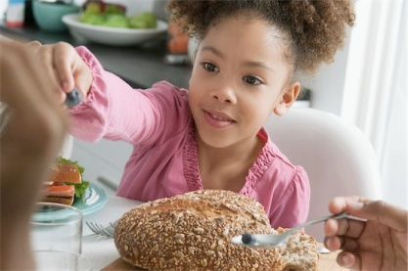Little ones, like adults, need to eat whole grains every day as part of an overall healthy diet. When you introduce whole-grain foods to children when they are young, it helps them learn to love them. And, it’s easy to make whole-grain foods a part of tasty meals and snacks. Here are ways to fit whole grains into your preschooler’s day:

**WG3b.**

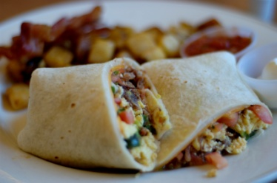**Start the Day the Whole-grain Way**

* **Cereal Mixer –** Combine two or three of their favorite whole-grain cereals with different shapes. Talk about the shapes to help them learn to name them.
* **Oatmeal Topper –** Top it with a favorite fruit and spices.
* **Wake and Make Burrito** **–** Stuff a whole-grain tortilla with chopped veggies, scrambled eggs and low-fat cheese.

**WG3c.**

**Create Fun Snacks**

* **Pre-pack Your Snacks –** Pack a sandwich bag with a little whole-grain dry cereal for your kids to eat at the park, mall or grocery store.
* **Crack Them Up –** Serve whole-grain crackers with soup or salads for lunch. Serve them with low-fat cheese and a slice of tomato on top for a quick snack.

**WG3d.**

**Make Quick and Easy Meals with Whole Grains**

* **Pick a Pita for Lunch –** Spread a whole-grain pita with low-fat cottage cheese and stuff it with chopped veggies. Warm and serve!
* **Make a Healthy Pizza –** Top a whole-grain tortilla or English muffin with fresh tomato slices, low-fat cheese, leftover chicken or other lean meat and pizza spices. Heat and serve!
* **Pass the Pasta –** Try different shapes and colors of whole-wheat pasta. Sprinkle it with a little olive oil and low-fat cheese. Add chopped veggies and spices or tomato sauce for a quick lunch or dinner. Use whole-grain pasta for your macaroni and cheese recipes and other family favorites, too.
* **Peanut Butter and Banana On a Roll** **–** Spread 1 tablespoon of peanut butter on a slice of 100% whole-grain bread or whole-grain tortilla. Add ½ of a banana and roll it up. Your kids will love it.
* **Quick Quesadilla –** Place one slice of low-fat cheese on a whole-wheat tortilla. Add chopped onions, peppers or other colorful veggies and microwave (45-60 seconds) until the cheese melts.
* **Sneak Attack –** Add oatmeal, cooked brown rice, whole corn meal or whole-wheat bread crumbs to casseroles. You can also use ½ whole-wheat flour and ½ all-purpose flour when making pancakes or muffins.

**WG3e.**

**Offer Something Sweet**

* **Make It a Whole-Grain Sundae –** Sprinkle crushed whole-grain cereal over a small scoop of frozen yogurt and top with berries or other fruits.
* **Try Sweet Toast** **–** Top a toasted piece of whole-grain bread with cinnamon, ½ teaspoon of sugar and applesauce.

**WG4a.**



**One Mom’s Story:  
Keeping My Kids Happy, Healthy and Regular With Whole Grains.**

I used to think eating healthy was so hard. But, some of the best advice, like eating whole grains is easier than I thought. Whole grains are good for digestion. And, because they have lots of fiber, they make potty time easier for my kids. I look at the ingredients and buy whole-grain crackers, bread, pasta, dry cereals, and tortillas with the word “whole” before the first ingredient. I get brown rice and oatmeal too, since they’re naturally whole-grain and easy to find. Sure it might take a few extra minutes at the store to make sure I’m buying whole grains, but it’s worth it to see my kids happy, healthy and regular.