**OMB BURDEN STATEMENT**:  According to the Paperwork Reduction Act of 1995, no persons are required to respond to a collection of information unless it displays a valid OMB control number.  The valid OMB control number for this information collection is 0584-0524. The time to complete this information collection is estimated as 35 minutes, including the time for reviewing instructions and completing the information.

**Attachment D2: Message Handout – Milk Messages**

**ME-1.**



**There’s no power like Mom Power.**  You are a positive influence in your children’s lives. Help them develop healthy eating habits for life. Offer them fat-free or low-fat (1%) milk and yogurt at meals and snacks.

**ME-2.**



**Milk Matters.**

Children of every age, and adults too, need the calcium, protein and vitamin D found in milk for strong bones, teeth and muscles. Serve fat-free or low-fat (1%) milk or yogurt at meals and snacks.

**ME-3.**



**They’re still growing.**Help your kids grow strong. Serve fat-free or low-fat (1%) milk at meals.

**ME1a.**

**One Mom’s Story:   
Using “Mom Power” for Good**

As a mom, it’s my job to make sure my family gets the foods they need every day – like milk. That’s why I serve fat-free or low-fat (1%) milk to my kids. I also keep low-fat or fat-free yogurt and cheese in the house for healthy snacks. This helps my kids eat better, develop healthy habits, and grow strong.

**ME1b.**

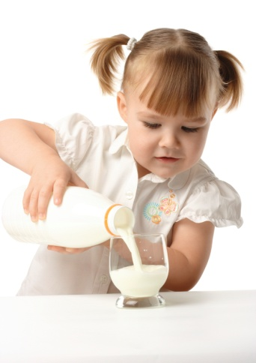**When it comes to keeping it fun, here are some ideas that work for us:**

1. **Keep fat-free or low-fat (1%) milk in the refrigerator for snacks**. A frosty glass of milk tastes great and is an easy way to refuel kids after play.
2. **Make it special:** On cold days, we enjoy hot milk with cinnamon and a touch of vanilla extract.
3. **Prepare snacks and meals together:** Once a week, the kids and I make smoothies. We blend together low-fat (1%) milk, their favorite fruits or 100% fruit juice, and fat-free yogurt.
4. **Mix milk, cheese, and yogurt with other foods.** I put plain fat-free yogurt on baked potatoes. It tastes like sour cream and my kids don’t know the difference. When I make oatmeal, I use low-fat (1%) milk instead of water for great taste and nutrition. Occasionally, I sprinkle low-fat cheese on foods like chicken, whole-grain noodles, and vegetables.

**ME1c.**

**Moms often ask:**

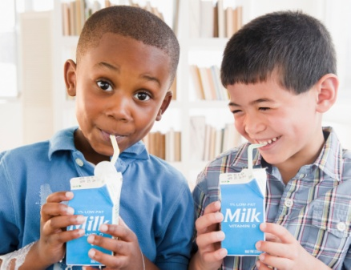**Q. How much milk does my family need each day?**

**A:** The amount of milk we need each day depends on age. Younger kids need 2 cups, while older kids and adults need 3 cups. Here are daily recommendations by age:

|  |  |
| --- | --- |
| **Age** | **Daily Amount Recommended** |
| Children ages 2-3 | 2 cups |
| Children ages 4-8 | 2 ½ cups |
| Kids ages 9-18 | 3 cups |
| Adults | 3 cups |

**Q. Do my kids get enough milk at school?**

**A:** Probably not. Most kids only get 1 cup (8 ounces) of low-fat milk as part of a school lunch. So, to get the recommended amount of milk each day, many kids need to have some at home, too.

**ME1d.**

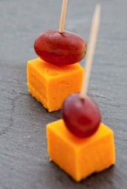**Q. How can I help my family get the milk they need each day?**

**A:** Try to make milk a part of the meals and snacks kids have at home. A cold glass of milk goes great with dinner, and after school or play. Offer foods made from milk – like low-fat or fat-free yogurt – as snacks and desserts. Eight ounces of yogurt is about the same as a cup of milk. You can also try small amounts of low-fat cheese as snacks. About 1½ - 2 ounces of most types of hard cheese is about the same as a cup of milk. Try cutting an eight-ounce block of cheese into eight equal, bite-sized pieces—each piece will be approximately 1 ounce. Plus, a block of cheese is usually less costly than pre-sliced cheese. If you buy sliced cheese, count each slice as about 1/3 cup of milk. Here are other ideas – check those you plan to try.

**ME1e.**

|  |  |
| --- | --- |
| **Give Them the Milk They Need** | |
|  | ***Tried It!*** |
| 1. Use fat-free or low-fat milk (1% fat) instead of water to make oatmeal and hot cereal for breakfast. |  |
| 1. Serve fat-free or low-fat yogurt as a snack. Mix it up with fruit and nuts. |  |
| 1. Try a grilled cheese sandwich made with low-fat cheese for breakfast. |  |
| 1. Make a dip for fruits or vegetables from fat-free or low-fat yogurt. |  |
| 1. Try chocolate or butterscotch pudding made from fat-free or low-fat milk. |  |

**ME1f.**

**One Mom’s Story:**

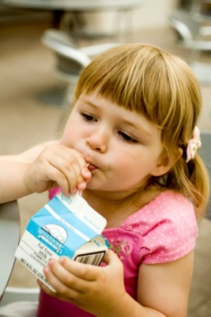**Fat-free and Low-fat (1%) Milk Are Healthier Than Whole Milk. Who Knew?**

Milk helps kids grow strong. So it’s important to me that my kids get the milk they need every day. I used to believe that fat-free and low-fat milk were not as healthy as wholemilk. Then I learned that they have the same calcium, protein, vitamin D, and other nutrients, just less fat. The saturated fat in other milk increases the risk of heart disease. So, my pediatrician told me that after age 2, kids don’t need that fat. That’s why I made the transition to low-fat (1%) milk. First I switched to 2% milk, then after a couple of weeks I switched to 1%. The kids didn’t even notice.

**ME-2a.**

**Fuel Their Day With Milk!**

As a mom, I want to make sure my kids get the fuel they need to grow strong, stay healthy, and power their day. That’s why I have fat-free or low-fat (1%) milk on hand. It gives everyone in our family the calcium, protein, and vitamin D we need, without the extra fat from whole milk. Sometimes they like to mix it up, so I keep low-fat milk products, like fat-free yogurt and low-fat cheese, in the fridge, too. I like to think of low-fat milk, cheese, and yogurt as healthy fuel for my family.

**Here are some ways we use it to fuel our day:**

a.

* **Keep it quick and easy** 
  + 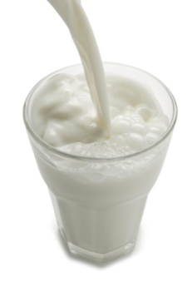Pour fat-free or low-fat (1%) milk over whole-grain cereal. Or, melt a slice of low-fat mozzarella cheese on toasted whole-wheat bread for a quick and easy breakfast.
  + Keep fat-free or low-fat (1%) milk in the refrigerator. A cold glass of milk is a tasty way to quench your kids’ thirst after play or school. And milk is a healthy way to replace some of the fluids lost during the day.
  + Pair their favorite fruit with low-fat cheese and whole-grain crackers for a quick and easy snack.

**b.**

* **Make it fun**
* Put out different kinds of low-fat yogurt, fruit, and whole-grain cereal on the table. Let your kids get creative and make their own combination. They’ll love the healthy snack they made all by themselves and sharing the recipe with their friends.
* Cut up and put their favorite fruit in a bowl. Add low-fat milk with a touch of vanilla extract. Then add whole-grain cereal on top for some crunch. Your kids will love this tasty and healthy snack.

**ME-3a.**

**Moms often ask:**

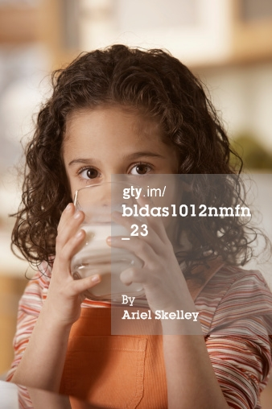

**Q. Why is it important for my elementary child to drink milk?**

**A.** Like children of all ages, elementary kids are still growing. So it’s important they drink the recommended amount of fat-free or low-fat (1%) milk to grow healthy and strong. For kids ages 9-13, that’s about 3 cups of milk each day. And fat-free and low-fat (1%) fat milk contains nine key nutrients like calcium, protein, and vitamin D, just without the extra saturated fat.

**ME-3b.**

**Q. How do I increase the amount of milk my child gets?**

**A**. Here are some tips moms can use to get their kids to drink more fat-free or low-fat (1%) milk:

* Serve fat-free or low-fat (1%) milk with meals and snacks.
* Put fat-free or low-fat (1%) milk at eye level in the refrigerator, so kids are more likely to see and ask for a glass or to have it poured over whole-grain cereal.
* Add milk to some of your child’s favorite foods, such as soups and oatmeal. For example, make creamy tomato soup instead of classic tomato soup by adding 1% fat milk.
* Occasionally, let your kids have some flavored fat-free or low-fat (1%) milk. Compare nutrition labels at the store and choose flavored milks with the least amount of sugar.
* Enjoy a glass of low-fat milk or yogurt with your child. Or, make a parfait together by layering low-fat yogurt, your favorite fruit, and unsalted nuts or cereal. There are many types of low-fat milk foods, so there is something for everyone to enjoy.