**OMB BURDEN STATEMENT**:  According to the Paperwork Reduction Act of 1995, no persons are required to respond to a collection of information unless it displays a valid OMB control number.  The valid OMB control number for this information collection is 0584-0524. The time to complete this information collection is estimated as 35 minutes, including the time for reviewing instructions and completing the information.

**Attachment D3: Message Handout – Fruit/Vegetable/Availability/Accessibility Messages**

**FV-E1.**

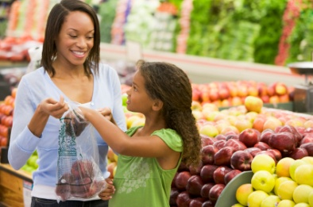

**Let your kids be produce pickers.**Help them pick fruits and veggies at the store.

**Attachment D3: Message Handout – Fruit/Vegetable/Availability/Accessibility Messages and Supporting Content**

**FV-E2.**

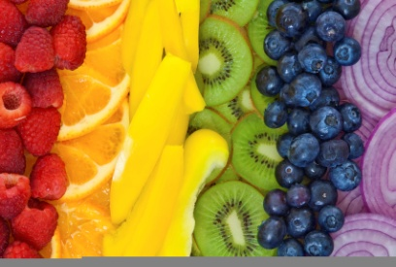

**When they come home hungry, have fruits and veggies ready to eat.**

**FV-E3.**

**Want your kids to reach for a healthy snack? Make sure fruits and veggies are in reach.**

**FV-E1a.**

**Q. How can I get my child to help with choosing fruits and vegetables?**

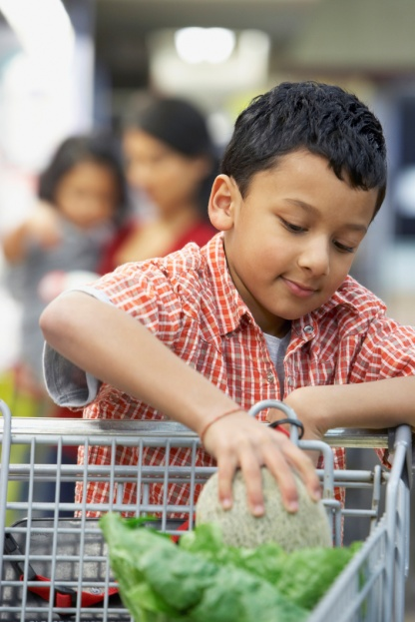**A. Try some of these ideas:**

-Before going to the market, look over the store flyer together. Ask them to pick out which fruits and vegetables to buy.

-Use games about fruits and vegetables to get kids excited about selecting them at the store.   
  
For example: Challenge your child to see how many colors he or she can include in fruit and vegetable choices. Different colors contain different nutrients. A mix of colors gives them the different vitamins and minerals they need to stay healthy.

* Encourage your child to choose from various forms of fruits and vegetables – canned, frozen, and fresh. They all contain important vitamins and minerals. Plus, canned and frozen forms last longer. Buy canned veggies without added salt and canned fruits without added sugar or packed in 100% fruit juice.
* Ask your kids to pick a fruit or vegetable for a snack or dessert.

**FV-E2a.**

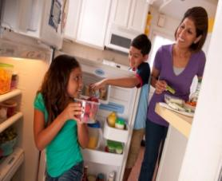

**Moms Story: Healthy Snacks for Hungry Kids:**

“I’m hungry.” That’s the first thing my kids say when they come through the door. I need something to feed them—fast. Sometimes they go to the kitchen and get their own snacks. I

found that when I put fruits and vegetables in a place where my kids can see them--they eat them. Now I keep cut-up veggies on a low shelf in the fridge and a bowl of fresh fruit on the counter. When I don’t have fresh fruits and veggies, I use canned or frozen. It takes a little planning, but it’s worth it. I know fruits and vegetables help them stay healthy.

**FV-E2b.**

**Keep Fruits and Veggies Where They’re Easy To See**

* Keep a bowl of washed fresh fruits on the kitchen table.
* Put washed and cut fruits and vegetables on a shelf in your refrigerator where your child can see them.

**FV-E2c.**

**Make-Ahead Fruit and Veggie Snacks from the Fridge**

* Toss veggies with cooked pasta and fat-free Italian dressing.
* Slice apples. Dip them in pineapple or orange juice to keep them from turning brown.
* Store apples in plastic snack bags or covered bowls in the fridge.
* Kids love to dip fresh veggies in low-fat ranch dressing. Cut up veggies. Store them near the dip on a low shelf in the fridge.

**FV-E2d.**

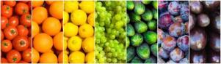

**One Mom’s Story: Eating a Rainbow**

I know kids need a variety of foods to stay healthy and I recently learned that eating different colored fruits and vegetables provides a wider variety of the nutrients we need. So, as a fun activity, when I take my kids to the farmers’ market or grocery store, I ask each of them to pick out a different colored fruit or vegetable. They’re more likely to try something new when they choose it themselves. And the more colors they try, the more nutrients they’ll likely to get.

That’s the pot of gold at the end of the rainbow!

**FV-E3a.**

**Dip-a-licious! Recipes Moms and Kids Love!**

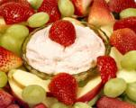

**1. Fruit Wands with Pink Princess Dip or “Swamp Slime”**

* Put pieces of fruit on a toothpick, skewer, or straw.
* Cover with plastic wrap and store in the refrigerator until snack time.
* Serve with low-fat strawberry (Princess Dip) or lime yogurt (Swamp
* Slime) for dipping.

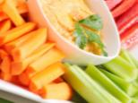

**2. Happy Snack Packs**

* Fill small containers or snack bags with cut-up veggies.
* Add a small container of fat-free ranch dressing for dipping.
* Decorate the outside of the bags with stickers.
* Store in the refrigerator on a shelf where they are easy for your child to see.

**3. Dip Your Favorite Veggies in These Tasty Dips**

* (1 serving is 2 tablespoons of dip)
* Honey-Mustard Dipping Sauce
* 1/4 cup fat-free plain yogurt
* 1/4 cup low-fat sour cream
* 2 teaspoons honey
* 2 teaspoons spicy brown mustard
* Mix all ingredients together. Store in a covered container in the refrigerator. Makes 4 servings.

**4. Curry Dip**

* 1 cup fat-free sour cream
* 1 cup fat-free plain yogurt
* 1 tablespoon curry powder
* Mix all ingredients together. Store in a covered container in the refrigerator. Makes 16 servings.

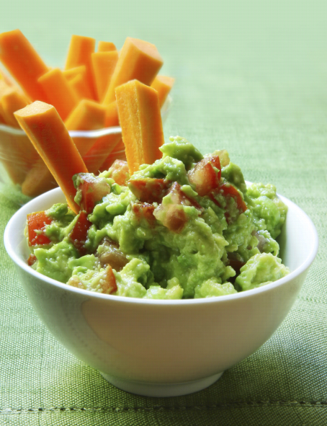**5. Avocado Dip**

* 2 medium ripe avocados
* 1 tablespoon lemon juice
* ¼ cup salsa
* 1/8 teaspoon salt
* Peel and chop avocados. Toss avocado with lemon juice in small bowl.
* Add salsa and salt. Mash with a fork.
* Cover and store in the refrigerator. Makes 12 servings

**Closing Question**

#### Of all of the ideas we talked about this evening, which one would you be most likely to try in your own household or to tell a friend to try?