<<Date>>

Certificate of Compliance

<<Name>>
<<Title>>
<<Company>>
<<Address_1>>
<<Address_2>>
<<City, State Zip>>

Dear <<Salutation>>:

This is to inform you that the Office on Smoking and Health is in receipt of the Ingredient Report and Smokeless Nicotine Data submitted on <<Date>>, behalf of <<Company>> for the smokeless tobacco products for the calendar year of 2011. The submission meets the requirements and is in full compliance with the Comprehensive Smokeless Tobacco Health Education Act, 15 U.S.C. § 4403. I appreciate your response and anticipate your subsequent submission due by March 31, 2012.

If you need additional assistance please contact Ruth L. Hayes, (770) 488-5743, or visit the FCLAA web page, http://www.cdc.gov/tobacco/fclaa.

Sincerely yours,
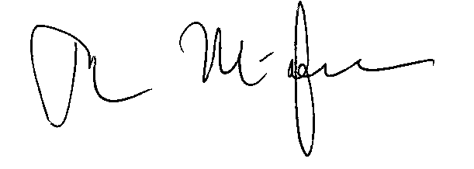

Tim A. McAfee, MD, MPH
Director
Office on Smoking and Health
National Center for Chronic Disease Prevention and Health Promotion

