The RoPR data collection system will be a web based collection mechanism. The screenshots included in this section are from the prototype system used with stakeholders to complete usability testing. The form has 6 sections.

Form Approved  
OMB No. 0935-XXXX  
Exp. Date XX/XX/20XX

1)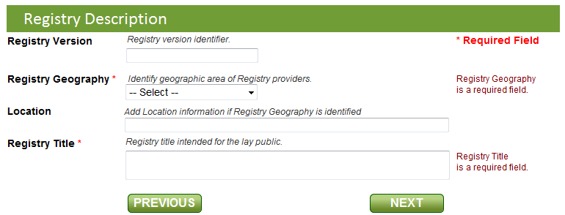

2)

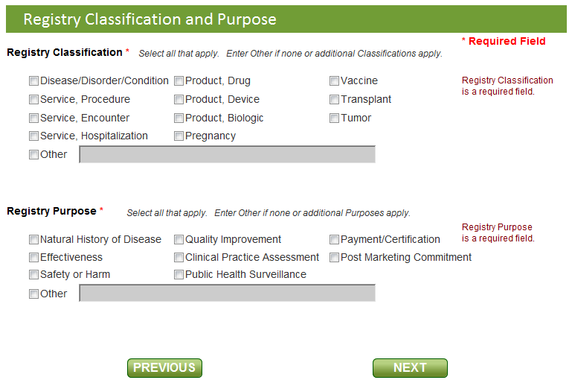

3)

Public reporting burden for this collection of information is estimated to average 45 minutes per response, the estimated time required to complete the survey. An agency may not conduct or sponsor, and a person is not required to respond to, a collection of information unless it displays a currently valid OMB control number. Send comments regarding this burden estimate or any other aspect of this collection of information, including suggestions for reducing this burden, to: AHRQ Reports Clearance Officer Attention: PRA, Paperwork Reduction Project (0935-XXXX) AHRQ, 540 Gaither Road, Room # 5036, Rockville, MD 20850.

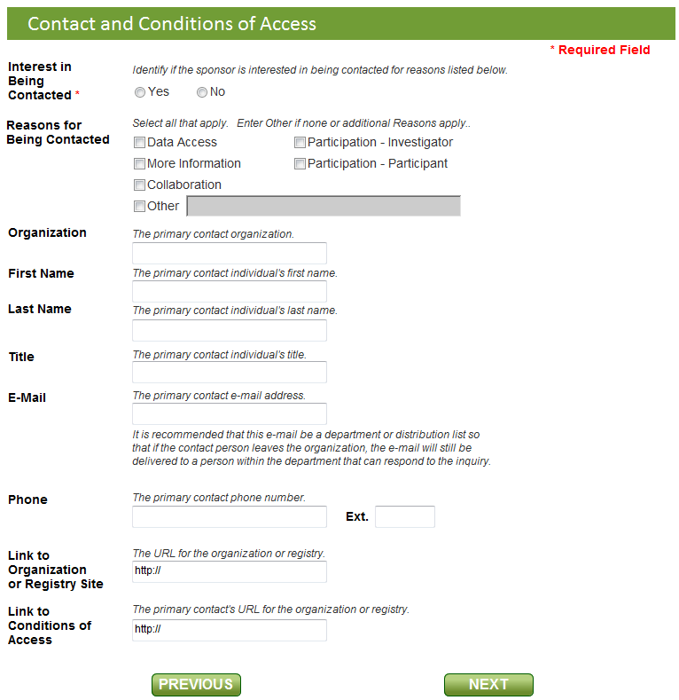

4)

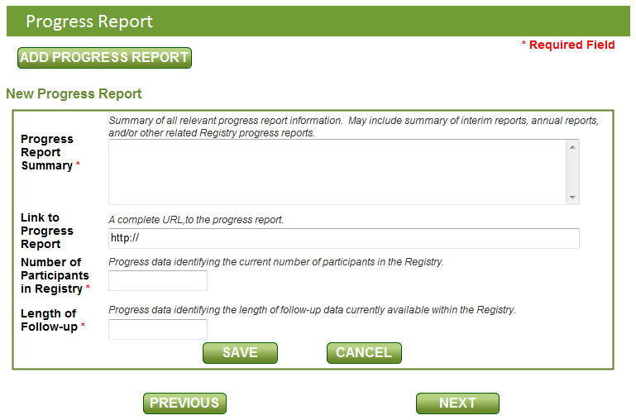

5)

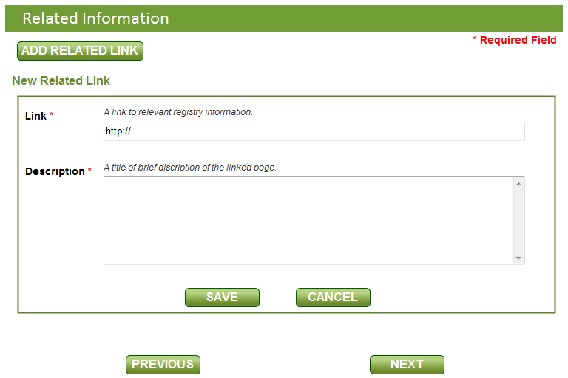

6)

