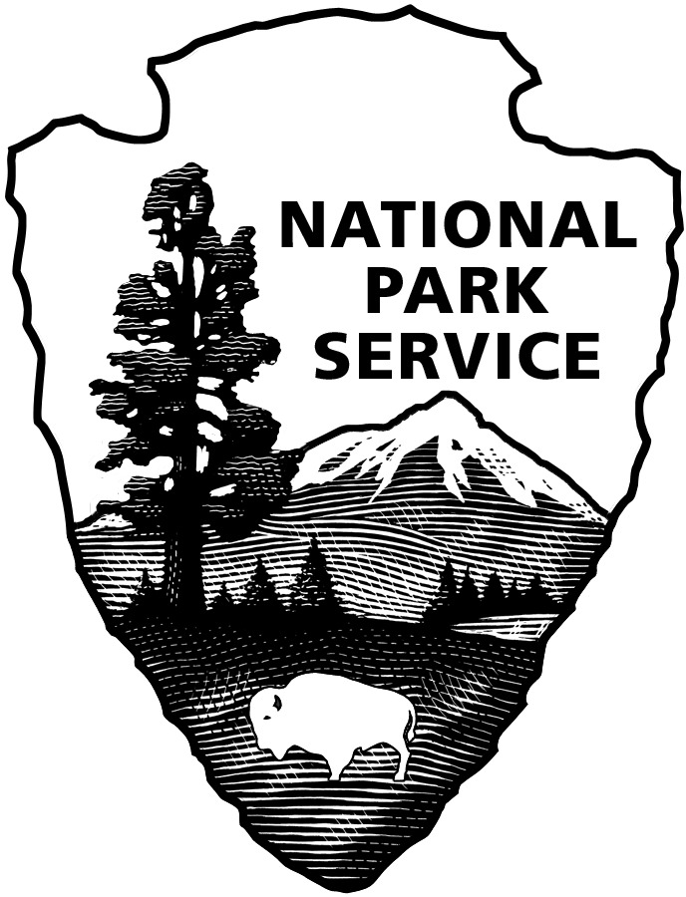
National Park Service
(Park Name)
(street, city, state, zip code)
(telephone number)

Application for Special Use Permit
Vehicle/Watercraft Use

Type of Permit:
□ Off-Road Vehicle □ Commercial Vehicle Access □ Snowmobile □ Vehicle Parking
□ watercraft
Complete the following:
Applicant’s Name_______________________________________________________
^{last} ^{first} ^{m.i.} ^{suffix}
Driver’s License number ___________________ State______ Expiration date _________
Applicant/Company Address: ________________________________________________________
^{street/p.o. box/city/zip code}
Social Security Number or Business Tax ID number: ________________
Telephone: ( ) ____________ Cell: ( ) ____________

Additional Drivers (limit of X, attach an additional sheet if needed):
Name: ___________________Driver’s License number/State ________________ exp. date _______
Name: ___________________Driver’s License number/State ________________ exp. date _______
Name: ___________________Driver’s License number/State ________________ exp. date _______
Emergency Contact’s Name__________________________ Telephone Number ___________
Vehicle Information:
Type of Vehicle:
□ Car/pass. □Van/lt. truck □Utl. Van/Truck □ Bus □RV/Camper/Trailer □ Snowmobile ATV/UVT □ 18-Wheeler Oversize Load □ Boat
VIN/ID Number ________________________
License Plate/Registration number __________________ State _____ Expiration Date ___________
Year: _________ Make: ____________________ Model _________________Color__________
Weight____________ Length ________Height____________ Number of Axles__________________
Maximum Number of Passengers:_________________ 4-wheel drive vehicle Y N (circle)
Watercraft motor(s) (circle one) inboard out-board number of motors_______ horsepower (each) _______
Vehicle Inspection Information:
Is your vehicle required to undergo State inspections? Yes / No Expiration date:_______
Insurance Information: Complete the following and attach copy of valid insurance card.
Company ______________________ Policy number ______________
Requested duration of permit: 7 day □ Annual □ Day Use □ Overnight □ Other ___________
Requested start date of permit: ___________________
Requested use area or route: _____________________________________________________________
If applicable, select your business, and provide the following information:

Contractor □ Sanitation/Refuse□ Plumbing/Heating□ Electrical□ Public Utility□ Municipal □ Delivery □ Transportation (bus, taxi, etc.) □ Other (specify) ____________________
Business Name (if applicable) _____________________________________

Contractor license Number (if applicable) ____________________________
Detail need for use of park roads: __________________________________________________

The applicant by his or her signature certifies that all the information given is complete and correct, and that no false or misleading information or false statements have been given.

Signature: ___________________________ Print Name: _________________________
Date: ___________
***********************************************************************************
Note: this is an application only, and does not serve as permission to conduct special activity in the park. The information provided will be used to determine whether a permit will be issued. Send the completed application along with the application fee in the form of a cashier’s check or money order made payable to National Park Service to ___________________________________ at the Park address found on the first page of this application.

Credit Card Authorization: All credit card information is protected under the Privacy Act.
Name as it appears on the card (print clearly): _________________________________________
(Circle): VISA MasterCard Discover No. _ _ _ _ _ _ _ _ _ _ _ _ _ _ _ _ Exp. _ _ / _ _ Security Code _ _ _ _
Total Amount Authorized: $________
Notice to Customers Making Payment by Personal Check: When you provide a check as payment, you authorize us either to use information from your check to make a one-time electronic fund transfer from your account or to process the payment as a check transaction. When we use information from your check to make an electronic fund transfer, funds may be withdrawn from your account as soon as the same day we receive your payment, and you will not receive your check back from your financial institution.

NOTICES
Privacy Act Statement: The Privacy Act of 1974 (5 U.S.C. 552a) provides that you be furnished with the following information in connection with information required by this application. This information is being collected to allow the park manager to make a value judgment on whether or not to allow the requested use. Applicants are required to provide their social security or taxpayer identification number for activities subject to collection of fees and charges by the National Park Service (31 U.S.C. 7701). Information from the application may be transferred to appropriate Federal, State, local agencies, when relevant to civil, criminal or regulatory investigations or prosecutions.

Paperwork Reduction Act Statement: We are collecting this information subject to the Paperwork Reduction Act (44 U.S.C. 3501) to provide the park managers the information needed to decide whether or not to allow the requested use. All applicable parts of the form must be completed in order for your request to be considered. You are not required to respond to this or any other Federal agency-sponsored information collection unless it displays a currently valid OMB control number.

Estimated Burden Statement: Public reporting burden for this form is estimated to average 15 minutes per response including the time it takes to read, gather and maintain data, review instructions and complete the form. Direct comments regarding this burden estimate or any aspects of this form to the Information Collection Clearance Officer, National Park Service,1849 C Street, NW (1237), Washington, D.C. 20240.

Title 18 U.S.C. Section 1001 makes it a crime for any person knowingly and willfully to make to any department or agency of the United States any false, fictitious, or fraudulent statements or representations as to any mater within its jurisdiction.

