Billing Contractor’s Web Portal
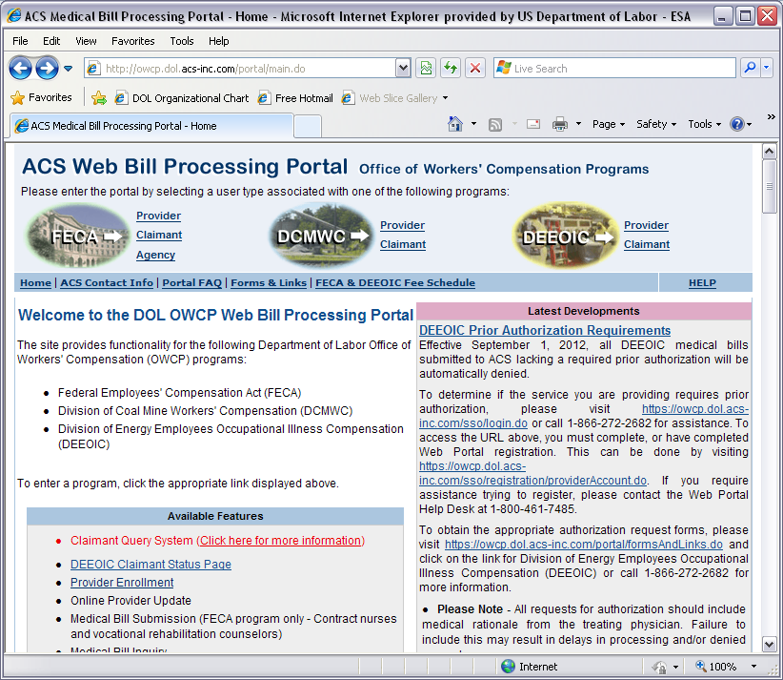

Billing Contractor’s Web Portal – Provider Enrollment
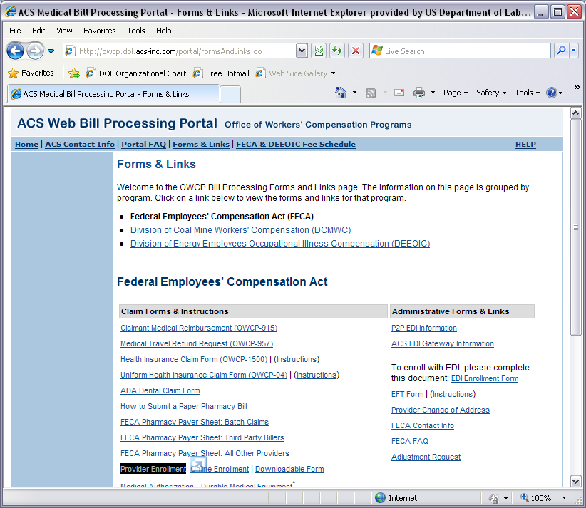

Billing Contractor’s Web Portal – Online Enrollment
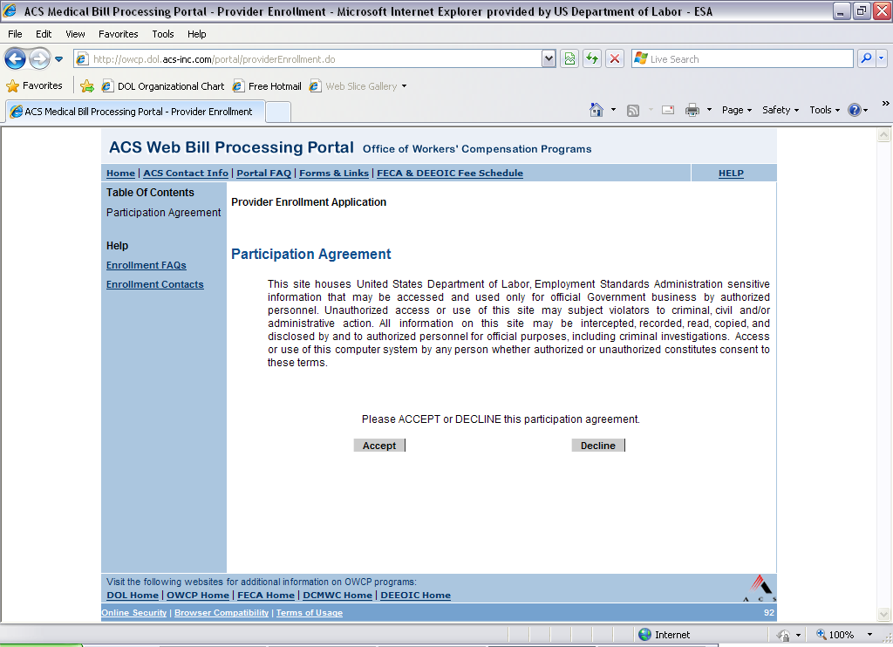

Billing Contractor’s Web Portal – Online Enrollment (once accept the participation agreement)
