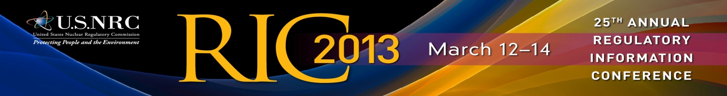

25th ANNUAL REGULATORY INFORMATION CONFERENCE
MARCH 12-14, 2013 BETHESDA, MD

OVERALL CONFERENCE EVALUATION

Your feedback on the RIC is very important to us. We use your comments to continually improve the conference each year. Please take this opportunity to provide your impressions and insights on this year’s program and accommodations.

Please check the column that most  accurately reflects your opinion: | Strongly  Agree | Agree | Neutral | Disagree | Strongly  Disagree | N/A
The conference met the overall RIC objective, to provide a communication forum and encourage openness in areas regarding nuclear safety and security initiatives and regulatory issues.
The RIC provided information that was new, important, useful, and pertinent information.
The RIC breakout sessions were sufficiently technical in content and worthwhile.
The RIC poster sessions were sufficiently technical in content and worthwhile.
Sufficient opportunity was provided during breakout sessions to ask questions and/or express individual views.
The program content and supporting information were readily accessible prior to the conference.
The U.S. NRC Headquarters Incident Response Experience Tour was a valuable experience.
The RIC staff was knowledgeable and courteous.
The RIC registration staff processed my registration expeditiously.
The RIC starting time, duration, and location were reasonably convenient.
The food and beverage provided during breaks were adequate.
Overall, the RIC was valuable and I plan to attend next year’s conference.

What factors influenced your decision to attend the conference
(mark all that apply)?

Interest in nuclear regulation Opportunity to network
Latest research information No registration fee
- Interest in nuclear safety and security Location
- Opportunity to present views Cost of hotel
- Easy access on Metrorail Career advancement
- Reimbursement from employer
- Other (please specify): ________________________________________________
Where did you stay while you attended the conference?
- Bethesda North Marriott and Conference Center
- Hilton/Doubletree Rockville
- Residence Inn Bethesda
- Hyatt Regency Bethesda
- The Legacy Hotel Rockville
- The Woodfin Suites
- Home or with Family/Relatives in the area
- Other (please specify) _________________________________________________

Please use the space below to provide additional comments, suggestions, or topics
you would like the RIC to address in the future.

Thank you for taking the time to complete this evaluation.
Please place it in one of the evaluation drop off boxes located
throughout the conference center, take it to the registration
service desk, or hand it to one of the RIC volunteers.

The estimated burden to respond to this voluntary information collection is 10 minutes. The information provided will be used to determine areas of improvement for future conferences. If a means used to impose an information collection does not display a currently valid OMB control number, the
NRC may not conduct or sponsor, and a person is not required to, the information collection. OMB NO. 3150-0197 EXPIRES ___________
OMB NO. 3150-01997 EXPIRES 09/31/2012
Public Protection Notification: If a means used to impose an information collection does not display a currently valid OMB control number, the NRC may not conduct or sponsor, and a person is not required to, the information collection.

