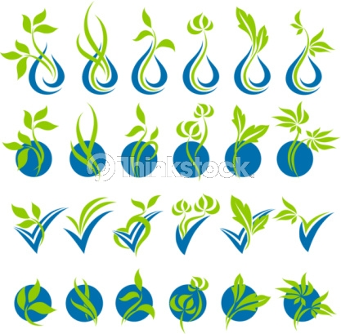
2
0
1
2

Minimizing respondent burden for large enterprises while maintaining data quality.

Your NASS contact:
Sue Jones
Sacramento, CA
456-789-0123
sue.jones@nass.usda.gov

Your Backup NASS contact:
John Cheer
Sacramento, CA
678-901-2345
John.cheer@nass.usda.gov

As an “impact” operation, data for your business impact the overall numbers for your industry. Because data from impact operations is so important, you are often asked to complete many surveys throughout the year. Work with us to customize the data collection strategy used for your operation(s) to reduce the amount of time your business takes to provide the necessary numbers.



Questions, Concerns, Comments?
Sue Jones, 456-789-0123
Sue.jones@nass.usda.gov

www.nasswebsite.gov

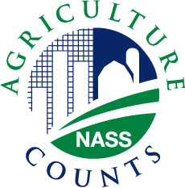
Agriculture Counts

IMPACT
The Impact Operation Program

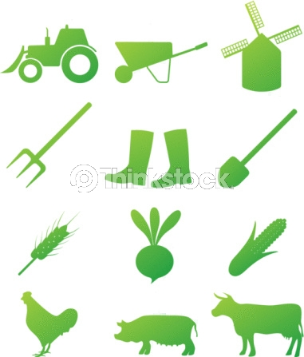

benefits of the impact operation program
- Development of an organizational structure of each operation allows us to work together with you to develop the most effective and efficient way to collect your data.
- Customized data collection reduces respondent burden for you.
- Your operation is assigned a personal contact at NASS who understands you business’s organizational structure.

Steps
- Review the materials in this packet.

- Write down any corrections to the organizational structure for your business. We will discuss this with you when we call in a couple of weeks.

- Review the calendar of surveys that need your business’s data.

- We will contact you in the next couple of weeks to discuss your business’s organizational structure and to customize a data collection plan for your business.

what is an impact operation?
An Impact Operation is a farming business whose individual data have a large impact on the overall numbers for a specific commodity.

what is the imapct operation program?
The Impact Operation Program addresses the particular needs of impact operations by customizing their data collection to minimize respondent burden and assigning them a personal contact at NASS.

is my response confidential?
Yes! Your response is confidential, it will only be used within our department to better help you and our nations agriculture.

how do i participate in the impact operation program?
To participate, work with us to develop an operational profile of your company and a customized data collection plan, following the steps listen in this brochure.

For information on open positions or to submit your resume, please visit our Web site at: www.lucernepublishing.com

