Broadband Access Loan and Loan Guarantee Program (Broadband Loan Program)
Broadband Collection and Analysis System (BCAS)
Quarterly Operating Report Submission

Login to system using USDA Level II eAuth ID
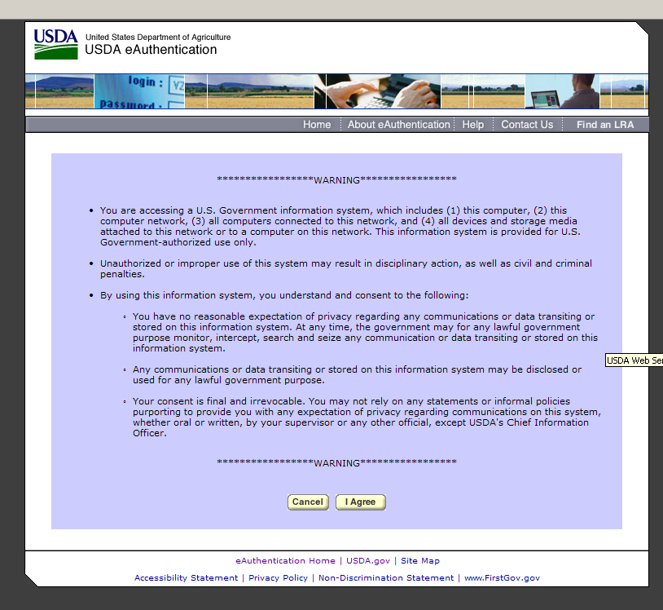

User Home Screen - select “New Report” to create a new Quarterly Operating Report
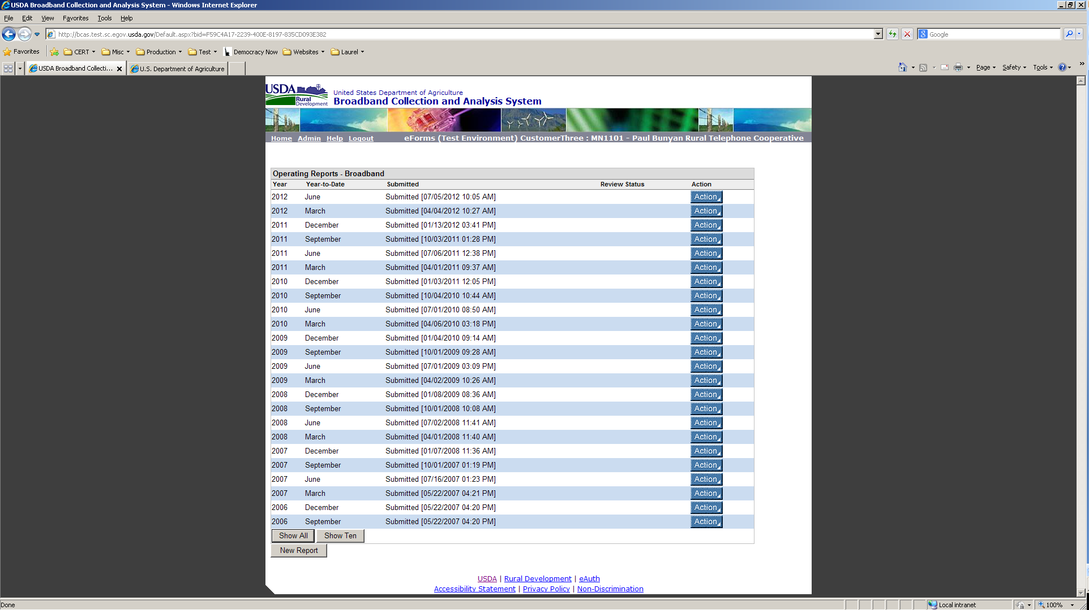

Select the Appropriate Reporting Period
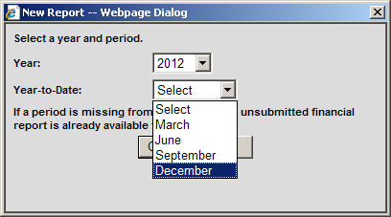

New Quarterly Operating Report is generated - click on the “Action” button then select “Edit” to edit report
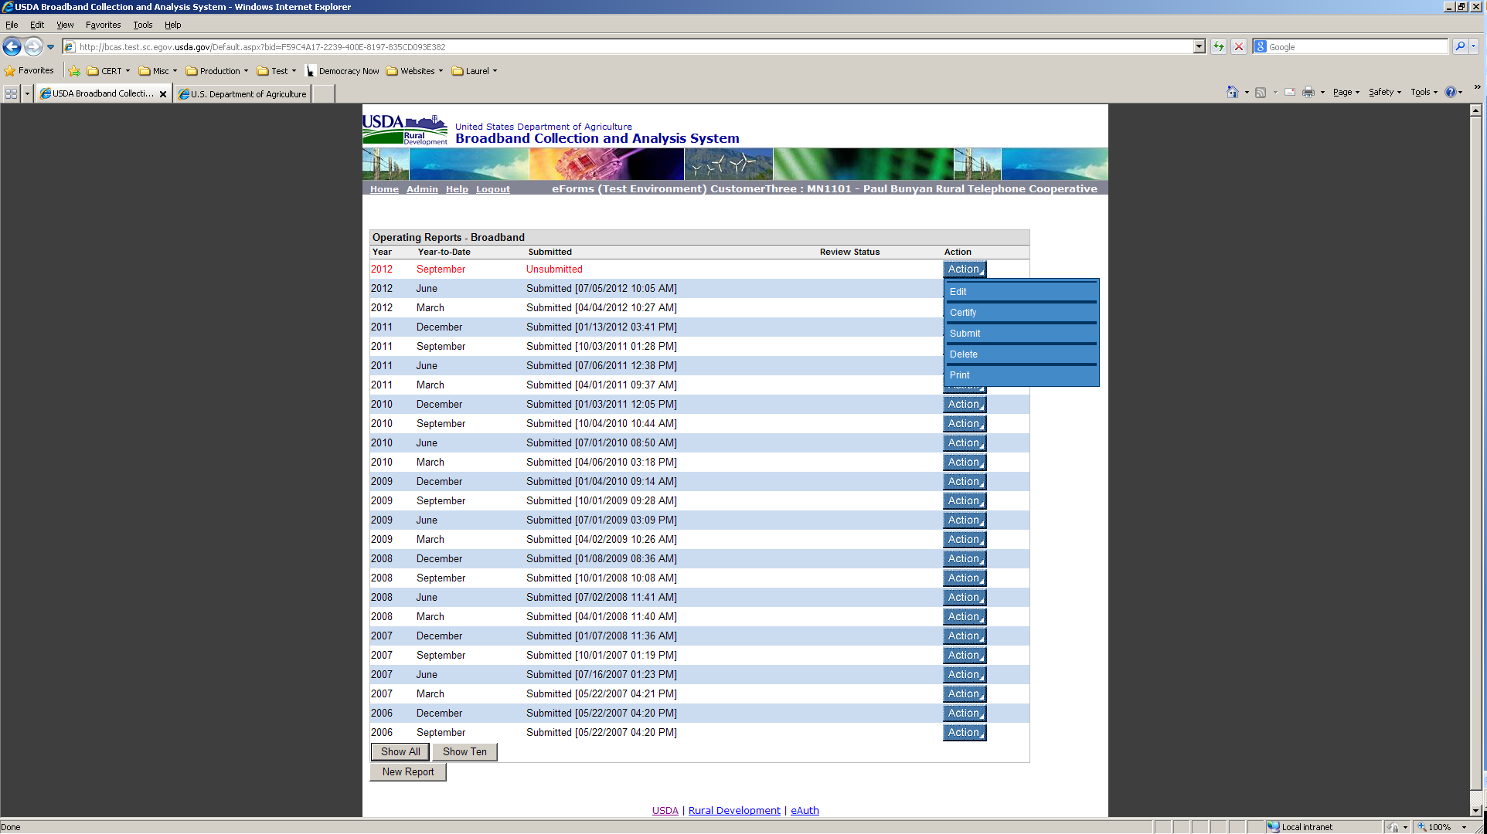

New Operating Report for September 2012
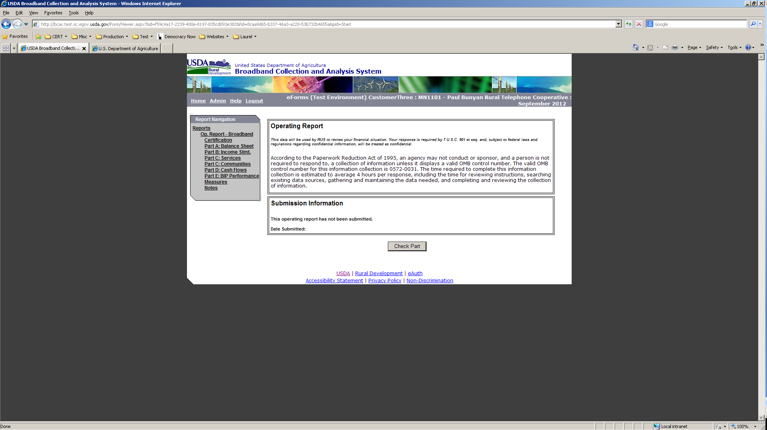

Part A: Balance Sheet
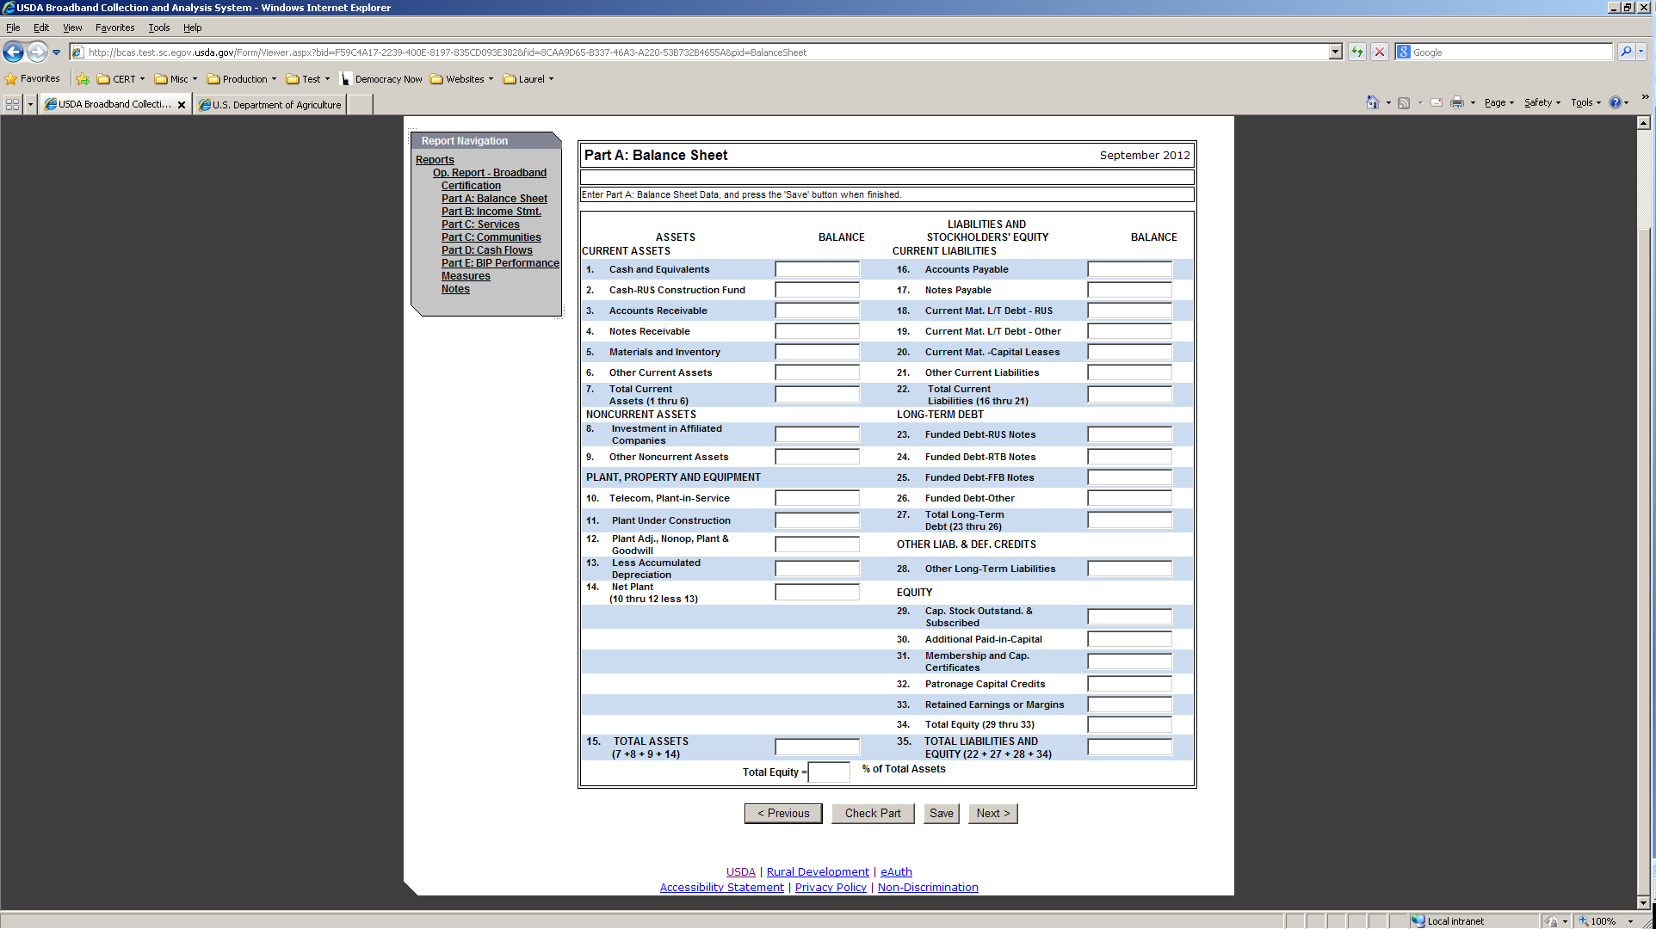

Part B: Statements of Income and Retained Earnings or Margins
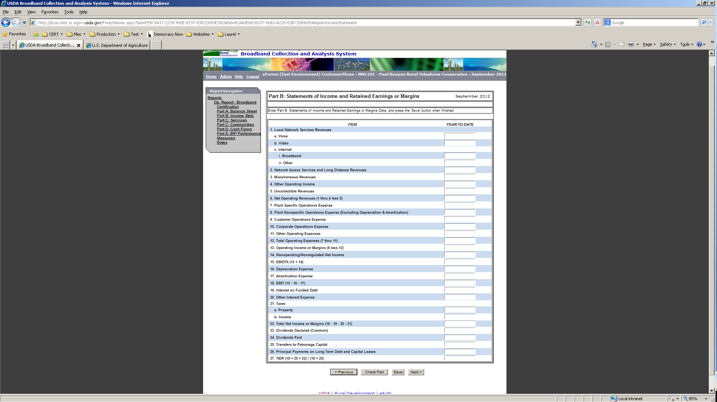

Part C: Subscriber Information - Services
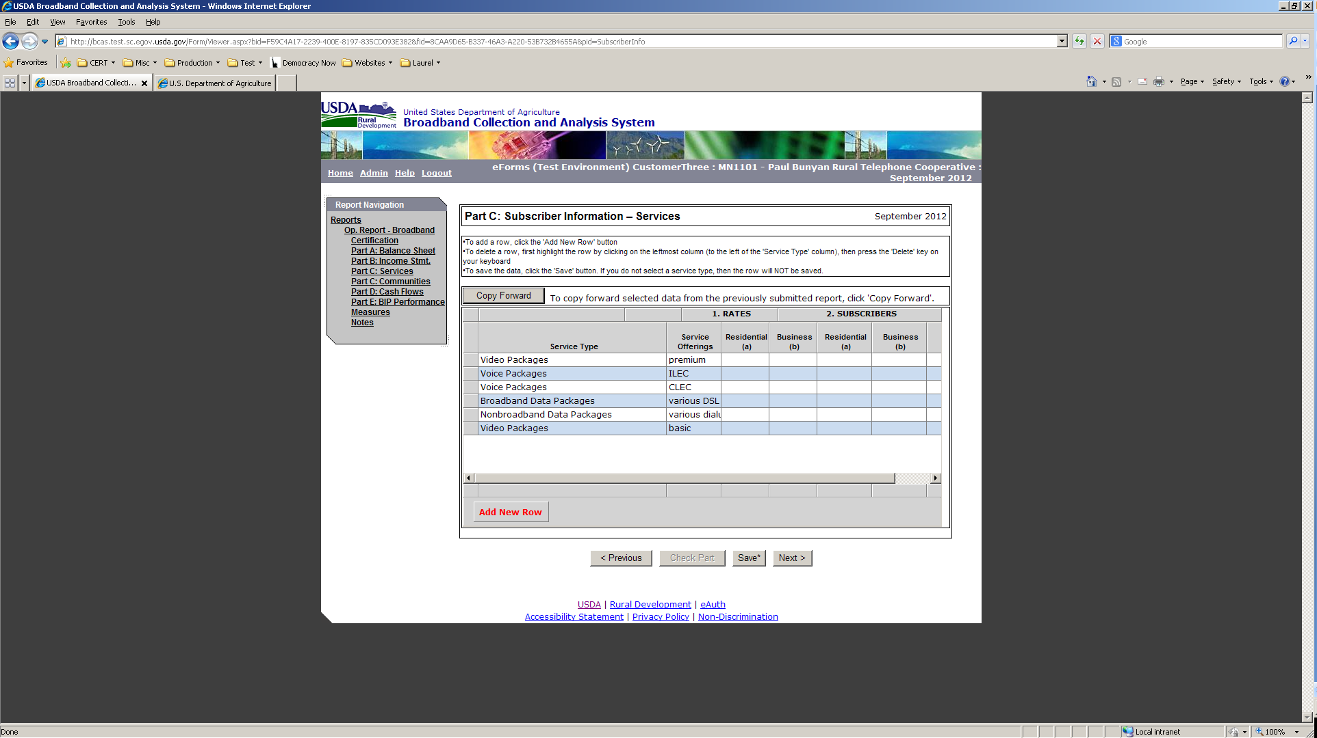

Part C: Subscriber Information - Communities
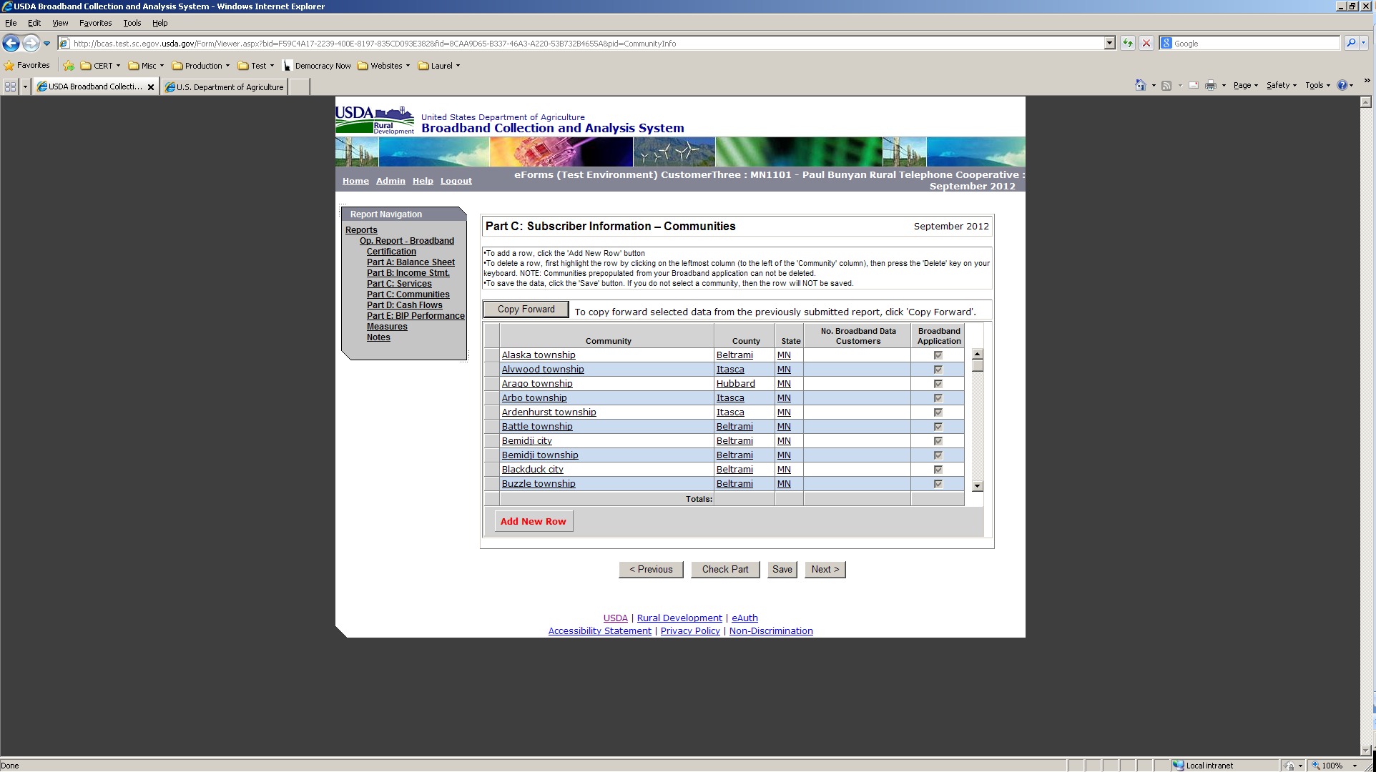

Part D: Statement of Cash Flows
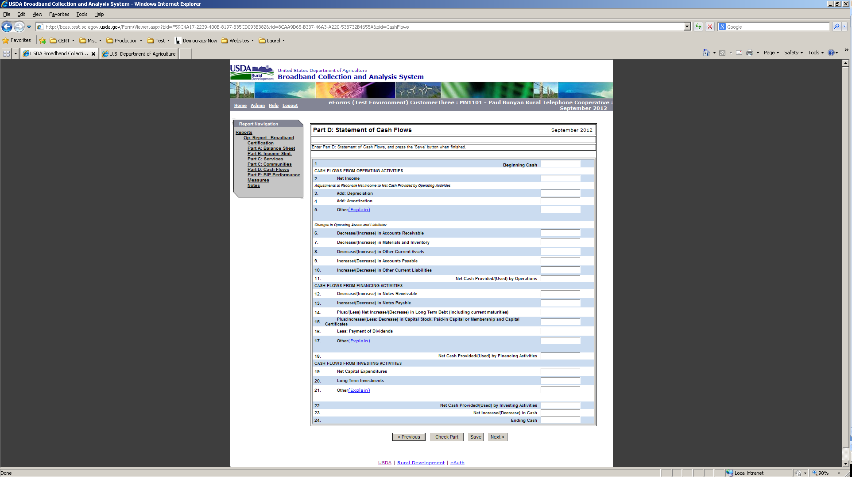

Notes to Operating Report – Broadband
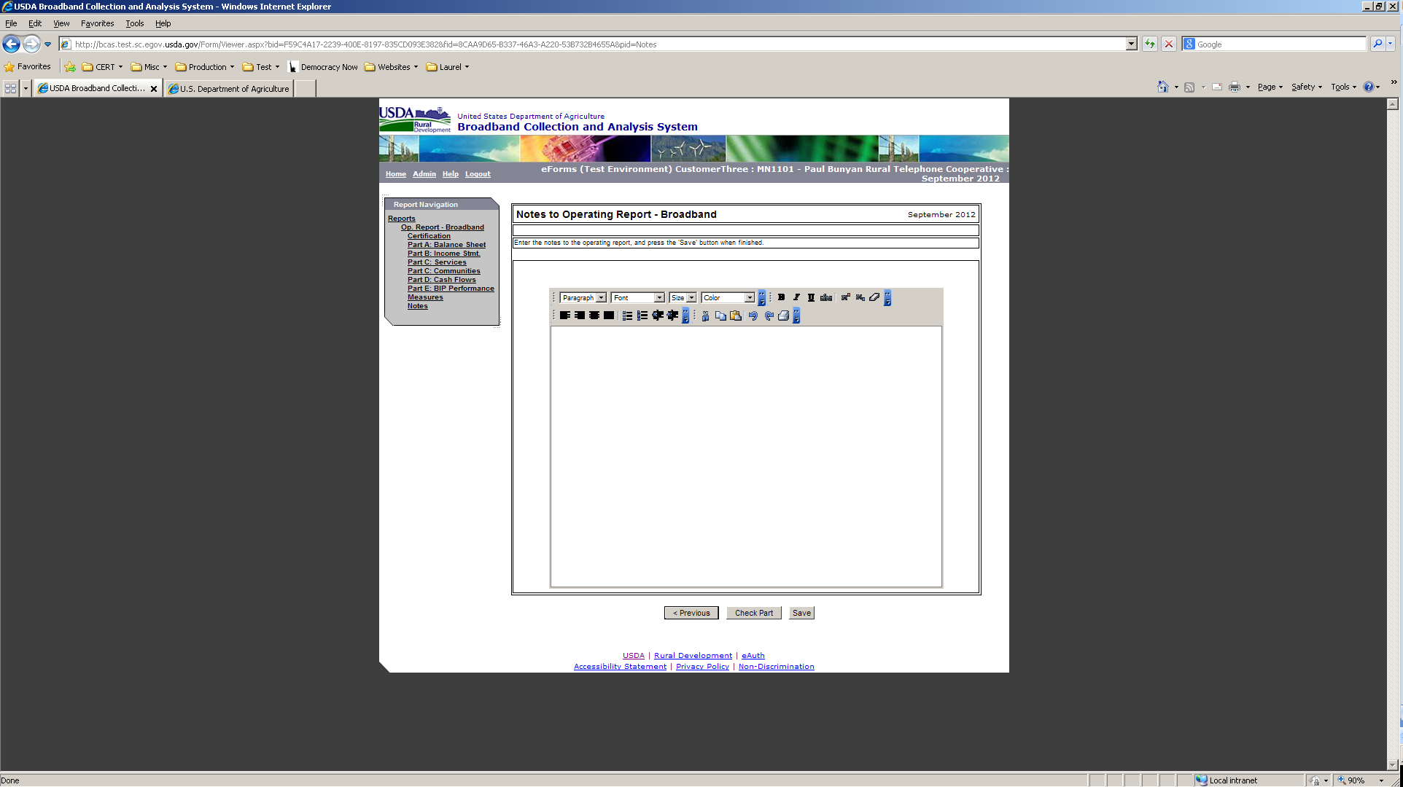

Certification – user must first check for errors or warnings and then can complete the Certification
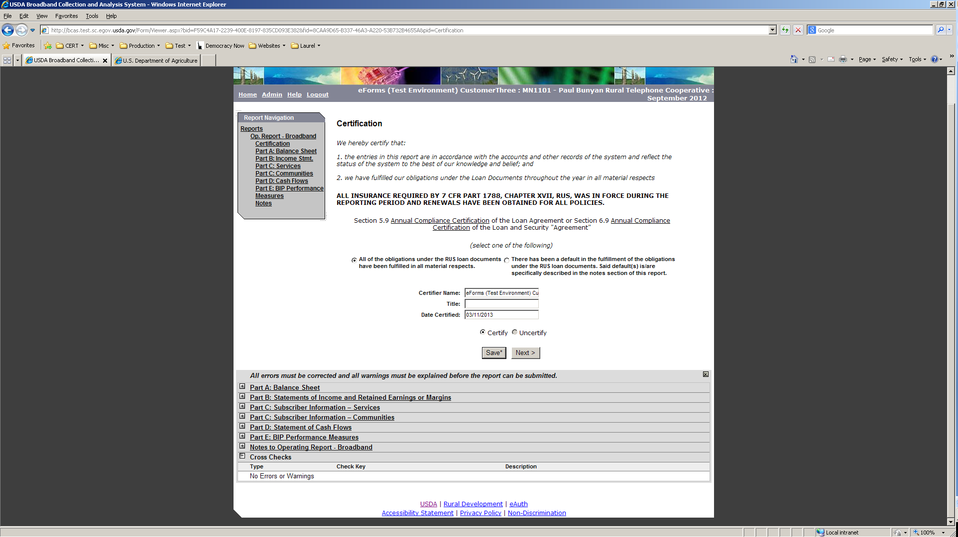

Select the appropriate Point of Contact and complete report submission
