Appendix DD.1
Feeding My Baby Study
Home health care Agency form – Length/Weight - ENGLISH
ID label

Date: _____/_____/20____

Measurements
Clothing: Child should wear only diapers

- Recumbent length (use length board with fixed headpiece and adjustable footboard)
  - Use NHANES standard procedures
  - If unable to capture acceptable length, reposition child and re-measure
│__│__│.│__│cm.

- Weight (use portable calibrated scale)
  - Use NHANES standard procedures
  - If unable to capture acceptable weight, reposition child and re-measure
│__│__│.│__│kg.
Concerns/Comments about measurements:
____________________________________________________________________________________________________________________________________________________________________________________________________________________________________________________________________________________________________________________________________________________________________________________________________________________________________________________________________________________
Standard NHANES procedures
Recumbent length (use length board with fixed headpiece and adjustable footboard)
- Cover length board with paper
- Lay child on length board with head towards headpiece in Frankfort horizontal plane
- Have caretaker apply gentle traction to bring the top of head in contact with fixed headpiece and secure head by lightly cupping palms of hands over ears
- Align legs by placing one hand gently but with mild pressure over knees
- With other hand slide foot piece to rest firmly at child’s heels
- Toes should point directly upward with both soles of feet flexed perpendicular against footboard.
- To encourage child to flex feet, run tip of finger down inside of foot
- Read measurement on length board that corresponds with the foot piece
- If unable to capture acceptable length, reposition child and remeasure

Length Boards for Measuring Infants
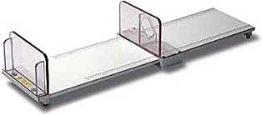
A recumbent measuring board should have a firm, flat base with an attached measuring tape, a fixed perpendicular headpiece and a smoothly sliding foot piece constructed of a durable material like wood or plexiglass that is easy to clean. The foot piece must form a 90º angle with the measurement surface. All edges must be smooth and finished. Measurements should be readable to the nearest 1/8 inch. The board should be placed on a secure table with enough room for the Assistant to be able to stand behind the back of the head of the child.

Weight (use portable calibrated scale)
  - Infants – standard scale
    - If use standard scale, weigh caretaker first
    - Tare scale
    - Hand caretaker the child
    - Capture weight of child
  - Infants – infant scale
    - Cover scale with paper
    - Place child on back or sitting, in center of tray
    - Capture weight of child
  - Toddlers
    - Have child stand on center of scale with hands by side
    - Record weight

Scales for Weighing Infants
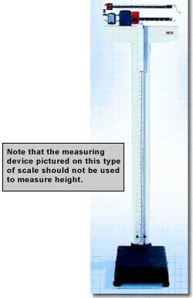
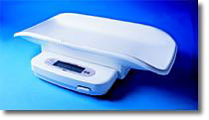
Infant beam balance or digital scales are appropriate to use for weighing infants. Beam balance scales should be marked in increments of 1 ounce or less. They should have a screw-type zeroing adjustment. There should be two sliding weights on a beam balance scale, one for whole pound increments and a second for ounces. Digital scales should read to one ounce or less. Both types should have features that allow for calibration.
