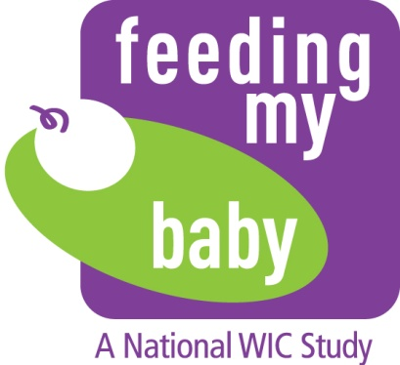
OMB Approval No. 0584-XXXX
Approval Expires: XX/XX/20XX

Appendix C.1
Participant Referral Script & FAX Cover Sheet – ENGLISH

We are conducting a very important study, “Feeding my Baby,” that will collect information on what WIC participants are feeding their babies. We’d like you to be part of it! Here is a flyer about the study. If you qualify for the study and join, you will receive $50. Here’s a form you can take to the recruiter to hear more about the study. You can then decide whether you want to participate or not. Your participation is voluntary and won’t affect your WIC benefits.
[WIC STAFF OR WIC PARTICIPANT WILL COMPLETE BOTTOM HALF AND YELLOW COPY WILL BE GIVEN TO ENROLLEE. KEEP WHITE COPY TO GIVE TO WESTAT]. Please take this yellow form to the recruiter over there once you have finished your WIC visit activities.

Script for WIC staff without an on-site recruiter/helper

We are conducting a very important study, “Feeding my Baby,” that will collect information on what WIC participants are feeding their babies. We’d like you to be part of it! Here is a flyer about the study. If you qualify for the study and join, you will receive $50. We will have someone call you to tell you more about the study. You can then decide whether you want to participate or not. Your participation is voluntary and won’t affect your WIC benefits. Someone will call you to tell you more about the study at a time that is convenient for you.

According to the Paperwork Reduction Act of 1995, no persons are required to respond to a collection of information unless it displays a valid OMB number. The valid OMB control number for this information collection is 0584-XXXX. The time required to complete this information collection is estimated to average 1 minute per response, including the time for reviewing instructions, searching existing data sources, gathering and maintaining the data needed, and completing and reviewing the collection of information.

- Fax
To: | [WESTAT SITE LIAISON NAME] | From: | [SITE FAX NUMBER]  [SITE NAME] [STATE]
Fax: | [WESTAT SECURE FAX NUMBER] | Pages: | [NUMBER OF REFERRAL FORMS]
Phone: | [WESTAT STUDY LIAISON PHONE NUMBER] | Date: | [CURRENT DATE]
Re: | Referral Forms | cc: | NOT APPLICABLE
Comments:
Here are [NUMBER OF FORMS BEING FAXED] Referral Forms for the eligible women enrolled at [SITE NAME] on [ENROLLMENT DATES]. Please let me know in case of any questions or discrepancies.

[SITE CONTACT NAME]
[SITE CONTACT EMAIL ADDRESS]
[SITE CONTACT PHONE NUMBER]

