online Questionnaire
NOAA Visitor Questionnaire
Thank you for taking the time to complete this questionnaire. Your honest feedback is appreciated.

- At which site were you asked to participate in this study?
Point Reyes
Mavericks
Monterey Bay
Island Packers in Ventura Harbor (departure point to Channel Islands)
Santa Cruz Island Scorpion Anchorage

- How long ago did you visit that site? [Mark one response.]
Less than 1 week ago
Between 1 and 2 weeks ago
More than 2 weeks ago
Not sure/don’t know

- What was your primary reason for visiting that site? [Mark one response.]
To walk, hike, picnic
To boat
To fish
To visit this marine area
Other (please describe):______________________________________________________

- Did you visit that site alone or with others? [Mark one response.]
Alone
With friends/family
Organized group

- Approximately how much time did you spend at that site? [Mark one response.]
Less than 4 hours
4 to 8 hours
8 to 12 hours
12 to 24 hours
24 to 48 hours
More than 48 hours

- What were your total trip expenditures?
$0 to $1,000
$1,000 to $3,000
$3,000 to $6,000
$6,000 to $10,000
More than $10,000

- During your visit, you were asked to participate in this study after viewing a sign that looks like this (see example below). How many signs like this did you look at?
\
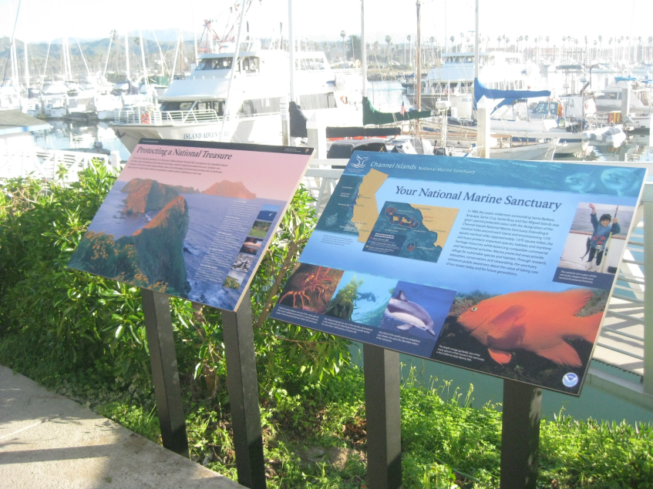 | [Mark one response.]  1  2-3  4 or more  Not sure/don’t recall

- For the sign or signs you looked at during your visit, where were they located? [Mark all that apply.]
On a walking path or recreational trail
On a boat launch, dock, or pier
Near ticketing office, concessions, or restroom
Not sure/don’t recall
Other (please describe):______________________________________________________

- Who do you think was responsible for installing the sign or signs? [Mark all that apply.]
Not sure/don’t know
City or local government
State of California
NOAA National Marine Sanctuaries
National Park Service
Other (please describe):______________________________________________________

- Using the following 7-point scales, what was your overall opinion of the sign or signs you looked at during your visit? [Mark one number on each scale below.]

10a. | Not at all informative | 1 | 2 | 3 | 4 | 5 | 6 | 7 | Very informative

10b. | Language was difficult to understand | 1 | 2 | 3 | 4 | 5 | 6 | 7 | Language was easy to understand

10c. | Tone was off-putting, bossy | 1 | 2 | 3 | 4 | 5 | 6 | 7 | Tone was friendly, helpful

- What do you think the sign or signs were trying to communicate? [Mark all that apply.]
Not sure/don’t recall
General information about the animals that live in the area
That this area is a protected ocean area
Rules and regulations about what you can and cannot do in the area
Other (please describe):______________________________________________________

- What, if anything, did you find out about the site you visited, that you didn’t know before reading the sign(s)? [Please describe.]
___________________________________________________________________________

- What effect, if any did the sign or signs have on your visit to this site?
None, the sign(s) neither enhanced nor detracted from my experience at this site.
The sign(s) detracted from my experience at this site.
The sign(s) enhanced my experience at this site.
Other (please describe):______________________________________________________

- On the sign or signs you looked at, did you see this symbol?
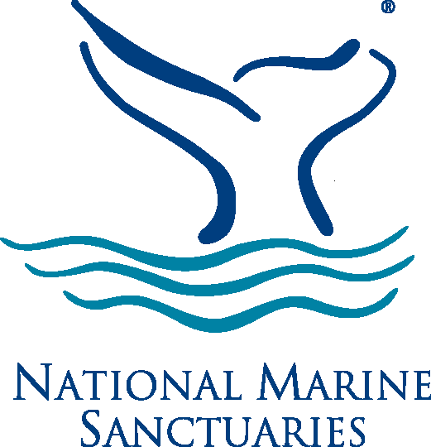 | No Yes

- Would you be interested in having the information on the sign or signs available in another medium? [Mark one response.]
No, I’m just not that interested in the information in any format.
No, I prefer getting the information from a sign.
Yes, I’d like to have the information in a brochure.
Yes, I’d like to access the information via a website.
Yes, I’d like to access the information via a mobile phone application.
Yes, I have another suggestion (please describe):___________________________________

- Thinking about the sign or signs you looked at on your visit, have you seen similar signs anywhere else on the California coast?
No [Program will skip to Question 17]
Yes 16a. Where on the California coast? [Mark all that apply.]
Not sure/don’t recall
Bodega Bay
Point Reyes
Golden Gate National Recreational Area
Mavericks
Monterey/Pacific Grove
Cambria/Moonstone
Santa Barbara
Ventura
Oxnard
Other (please describe): ____________________________________________

- Have you heard of the National Marine Sanctuaries?
No Yes

- Please indicate whether you think the following statements are “true” or “false.”
[Circle one response in each row.]

18a. | National Marine Sanctuaries helps to protect marine and Great Lakes ecosystems. | True | False

18b. | People are not allowed to visit National Marine Sanctuaries. | True | False

- What is your opinion of the following statement? [Circle one response.]

The health of the ocean and the actions of humans are inter-connected. | I Strongly Disagree | I  Disagree | Neither Agree or Disagree | I  Agree | I Strongly  Agree

Now a few questions about you:

- Are you? Male Female

- What is your age?
18 to 24 25 to 34 35 to 44 45 to 54 55 to 64 65+

- [US residents only] What is your home zip code? ______________________

Thank you so much for completing the survey! If you would like to be entered into a drawing to win one of four $50 Amazon gift cards, please enter your email address, and select "Done."
Regardless of whether or not you would like to participate in the raffle, please select "Done" to submit the survey; your responses are important to us.
Email address

Your participation is strictly voluntary and anonymous. Notwithstanding any other provision of the law, no person is required to respond to, nor shall any person be subject to a penalty for failure to comply with, a collection of information subject to the requirements of the Paperwork Reduction Act, unless that collection of information displays a currently valid OMB Control Number.

Any ISP or email address information will not be distributed, made public, nor shared with any other persons or entity.

