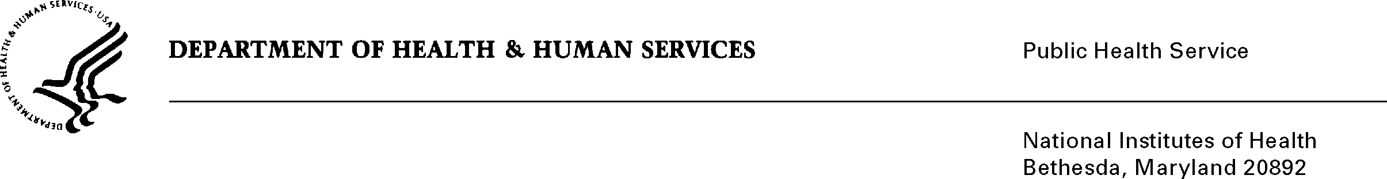

DATE: June 14, 2012

TO: Mary Anne Bright, Associate Director
Office of Public Information and Resource Management
Office of Communications and Education, NCI

FROM: NIH Privacy Act Officer

SUBJECT: Applicability of the Privacy Act: “Cancer Information Service (CIS)”

I have reviewed the NCI submission to OMB requesting approval for the revision to the “Collection of Customer Service, Demographic, Smoking/Tobacco Use Information From the National Cancer Institute’s Cancer Information Service (CIS) Clients (NCI)”. The CIS provides cancer information to cancer patients, family members and friends of patients, health professionals and the general public, in both English and Spanish. This information is provided through a toll-free number, instant messaging, email services, Facebook, and a Smartphone application.

I have determined the Privacy Act will apply to this data collection (OMB No. 0925-0208). Although the proposed methodologies will require the collection of customer service information (i.e., past use of CIS, caller’s zip code), demographic information (i.e., age, education, ethnicity, race, sex, income, number of household members, health insurance coverage, source of health care, client category), and smoking intake information (i.e., use history, behaviors, outside influences, household exposure), data will not be retrieved by personal identifiers except when information is to be sent or clients have agreed to smoking cessation call backs. In these cases, personally identifiable information will be collected and retrieved by name, mailing address, e-mail address, and/or telephone number. Raw data from data collections that include personal information will not be retained once the data have been aggregated.

The data collection is designed to obtain information about individuals who contact the CIS for cancer information or smoking cessation. The study will survey a sample of CIS telephone clients, Smoking Cessation “Quitline” clients, LiveHelp (instant messaging) clients and e-mail clients. The evaluation results will help CIS improve its program, products, and services.

The data collection is covered by NIH Privacy Act Systems of Record 09-25-0156, “Records of Participants in Programs and Respondents in Surveys Used to Evaluate Programs of the Public Health Service, HHS/PHS/NIH/OD”. If you have any questions, please contact my office at (301) 402-6201.

Karen M. Plá

Enclosure

cc: Vivian Horovitch-Kelley, NCI PRA Liaison

