APPENDIX 1 B

DATA COLLECTION INSTRUMENTS AND
ELECTRONIC CONTACT RECORD FORM (ECRF)

EXAMPLE OF LIVEHELP TRANSCRIPT AND
LIVEHELP QUESTIONS

(CUSTOMER SERVICE AND DEMOGRAPHICS QUESTIONS)

Public Burden Statement
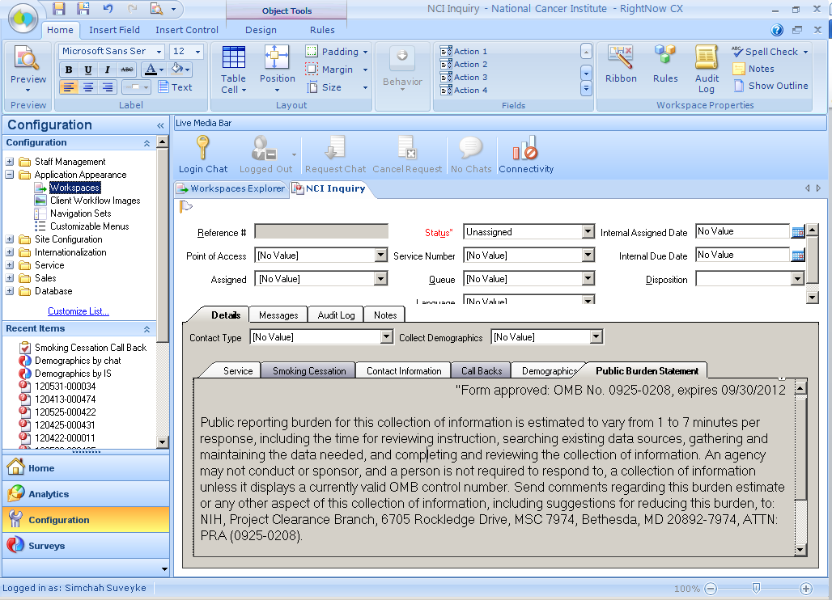

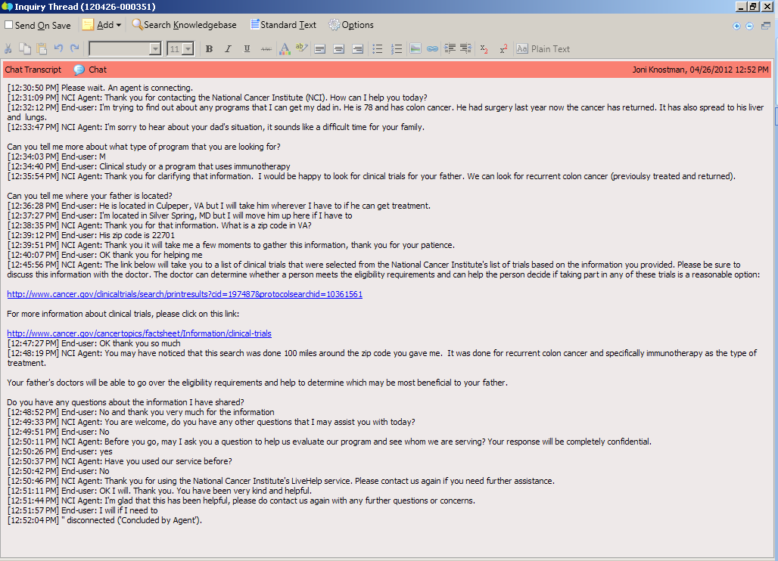

Customer Service Questions

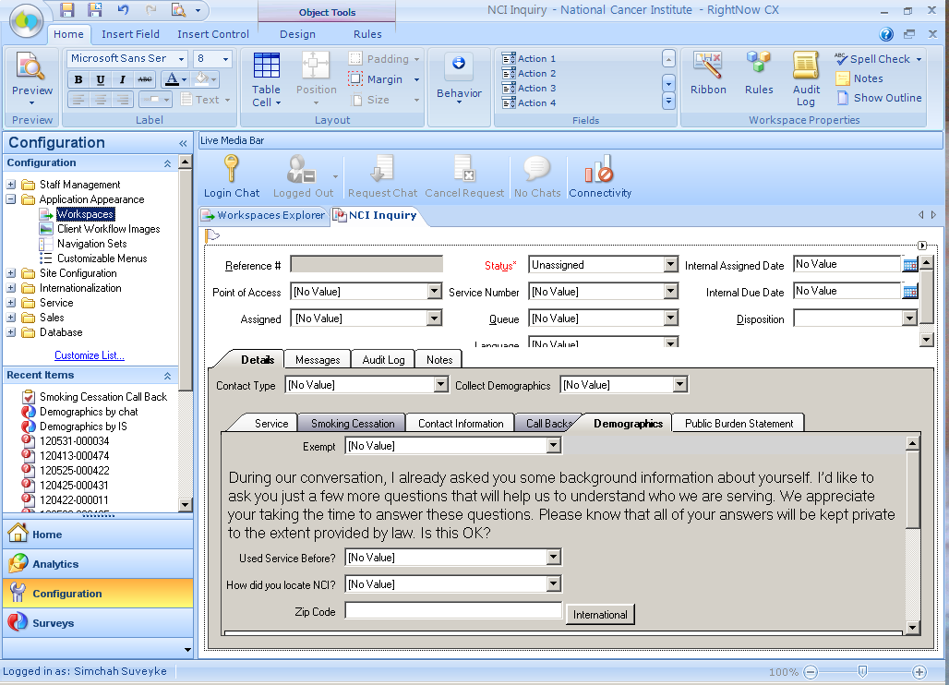

Demographic Questions:

What is your age?
Age
Don’t know
Break off
Did not complete
Callers age 96 or older
Not sampled
Refusal
Did not ask
What is your Sex?
Male
Female
Don’t know
Did Not Complete
Not sampled
Refusal
Did not ask
Which of These Ethnicities Best Describes You?
Hispanic or Latino
Not Hispanic or Latino
Don’t know
Did not complete
Not sampled
Refusal
Did not ask
Which of These Races Best Describes You? You can select more than one:
American Indian or Alaska Native
Asian
Black or African American
Native Hawaiian or Other Pacific Islander
White
Don’t know
Did not complete
Not sampled
Refusal
Did not ask

What Is the Highest Level of Education You Have Completed?
Grade school
Some high school
High school graduate
Some college
College graduate
Post-graduate
Not sampled
Refusal
Did not ask
Don’t know
Did not complete
Is There a Place You Usually Go to When You are Sick or Need Advice About Your Health?
Yes
No
Don't Know
Did not complete
Not sampled
Refused
Did not ask
What Kind of Place Do You Go Most Often?
A doctor’s office
A clinic, health center, or hospital clinic
The emergency room, or
Some other place
No one place
Valid skip
Don’t know
Did not complete
Not sampled
Refused
Did not ask
In the Last 12 Months, Did You Have Any Kind of Healthcare Coverage, Including Health Insurance, Prepaid Plans Such As HMOs or Government Plans Such as Medicare?
Yes
No
Don’t know
Did not complete
Not sampled
Refused
Did not ask
Would You Say You Had This Coverage During All 12 Months or Less Than 12 Months?
All 12 months
Less than 12 months
Valid skip
Don’t know
Did not complete
Not sampled
Refused
Did not ask
Which Type of Coverage Did You Have?
Was it public, such as Medicare, Medicaid, or other government plans?
Was it private, such as an HMO, Blue Cross, Kaiser, Aetna?
Or, was it both public and private?
Valid skip
Don’t know
Did not complete
Not sampled
Refused
Did not ask
The final questions are about your family income. I understand that this is sensitive information and I would like to stress again that all of the information you provide is confidential. What Was Your Total Household Income from All Sources Before Taxes Last Year? Just Stop Me When I Get to the Right Category
Less than $10,000
$10,000 to $19,000
$20,000 to $29,000
$30,000 to $39,000
$40,000 to $59,000
$60,000 to $79,000
$80,000 or more
Don’t know
Did not complete
Not sampled
Refused
Including Yourself, How Many People Living in Your Household are Supported by This Total Household Income?
Total People
Valid skip
Don’t know
Did not complete
Not sampled
Refused
Did not ask

