**APPENDIX 1 C**

**DATA COLLECTION INSTRUMENTS and**

**electronic contact Record Form (ECRF)**

**REACTIVE SMOKING CESSATION Questions**

**(customer service and demographics questions)**

**Public Burden Statement**

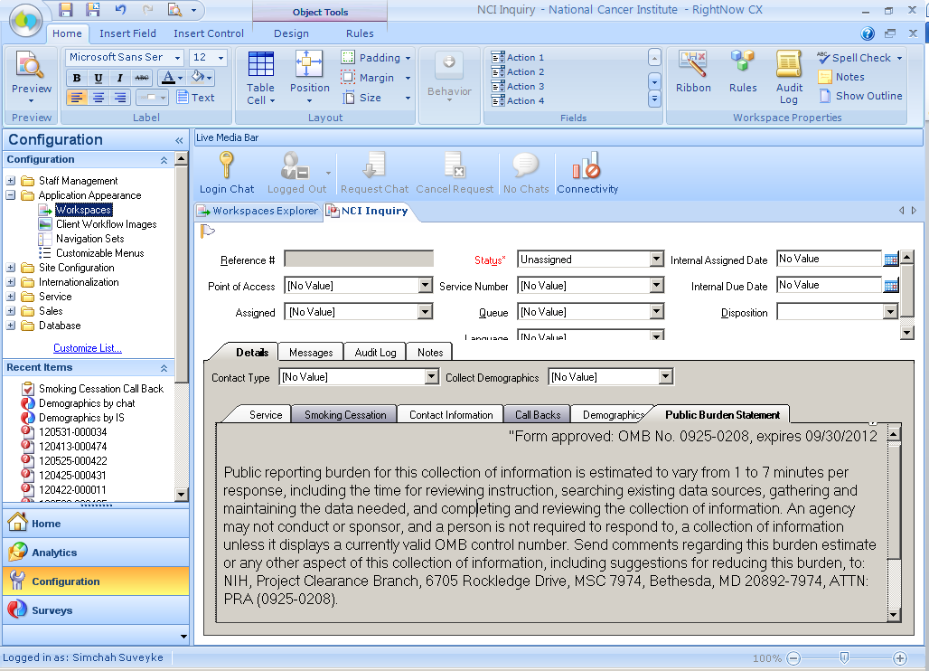

**Smoking Cessation Intake Form (SCIF): Dependency Tab > Summary**

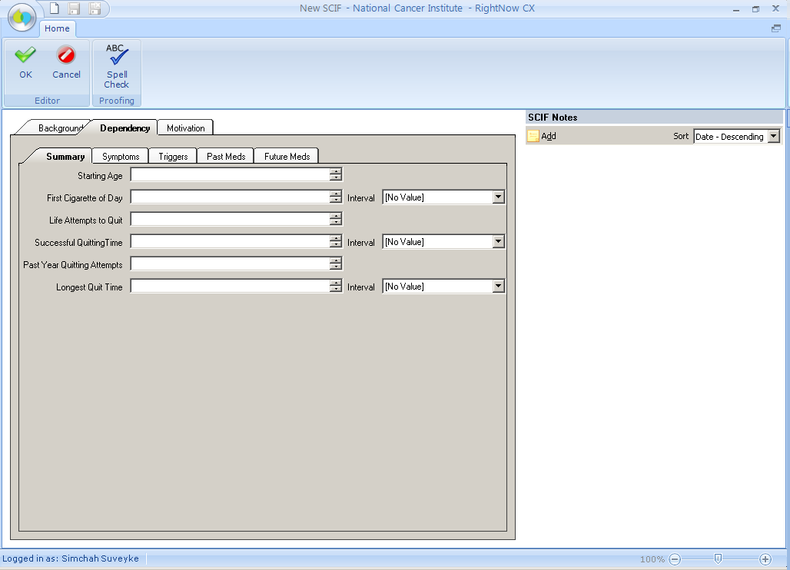

**Smoking Cessation Intake Form (SCIF): Dependency Tab Symptoms**

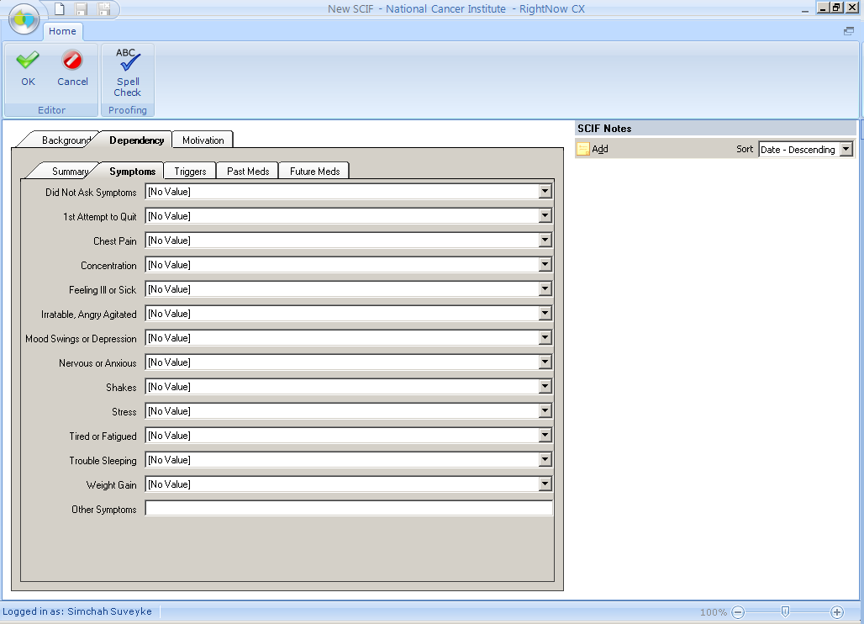

**Smoking Cessation Intake Form (SCIF): Dependency Tab > Triggers**

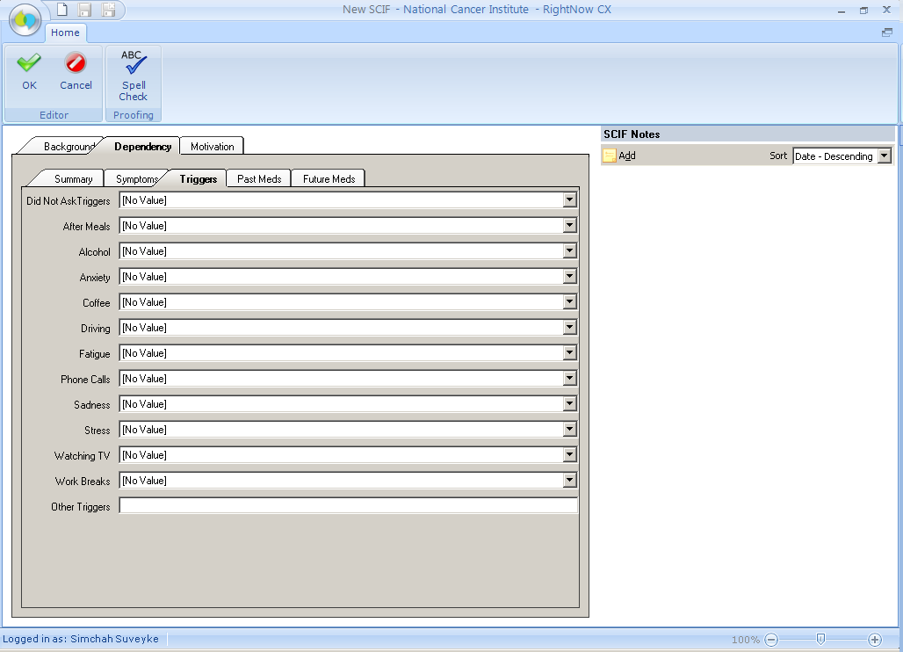

**Smoking Cessation Intake Form (SCIF): Dependency Tab > Past Meds**

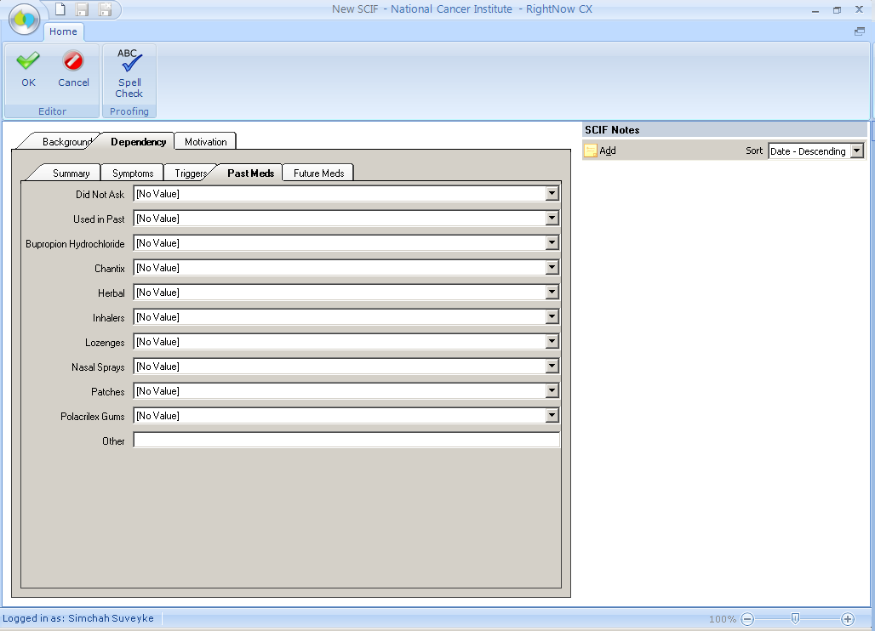

**Smoking Cessation Intake Form (SCIF): Dependency Tab > Future Meds**

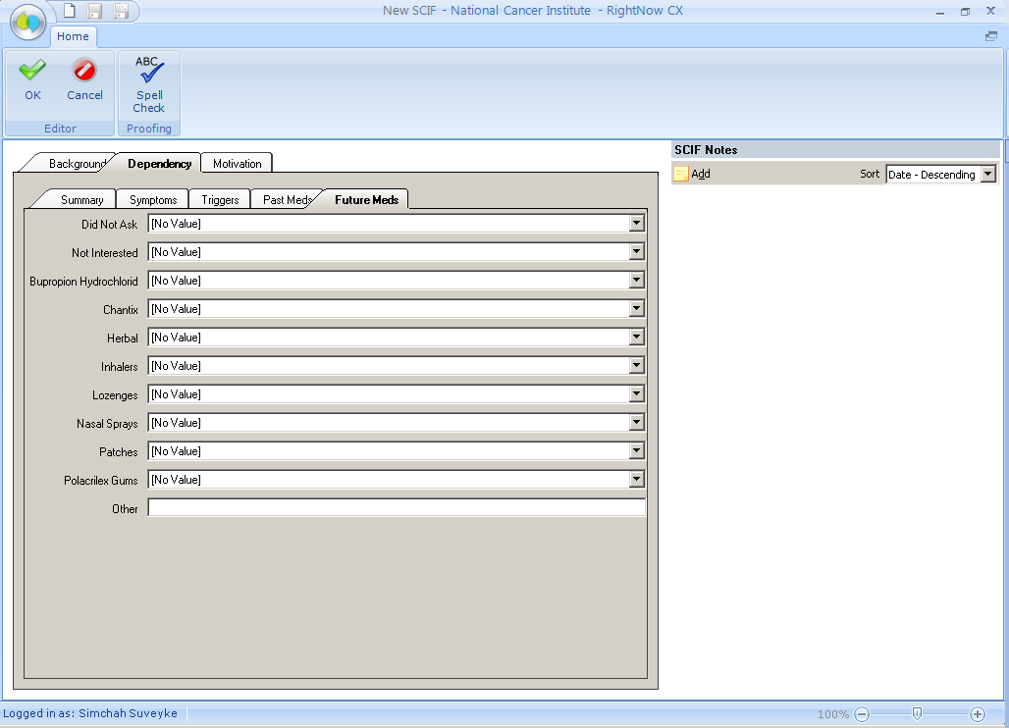

**Smoking Cessation Intake Form (SCIF): Motivation Tab**

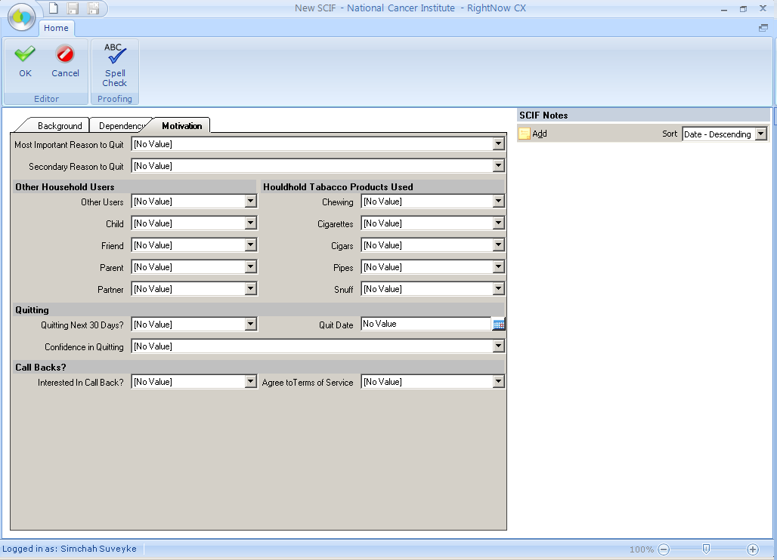

**Electronic Coding Records Form (ECRF): seen within the Service Tab**

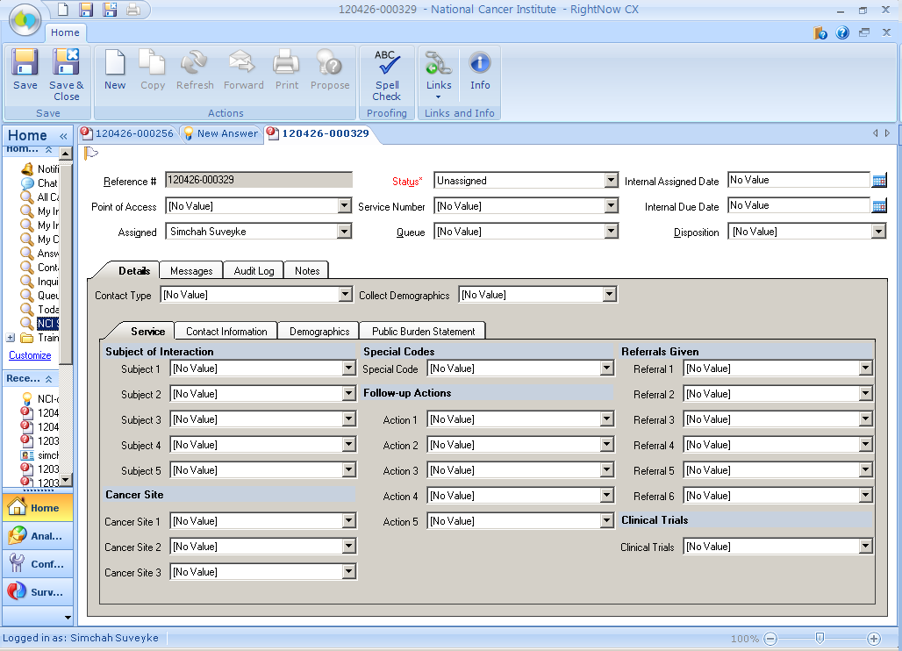

***Spanish Version***

**Electronic Coding Records Form (ECRF): seen within the Service Tab**

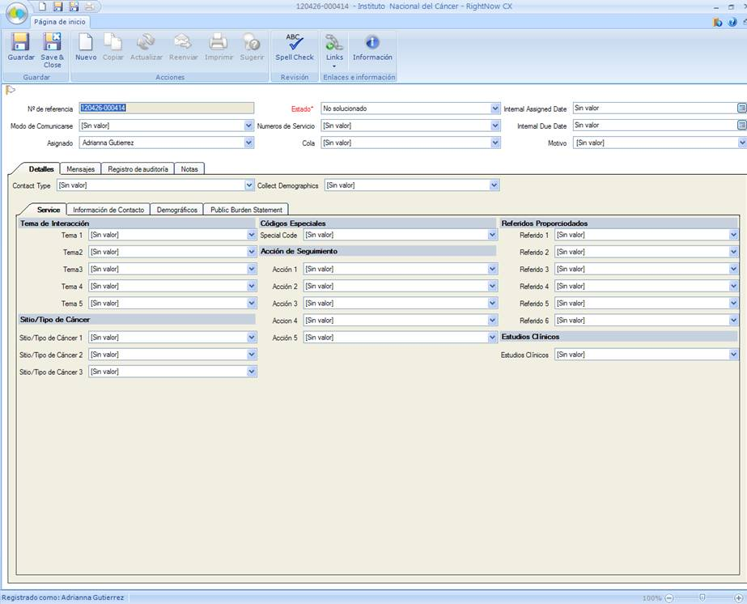

**Customer Service Questions**

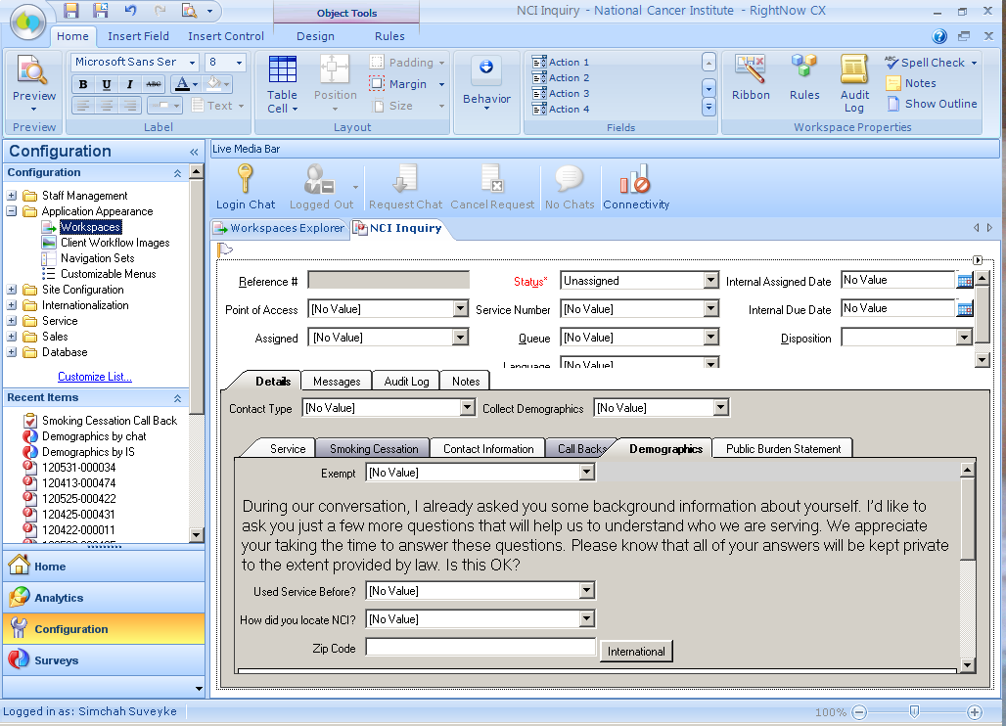

Top of Form